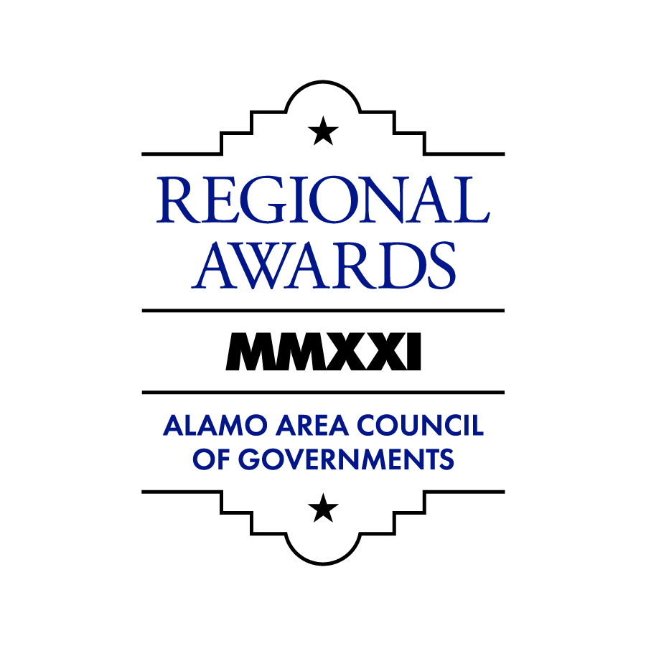

2021 AACOG Regional Awards
The Alamo Area Council of Governments (AACOG) is accepting nominations for the 2021 AACOG Regional Awards. Award recipients will be honored during the AACOG Area Council and Board of Directors Annual Luncheon on Wednesday, December 8, 2021.

Who is eligible for nomination?
Any person, corporation, community project, or government project that has contributed to the positive advancement of the communities inside the Alamo Area (Atascosa, Bandera, Bexar, Comal, Frio, Gillespie, Guadalupe, Karnes, Kendall, Kerr, McMullen, Medina, and Wilson counties) is eligible for nomination. Previous award recipients are ineligible for the same category if they have won within the past 3 years. Current elected officials are also ineligible for nomination unless directly involved in a project.

Nomination categories
- Regional Citizen of the Year
- Corporate/Business Steward of the Year
- Community/Non-profit Project of the Year
- Governmental Project of the Year
- Lifetime Achievement Award

Scoring Categories
- Overall Project Description – (30 Points) Describe the individual, project, or effort; explain the 5 W’s (Who, What, Where, When, Why).
- Overall Impact on the Community / Region (20 points) – Explain how this project benefits the residents of the respective community and/or the greater Alamo Area
- Measurable Achievements (30 points) – Provide quantitative data reflecting the success of the individual’s efforts or program’s goals. Describe how many residents were positively impacted, reached, communicated to, etc.
- Partnerships Developed (20 points) – Describe and list any collaboration with community organizations, governmental agencies, churches, or other organized groups that aided to the success of this individual’s efforts or project.

How to nominate?
- Complete one paper or online form for each entry (nomination entries are unlimited by using a new form for each entry). Supporting documentation and letters of support are encouraged and can be mailed, uploaded via the online form, or sent to msegura@aacog.com.
- The nomination form can be completed online at www.AACOGawards.com; acquired from AACOG at 2700 NE Loop 410, Suite 101, San Antonio, Texas, 78217; or by requesting a form via email from msegura@aacog.com.

- Complete entire nomination form (incomplete forms will not be considered). Please ensure all information is legible and documents are uploaded properly.

- Nomination form(s) must be received no later than 11:59 p.m. on Friday, September 10, 2021.

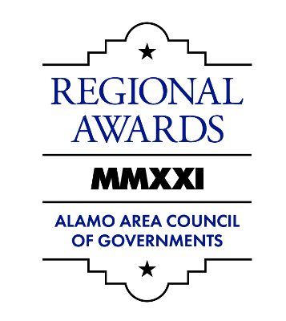

2021 AACOG Regional Awards

Nomination Form (Page One)

Nominations due by 11:59 p.m. on Friday, September 10, 2021

Where to submit a nomination?

By Mail:
Alamo Area Council of Governments
Attn: Miguel Segura, Public Affairs Manager

2700 NE Loop 410, Suite 101, San Antonio, TX, 78217

By email: msegura@aacog.com Online: www.AACOGawards.com

Select Award Category:
Please check one of the award categories below. Previous winners of these awards are available for viewing online at www.AACOGawards.com. For further information on what category to select to recognize an individual, company, or project, please contact AACOG External Affairs & Communications at (210) 362-5203 or msegura@aacog.com.
REGIONAL CITIZEN OF THE YEAR:
This award honors individuals who have contributed to the betterment of the AACOG region. The award is given to individuals residing within the Alamo Area who demonstrate a dedication to the region through their activities outside the scope of their employment. Current elected officials are ineligible for nomination.

Corporate / BUSINESS STEWARD OF THE YEAR
This award honors businesses and corporations that have contributed to the betterment of the AACOG region. It is given annually to small, medium, and large for-profit companies that make a positive impact on their local communities through activities such as employee volunteering initiatives, fundraising activities, and other efforts that have established the corporation as a community partner.

Community/NON-PROFIT Project OF THE YEAR
This award honors community-based or non-profit projects that have contributed to the betterment of the AACOG region. These awards are given annually to community-based or non-profit driven projects that have made a positive impact to the communities involved in and affected by the project. Projects not yet completed are ineligible.

GOVERNMENT Project OF THE YEAR
This award honors government projects that have contributed to the betterment of the region. These awards are given annually to completed governmental entity-based projects that have significantly impacted the community for the better. Projects not yet completed are ineligible.

LIFETIME ACHIEVEMENT AWARD
This award honors individuals that have significantly contribute to the betterment of the AACOG region as a whole over their lifetime. This recognition does not need to be awarded every year. Individuals nominated under this category may instead be recognized under the Regional Citizen of the Year category, at the discretion of the AACOG Community Affairs Committee.

2021 AACOG Regional Awards

Nomination Form (Page Two)

Nomination:

Name of Nominee:
Address:

City/State/Zip:

Phone: ______________________________ Email / Website:

Person Making Nomination:

Name:
Address:

City/State/Zip:

Phone: ______________________________ Email:

Where did you hear about this awards program?

Your relationship to nominated party:

2021 AACOG Regional Awards

Nomination Form (Page Three)

Please answer the following questions on this page.

- Describe the project or individual being nominated; please cover who, what, where, when, and why this nominee deserves to receive this award. (500 word max.) (30 Points)

- Describe the project / individual’s positive impact on the community and its residents. (500 word max.) (20 Points)

2021 AACOG Regional Awards

Nomination Form (Page Four)

- Describe the achievements of this project / individual and why this nominee deserves to receive this award. (250 word max) (30 Points)

- Please list and describe any partnerships developed through this project / individual’s efforts. (250 word max.) (20 Points)

Please submit at least two photos that describe the project for which you are nominating.

