FY16-17
Contract (Grant) # 582-16-60180
PGA # 582-16-60849-01
Task 4.1.1

Photochemical Modeling

QUALITY ASSURANCE PROJECT PLAN (QAPP)

Level III: Secondary Data
Revision: 0

January 25, 2016

Prepared by:

Alamo Area Council of Governments

PREPARED UNDER A GRANT FROM THE
TEXAS COMMISSION ON ENVIRONMENTAL QUALITY

The preparation of this report was financed through grants from the State of Texas
through the Texas Commission on Environmental Quality.
The content, findings, opinions and conclusions are the work of the author(s) and
do not necessarily represent the findings, opinions or conclusion of the TCEQ.

TABLE OF CONTENTS
TABLE OF CONTENTS ii
LIST OF FIGURES ii
LIST OF TABLES ii
APPROVAL SHEET iii
DISTRIBUTION LIST iv
1 PROJECT DESCRIPTION AND OBJECTIVES 1-1
1.1 Purpose of Study 1-1
1.2 Project Objectives 1-1
2 PROJECT ORGANIZATION AND RESPONSIBILITIES 2-1
2.1 Responsibilities of Project Participants 2-1
2.2 Project Organization Chart 2-1
2.3 Project Schedule 2-2
3 SCIENTIFIC APPROACH 3-1
3.1 Data Needed 3-1
3.2 Sources of Data to be Used 3-1
3.3 Modeling Domain 3-1
3.4 Meteorological Model Inputs 3-3
3.5 Emission Inventory Inputs 3-3
3.6 Chemistry 3-4
4 QUALITY METRICS 4-1
4.1 Data 4-1
4.2 Quality Control 4-1
5 DATA ANALYSIS, INTERPRETATION AND MANAGEMENT 5-1
5.1 Data Reporting Requirements 5-1
5.2 Data Management Procedures 5-1
6 DATA REPORTING 6-1
6.1 Project Deliverables 6-1

LIST OF FIGURES
Figure 3-1: Nested Photochemical Modeling Grids for the June 2012 Episode 3-2

LIST OF TABLES
Table 2-1: AACOG’s Project Team Participants and Their Responsibilities 2-1
Table 2-2: Summary of Project Schedule and Milestones 2-2

APPROVAL SHEET
This document is a Quality Assurance Project Plan (QAPP) for Photochemical Model Development in the AACOG Region.

____________________________________________________ ______________
Steven Smeltzer Date
Project Manager, AACOG

____________________________________________________ ______________
Brenda Williams Date
QA/QC Director, AACOG

____________________________________________________ ______________
Parviz Nazem Date
Environmental Modeler, AACOG

DISTRIBUTION LIST

Steven Smeltzer AACOG ssmeltzer@aacog.com (210) 362-5266
Brenda Williams AACOG bwilliams@aacog.com (210) 362-5246
Parviz Nazem AACOG pnazem@aacog.com (210) 362-5317

Leigh Ann Brunson TCEQ leigh_ann.brunson@tceq.texas.gov (512) 239-1903
Bright Dornblaser TCEQ bright.dornblaser@tceq.texas.gov (512) 239-1978

During the course of the project, any revision to the QAPP will be circulated to everyone on the distribution list. Paper copies need not be provided to individuals if equivalent electronic information systems can be used.

PROJECT DESCRIPTION AND OBJECTIVES

AACOG has prepared this Level III Quality Assurance Project Plan (QAPP) for the Texas Commission on Environmental Quality (TCEQ) following EPA guidelines. The nature of the technical analysis and tasks to be conducted as part of this project are consistent with quality assurance (QA) Category III – National Risk Management Research Laboratory (NRMRL) QAPP requirements for secondary data projects. This QAPP is in effect for the duration of this project, January 25, 2016 through December 30, 2017.

Purpose of Study

The Clean Air Act (CAA) is the comprehensive federal law that regulates airborne emissions across the United States. This law authorizes the U.S. Environmental Protection Agency (EPA) to establish National Ambient Air Quality Standards (NAAQS) to protect public health and the environment. EPA established criteria for six commonly-found pollutants known to injure health, harm the environment, and/or cause property damage. Air quality monitors measure concentrations of these pollutants throughout the country. Of the six “criteria” pollutants, the one that poses the greatest challenge to the San Antonio-New Braunfels Metropolitan Statistical Area (MSA) is ground-level ozone. Ozone monitors in the MSA have recorded violations of the 70 ppb 2015 ozone standard.

When regions fail to comply with the NAAQS, the Clean Air Act (CAA) requires that the state, in consultation with local governments, revise the state implementation plan (SIP) to address the violation. The SIP is a blueprint for the methodology that the region and state will follow to attain and maintain federal air quality standards. Most ozone SIPs require photochemical modeling be conducted to determine how a region can meet air quality standards. EPA modeling guidance provides a detailed process for developing and analyzing photochemical modeling episodes, from the planning stage to control strategy development and evaluation. This project will involve updating the previous Photochemical Model completed under PGA14-1, 582-14-40051, Amendment 2, Task 4, Deliverable 4.1.2 delivered to TCEQ on October 30, 2015 in support of strategic initiatives needed to meet the NAAQS.

Project Objectives

The photochemical modeling that will be conducted under this project will depend on the availability of a 2012 ozone episode simulation that accounts for local meteorology. TCEQ is working on the 2012 episode now and AACOG will need the files to conduct the modeling. If that simulation is available during the biennium and within a reasonable timeframe to allow completion of the runs, appropriate modeling sensitivities on future projections may be performed, which could include Anthropogenic Precursor Culpability Assessment (APCA) runs or source category sensitivities. The information obtained from these runs could provide preliminary information regarding the more efficient control strategies to pursue.

“ENVIRON, an independent consulting firm that specializes in environmental planning, developed an ozone source attribution approach that has become known as the “Ozone Source Apportionment Technology,” or OSAT. OSAT provides a method for estimating the contributions of multiple source areas, categories, and pollutant types to ozone formation in a single model run.” “OSAT uses multiple tracer species to track the fate of ozone precursor emissions (VOC and NO_{X}) and the ozone formation caused by these emissions within a simulation.” “APCA differs from OSAT in recognizing that certain emission groups are not controllable (e.g., biogenic emissions) and that apportioning ozone production to these groups does not provide information that is relevant to control strategies. To address this, in situations where OSAT would attribute ozone production to non-controllable (i.e., biogenic) emissions, APCA re-allocates that ozone production to the controllable portion of precursors that participated in ozone formation with the non-controllable precursor.”

In addition to possible sensitivity runs on the 2012 episode model, AACOG will develop 2020 or 2023 photochemical model projections. Further work can include working on the base case May 16 - June 30, 2012 photochemical modeling episode. In applying the photochemical model, AACOG will not analyze or model control strategies unless they meet the following criteria:

- The geographic applicability is limited to the Performing Party’s program area; and
- The control strategy is an appropriate local strategy inside its program area that is voluntary or can be implemented by local governments (in a manner consistent with existing state statutes) that choose to participate in the local ozone reduction plan.

PROJECT ORGANIZATION AND RESPONSIBILITIES

Responsibilities of Project Participants

This study will be conducted by the Alamo Area Council of Governments (AACOG) under Contract (Grant) # 582-16-60180, PGA # 582-16-60849-01 and provided to the Texas Commission on Environmental Quality (TCEQ). Staff working on this project and their specific responsibilities are listed below. “The project manager is ultimately responsible for assessing whether the performance and acceptance criteria for the intended modeling use were met and works iteratively with the intended users of the results.”

Table 2-1: AACOG’s Project Team Participants and Their Responsibilities
Participant | Project Responsibility
Steven Smeltzer | Project manager and expert on developing emission inventory inputs, running photochemical models, and analyzing the results of photochemical model outputs. He will ensure the project implementation follows all contract requirements and that project quality standards are met on all deliverables. He will assist in interactions with TCEQ as required.
Parviz Nazem | Expert on developing emission inventories and will be responsible for projecting the photochemical model base cases.
Brenda Williams | Expert on air quality analysis and will be responsible for implementing project review and quality assurance.

In addition, TCEQ staff will participate in the review of the technical documentation generated during this project.

Project Organization Chart
Brenda Williams
QA/QC Director,
AACOG
210-362-5249
Steven Smeltzer
Project Manager,
AACOG
210-362-5266

Parviz Nazem
Environmental Modeler,
AACOG
210-362-5317

Project Schedule

The table below shows the overall schedule for completion of this project.

Table 2-2: Summary of Project Schedule and Milestones
Work Element | Deliverable Date
Deliverable 4.1.1: QAPP  Drafts submitted to TCEQ for review and approval | January 25, 2016
Deliverable 4.1.2: Final Report  Draft Report  Final Report | November 30, 2017  December 30, 2017

SCIENTIFIC APPROACH

Data Needed
Meteorological, boundary and initial conditions, land use data, chemistry parameters, and emission inventory inputs will be downloaded from TCEQ’s modeling ftp server to be used in the model setup for the June 2012 photochemical modeling episodes. As part of the process in developed base case and future case emission inventories, local data will be used when available. Local emission inventories can include construction equipment, diesel truck idling emission, oil and gas production activities in the Eagle Ford, industrial fuel combustion emissions, quarry and landfill equipment, updated point source data, and local data on the San Antonio International Airport.

Sources of Data to be Used
The latest version of Comprehensive Air Quality Model with Extensions eulerian photochemical dispersion model will be used in all the photochemical model runs performed by AACOG. CAMx advanced technical features will be used to model the June 2012 episode and are described in the CAMx user guide. All the CAMx advanced settings that will be used to simulate the episodes will be consistent with settings used to conduct SIP modeling for other areas in Texas. Both the CAMx and WRF models are being used to develop ozone air quality attainment demonstrations for multiple Texas regions including Dallas and Houston.

Modeling Domain
The modeling domain identifies the geographic boundaries of the study area including the horizontal grid, vertical layers, and initial and boundary conditions. The meteorological and photochemical modeling domains include all of the eastern and central U.S. as well as parts of southeastern Canada and northern Mexico. The modeling domains are large enough to capture major sources that would be upwind from San Antonio, as winds tend to arrive from the southeast, east, and northeast on ozone exceedance days.

The photochemical modeling domain for the June 2012 episode covers a much larger geographical area than southern Texas alone to reduce the influence of boundary conditions (Figure 3-1). The grid system used in the model is consistent with EPA’s Regional Planning Organizations (RPO) Lambert Conformal Conic map projection with the following parameters:

• First true latitude (Alpha): 33°N
• Second true latitude (Beta): 45°N
• Central longitude (Gamma): 97°W
• Projection origin: (97°W, 40°N)
• Spheroid: perfect sphere, radius: 6,370 km

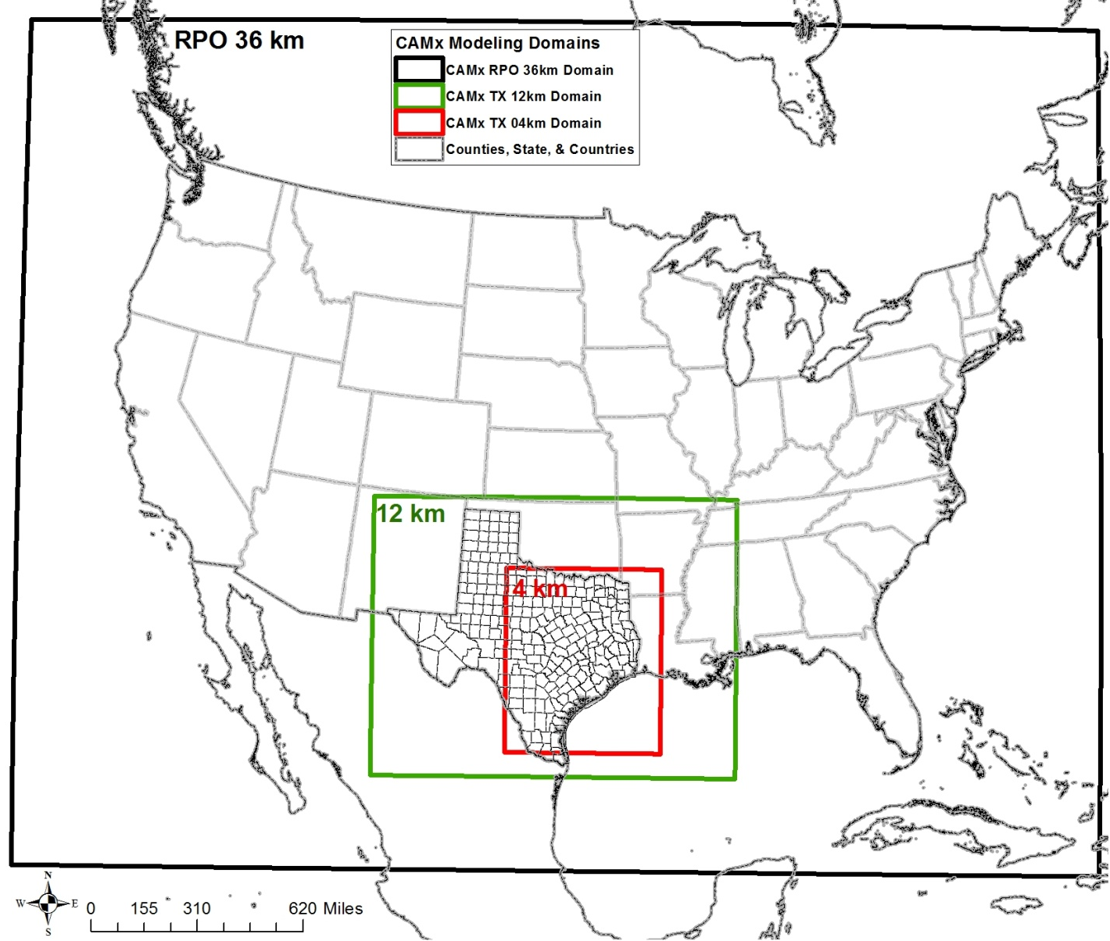
Figure 3-1: Nested Photochemical Modeling Grids for the June 2012 Episode
Coordinates from NW to SE corners:
CAMx RPO 36-km = 148 x 112 (-2,736, 1,944) to (2,592, -2,088)
CAMx TX 12-km = 149 x 110 (-984, -312) to (804, -1,632)
CAMx TX 4-km = 191 x 218 (-328, -644) to (436, -1,516)

Plot Date: June 26, 2014
Fuel Type
Green: Biomass
Blue: Natural Gas
Red: Coal
Black: Petcoke
Map Compilation: June 10, 2013
Source: TCEQ.

The meteorological model has 38 vertical layers extending from the surface up to approximately 15 km, while the CAMx model uses 28 vertical layers up to approximately 13.6 km. The surface layer is roughly 34 m thick. The meteorological and photochemical layers are finer at the surface to capture vertical gradients as the mixing height changes during the day and to model pollutant concentrations at the surface.

Meteorological Model Inputs
The Weather Research and Forecasting (WRF) model inputs developed by TCEQ will be used for the meteorological inputs into the photochemical model. WRF was used by TCEQ to calculate the meteorological inputs for the June 2012 photochemical model. The “WRF Model is a next-generation mesoscale numerical weather prediction system designed to serve both operational forecasting and atmospheric research needs. It features multiple dynamical cores, a 3-dimensional variational (3DVAR) data assimilation system, and a software architecture allowing for computational parallelism and system extensibility. WRF is suitable for a broad spectrum of applications across scales ranging from meters to thousands of kilometers.”

Emission Inventory Inputs
Before the emission inventories are entered into the photochemical model, the emissions will be pre-processed using the Emissions Processing System 3.0 (EPS3) to allocate the data to the proper spatial and temporal resolutions used by the photochemical model. The Emissions Processing System allocates emissions to account for monthly, weekly, and hourly variations in emission rates, assigns emissions to the appropriate grid cells, and disaggregates or speciates chemical compounds for the photochemical model’s chemical mechanism. To accurately predict ozone formation, the photochemical model requires a detailed emission inventory for every grid used in the model.

Carbon monoxide (CO), nitrogen oxides (NO_{X}), and Volatile organic compound (VOC) emissions from all anthropogenic and biogenic sources will be included in the model for all grid domains. Emissions data will be processed through EPS3 for the following source categories:

- Point
- Area
- Non-road
- Off-road
- Oil and gas (including the Eagle Ford)
- Mobile

CAMx ready binary Biogenics emission files used in the modeling domain will be download from TCEQ modeling ftp server.

The emissions for each of these categories will be temporally allocated to the appropriate hours, week days, and seasons based on data obtained from surveys for local emission sources. In the absence of survey data, TCEQ existing data or other appropriate surrogates will be used.

Chemistry
All VOC and NO_{X} emissions will be chemically speciated in EPS3 based on the latest version of the carbon bond mechanism design, Carbon Bond 6 (CB6). CAMx Chemistry parameters will be downloaded from TCEQ modeling ftp server and used in all modeling runs.

QUALITY METRICS

In this section, the quality requirements for the data used in this study and the procedures for determining the quality of the data are described. Note that 10% of the data used in this study will be audited. After each section is completed, the QA/QC manager will check the data inputs into the formulas and will check all documentation on methodologies. All formulas will be recalculated by the QA/QC manager to make sure the results can be replicated and are accurate. The QA/QC manager will work closely with the project manager to update the calculations, photochemical model inputs and outputs, and documentation. The results of the audit process will be provided in the draft and final photochemical modeling results submitted to TCEQ.

Data
The data used in analyzing the results from the photochemical model must meet all EPA guidance for the use of photochemical models. The data must be reasonably consistent with other studies and be sufficiently complete. In addition, data will be assessed for missing information and outliers.

Quality Control
Quality control (QC) system of routine technical activities implemented by personnel to measure and control the quality of the data will be used. The QC system is designed to:

- Provide routine and consistent checks and documentation points in the model development process to verify data integrity, correctness, and completeness;
- Identify and reduce errors and omissions;
- Maximize consistency within the model preparation and documentation process; and
- Facilitate internal and external review processes.

QC activities include technical reviews, accuracy checks, and the use of approved standardized procedures for calculations. These activities should be included in development planning, data collection and analysis, calculations, and reporting.

Equations, data sources, and methodology will be checked throughout the development of the model. “Simple QA procedures, such as checking calculations and data input, can and should be implemented early and often in the process. More comprehensive procedures should target:

- Critical points in the process;
- Critical components of the model development; and
- Areas or activities where problems are anticipated”

Special emphases will be put on critical components, such as EPS3 run scripts, CAMx job scripts, and photochemical modeling output, for quality checks. Photochemical model data developed through the process will be compared to previous data sets. Twenty five percent of calculations will be independently replicated to ensure accuracy. The project manager will ensure that all of the QA checks performed are compiled, and maintained in the project archives.

When errors and omissions are identified, they will be corrected and all documentation will be updated with the corrections. All calculation methodologies will be documented and described in detail so external officials and other interested parties can replicate the results. Data that are found to be questionable will be examined in greater detail to determine what errors might be present and what adjustments might be needed. If data are revised, the procedures and assumptions used will be thoroughly documented. The Project Manager will review and approve all data adjustments.

AACOG will use a senior peer reviewer not directly involved in conducting the project to review all methods and results of the work. The senior peer reviewer will be involved in the initial planning stages of this project to ensure the planned approaches are technically sound, and will also provide quality checks and review on all final products prior to submittal to TCEQ to ensure the project procedures were properly implemented. When the photochemical model analyses are completed, documentation and spreadsheets will be sent to TCEQ and other interested parties for review.

DATA ANALYSIS, INTERPRETATION AND MANAGEMENT

Data Reporting Requirements

Primary data on photochemical modeling inputs and results that are assembled for this study will be reported electronically and documented in the project final report. Any data that are assembled for this study and photochemical modeling outputs will also be delivered electronically and documented in the final report. Data that are documented elsewhere, such as emission inventory, meteorological inputs, land use data, chemistry parameters, or initial and boundary conditions inputs will be documented in the final report by reference to the original data source. Records will be maintained that include sufficient information to reconstruct each modeling result.

Data Management Procedures

Hard copy data received during the course of the project will be cataloged into the file index and made available for copying or checkout. Electronic data files will be stored in a specific project directory on AACOG’s fileserver network drives and on a Fedora Linux server. Original data files will be kept in a separate folder and will not be altered or changed. Project staff will make copies of any data files needed and perform their work with the copy. All project staff will have access to these files and all files on the fileserver network drive undergo automatic backup each night such that any information can be easily retrieved as necessary. After the final product is completed and approved by TCEQ, all project data will be archived on CD-ROM for storage.

DATA REPORTING

Project Deliverables

The project final delivery will include a report documenting the photochemical model inputs, outputs, and results. All relevant QA/QC findings will be included in the final report. The report will describe the steps taken and any background that is relevant to the project. The report shall provide the report in Microsoft Office Word and Adobe Acrobat Reader (*.pdf) formats. The final report will include the following components:

- An executive summary and abstract,
- An introduction that discusses background and objectives. Include relationships to other studies if applicable,
- A discussion of the pertinent accomplishments, shortfalls, and limitations of the work completed, and
- Recommendations, if any, for what should be considered next as a new study.

The final report will provide a comprehensive overview of activities undertaken and data collected and analyzed during the study. The final report will highlight major activities and key findings, provide pertinent analysis, describe encountered problems and associated corrective actions, and detail relevant statistics including data, parameter, or model completeness, accuracy and precision.

Modeling files for the June 2012 photochemical modeling episode will be based on the grid system consistent with EPA’s Regional Planning Organizations (RPO) Lambert Conformal Conic map projection with the following parameters:

- First True Latitude (Alpha): 33°N
- Second True Latitude (Beta): 45°N
- Central Longitude (Gamma): 97°W
- Projection Origin: 97°W, 40°N
- Spheroid: Perfect Sphere, Radius: 6,370 km

All future TCEQ photochemical model emissions processing work will be based on the grid system listed above.

EPA. November 17, 2015. “Summary of Clean Air Act.” Available online: http://www2.epa.gov/laws-regulations/summary-clean-air-act. Accessed: 10/24/15.
EPA, Dec. 2014. “Modeling Guidance for Demonstrating Attainment of Air Quality Goals for Ozone, PM_{2.5}, and Regional Haze 2014 Draft”. Available online: http://www.epa.gov/scram001/guidance/guide/Draft_O3-PM-RH_Modeling_Guidance-2014.pdf. Accessed 10/24/15.
ENVIRON International Corporation, April 2014. “User’s Guide COMPREHENSIVE AIR QUALITY MODEL WITH EXTENSIONS Version 6.1”. Novato, California. Available online: http://www.camx.com/files/camxusersguide_v6-10.pdf. Accessed 10/24/15. p. 144.
Ibid.
Ibid. p. 160-161.
EPA. December 2002. “Guidance for Quality Assurance Project Plans for Modeling EPA QA/G-5M.” EPA/240/R-02/007. Available online: http://www2.epa.gov/sites/production/files/2015-06/documents/g5m-final.pdf. Accessed 11/19/2015.
TCEQ. 11/4/15. “SIP modeling files”. Available online: ftp://amdaftp.tceq.texas.gov/pub/TX/camx/basecase/. Accessed 10/24/15.
ENVIRON International Corporation, April 2014. “User’s Guide COMPREHENSIVE AIR QUALITY MODEL WITH EXTENSIONS Version 6.1”. Novato, California. Available online: http://www.camx.com/files/camxusersguide_v6-10.pdf. Accessed 10/24/15. p. 144.
AACOG, April 2009. “Conceptual Model - Ozone Analysis of the San Antonio Region: Updates through Year 2008”. San Antonio, Texas. Available online: https://www.aacog.com/index.aspx?NID=98. Accessed 10/24/15.
TCEQ. “Rider 8 State and Local Air Quality Planning Program - Modeling Domains”. Austin, Texas. Available online: http://www.tceq.texas.gov/airquality/airmod/rider8/modeling/domain. Accessed 10/24/15.
ENVIRON, June 30, 2009. “Application of CAMx for the Austin San Antonio Joint Meteorological Model Refinement Project”. prepared by Chris Emery, Jeremiah Johnson, and Piti Piyachaturawat of ENVIRON International Corporation, Air Sciences Group, Novato, CA, p. 1-2.
Susan Kemball-Cook, Yiqin Jia, Ed Tai, and Greg Yarwood August 31, 2007. “Performance Evaluation of an MM5 Simulation of May 29-July 3, 2006.” Prepared for Texas Commission on Environmental Quality. ENVIRON International Corporation, Novato, CA. p. 2-1. Available online: http://www.tceq.state.tx.us/assets/public/implementation/air/am/contracts/reports/mm/2006_MM5_Modeling_Final_Report-20070830.pdf. Accessed 10/24/15.
National Center for Atmospheric Research. “WRF Model Version 3.2“ Available online: http://www.wrf-model.org/index.php. Accessed 10/24/15.
ENVIRON International Corporation, August 2009. “User’s Guide Emissions Processor Version 3”. Novato, CA. Available online: ftp://amdaftp.tceq.texas.gov/pub/HGB8H2/ei/EPS3_manual/EPS3UG_UserGuide_200908.pdf. Accessed 10/24/15.
Greg Yarwood, Jaegun Jung, Gary Z. Whitten, Gookyoung Heo, Jocelyn Mellberg, and Mark Estes, Oct. 2010. “Updates to the Carbon Bond Mechanism for Version 6 (CB6)”. Presented at the 9th Annual CMAS Conference, Chapel Hill, NC, October 11-13, 2010. p. 2. Available online: http://www.cmascenter.org/conference/2010/abstracts/emery_updates_carbon_2010.pdf. Accessed 10/24/15.
Eastern Research Group, Inc, Jan. 1997. “Introduction: The Value of QA/QC’. Quality Assurance Committee Emission Inventory Improvement Program, U.S. Environmental Protection Agency. p. 1.2-1. Available online: http://www.epa.gov/ttn/chief/eiip/techreport/volume06/vi01.pdf. Accessed 10/24/15.
Ibid., p. 1.2-2.

