FY14-15
PGA14-01
582-14-40051
Amendment No. 2
Task 4, Deliverable 4.2

Ozone Analysis
June 2006 Photochemical Modeling Episode

Technical Report

October 30, 2015

Prepared by:

Alamo Area Council of Governments

Prepared Under a Grant from the
Texas Commission on Environmental Quality

The preparation of this report was financed through grants from the State of Texas through the Texas Commission on Environmental Quality.
The content, finding, opinions and conclusions are the work of the authors and do not necessarily represent findings, opinions or conclusions of the TCEQ.
Title: Ozone Analysis  June 2006 Photochemical Modeling Episode |  | Report Date: October 30, 2015
Authors: AACOG Natural Resources Department |  | Type of Report: Technical Analysis
Performing Organization Name & Address:  Alamo Area Council of Governments  8700 Tesoro Drive, Suite 700  San Antonio, Texas 78217 |  | Period Covered: 2006, 2012, and 2018
Sponsoring Agency Name:
The preparation of this report was financed through grants from the State of Texas through the Texas Commission on Environmental Quality.
Abstract: On October 1, 2015, the EPA revised the National Ambient Air Quality Standard (NAAQS) for ground-level ozone from 75 parts per billion (ppb) to 70 ppb. The EPA is likely to make attainment and nonattainment designations based on design values (DV) determined from ozone observations at regulatory monitors between 2014 and 2016. Since observations at ozone regulatory monitors in the San Antonio area would not meet the current 70 ppb during that time period, the San Antonio-New Braunfels MSA (or other local geography boundary deemed appropriate by the EPA) is at risk for a nonattainment designation. If the EPA assigns the MSA as “marginal,” then the MSA would have until December 31, 2020 to attain the ground-level ozone standard. For a “moderate” designation, the MSA would have until 2023 to reach attainment. This study was conducted to project 2012 and 2018 emissions based on actual weather conditions that occurred in 2006, which will contribute to the understanding of the magnitude of the effort needed to reach attainment. Many photochemical model runs were conducted, and the projected ozone values resulted in an overall reduction, ranging in design values (DV) between 66 and 76 ppb at the ozone regulatory monitors. The resulting projected ozone design values were greatly impacted by air transport from geographic regions outside the 8-county MSA, which is beyond local control. For peak 1-hour ozone on DV days, the average contribution of ozone was 63 percent for regions outside the 8-county MSA. The local region accounted for the remaining 37 percent, most of which came from Bexar County, representing an average 28 percent contribution, and Guadalupe County, representing an average 7 percent contribution. The Anthropogenic Precursor Culpability Assessment (APCA), which was used to determine state contribution to peak 1-hour ozone values, resulted in a maximum contribution of 60 percent from Texas. This same analysis also indicated significant contributions from non-land sources, including the Gulf of Mexico and the Atlantic and Pacific Oceans.

Related Reports:  AACOG, May 22, 2014. “Photochemical Modeling  Quality Assurance Project Plan (QAPP)”. TCEQ Contract: 582-14-40051-FY14-01, Task 4.1 | Distribution Statement:  Alamo Area Council of  Governments, Natural Resources Department |  | Permanent File:  Alamo Area Council of  Governments, Natural Resources Department
No. of Pages: 140

Executive Summary
The U.S. Environmental Protection Agency (EPA) is charged by the United States Congress with the maintenance of regional air quality across the United States through a series of standards, the National Ambient Air Quality Standards (NAAQS). When regions fail to comply with these standards, the Clean Air Act requires that the state, in consultation with local governments, revise the state implementation plan (SIP) to address the violation. Ground-level ozone is one of the most common air pollutants in the country as well as one of the six “criteria” pollutants for which the EPA established standards. Under the current ozone standard, a region is in violation of the Clean Air Act if the annual fourth highest 8-hour average ozone concentration, averaged over three consecutive years, exceeds 70 parts per billion (ppb). The 2012 – 2014 ozone value was 80 ppb at Continuous Air Monitoring Station (CAMS) C58, indicating that the San Antonio region has a monitor measuring concentrations in violation of the 70 ppb 8-hour ozone NAAQS.

The current timeline for the processed revision of the ozone standard is provided below. This timeline does not include potential delays in implementation due to possible litigation on the new proposed standard.
- October 1, 2015 | EPA releases the new 8-hour ozone standard of 70 ppb
- October 2016 | State designation recommendations due to the EPA
- June 2017 | EPA sends letter to states with proposed nonattainment area designations
- October 1, 2017 | EPA determination of attainment or non-attainment for affected areas (EPA anticipates it to be based on the 2014 - 2016 3-year average in the San Antonio-New Braunfels MSA)
- October 1, 2020 | SIP elements for non-attainment areas are due
- December 31, 2020 | Attainment deadline for “Marginal” areas
- December 31, 2023 | Attainment deadline for “Moderate” areas
The Alamo Area Council of Governments (AACOG) conducted ozone analysis using photochemical models that simulate actual high-ozone episodes that prevailed in the region over the course of several days. The photochemical modeling episode was based on the time period between May 24, 2006 and July 2, 2006, consistent with photochemical modeling in the Austin and Dallas regions. The time period was established as a baseline for which to analyze the accuracy of the selected parameters, ensuring they were suitable for future projections. Analysis included comparing the photochemical model predicted results to observed data from eleven monitors in the San Antonio-New Braunfels MSA. In general, the model’s ozone predictions correlated well with observed peak hourly ozone values. However, the model underpredicted ozone observations at all monitors between July 26 and July 29 and tended to underpredict ozone observations below 60 ppb. Tile plots indicated that there were no unusual patterns of ozone formation. Ozone plumes were produced in the urban core areas of San Antonio and Austin and mainly along I-35 corridor. These urban plumes were predicted for each urban core and downwind areas of the cities.

The photochemical model was updated with 2012 and 2018 projected anthropogenic emission inventories to estimate predicted future ozone concentrations under the same meteorological conditions as the 2006 base case. Although there is an overall reduction of ozone on every day in the San Antonio-New Braunfels MSA between 2006 and 2018, significant transport still occurs. The 2018 projection cases were compared to the 2012 projection cases to determine future ozone design values. When the model was run with both TCEQ updated 2012 and 2018 emissions inventories, and AACOG’s local emission inventory, the predicted design values were 71.3 ppb at C23, 76.4 ppb at C58, and 65.6 ppb at C59. Both C58 and C23 do not meet the 70 ppb 8-hour ozone standard. As indicated by the modeling results, it will be difficult for the San Antonio-New Braunfels MSA to attain the new standard by 2018.

By raising the minimum threshold to 70 ppb, used in the above attainment demonstration, the applicable days drop below EPA’s guidance that suggests at least 10 days be included in the analysis. The design value increased at both C58 and C23 when the minimum threshold was increased. When the minimum threshold was raised to 70 ppb, the maximum design value increased 1.2 ppb at C58 and 1.0 ppb at C23. The photochemical model was also tested using different grid cell arrays to determine the model responses. The maximum DV at C58 decrease from 76.4 ppb to 76.2 ppb when a 7x7 grid cell array is used instead of a 3x3 grid cell array. The photochemical model overall was not very sensitivity to changes in the design value when different grid cell arrays are used.

The June episode was run at the 4-km, 12-km, and 36-km grid sizes using APCA. As expected, Bexar County emissions were the largest contribution of peak hourly ozone on design value days at C58 (27.8 percent). Surprisingly, the second largest contribution came from Guadalupe County, 6.9 percent. Other counties contribution was Comal County at 0.9% percent, Atascosa County, at 0.7 percent, and Wilson County at 0.3 percent. Emissions from outside the 8 county San Antonio-New Braunfels MSA was 63.3 percent. These emissions are beyond local control and contribute significantly to local ozone. The maximum impact of Bexar County is 37.8 ppb at C58 monitor and 39.0 ppb at C23 monitor on Design Value days. Guadalupe County’s maximum contribution was 26.2 ppb at C58 and 21.6 ppb at C23. Comal County had a maximum contribution of 2.7 ppb, Atascosa county maximum contribution was 2.3 ppb, and Wilson County had a maximum contribution of 1.2 ppb. These results show local emission sources can have a significant impact on ozone recorded at local regulatory monitors.

An APCA was also run at the 4-km, 12-km, and 36-km grid sizes to analyze the impact of other states on ozone recorded at regulatory monitors in the San Antonio-New Braunfels MSA. In the APCA run, Texas emission sources were the largest contribution of peak hourly ozone on design value days at C58 (60.0 percent). There was also a significant contribution from the Gulf of Mexico, Atlantic, and Pacific ocean regions (4.3 percent) in 2018. From other states, Louisiana at 3.4 percent had the highest contribution to peak 1-hour ozone followed by Oklahoma at 1.3 percent. Surprisingly, both the Western U.S. (1.3 percent) and North Central U.S. (1.0 percent) had larger contributions to ozone in San Antonio-New Braunfels MSA than expected. Other states that had a significant contribution to peak 1-hour ozone were Kansas (0.7 percent), Arkansas (0.6 percent), and Colorado (0.5 percent). Texas can contribute up to 60.6 ppb of hourly ozone at the C58 monitor. Combined, the Gulf of Mexico, Atlantic, and Pacific ocean regions can contribute up to 13.6 ppb and Louisiana can contribute up to 7.0 ppb. Oklahoma (2.6 ppb), Western U.S. (2.4 ppb), and North Central U.S. (1.9 ppb) can also have a significant maximum impact on local hourly ozone. Although the average impact from Mississippi was only 0.3 ppb, the maximum impact was as high as 2.6 ppb. Anthropogenic emissions from Mexico and Canada had a small local impact with a maximum impact of only 0.9 ppb on high-ozone days.

Table of Contents

Executive Summary iii
List of Figures viii
List of Tables xi
List of Equations xii
1 Background 1-1
1.1 Ozone Standard 1-1
1.2 Design Value at Ozone Monitors in San Antonio 1-3
1.3 Ozone Analysis 1-4
2 Meteorological and Photochemical Modeling Development 2-1
2.1 EPA Modeling Guidance 2-1
2.2 Model Selection 2-1
2.3 Modeling Domain 2-2
2.4 Base Case Emissions Inventory 2-3
2.5 Emission Inventory Parameters 2-3
2.6 Quality Assurance (QA) 2-4
2.7 Emission Inventory Projections, 2012 and 2018 2-5
2.8 Summary of the 2012 and 2018 Projection Year Emission Inventory Development 2-8
2.9 Emission Inventory Tile Plots 2-11
3 Base Case Modeling 3-1
3.1 CAMx Model Development 3-1
3.1.1 CAMx Configurations 3-1
3.1.2 Plume-in-Grid Sub-model 3-2
3.1.3 Boundary Conditions, Initial Conditions, and Land Use File 3-2
3.2 CAMx Base Case Runs 3-2
3.3 Diagnostic and Statistical Analysis of CAMx Runs 3-4
3.3.1 Hourly Ozone Time Series 3-4
3.3.2 Hourly NO_{X} Time Series 3-11
3.3.3 Daily Ozone Plots 3-16
3.4 Statistical Analysis 3-20
3.5 Ozone Scatter Plots 3-36
3.6 NO_{X} Scatter Plots 3-40
3.7 Daily Maximum 8-Hour Ozone Fields 3-42
3.8 Summary of CAMx Base Case Runs 3-51
4 Future Year Modeling 4-1
4.1 Projections Cases 4-1
4.2 Tile Plots – Ozone Concentration: 2012, and 2018 4-3
4.3 Modeled Attainment Demonstration 4-17
4.4 Minimum Threshold Analysis 4-25
4.5 Grid Cell Array Size Analysis 4-28
5 San Antonio-New Braunfels MSA Counties APCA Run 5-1
5.1 APCA Run Setup 5-1
5.2 Contribution by Source Region 5-4
6 Other States APCA Run 6-1
6.1 APCA Run Setup 6-1
6.2 Contribution by Source Region 6-3
Appendix A: Run Log 1

List of Figures

Figure 1-1: Air Quality Monitoring Sites in the San Antonio-New Braunfels MSA 1-5
Figure 2-1: NO_{X} Emissions (tons/day) for the San Antonio-New Braunfels MSA with Local Data, 2012 and 2018 2-9
Figure 2-2: VOC Emissions (tons/day) for the San Antonio-New Braunfels MSA with Local Data, 2012 and 2018 2-9
Figure 2-3: Texas Area Emissions 4-Km Grid Tile Plots, 2012 and 2018 Weekday, 12:00–13:00 2-12
Figure 2-4: United States On-Road Emissions 4-Km Grid Tile Plots, 2012 and 2018 Weekday, 12:00 – 13:00 2-13
Figure 2-5: Texas Non-Road Emissions 4-Km Grid Tile Plots, 2012 and 2018 Weekday, 12:00 – 13:00 2-14
Figure 2-6: United States Oil and Gas Emissions 4-Km Grid Tile Plots, 2012 and 2018 Weekday, 12:00 – 13:00 2-15
Figure 2-7: United States Off-Road Emissions 4-Km grid Tile Plots, 2012 and 2018 Weekday, 12:00 – 13:00 2-16
Figure 2-8: Low Points Emissions 4-km grid Tile Plots, 2012 and 2018 Weekday, 12:00 – 13:00 2-17
Figure 3-1: 1-Hour Ozone Time Series Observed (C23) vs. Predicted (CAMx) for Base Case TCEQ Run 5, 2006 3-5
Figure 3-2: 1-Hour Ozone Time Series Observed (C58) vs. Predicted (CAMx) for Base Case TCEQ Run 5, 2006 3-5
Figure 3-3: 1-Hour Ozone Time Series Observed (C59) vs. Predicted (CAMx) for Base Case TCEQ Run 5, 2006 3-6
Figure 3-4: 1-Hour Ozone Time Series Observed (C622) vs. Predicted (CAMx) for Base Case TCEQ Run 5, 2006 3-6
Figure 3-5: 1-Hour Ozone Time Series Observed (C678) vs. Predicted (CAMx) for Base Case TCEQ Run 5, 2006 3-6
Figure 3-6: 1-Hour Ozone Time Series Observed (C501) vs. Predicted (CAMx) for Base Case TCEQ Run 5, 2006 3-7
Figure 3-7: 1-Hour Ozone Time Series Observed (C502) vs. Predicted (CAMx) for Base Case TCEQ Run 5, 2006 3-8
Figure 3-8: 1-Hour Ozone Time Series Observed (C503) v. Predicted (CAMx) for Base Case TCEQ Run 5, 2006 3-8
Figure 3-9: 1-Hour Ozone Time Series Observed (C504) vs. Predicted (CAMx) for Base Case TCEQ Run 5, 2006 3-9
Figure 3-10: 1-Hour Ozone Time Series Observed (C505) vs. Predicted (CAMx) for Base Case TCEQ Run 5, 2006 3-9
Figure 3-11: 1-Hour Ozone Time Series Observed (C506) vs. Predicted (CAMx) for Base Case TCEQ Run 5, 2006 3-10
Figure 3-12: 1-Hour NO_{X} Time Series Observed (C58) vs. Predicted (CAMx) for Base Case TCEQ Run 5, 2006 3-12
Figure 3-13: 1-Hour NO_{X} Time Series Observed (C59) vs. Predicted (CAMx) for Base Case TCEQ Run 5, 2006 3-13
Figure 3-14: 1-Hour NO_{X} Time Series Observed (C622) vs. Predicted (CAMx) for Base Case TCEQ Run 5, 2006 3-13
Figure 3-15: 1-Hour NO_{X} Time Series Observed (C678) vs. Predicted (CAMx) for Base Case TCEQ Run 5, 2006 3-15
Figure 3-16: Statistics for All CAMS for 1-Hr Average Ozone during June Episode AACOG Base Case Run 4 and TCEQ Run 5 3-17
Figure 3-17: CAMS 23 Statistics for 1-Hr Average Ozone during June Episode AACOG Base Case Run 4 and TCEQ Run 5 3-18
Figure 3-18: CAMS 58 Statistics for 1-Hr Average Ozone during June Episode AACOG Base Case Run 4 and TCEQ Run 5 3-19
Figure 3-19: Daily performance for 1-Hour Ozone in San Antonio for Base Case AACOG Run 4 and Base Case TCEQ Run 5 3-22
Figure 3-20: Soccer-Style Plot of Normalized Gross Error and Normalized Bias by Exceedance Days, Base Case AACOG Run 4 & TCEQ Run 5 3-26
Figure 3-21: San Antonio CAMs Performance for Base Case AACOG Run 4 and Base Case TCEQ Run 5 3-27
Figure 3-22: Soccer-Style Plot of Normalized Gross Error and Normalized Bias by Monitor for Every Day, Base Case AACOG Run 4 and TCEQ Run 5 3-30
Figure 3-23: Soccer-style Plot of Normalized Gross Error and Normalized Bias by Monitor for Exceedance Days, Base Case AACOG Run 4 and TCEQ Run 5 3-31
Figure 3-24: Hourly Ozone Scatter Plots in San Antonio for Base Case AACOG Run 4, and Base Case TCEQ Run 5 3-37
Figure 3-25: 8-Hour Daily Maximum Ozone Scatter Plots for Base Case AACOG Run 4 and TCEQ Run 5 3-38
Figure 3-26: Hourly NO_{X} Scatter Plots for Base Case AACOG Run 4 and Base Case TCEQ Run 5 3-41
Figure 3-27: Tile Plots of Modeled Maximum 8-Hour Ozone, Base Case TCEQ Run 5 on Exceedance Days 3-43
Figure 3-28: Tile Plots of Modeled Peak 1-Hour Ozone, Base Case TCEQ Run 5 on Exceedance Days 3-46
Figure 4-1: Predicted Daily Maximum 8-Hour Ozone Concentrations in the 4-km Subdomain, 2006, 2012 Projection Case 1 and 2018 Projection Case 1 4-4
Figure 4-2: Change in San Antonio-New Braunfels MSA 8-Hour Design Values, 2018 4-24
Figure 4-3: Minimum Threshold Analysis 8-Hour Design Values, 2018 4-26
Figure 4-4: Grid Cell Array Size around Regulatory Sited San Antonio-New Braunfels Ozone Monitors 4-28
Figure 4-5: Grid Cell Array 8-Hour Design Values, 2018 4-29
Figure 5-1: APCA Regions for San Antonio-New Braunfels MSA Counties at the 4-Km grid Level, 2018 5-3
Figure 5-2: ICQ plots for C58, C23, and C59 for Hourly Ozone on Design Value Days, 2018 5-7
Figure 5-3: Pie Chart for C58 for Average Peak 1-Hour Ozone on Design Value Days, 2018 5-8
Figure 5-4: Pie Chart for C23 for Average Peak 1-Hour Ozone on Design Value Days, 2018 5-8
Figure 5-5: Pie Chart for C59 for Average Peak 1-Hour Ozone on Design Value Days, 2018 5-9
Figure 6-1: APCA Other States/Regions at the 36-Km Grid Level, 2018 6-2
Figure 6-2: Pie Chart for C58 by States/Other Regions for Average Peak 1-Hour on High-Ozone Days, 2018 6-7
Figure 6-3: Pie Chart for C23 by States/Other Regions for Average Peak 1-Hour on High-Ozone Days, 2018 6-8
Figure 6-4: Pie Chart for C59 by States/Other Regions for Average Peak 1-Hour on High-Ozone Days, 2018 6-9
Figure 6-5: ICQ plots for C58, C23, and C59 for Hourly Ozone by Other States/Regions on Design Value Days, 2018 6-10

List of Tables

Table 1-1: 4th Highest Ozone Values and Design Values at San Antonio Regional Monitors, 2012-2015 1-3
Table 2-1: Emission Inventory Sources by Type for 2012 and 2018 2-6
Table 2-2: NO_{X} Emissions (tons/day) for the San Antonio-New Braunfels MSA with Local AACOG Data, 2012 and 2018 2-10
Table 2-3: VOC Emissions (tons/day) for the San Antonio-New Braunfels MSA with Local AACOG Data, 2012 and 2018 2-10
Table 3-1: Daily performance for 1-Hour Ozone in San Antonio on all Days for Base Case AACOG Run 4 and TCEQ Base Case Run 5 3-24
Table 3-2: Average 8-Hour Ozone Prediction for All Days average by CAMS Performance, Base Case AACOG Run 4 and Base Case TCEQ Run 5 3-31
Table 3-3: Average 8-Hour Ozone Prediction for Exceedance Days Average for AACOG Base Case Run 4 and TCEQ Base Case Run 5 3-34
Table 3-4: R² Values for Ozone Scatter Plots by Selected Monitors, Base Case AACOG Run 4 and Base Case TCEQ Run 5 3-39
Table 3-5: R² Values for NO_{X}, June 2006, Base Case AACOG Run 4 and TCEQ Run 5 3-40
Table 3-6: Comparison of Observed and Modeled Daily Peak 1-hour Ozone Level within the San Antonio MSA for Base Case AACOG Run 4 and TCEQ Run 5 3-49
Table 3-7: Comparison of Observed and Modeled Daily Maximum 8-Hour Ozone Level within the San Antonio MSA for Base Case AACOG Run 4 and TCEQ Run 5 3-50
Table 4-1: 4th Highest Ozone Value at Each Regulatory Sited Ozone Monitor in the San Antonio-New Braunfels MSA, 2010-2014 4-18
Table 4-2: Calculated Baseline Modeling Site-Specific Design Value, 2012 4-19
Table 4-3: Peak 8-Hour Ozone (ppb) Predictions at C23, C58, C59, C622, and C678: 2012 and 2018 Modeled Cases 4-20
Table 4-4: Minimum Threshold Analysis for base Case 2 (TCEQ), 2018. 4-27
Table 4-5: RRFs and DVFs using 1x1, 3x3, 5x5, and 7x7 Grid Cell Arrays, 2018 4-30
Table 5-1: APCA results for C58, C23, C59 by San Antonio-New Braunfels MSA County, 2018 5-5
Table 6-1: APCA results for C58, C23, and C59 by Source Region for Other States/Regions, 2018 6-4

List of Equations

Equation 3-1, Unpaired Peak Prediction Accuracy 3-20
Equation 3-2, Mean Normalized Bias 3-20
Equation 3-3, Mean Normalized Gross Error 3-21
Equation 4-1, the Design Value 4-18
Equation 4-2, the Baseline Design Site-Specific Modeling Design Value 4-18
Equation 4-3, Future Design Value Calculation 4-19

Background

The U.S. Environmental Protection Agency (EPA) is charged by the United States Congress with the maintenance of regional air quality across the United States through a series of standards, the National Ambient Air Quality Standards (NAAQS). When regions fail to comply with these standards, the Clean Air Act (CAA) requires that the state, in consultation with local governments, revise the State Implementation Plan (SIP) to address the violation. The SIP is a blueprint for the methodology that the region and state will follow to attain and maintain the federal air quality standards.

Ozone Standard
Ground-level ozone is one of the most common air pollutants in the country as well as one of the six “criteria” pollutants for which the EPA established standards. The CAA requires the Environmental Protection Agency (EPA) to set NAAQS for pollutants considered harmful to public health and the environment. EPA has set NAAQS for six principal pollutants, which are called "criteria" pollutants. The CAA requires primary standards to be “requisite to protect public health with an adequate margin of safety,” including the health of groups of people considered more at risk. The Clean Air Act bars EPA from considering cost in setting the NAAQS.

“Sections 108 and 109 of the CAA govern the establishment, review, and revision, as appropriate, of the National Ambient Air Quality Standards (NAAQS) to provide protection for the nation’s public health and the environment. The CAA requires periodic review of the science upon which the standards are based and the standards themselves.” The timeline provided highlights historical or future dates related to revising the NAAQS. The timeline does not include potential delays in implementation due to possible ligation for the most recently proposed standard.
Date | Action
March 27, 2008 | EPA revised primary and secondary ozone standards from 84 ppb to 75 ppb (8-hour average). In 2013, the D.C. Circuit remanded the secondary standard to the Agency for reconsideration because the Agency did not determine what level of protection was requisite to protect the public welfare.
January 19, 2010 | EPA proposed to reconsider the 2008 ozone standard.  - Change primary standard to within range of 60 to 70 ppb.
September 2, 2011 | January 2010 proposal was withdrawn and EPA focused on the upcoming 5 year review.
June 19, 2013 | Coalition of public health and environmental groups, including Sierra Club and American Lung Association (ALA), file lawsuits in federal court asking the court to set a deadline for action on overdue ozone standard reviews.
April 29, 2014 | U.S. District Court in San Francisco ordered EPA to complete the review of the ozone standards (proposal by Dec.1, 2014, final by Oct.1, 2015).
November 25, 2014 | EPA released a proposal to update the NAAQS for ground-level ozone.
December 17, 2014 | Rule is published in the Federal Register.
January - February 2015 | Three public hearings were held on the Proposed Ozone Standard.
March 17, 2015 | Comments were due to the EPA on the Proposed Rule.
October 1, 2015 | Court-ordered deadline for EPA to issue the final ozone standard. – EPA Set the final Standard at 70 ppb
October 2016 | State designation recommendations due to the EPA.
June 2017 | EPA sends letter to states with proposed nonattainment area designations.
October 1, 2017 | EPA determination of attainment or non-attainment for affected areas (may be based on 2014, 2015, and 2016 3-year average in the San Antonio-New Braunfels MSA).
October 1, 2020 | SIP elements for non-attainment areas are due.
December 31, 2020 | Attainment deadline for “Marginal” areas.
December 31, 2023 | Attainment deadline for “Moderate” areas.

EPA has a list of factors they believe are appropriate to consider when determining nonattainment boundaries. In addition to the following nine factors, the EPA also considers any other relevant information provided by states or tribes:

- Emission data
- Air quality data
- Population density and degree of urbanization (including commercial development)
- Traffic and commuting patterns
- Growth rates and patterns
- Meteorology (weather/transport patterns)
- Geography/topography (mountain ranges or other air basin boundaries)
- Jurisdictional boundaries (e.g., counties, air districts, reservations, metropolitan planning organizations (MPOs))
- Level of control of emission sources

“In general, a State’s demonstration supporting the boundary recommendation for an area should show that: 1) violations are not occurring in the excluded portions of the recommended area, and 2) the excluded portions do not contain emission sources that contribute to the observed violations. A State submittal that only addresses whether monitored violations are occurring in an area will not suffice as the sole justification for designating the boundaries of a nonattainment area.”

Design Value at Ozone Monitors in San Antonio
A region is in violation of the Clean Air Act if the annual fourth highest 8-hour average ozone concentration, averaged over three consecutive years, exceeds 70 parts per billion (ppb). This average is referred to as the design value. The fourth highest 8-hour averages and design values for the three most recent complete years of data, 2012-2014, from the three regulatory continuous ambient monitoring stations (CAMS) in the San Antonio region are listed in Table 1-1. The table also lists the current 2013-2015 Design value for the Region. The 2015 ozone values may change because the year is not completed and the ozone readings at the monitors will not be certified by TCEQ until 2016.

Table 1-1: 4th Highest Ozone Values and Design Values at San Antonio Regional Monitors, 2012-2015
CAMS | 2012 (ppb) | 2013 (ppb) | 2014 (ppb) | 2015 (ppb) | 2012-2014  Design Value | 2013-2015 Design Value
C23 | 87 | 83 | 72 | 79 | 75 | 74
C58 | 81 | 76 | 69 | 80 | 80 | 78
C59 | 70 | 69 | 63 | 67 | 67 | 66
Bolded values on the table are above the 70 ppb standard

Under the 2015 revision of the ozone standard, a region is in violation of the ozone NAAQS when the design value exceeds 70 ppb. As shown in Table 1-1, the 2012-2014 design value (truncated average) is 80 ppb at C58, 75 ppb at C23, and 67 ppb at C59, indicating that the San Antonio region has two monitors measuring concentrations in violation of the 70 ppb 8-hour ozone NAAQS. The current 2013-2015 design values also show two monitors, C58 and C23, violating the ozone standard at 78 ppb.

There are 21 regulatory and non-regulatory air quality monitors in the San Antonio region that record meteorological data and air pollutant concentrations, including ozone levels. The data collected at these sites is processed for quality assurance by the Texas Commission on Environmental Quality (TCEQ) and is accessible via the Internet. Figure 1-1 displays the location of the CAMS within the San Antonio region. Meteorological data measured at these sites include temperature, wind speed, wind direction, precipitation, solar radiation, and relative humidity. Most stations measure one or more air pollutants including ozone (O₃), carbon monoxide (CO), nitrogen oxides (NO, NO₂), particulate matter equal to or less than 2.5 micrometers in diameter (PM_{2.5}), particulate matter greater than 2.5 but less than 10 micrometers in diameter (PM₁₀), and volatile organic compounds (VOCs). Ozone is monitored at C23, C58, C59, C501, C502, C503, C504, C505, C506, C622, and C678.

Ozone Analysis

The Alamo Area Council of Governments conducts ozone analysis using photochemical models that simulate actual high-ozone episodes which prevailed in the region over the course of several days. The modeling episode currently being refined and used for the San Antonio region is based on the May 24 to July 2, 2006 time period. Both Austin and Dallas are also using the same episode to conduct photochemical modeling analysis in their regions. This episode included several periods of high-ozone across Texas.

Once completed, the May 24 to July 2, 2006 model was projected to 2012 and 2018 using forecasted changes in anthropogenic emissions. The years 2012 and 2018 were selected because of the availability of several forecasted emissions inventories from previous work completed by TCEQ. Since photochemical models simulate the atmospheric and meteorological conditions that helped produce high-ozone values during a particular episode, an important advantage the models provide is the ability to test various scenarios, such as changes in emission rates, under the same set of meteorological conditions that favor high-ozone concentrations.

Additional analysis was conducted on individual counties in the San Antonio-New Braunfels MSA and for other states using the Anthropogenic Precursor Culpability Assessment (APCA) tool in the photochemical model. APCA “provides a method for estimating the contributions of multiple source areas, categories, and pollutant types to ozone formation in a single model run.”
Figure 1-1: Air Quality Monitoring Sites in the San Antonio-New Braunfels MSA
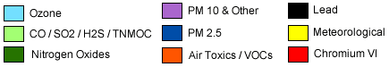
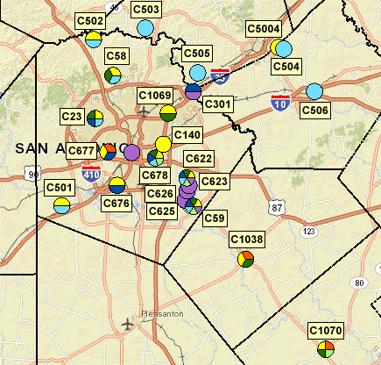

Meteorological and Photochemical Modeling Development

EPA Modeling Guidance

If a region fails to meet the National Ambient Air Quality Standards (NAAQS), EPA can designate the region as a non-attainment area. The state must submit a revision to the State Implementation Plan (SIP) designed to achieve attainment of the ozone NAAQS for all nonattainment areas. Most ozone SIPs revisions require photochemical modeling be conducted to determine if a region can meet air quality standards. EPA modeling guidance provides a detailed process, from the planning stage through control strategy development and evaluation, for developing and analyzing photochemical modeling episodes.

Model Selection

The Weather Research and Forecasting (WRF) model was selected for the meteorological inputs into the photochemical model. WRF v3.2, released in April 2010, was used to calculate the meteorological inputs for the June 2006 photochemical model. The “WRF Model is a next-generation mesoscale numerical weather prediction system designed to serve both operational forecasting and atmospheric research needs. It features multiple dynamical cores, a 3-dimensional variational (3DVAR) data assimilation system, and a software architecture allowing for computational parallelism and system extensibility. WRF is suitable for a broad spectrum of applications across scales ranging from meters to thousands of kilometers.”

The latest version of Comprehensive Air Quality Model with Extensions (CAMx 6.0) Eulerian photochemical grid model was used in all the photochemical model runs performed by AACOG. CAMx advanced technical features were used to model the June 2006 episode and are described in the CAMx user guide. The advanced CAMx features include:

- Two-way nested grid structure: for the 36-, 12-, and 4-km grid system
- Plume-in-grid (PiG): to track chemistry and dispersion of large individual point source NO_{X} emission plumes
- Horizontal advection solver: Piecewise Parabolic Method (PPM)
- Gas phase chemistry mechanism: Carbon Bond Version 6 (CB6)
- Multiple gas phase chemical solver: set to Euler-Backward Iterative (EBI) to increase the speed and accuracy of the chemistry solution
- Dry deposition model: set to ZHANG03 – “This parameterization calculates particle dry deposition velocities as a function of particle size and density as well as relevant meteorological variables.”

All the CAMx advanced settings used to simulate the May 24 to July 2 (June 2006) episode are consistent with settings used to conduct SIP modeling for other areas in Texas. Both the CAMx and WRF models are being used to develop ozone air quality attainment demonstrations for multiple Texas regions including Dallas and Houston. The attainment demonstrations are used to determine if a region meets the ozone NAAQS. Both WRF and CAMx met all EPA recommendations regarding the selection of a model.

Modeling Domain
The modeling domain identifies the geographic boundaries of the study area including the horizontal grid, vertical layers, initial conditions, and boundary conditions. The June 2006 meteorological and photochemical modeling domains include all of the eastern and central U.S. as well as parts of southeastern Canada and northern Mexico. The modeling domains are large enough to capture major sources that would be upwind from San Antonio, as winds tend to arrive from the southeast, east, and northeast on ozone exceedance days. The grid system used in the model is consistent with EPA’s Regional Planning Organizations (RPO) Lambert Conformal Conic map projection with the following parameters:

• First true latitude (Alpha): 33°N
• Second true latitude (Beta): 45°N
• Central longitude (Gamma): 97°W
• Projection origin: (97°W, 40°N)
• Spheroid: perfect sphere, radius: 6,370 km

The meteorological model has 38 vertical layers extending from the surface up to approximately 15 km, while the CAMx model uses 28 vertical layers up to approximately 13.6 km. The surface layer is roughly 34 m thick. The meteorological and photochemical layers are finer at the surface to capture vertical gradients as the mixing height changes during the day and to model pollutant concentrations at the surface.

Base Case Emissions Inventory
Three anthropogenic emission inventories were used for the June 2006 modeling episode: 2006 Base Line, 2012 Projection Case, and 2018 Projection Case. The model was run with TCEQ’s baseline emission inventory for 2006 to test model performance. The model was run with the projected emission inventories to predict the impact of emissions changes over time–both quantitative and spatial–on ozone formation and dispersion. Model inputs accounted for the chemical and meteorological characteristics associated with the May 24 to July 2, 2006 episode. The meteorological inputs, chemistry parameters, and biogenic emissions were identical for every model run.

Before the emission inventories were entered into the photochemical model, the emissions were pre-processed using the Emissions Processing System 3.0 (EPS3) to allocate the data to the proper spatial and temporal resolutions used by the photochemical model. The Emissions Processing System allocates emissions to account for monthly, weekly, and hourly variations in emission rates, assigns emissions to the appropriate grid cells, and disaggregates or speciates chemical compounds for the photochemical model’s chemical mechanism. To accurately predict ozone formation, the photochemical model requires a detailed emission inventory for every grid cell used in the model.

Emission Inventory Parameters
CO, NO_{X}, and VOC emissions from all anthropogenic and biogenic sources were included in the model for all grid domains. Emissions data was processed through the latest version of EPS3 for the following source categories:

- Biogenic
- Point
- Area
- Non-road
- Off-road
- Oil and gas (including the Eagle Ford)
- Mobile

The emissions for each of these categories were temporally allocated to the appropriate hours, week days, and seasons based on data obtained from surveys of local sources. In the absence of survey data, EPA defaults or other appropriate surrogates were used for non-point source emissions. All VOC and NO_{X} emissions were chemically speciated in EPS3 based on the latest version of the carbon bond mechanism design, Carbon Bond 6 (CB6).

Quality Assurance (QA)
The quality control (QC) system is designed to:

- “Provide routine and consistent checks and documentation points in the inventory development process to verify data integrity, correctness, and completeness;
- Identify and reduce errors and omissions;
- Maximize consistency within the inventory preparation and documentation process; and
- Facilitate internal and external inventory review processes.

QC activities include technical reviews, accuracy checks, and the use of approved standardized procedures for emission calculations. These activities should be included in inventory development planning, data collection and analysis, emission calculations, and reporting.”

Equations, data sources, and methodologies were checked throughout the processing of each emission source. “Simple QA procedures, such as checking calculations and data input, can and should be implemented early and often in the process. More comprehensive procedures should target:

- Critical points in the process;
- Critical components of the inventory; and
- Areas or activities where problems are anticipated.”

QA procedures used to check emissions inventory preparation for the photochemical mode included:

- Examination of raw data files for inconsistencies in emissions and/or locations,
- Review of message files from EPS3 scripts for errors and warnings,
- Verification of consistency between input and output data, and
- Creation of output emissions and ozone tile plots for visual review.

Special emphasis was placed on critical components, such as on-road vehicles, Eagle Ford emission sources, and point sources, for quality checks.

All raw data files were checked to ensure emissions were consistent by county and source type. Any inconsistencies were noted, checked, and corrected. When running the EPS3 job scripts, several message files are generated from each script that record data inputs, results, and errors. As part of the QA procedure, modeling staff reviewed all error messages and corrected the input data accordingly.

Errors can occur in EPS3 and go unnoticed by the built-in quality assurance mechanisms; therefore, further QA methods were applied. Input and output emissions by source category were compared. If there were inconsistencies between values, input data were reviewed and any necessary corrections were made. Emission tile plots by source category were also developed and reviewed for inconsistencies in emissions and spatial allocation. When errors and omissions were identified, they were corrected and all documentation was updated with the corrections.

Emission Inventory Projections, 2012 and 2018
The 2012 and 2018 projection inventories were used as inputs in the photochemical model to calculate future ozone concentrations. Table 2-1 shows the data sources for the 2012 and 2018 Emissions Inventory. The 2012 and 2018 modeling emission inventories account for existing and planned emission control strategies, including the Federal Motor Vehicle Control Program (FMVCP), Texas Low Emission Diesel (TxLED) program, Tier 4 emission standards, Mass Emissions Cap and Trade (MECT) program in Houston, and Highly Reactive VOC Emission Cap and Trade (HECT) program in the Houston.

Table 2-1: Emission Inventory Sources by Type for 2012 and 2018
Type | Sub Category | Source
Point | Electric Generating Units (EGU) | - Ozone Season Day emissions from TCEQ  - Each modeling day has the same emissions  - Local data for EGUs in the San Antonio-New Braunfels MSA (CPS Energy and San Miguel)  - Local Data from Capital Area Council of Governments (CAPCOG) for all EGUs
 | Non-Electric Generating Units (NEGU) | - Ozone Season Day emissions from TCEQ  - Local data for Cement Kilns in the San Antonio-New Braunfels MSA and Austin–Round Rock–San Marcos MSA (Alamo Cement, Chemical Lime, Capitol Cement, TXI, CEMEX)  - Local data from CAPCOG for all NEGUs  - Offshore platforms monthly emissions from 2011 GWEI
Area | Area Sources | - Ozone Season Day emissions from TCEQ  - Local data from CAPCOG for commercial fuel consumption and industrial fuel consumption
Mobile | All Categories | - Ozone Season Day emissions from TCEQ using MOVES 2014.  - Within Texas, the vehicle miles traveled (VMT), estimates are based on the Highway Performance Monitoring System (HPMS) for more rural areas.  - Local data for Extended Diesel Truck Idling  - Local data from CAPCOG heavy duty truck idling
Non-Road | All Categories | - Ozone Season Day emissions from TCEQ using TexN 1.61 model  - Local data for construction equipment, quarry equipment, mining equipment, landfill equipment, agricultural tractors, and combines projected to 2012 and 2018 using TexN model  - Local data from CAPCOG for construction and mining equipment, industrial equipment, agricultural equipment, and residential lawn and garden equipment
Off-Road | Locomotives | - Ozone Season Day emissions from TCEQ based on the 2011 NEI for linehaul and switcher locomotives
 | Marine | - Ozone Season Day emissions from TCEQ
 | Aircraft | - Ozone Season Day emissions from TCEQ using Eastern Research Group (ERG) 2011 airport Data  - Local data for San Antonio International Airport (SAIA)  - Local data from CAPCOG for Austin-Bergstrom International Airport (ABIA)

Type | Sub Category | Source
Oil and Gas | Oil and Gas Production | - Oil and gas shale production emission inventory from TCEQ for Barnett, Haynesville, and Permian Basin  - Other oil and gas emissions, including offshore, from TCEQ  - Local Data from CAPCOG for oil and gas equipment, agricultural equipment
 | Drill Rig | - Drill rigs emissions from TCEQ
 | Eagle Ford | - Latest local Eagle Ford Emission Inventory for Exploration, Pad Constriction, Drilling, Hydraulic Fracturing, Completion, Production, Mid-Stream, and On-Road emissions (low development scenario)
Biogenic | All Categories | - Same emissions as 2006

Summary of the 2012 and 2018 Projection Year Emission Inventory Development
Projected anthropogenic NO_{X} and VOC emissions (tons/day) for the San Antonio-New Braunfels MSA region are provided in Figure 2-1 and Figure 2-2. Local San Antonio-New Braunfels MSA emission data used in the model are construction equipment, landfill equipment, quarry equipment, agricultural tractors, combines, commercial airports, point sources, and heavy duty truck idling. Emissions are lower on Saturday and Sunday compared to weekdays. Estimated NO_{X} emissions are significantly lower in 2018: emissions decreased from 182 tons per weekday in 2012 to 133 tons per weekday in 2018. VOC emissions increased from 258 tons per weekday in 2012 to 286 tons per weekday in 2018.

The largest source of NO_{X} emissions in 2012 are on-road vehicles at 76 tons per weekday, followed by point at 50 tons per weekday, and non-road equipment at 20 tons per weekday (Table 2-2). By 2018, the largest sources of NO_{X} emissions are point at 50 tons per weekday, followed by on-road at 38 tons per weekday, and area at 20 tons per weekday. The largest contributors of VOC emissions are area at 134 tons per weekday and oil and gas production sources at 101 tons per weekday in 2018 (Table 2-3). Other significant sources of VOC emissions in the San Antonio-New Braunfels MSA are on-road at 23 tons per weekday in 2018 and non-road at 19 tons per weekday in 2018. The only difference between the weekday and Friday anthropogenic emission inventories is on-road emissions. The Texas Transportation Institute calculated higher on-road emissions on Fridays compared to the other 4 weekdays.

Figure 2-1: NO_{X} Emissions (tons/day) for the San Antonio-New Braunfels MSA with Local Data, 2012 and 2018
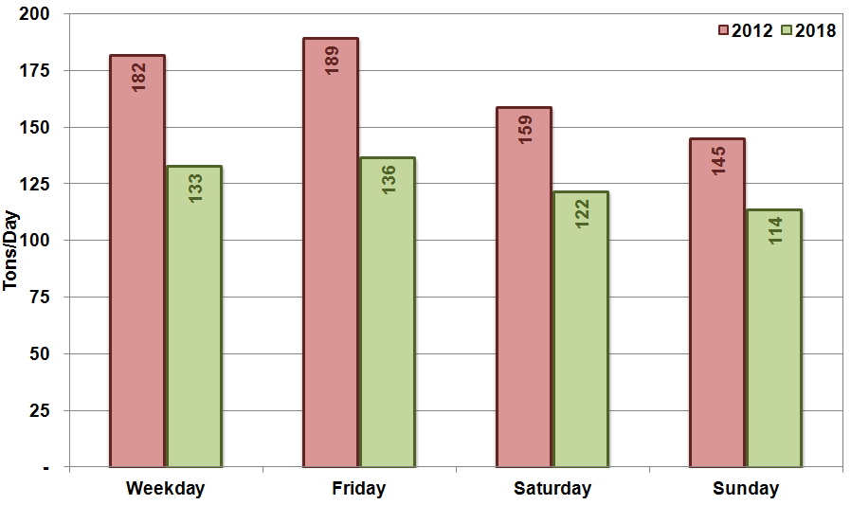

Figure 2-2: VOC Emissions (tons/day) for the San Antonio-New Braunfels MSA with Local Data, 2012 and 2018
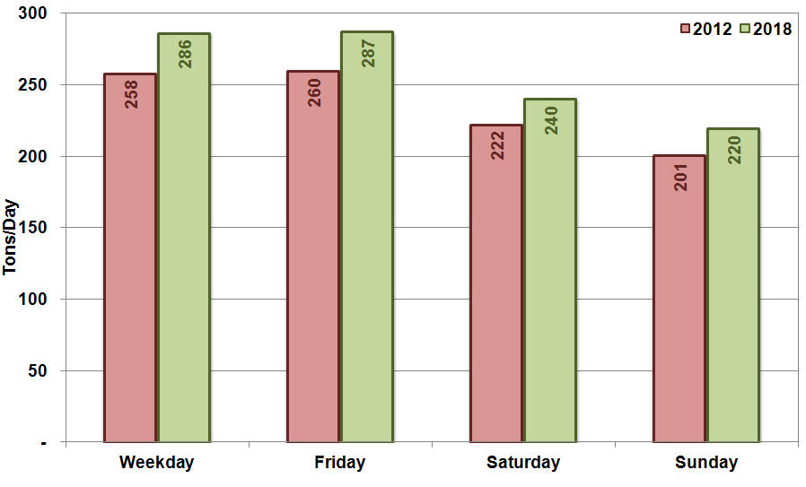

Table 2-2: NO_{X} Emissions (tons/day) for the San Antonio-New Braunfels MSA with Local AACOG Data, 2012 and 2018
Year | Day of Week | On-Road | Point | Area | Non-Road | Off-Road | Oil and Gas | Total NO_{X}
2012 | Weekday | 76.4 | 49.5 | 15.0 | 19.7 | 8.1 | 12.9 | 181.6
 | Friday | 84.1 | 49.5 | 15.0 | 19.7 | 8.1 | 12.9 | 189.3
 | Saturday | 63.0 | 49.5 | 13.3 | 15.8 | 4.5 | 12.9 | 158.8
 | Sunday | 53.3 | 49.5 | 11.6 | 13.4 | 4.5 | 12.9 | 145.1
2018 | Weekday | 37.8 | 50.0 | 19.9 | 11.8 | 7.9 | 5.6 | 133.0
 | Friday | 41.3 | 50.0 | 19.9 | 11.8 | 7.9 | 5.6 | 136.5
 | Saturday | 31.3 | 50.0 | 18.0 | 10.2 | 6.4 | 5.6 | 121.5
 | Sunday | 27.0 | 50.0 | 16.2 | 8.6 | 6.4 | 5.6 | 113.8

Table 2-3: VOC Emissions (tons/day) for the San Antonio-New Braunfels MSA with Local AACOG Data, 2012 and 2018
Year | Day of Week | On-Road | Point | Area | Non-Road | Off-Road | Oil and Gas | Total VOC
2012 | Weekday | 35.3 | 6.0 | 107.2 | 19.4 | 3.3 | 86.7 | 257.9
 | Friday | 36.9 | 6.0 | 107.2 | 19.4 | 3.3 | 86.7 | 259.5
 | Saturday | 31.6 | 6.0 | 61.1 | 36.0 | 0.8 | 86.7 | 222.2
 | Sunday | 29.9 | 6.0 | 43.4 | 33.7 | 0.8 | 86.7 | 200.5
2018 | Weekday | 23.3 | 6.0 | 134.2 | 18.5 | 3.2 | 101.0 | 286.2
 | Friday | 24.1 | 6.0 | 134.2 | 18.5 | 3.2 | 101.0 | 286.9
 | Saturday | 21.2 | 6.0 | 86.2 | 24.9 | 1.0 | 101.0 | 240.3
 | Sunday | 20.4 | 6.0 | 67.9 | 23.3 | 1.0 | 101.0 | 219.6

Emission Inventory Tile Plots

The graphic software, Package for Analysis and Visualization of Environmental data (PAVE), was used to display EPS3 formatted 4-km fine grid emissions by source type. Tile plots are used to visually verify the distribution of emissions in the photochemical model compared to actual locations. Also, hourly tile plots were checked to make sure there were no unusual patterns of emissions. Through the use of emission tile plots, the photochemical modeling emission inputs were evaluated spatially for accuracy using EPA modeling guidance.

Emission plots of TCEQ emission files in PAVE were used to check the emission inventory inputs. Texas Area Source NO_{X} and VOC emissions tile plots are provided in Figure 2-3 for 2012 and 2018. The tile plots show concentrations of high NO_{X} and VOC emissions in the population centers in Texas. The highest emissions are in Houston, Dallas, San Antonio, and Austin, while the less populated counties tend to have the lowest emissions. When comparing projection years, area source emissions are similar for 2012 and 2018. There is a significant decrease in total on-road NO_{X} and VOC emissions from 2012 to 2018 (Figure 2-4). Reasons for these decreases can be attributed to more stringent emissions standards for gasoline and diesel engines, and attrition of older, higher-polluting vehicles. The largest concentrations of on-road emissions are in Dallas, Houston, Austin, and San Antonio. On-road emissions are also concentrated in other urban areas and along major highways including I-10, I-35, and I-37.

Similar to on-road emissions, there is a significant decrease in non-road emissions from 2012 to 2018 (Figure 2-5). Like area sources, non-road emissions were concentrated in large urban areas in Texas. Oil and gas emissions are concentrated in oil and gas fields across Texas (Figure 2-6). NO_{X} emissions across all the fields decreased in 2018 as emission controls are placed on compressors and cleaner Tier 4 generators replace older equipment. Overall there is a decrease in oil and gas VOC emissions, but emissions from some fields increase depending on projected growth in production.

Off-road emissions on land are concentrated along railway lines with some emissions near large lakes in Texas (Figure 2-7). Offshore emissions are also concentrated along main shipping channels with major destinations to Corpus Christi, Galveston, Houston, Beaumont, and Lake Charles. These cities have major port facilities for transporting raw materials and finished products. Low level point source emissions below 34 meters are concentrated in Dallas, Houston, and San Antonio (Figure 2-8). These urban areas have the highest concentrations of large industrial point sources. There are also numerous low level offshore point sources in the 4-km grid. The offshore point sources are usually oil and gas production facilities.

Figure 2-3: Texas Area Emissions 4-Km Grid Tile Plots, 2012 and 2018 Weekday, 12:00–13:00
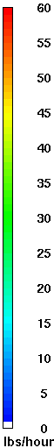
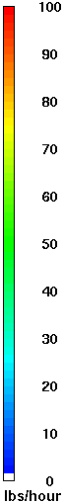
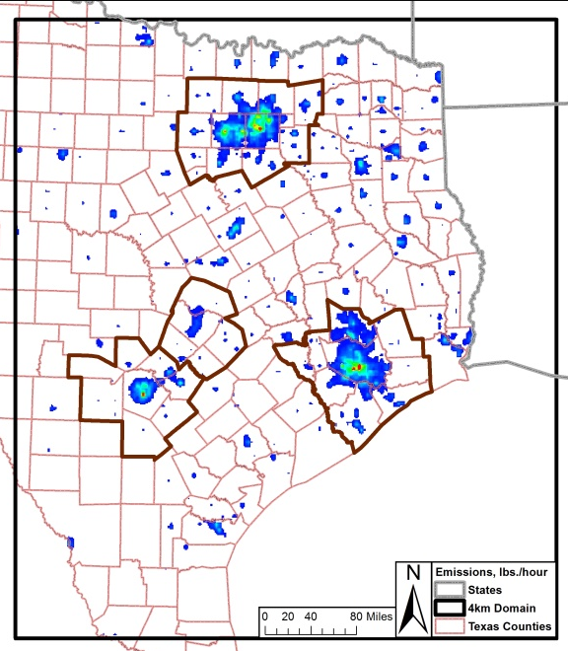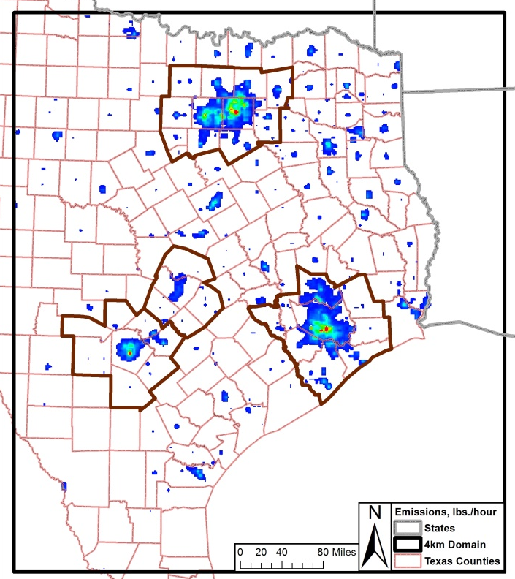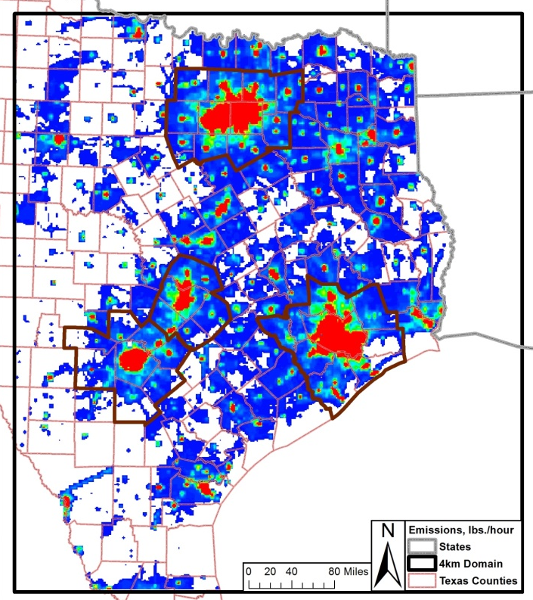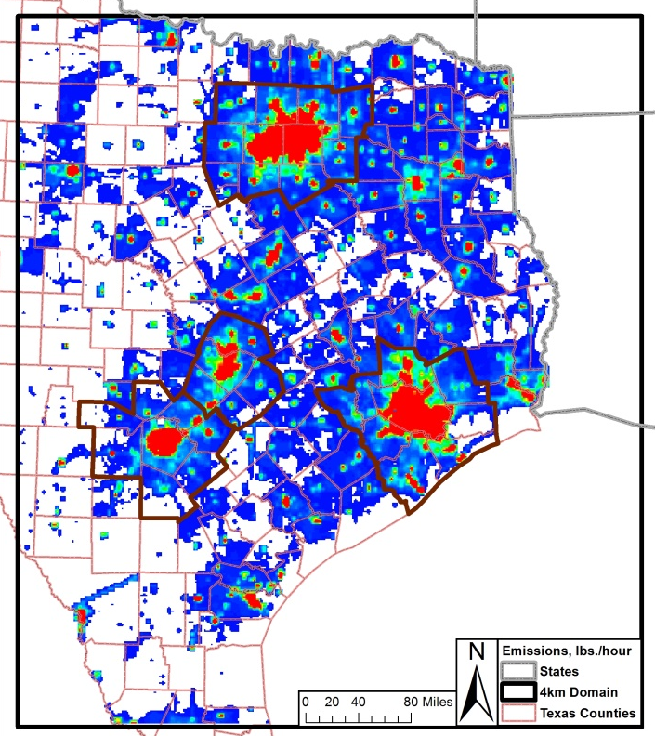
2012 NO_{X} 2018 NO_{X}

2012 VOC 2018 VOC

Figure 2-4: United States On-Road Emissions 4-Km Grid Tile Plots, 2012 and 2018 Weekday, 12:00 – 13:00
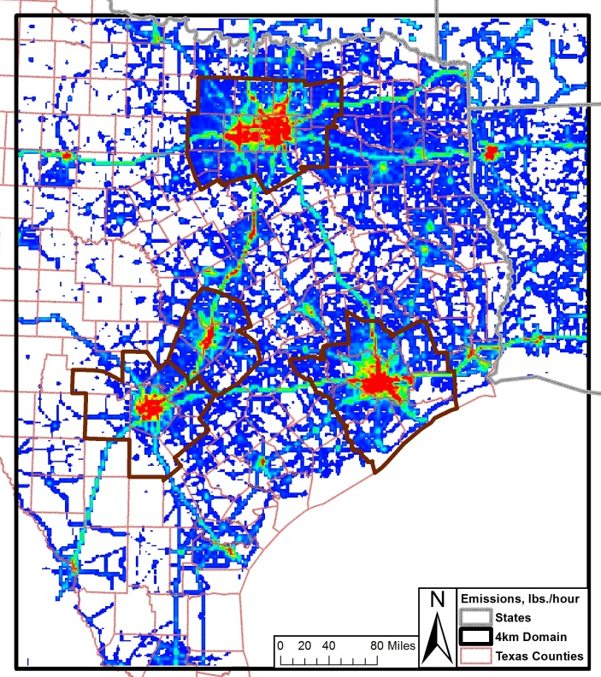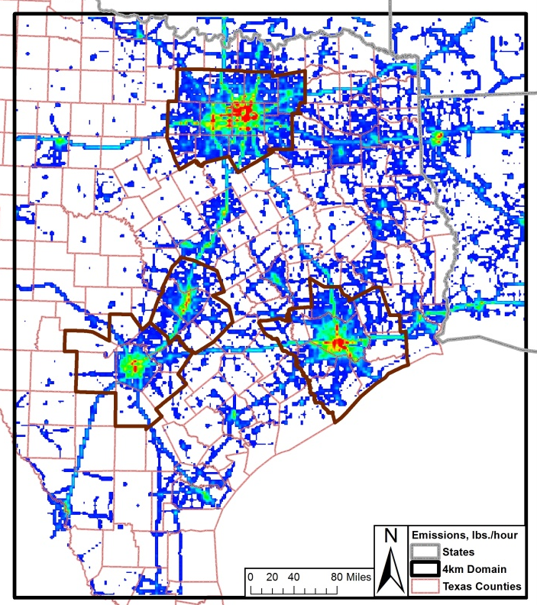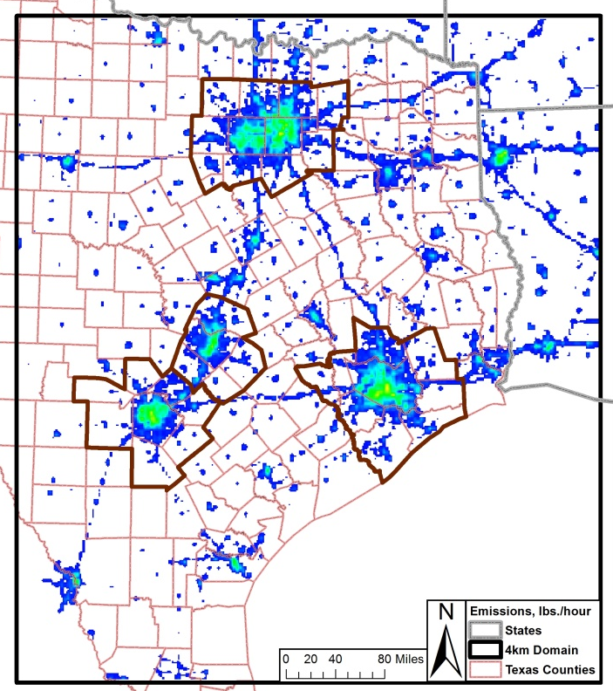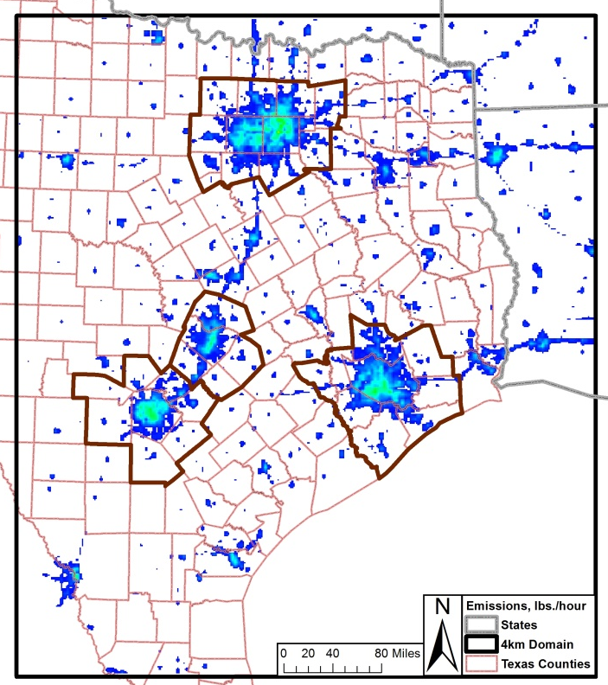
2012 NO_{X} 2018 NO_{X}

2012 VOC 2018 VOC

Figure 2-5: Texas Non-Road Emissions 4-Km Grid Tile Plots, 2012 and 2018 Weekday, 12:00 – 13:00
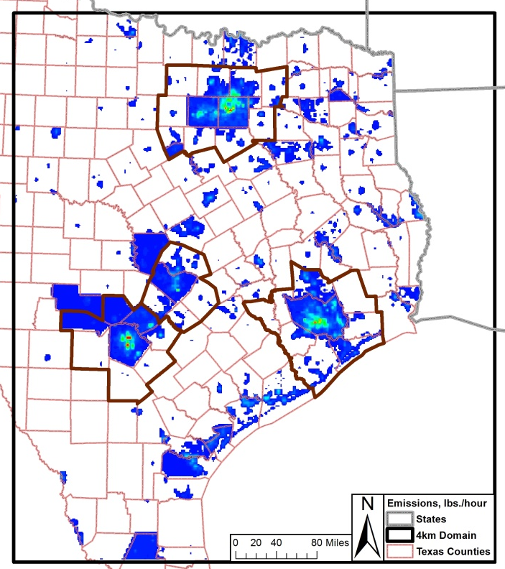
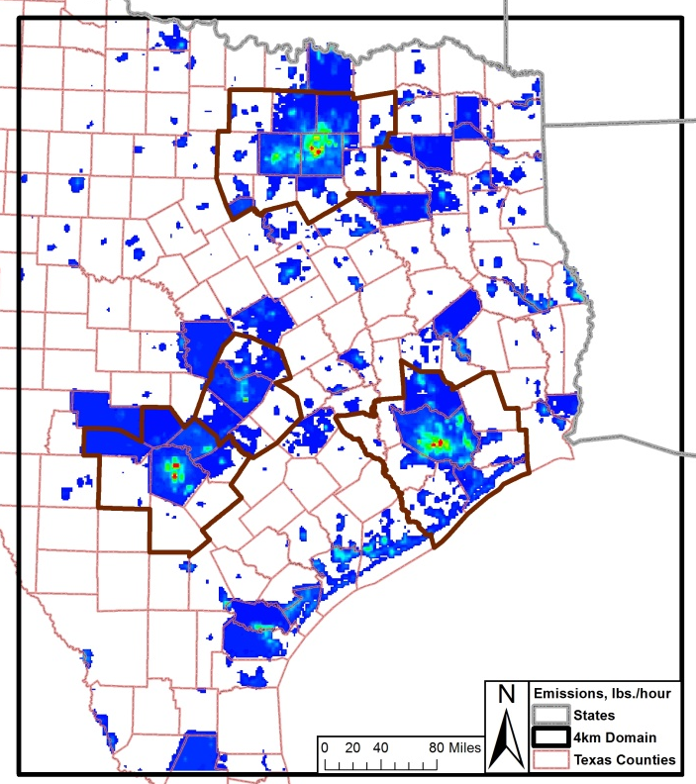
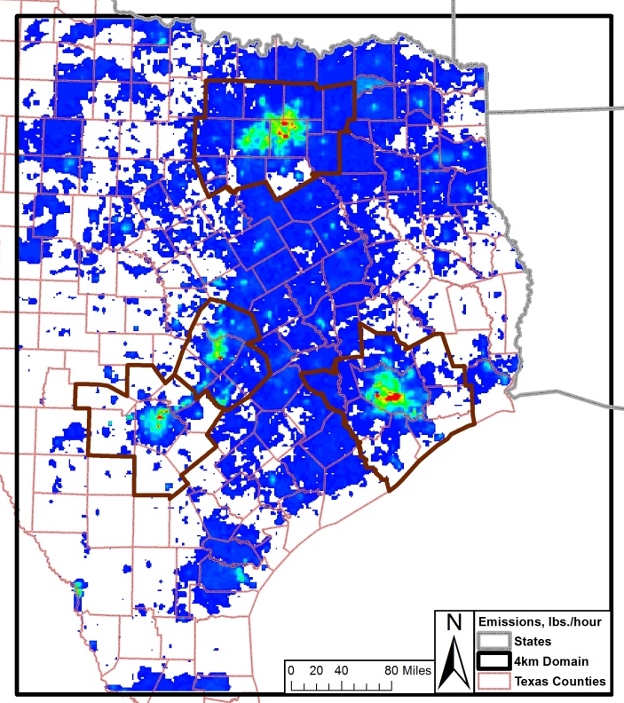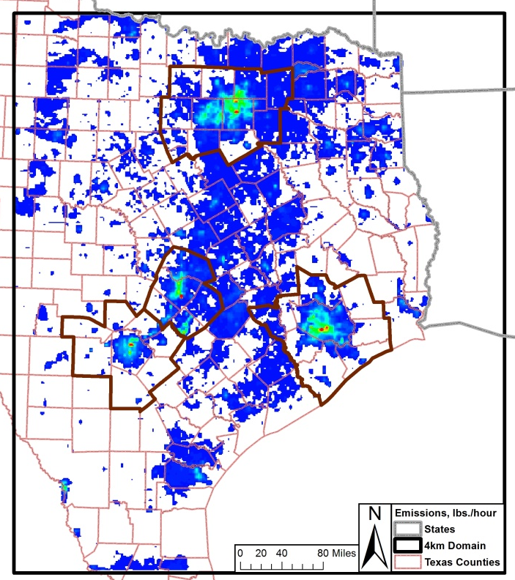
2012 NO_{X} 2018 NO_{X}

2012 VOC 2018 VOC

Figure 2-6: United States Oil and Gas Emissions 4-Km Grid Tile Plots, 2012 and 2018 Weekday, 12:00 – 13:00
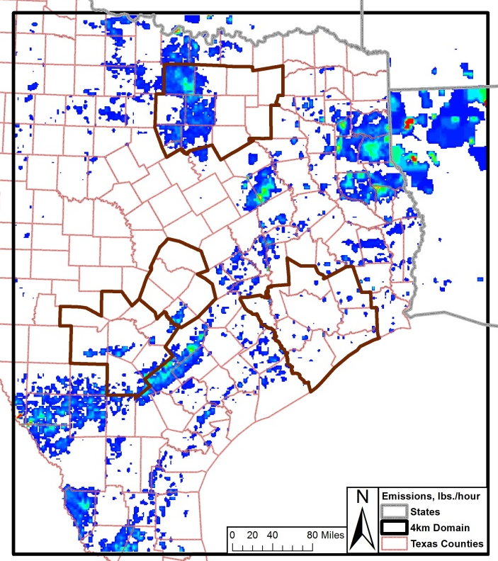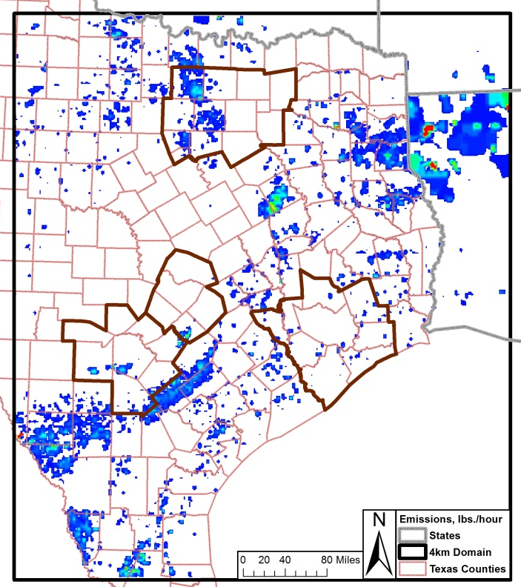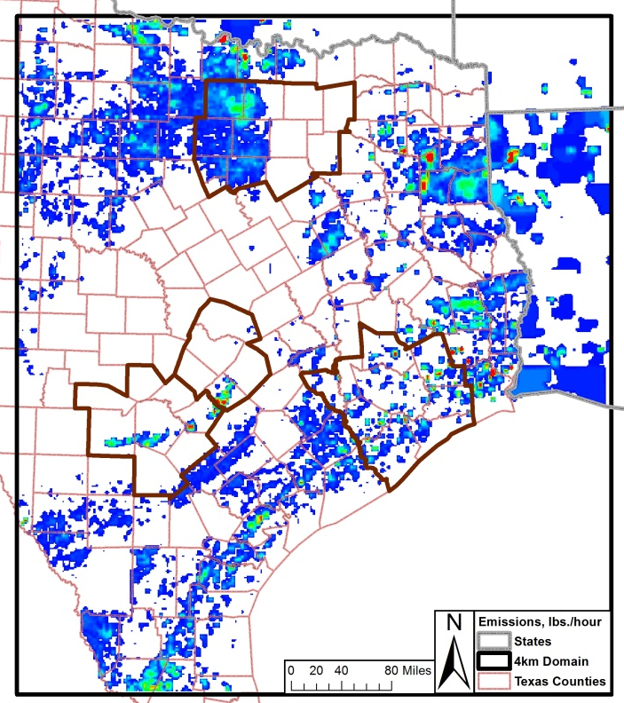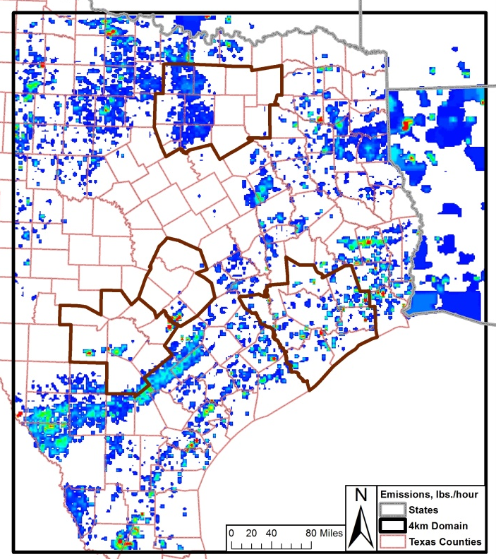
2012 NO_{X} 2018 NO_{X}

2012 VOC 2018 VOC

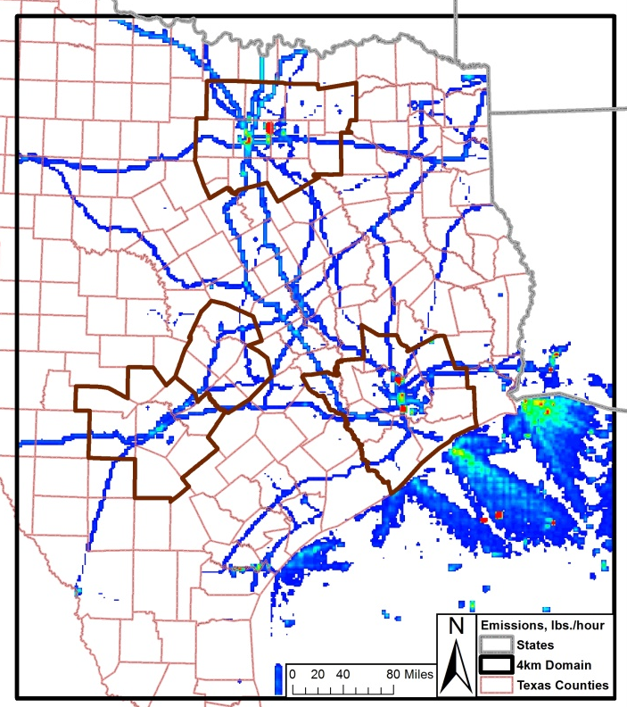
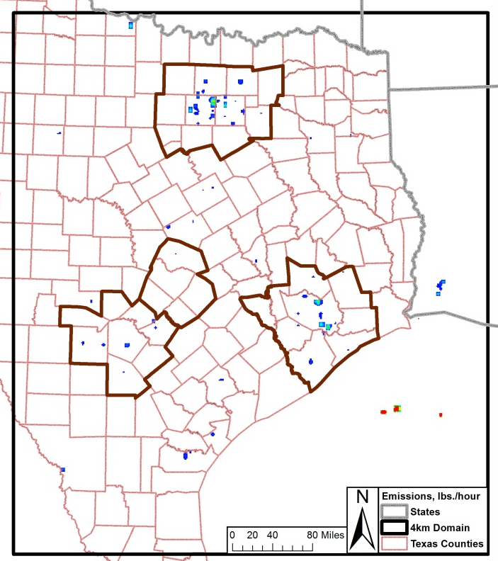
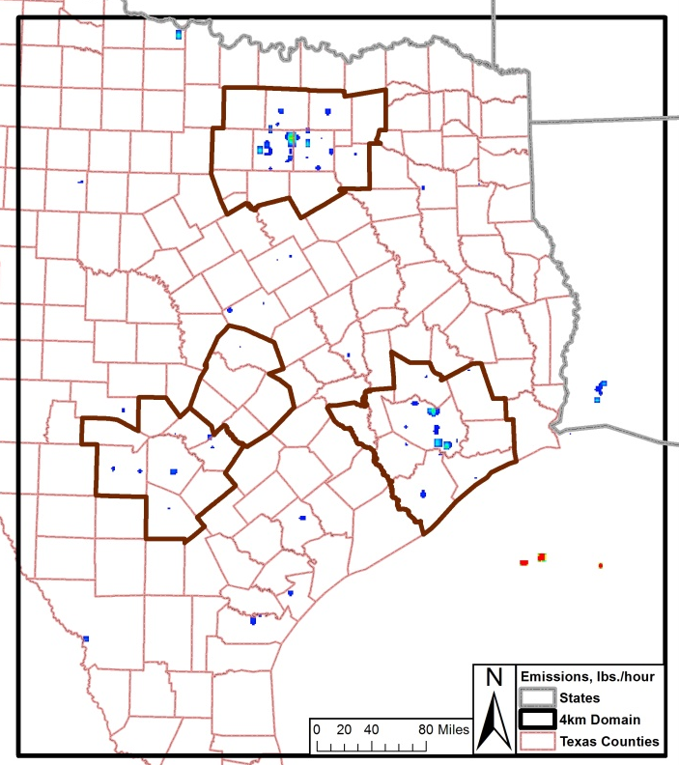
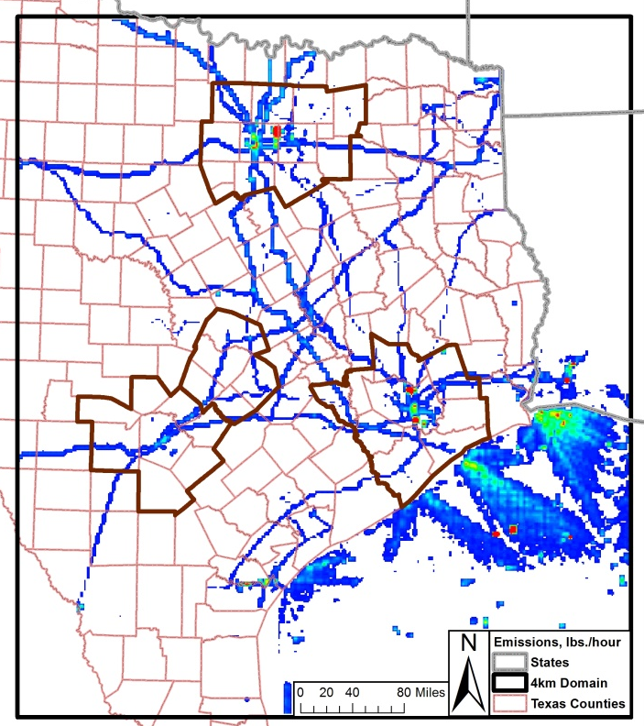
Figure 2-7: United States Off-Road Emissions 4-Km grid Tile Plots, 2012 and 2018 Weekday, 12:00 – 13:00
2012 NO_{X} 2018 NO_{X}

2012 VOC 2018 VOC

Figure 2-8: Low Points Emissions 4-km grid Tile Plots, 2012 and 2018 Weekday, 12:00 – 13:00
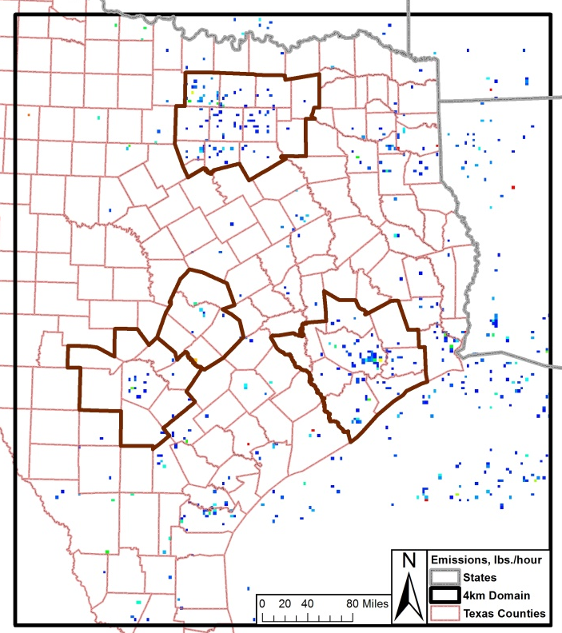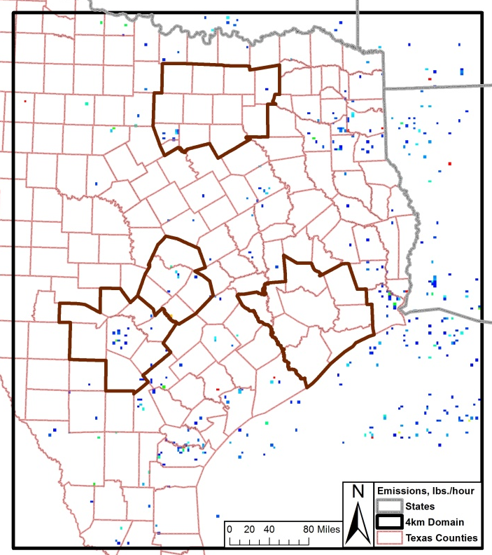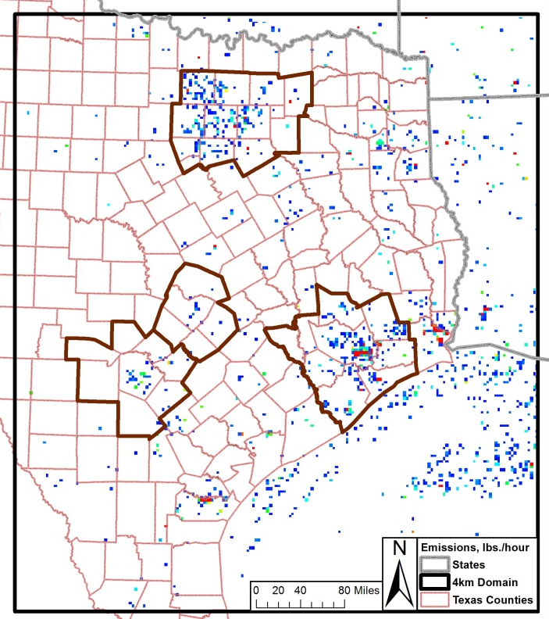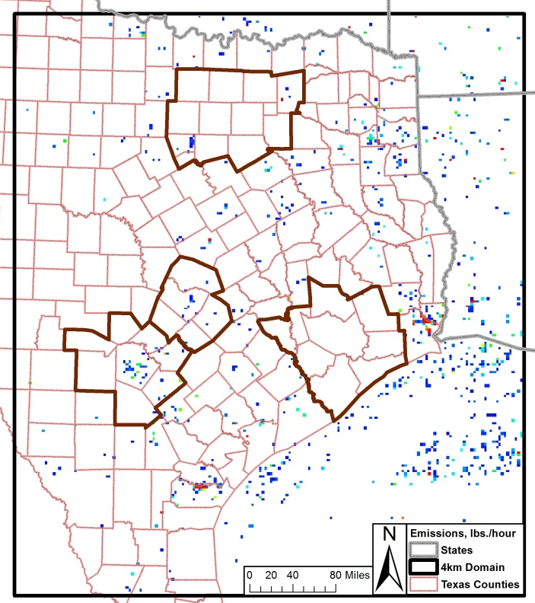
2012 NO_{X} 2018 NO_{X}

2012 VOC 2018 VOC

Base Case Modeling

CAMx Model Development
The base case CAMx simulation was developed for an elevated ozone episode in the San Antonio region that extended between May 24 and July 2, 2006. To simulate ozone formation, transport, and dispersion for the June 2006 episode, CAMx required several inputs including:
- Three-dimensional hourly meteorological fields generated by WRF via the WRF2CAMx interface tool;
- Land Use/Land Cover LULC;
- Three-dimensional hourly emissions generated by EPS3 by pollutant (latitude, longitude, and height);
- Initial conditions and boundary conditions (IC/BC);
- Photolysis rate inputs, including ultraviolet (UV) albedo, haze opacity, and total atmospheric ozone column fields.

CAMx Configurations
CAMx version 6.00 was used to model the 2006 episode to match the current TCEQ platform being developed for Texas. The configurations used for the extended June 2006 CAMx episode were:
- Duration: May 24 – July 2, 2006
- Time zone: CST (central standard time)
- I/O frequency: 1 hour
- Map projection: Lambert Conformal Conic
- Nesting: 2-way fully interactive 36/12/4-km computational grids
- Chemistry mechanism: CB6
- Chemistry solver: EBI (Euler-Backward Iterative)
- Advection solver: PPM (Piecewise Parabolic Method)
- Dry deposition model: ZHANG03
- Plume-in-Grid model: On for large NO_{X} sources, parameters set by TCEQ
- Probing Tools: None
- Dry deposition: On
- Wet deposition: On
- 3-D output: Off (2-D surface output only)
- PiG sampling grids: Off
- Asymmetric Convective Model 2 (ACM2) Diffusion
- TUV Cloud Adjustment
- Photolysis rate adjusted by cloud cover
- BC/IC from GEOS-CHEM model

Plume-in-Grid Sub-model
The photochemical model runs developed for the June 2006 episode utilize the Plume-in-Grid sub-model (PiGs) to track individual plume sources and help reduce the artificial diffusion of point source emissions in the modeling grid. The PiGs accounts “for plume-scale dispersion and chemical evolution, until such time as puff mass can be adequately represented within the larger grid model framework.” All CAMx runs employed the PiGs option for large NO_{X} point sources using TCEQ PiGs threshold values. The PiGs threshold values are:
- Texas 5 tons/day NO_{X}
- Mexico, Oklahoma, Louisiana, Arkansas 7.5 tons/day NO_{X}
- Mississippi 10 tons/day NO_{X}
- Alabama, Tennessee, Ohio 15 tons/day NO_{X}
- Other states 25 tons/day NO_{X}

Boundary Conditions, Initial Conditions, and Land Use File
Boundary and initial conditions used for the 36-km domain were provided by the GEOS–Chem Model. “GEOS–Chem is a global 3-D chemical transport model (CTM) for atmospheric composition driven by meteorological input from the Goddard Earth Observing System (GEOS) of the NASA Global Modeling and Assimilation Office. It is applied by research groups around the world to a wide range of atmospheric composition problems.” Boundary conditions were developed for each grid cell at the edge of the 36-km grid for every layer and hour of the modeling episode.

The land use distribution file is used to determine the dry deposition rates of all gases and surface albedo. The fraction of land use in each grid for the 4-km, 12-km, and 36-km grids was based on the Leaf Area Index (LAI) database. The GLASS Leaf Area Index (LAI) product is described as a “global LAI product with long time series, generated and released by the Center for Global Change Data Processing and Analysis of Beijing Normal University.”

CAMx Base Case Runs
Once all the data was input into CAMx, the model was run to produce two 2006 base case and projection case runs. The two base case runs were tested with different emission inventories, biogenic files, and meteorological files to determine modeling performance before the photochemical model was projected to 2012 and 2018. The results are provided below for Base Case AACOG Run 4 and TCEQ Run 5. Previous base case runs are documented in the Alamo Area MPO report “Development of the Extended June 2006 Photochemical Modeling Episode. Base Case AACOG Run 4 uses AACOG’s local emission inventory, while base case TCEQ Run 5 uses the preliminary version of TCEQ’s emission inventory. The two base case analyses used a different version of CAMx, chemical parameters, and different versions of EPS3 so it is not a true sensitivity test between the two base case runs.

WRF RPO Base Case AACOG Run 4
- WRF v3.2
- CAMx 5.40
- EPS3 version 1
- 5 layer thermal diffusion and no LSM
- YSU PBL scheme
- Kain-Fritsch cumulus
- WSM5 microphysics for us_36km and tx_12km domains
- WSM6 microphysics for tx_4km domain
- 3D upper-air and surface nudging using NWS data with time shift (ts) for tx_4km domain
- WRF to CAMx conversion: wrf2camx v3.2 with YSU Kv, and 100m kvpatch (kv100)
- Chemistry Parameters: CAMx5.4.chemparam.7
- Photolyis_Rates: camx_cb6_photorate.tceq2zhang26a.2012AUG02.tuv48'
- Local San Antonio-New Braunfels MSA emission data including construction equipment, landfill equipment, quarry equipment, agricultural tractors, combines, commercial airports, point sources, and heavy duty truck idling
- RPO 36-km grid system

WRF RPO EPS3 version 2 Base Case TCEQ Run 5
- WRF v3.2
- CAMx6.00
- EPS3 version 2
- 5 layer thermal diffusion and no LSM
- YSU PBL scheme
- Kain-Fritsch cumulus
- WSM5 microphysics for us_36km and tx_12km domains
- WSM6 microphysics for tx_4km domain
- 3D upper-air and surface nudging using NWS data with time shift (ts) for tx_4km domain
- WRF to CAMx conversion: wrf2camx v3.2 with YSU Kv, and 100m kvpatch (kv100)
- Chemistry Parameters: CAMx6.0.chemparam.7
- Photolyis_Rates: camx6_cb6_tuv.2013MAY08.tuv48
- TCEQ 2006 Emission Files
- RPO 36-km grid system

Diagnostic and Statistical Analysis of CAMx Runs
Each CAMx run was compared to observed data from eleven monitors in the San Antonio - New Braunfels MSA (C23, C58, C59, C501, C502, C503, C504, C505, C506, C622, and C678) to evaluate the model’s performance in predicting ozone concentrations. The performance of the June 2006 modeling episode was evaluated in two ways: (1) how well was the model able to replicate observed concentrations of ozone and (2) how accurate was the model in characterizing the sensitivity of ozone to changes in emissions?

The first question was answered by a series of operational evaluations including time series comparisons, daily ozone plots, statistical analyses, scatter plots, and plots of daily maximum 8-hour ozone fields. These operation tests specifically address the accuracy of the model’s predictions as compared to actual ozone concentrations observed at AACOG monitors.

Hourly Ozone Time Series
Time series plots of observed and predicted hourly ozone were constructed for each potential non-attainment regulatory monitor located in the San Antonio-New Braunfels MSA. EPA recommends creating these plots because they “can indicate if there are particular times of day or days of the week when the model performs especially poorly.” Figure 3-1 through Figure 3-11 provide a comparison of the hourly observed and predicted data for every ozone monitor in the San Antonio-New Braunfels MSA. The data for these time series plots was derived solely from base case TCEQ Run 5.

Using the inputs described earlier, the CAMx model slightly underpredicted ozone concentrations at all monitors from June 26 to June 29. On other days of the episode, the model’s ozone estimations correlated well with observed peak hourly ozone values and predicted peak hourly ozone values. For most monitors, for the first half of the episode, there was an excellent correlation between observed peak hourly ozone and predicted hourly ozone in the second half of the episode, with some underprediction at C506 and on June 8 at C58.

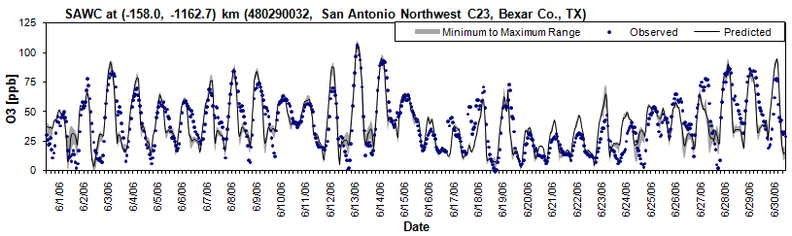
Figure 3-1: 1-Hour Ozone Time Series Observed (C23) vs. Predicted (CAMx) for Base Case TCEQ Run 5, 2006
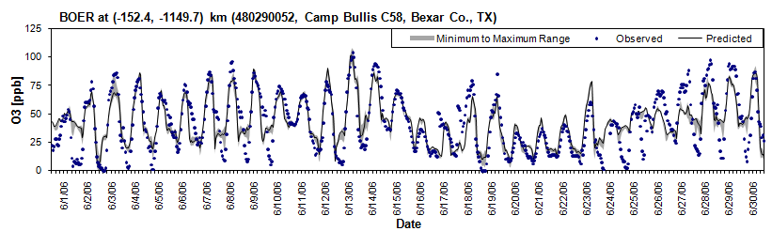
Figure 3-2: 1-Hour Ozone Time Series Observed (C58) vs. Predicted (CAMx) for Base Case TCEQ Run 5, 2006
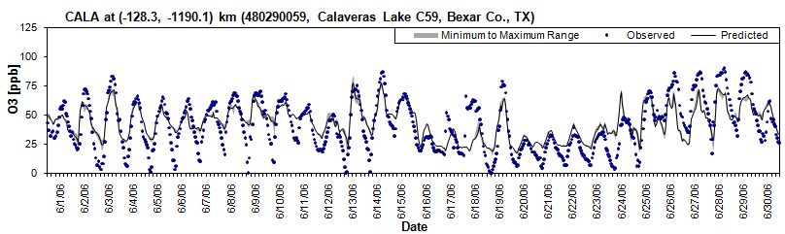
Figure 3-3: 1-Hour Ozone Time Series Observed (C59) vs. Predicted (CAMx) for Base Case TCEQ Run 5, 2006

Figure 3-4: 1-Hour Ozone Time Series Observed (C622) vs. Predicted (CAMx) for Base Case TCEQ Run 5, 2006

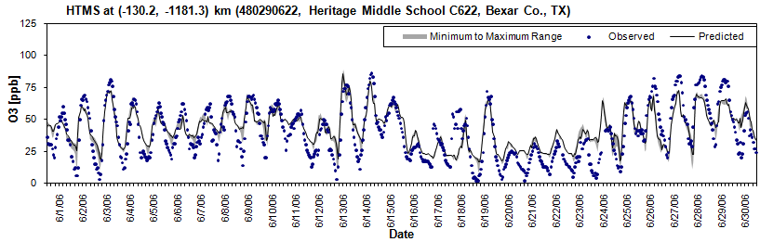
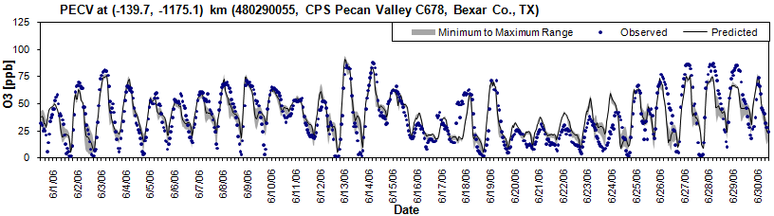
Figure 3-5: 1-Hour Ozone Time Series Observed (C678) vs. Predicted (CAMx) for Base Case TCEQ Run 5, 2006

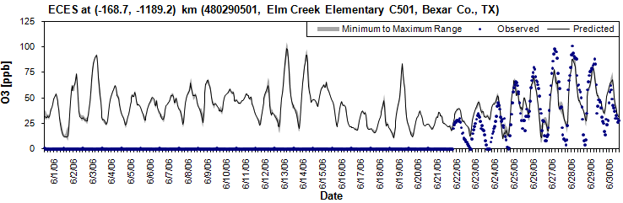
Figure 3-6: 1-Hour Ozone Time Series Observed (C501) vs. Predicted (CAMx) for Base Case TCEQ Run 5, 2006

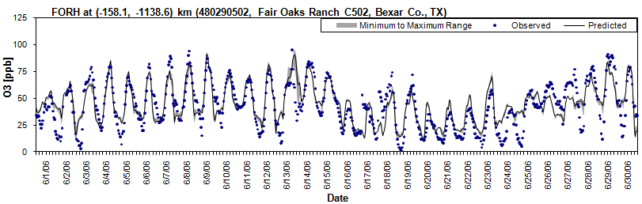
Figure 3-7: 1-Hour Ozone Time Series Observed (C502) vs. Predicted (CAMx) for Base Case TCEQ Run 5, 2006
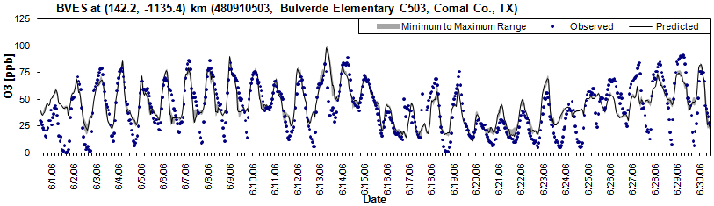
Figure 3-8: 1-Hour Ozone Time Series Observed (C503) v. Predicted (CAMx) for Base Case TCEQ Run 5, 2006

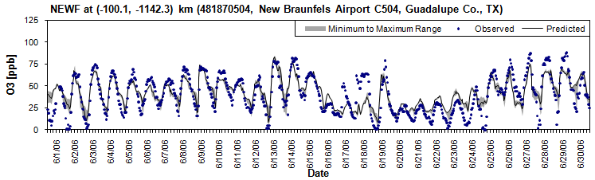
Figure 3-9: 1-Hour Ozone Time Series Observed (C504) vs. Predicted (CAMx) for Base Case TCEQ Run 5, 2006
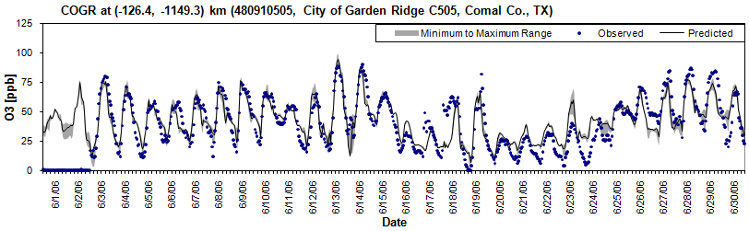
Figure 3-10: 1-Hour Ozone Time Series Observed (C505) vs. Predicted (CAMx) for Base Case TCEQ Run 5, 2006

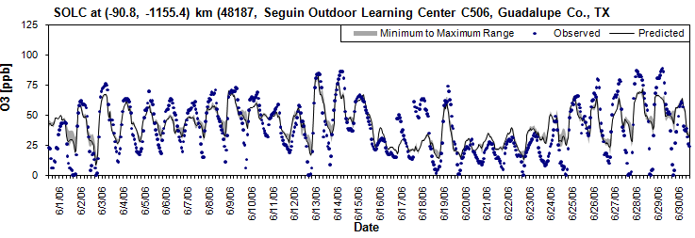
Figure 3-11: 1-Hour Ozone Time Series Observed (C506) vs. Predicted (CAMx) for Base Case TCEQ Run 5, 2006

Hourly NO_{X} Time Series
Time series plots were created of observed and predicted hourly NO_{X} for each monitor located in the San Antonio MSA. The photochemical model over predicted NO_{X} emissions at the C58 monitor on most days during the June 2006 episode. The average predicted hourly NO_{X} was 6.8 ppb, while the average observed hourly NO_{X} was only 3.9 ppb. Likewise, the average predicted maximum NO_{X} was 19.4 ppb, whereas the average observed maximum NO_{X} was 8.4 ppb. NO_{X} emission might be underpredicted because some NO_{X} sources are not accounted for in the emission inventory or the model might have a hard time predicting the NO_{X} diurnal cycle.

In contrast, NO_{X} was underpredicted at C59 on several days including the ozone exceedance days of June 7, 8, 9, 13, and 14. Model performance was good for most days at the C622 and C678 NO_{X} monitors in southeast Bexar County. The average predicted NO_{X} was higher at C678, and lower at both the C59 and C622 monitors on the southeast side of San Antonio. At C678 the photochemical model underpredicted NO_{X} on June 27 and June 28 (Figure 3-12 through Figure 3-15).

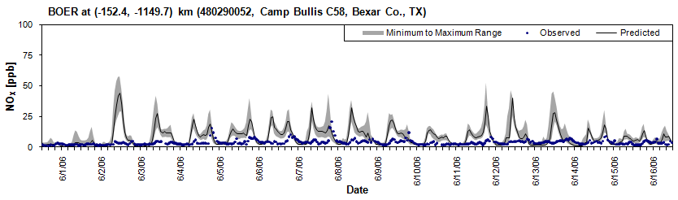
Figure 3-12: 1-Hour NO_{X} Time Series Observed (C58) vs. Predicted (CAMx) for Base Case TCEQ Run 5, 2006
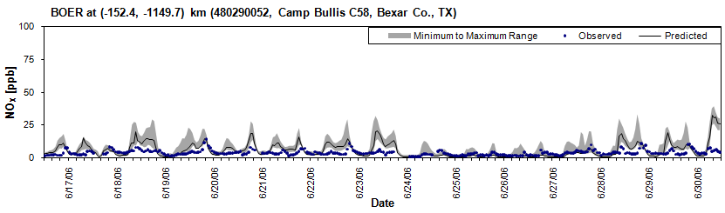

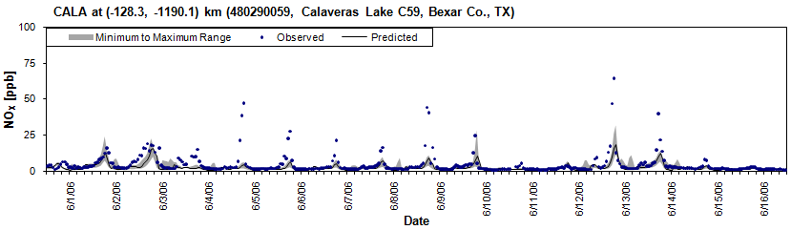
Figure 3-13: 1-Hour NO_{X} Time Series Observed (C59) vs. Predicted (CAMx) for Base Case TCEQ Run 5, 2006
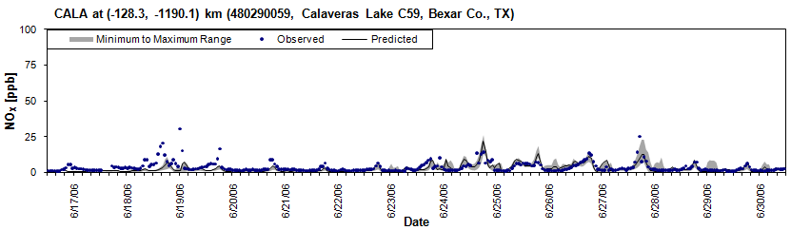
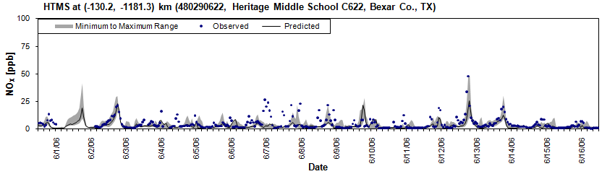
Figure 3-14: 1-Hour NO_{X} Time Series Observed (C622) vs. Predicted (CAMx) for Base Case TCEQ Run 5, 2006
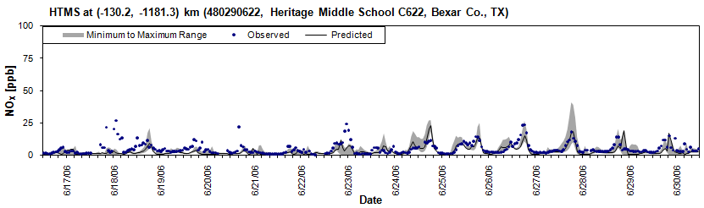

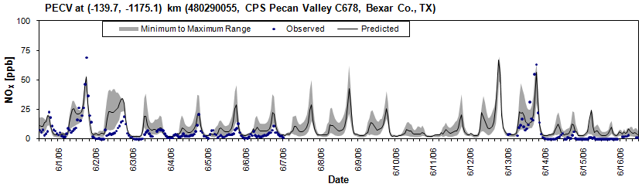
Figure 3-15: 1-Hour NO_{X} Time Series Observed (C678) vs. Predicted (CAMx) for Base Case TCEQ Run 5, 2006
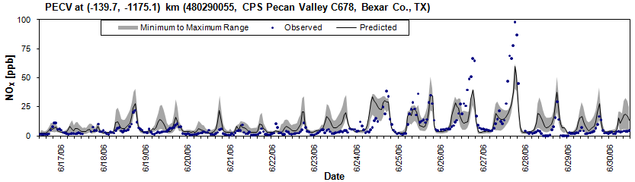

Daily Ozone Plots
Daily predicted peak maximum, peak average, and peak minimum ozone were plotted for peak value at all ozone monitors in the San Antonio-New Braunfels MSA and for the C23 and C58 monitors. Both AACOG Run 4 and TCEQ Run 5 were plotted. See Figure 3-16, Figure 3-17, and Figure 3-18. AACOG Run 4 using WRF over predicted hourly ozone on June 13 and June 14. There was also a slight over prediction on the June 4 and the June 9 exceedance days. There was a significant underprediction on June 18th, but this day was not an exceedance day in the San Antonio-New Braunfels MSA. TCEQ Run 5 slightly under-predicted ozone at C58 on June 8, but the model performance was good overall. TCEQ Run 5 modeling performance for the exceedance days in the second half of the episode, June 26, 27, 28, and 29, showed underprediction.

Since there were several significant differences in the local emission inventory, model results for TCEQ Run 5 generated predicted data that are closer to the observed data at CAMS 23. This could be seen in Figure 3-17 where the results for June 13, 14, 18, and 28 are more accurate. At CAMS 58, shown in Figure 3-18 the results of AACOG Run 4 and TCEQ Run 5 are very similair signifying that the use of local data did not materially change or improve the predicted data. Changes in meterological conditions can have greater impact on the model’s predicted ozone formation than changes to the emission inventories. Overall, the predicted results are improved in the first half of the month when using local data (AACOG Run 4) and are similarly inaccurate for the second half of the month whether using local or state data (TCEQ Run 5).

Figure 3-16: Statistics for All CAMS for 1-Hr Average Ozone during June Episode AACOG Base Case Run 4 and TCEQ Run 5
Base Case AACOG Run 4
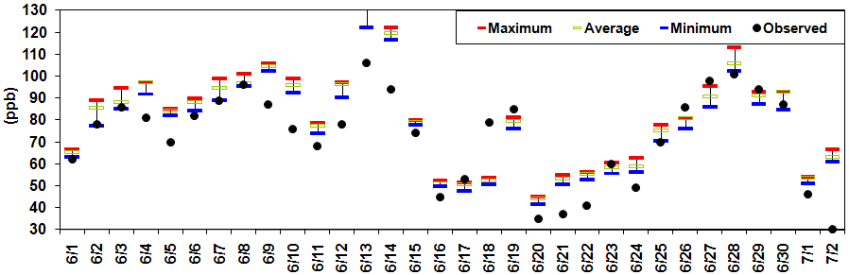
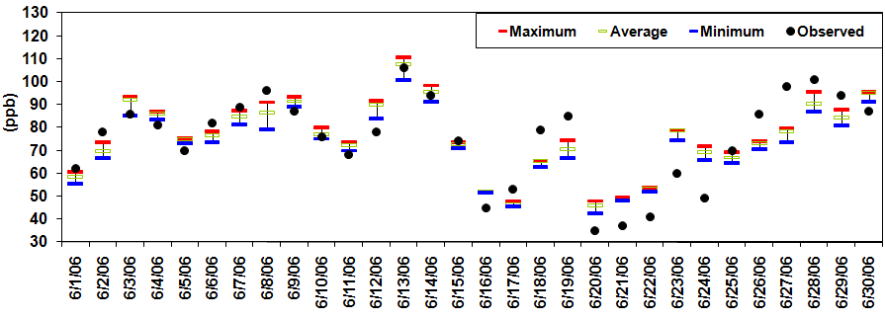
Base Case TCEQ Run 5
Figure 3-17: CAMS 23 Statistics for 1-Hr Average Ozone during June Episode AACOG Base Case Run 4 and TCEQ Run 5
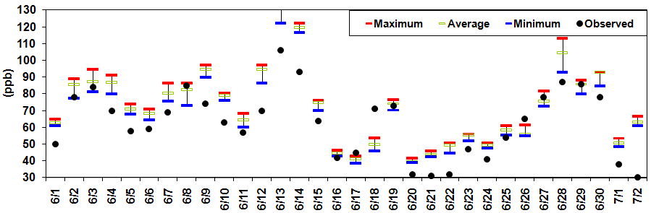
Base Case AACOG Run 4
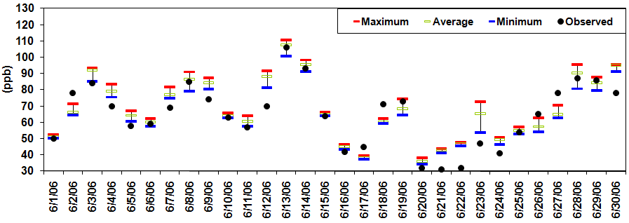
Base Case TCEQ Run 5

Figure 3-18: CAMS 58 Statistics for 1-Hr Average Ozone during June Episode AACOG Base Case Run 4 and TCEQ Run 5
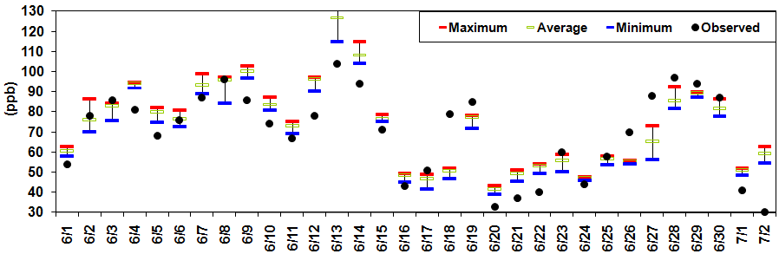
Base Case AACOG Run 4
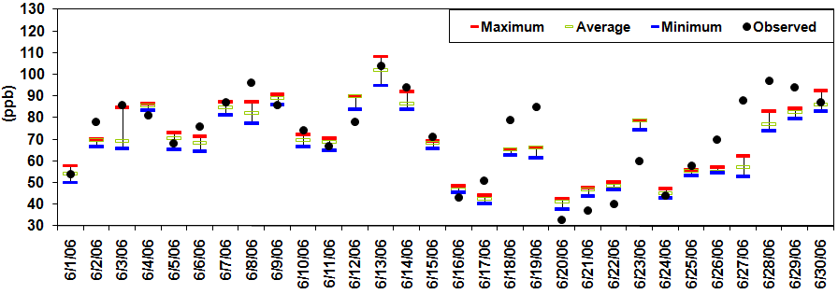
Base Case TCEQ Run 5

Statistical Analysis
There are several statistical measures recommended by the EPA for the purpose of evaluating performance of each base case run. This section will describe each statistical measurement, the statistical results for the modeled runs, and what the statistics indicate about overall model performance. The following six statistical measures were calculated to analyze the model’s ability to predict ozone concentrations for the June 2006 episode: unpaired peak prediction accuracy, paired peak predicted accuracy, mean normalized bias, mean normalized gross error, average peak predicted bias, and average peak predicted error. All results are based on predicted hourly ozone values above 60 ppb at each monitor. EPA states “it is important to include multiple statistical measures in any operational evaluation to fully characterize model performance.”

Unpaired Peak Prediction Accuracy (PPAu)
EPA recommends that the unpaired peak prediction accuracy be within 20 percent of the observed hourly ozone. The main purpose of this statistical analysis is to determine if the model is underpredicting ozone formation at each monitor.

Equation 3-1, Unpaired Peak Prediction Accuracy
PPAu = 100 x [(peak_{pred} ÷ peak_{obs})] – 1)

Mean Normalized Bias (MB)
The calculation of this measure is shown in Equation 3-2. According to the EPA, mean normalized bias should be within 15 percent.

Equation 3-2, Mean Normalized Bias
1
n
(Model – Obs.)
Obs.
x 100%
MNB = 1/n Σ

Mean Normalized Gross Error (ME)
The calculation of this measure is shown in Equation 3-3. The recommended maximum value for mean normalized gross error should be 35 percent.

Equation 3-3, Mean Normalized Gross Error
1
n
|Model – Obs. |
Obs.
x 100%

ME = 1/n Σ

Average Peak Predicted Bias and Error (APPB and APPE)
These statistical measurements use Equation 3-2 for APPB and Equation 3-3 for APPE.

The four statistical measures were calculated for all hourly ozone pairs, ozone pairs on days that the 8-hour peak observed concentrations were greater than 60 ppb, and ozone exceedance days. The statistical measures were also calculated for individual monitors averaged over all days in the June 2006 modeling episode. Days without complete observed datasets were removed from the statistics.

The results of these statistical analyses indicate the model AACOG Run 4 over predicted peak ozone on 13 days of the month and most of exceedance days, while TCEQ Run 5 over predicted peak ozone on 7 days of the month, including exceedance day of June 12. Statistical results for the rest of June exceedance days were within the level recommended by EPA for TCEQ Run 5. Although the statistics indicated significant overprediction on June 20, 21, 22, 23 and 24 for TCEQ Run 5, none of these days had peak ozone levels observed or predicted above 60 ppb. For model performance, overprediction of peak accuracy is considered better than underprediction because the calculations are based on the highest value in the grid cells surrounding the monitors. Figure 3-19 compares unpaired peak accuracy, mean normalized bias, and mean normalized error for each base case run.

Figure 3-19: Daily performance for 1-Hour Ozone in San Antonio for Base Case AACOG Run 4 and Base Case TCEQ Run 5
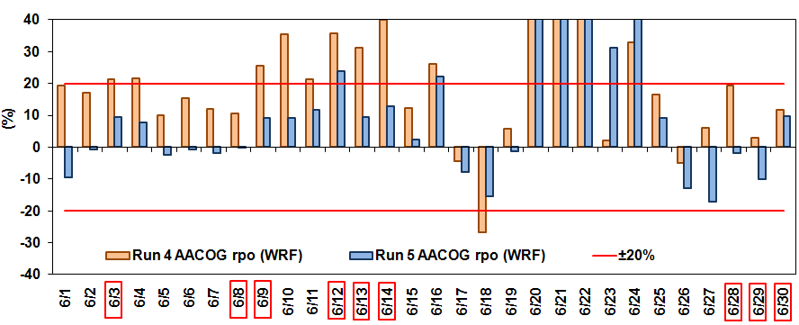
Unpaired Peak Accuracy
Mean Normalized Bias
Mean Normalized Error

Table 3-1: Daily performance for 1-Hour Ozone in San Antonio on all Days for Base Case AACOG Run 4 and TCEQ Base Case Run 5
Statistical Analysis | Average All Days |  | Average Days > 60 ppb observed |  | Average On Exceedance Days
 | AACOG Run 4 | TCEQ Run 5 | AACOG Run 4 | TCEQ Run 5 | AACOG Run 4 | TCEQ Run 5
Unpaired Peak Prediction Accuracy (%) | 19.6 | 9.0 | 15.5 | 2.3 | 22.1 | 9.0
Peak Bias (unpaired time) | 0.2 | -4.3 | 0.8 | -5.0 | 3.5 | -4.3
Peak Error (unpaired time) | 8.7 | 8.5 | 8.9 | 7.9 | 9.0 | 8.5
Bias (normalized) (%) | 0.2 | -7.7 | 1.2 | -8.6 | 4.9 | -7.7
Gross Error (normalized) (%) | 12.7 | 13.7 | 12.9 | 12.5 | 12.2 | 13.7

Model performance was good on most exceedance days for both AACOG Run 4 and TCEQ Run 5. The only exceedance day on which AACOG Run 4 noticeably failed to meet the EPA recommended value for mean normalized bias was on June 12. Every exceedance day exhibited normalized error within EPA recommended levels. As shown in Table 3-1, every WRF modeling runs exhibited similar performance for peak error and normalized error and significantly different results for Unpaired Peak Prediction Accuracy during exceedance days. Normalized error on exceedance days was well below EPA’s recommendation of 35 percent. TCEQ Run 5 showed improved results as compared to AACOG Run 4 for the first half of the month.

The soccer-style plots in Figure 3-20 show most days are within EPA’s recommendation for statistical analysis for exceedance days. To meet EPA’s guidance for error and bias, values should be within the plots’ blue squares. The one day for which measures of error and bias were outside of the blue box in the graphs was June 18 (upper left hand corner of the plot). The model significantly underpredicted ozone on this day; however, June 18 is not an exceedance day in the San Antonio-New Braunfels MSA. For TCEQ Run 5 model performance was slightly degraded and two exceedance days, June 26 and June 27, did not fall within the blue box.

When statistical analysis was performed on data for individual monitors (Figure 3-21, Figure 3-22, Figure 3-23), unpaired peak accuracy for AACOG Run 4 met EPA guidelines for all monitors and were especially good for C23, C678, C503, and C505. Model performance for TCEQ Run 5 was less accurate at C59 and C506 for both unpaired peak accuracy and normalized bias statistical analysis. For mean normalized bias, all monitors meet EPA guidance for each run. Normalized error values for all days and on exceedance days were well below EPA’s recommendation of 35 percent. The results of AACOG Run 4 and TCEQ Run 5 demonstrated a good modeling performance overall, with the best performance for normalized error at every monitor.

Figure 3-20: Soccer-Style Plot of Normalized Gross Error and Normalized Bias by Exceedance Days, Base Case AACOG Run 4 & TCEQ Run 5
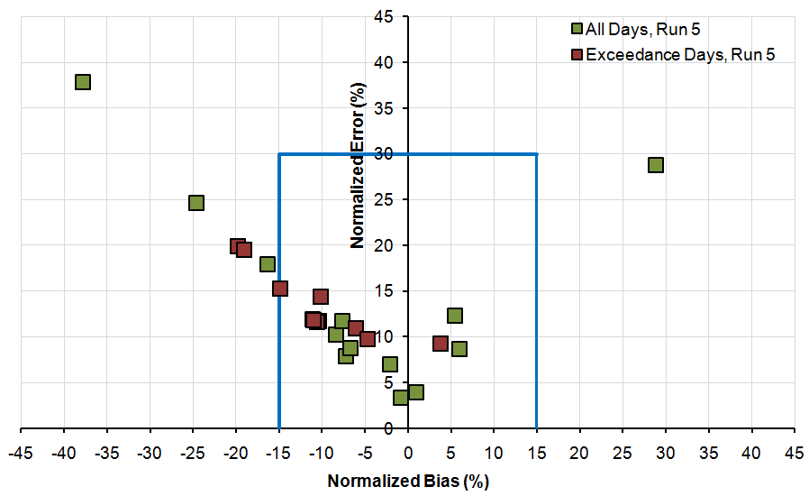
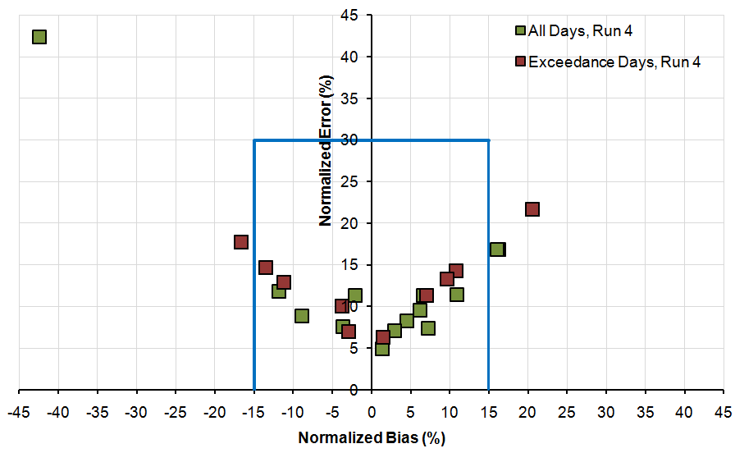
June 26 and June 27
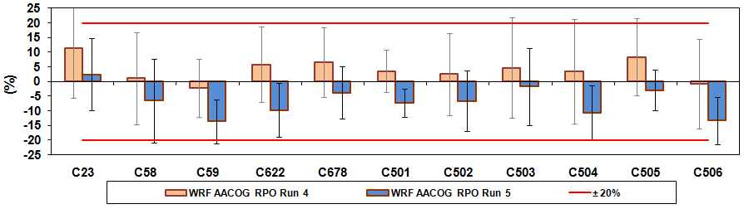
Figure 3-21: San Antonio CAMs Performance for Base Case AACOG Run 4 and Base Case TCEQ Run 5
Unpaired Peak Accuracy (All Days)
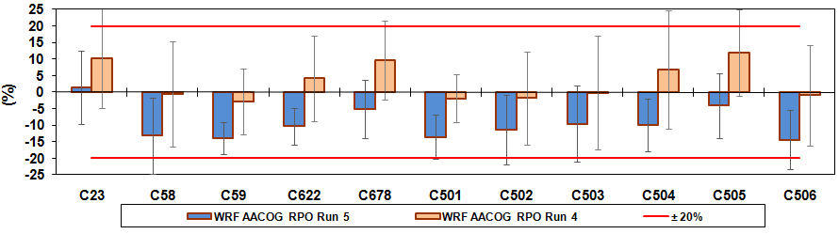
Unpaired Peak Accuracy (Exceedance Days)

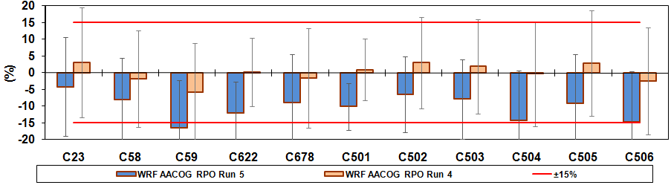
Mean Normalized Bias (All Days)

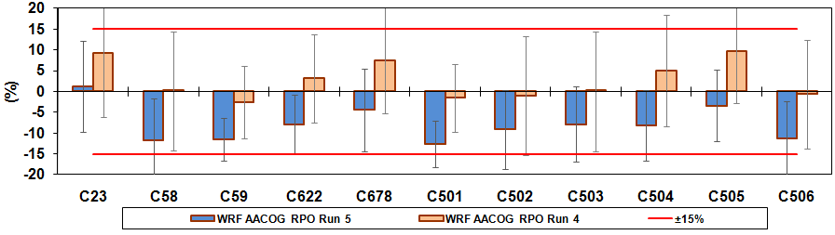
Mean Normalized Bias (Exceedance Days)

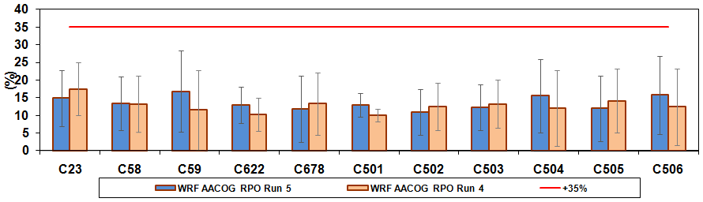
Mean Normalized Error (All Days)

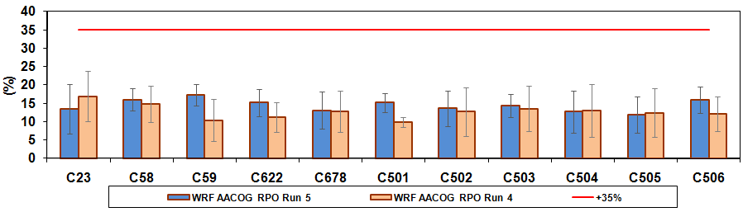
Mean Normalized Error (Exceedance Days)

Figure 3-22: Soccer-Style Plot of Normalized Gross Error and Normalized Bias by Monitor for Every Day, Base Case AACOG Run 4 and TCEQ Run 5
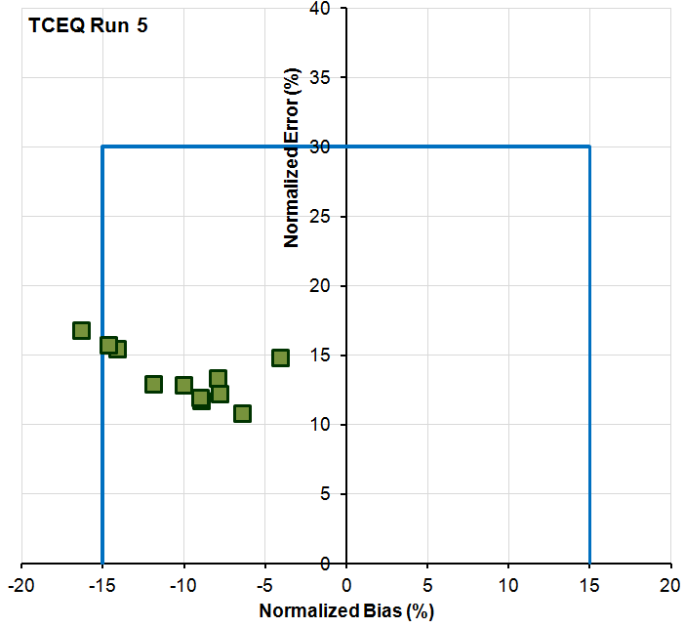
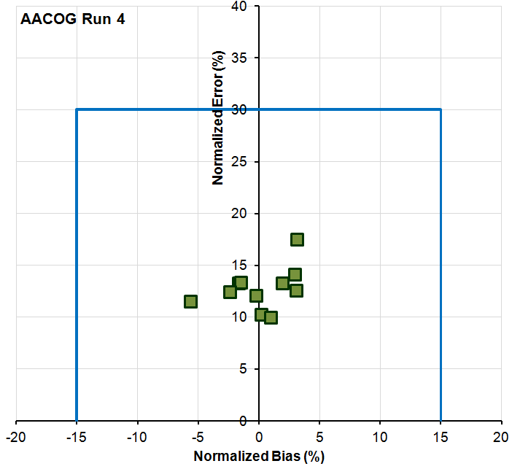

Figure 3-23: Soccer-style Plot of Normalized Gross Error and Normalized Bias by Monitor for Exceedance Days, Base Case AACOG Run 4 and TCEQ Run 5
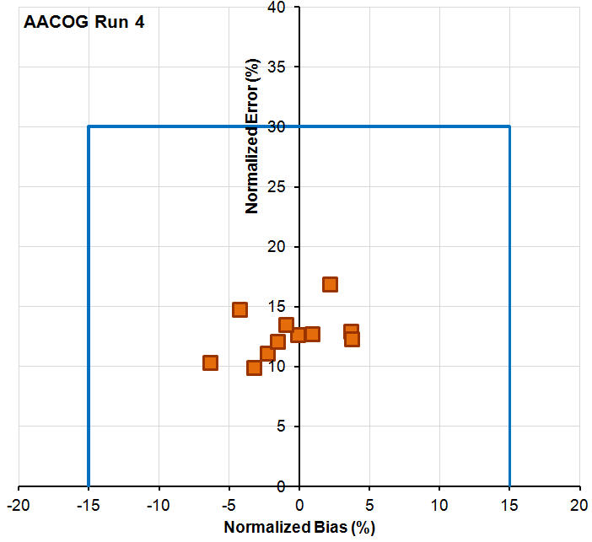
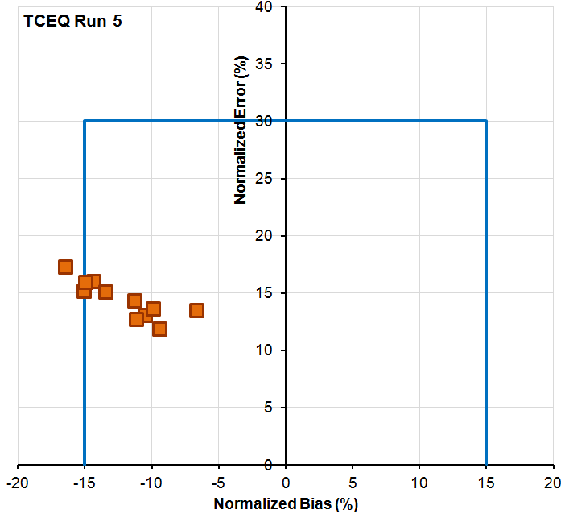
Table 3-2: Average 8-Hour Ozone Prediction for All Days average by CAMS Performance, Base Case AACOG Run 4 and Base Case TCEQ Run 5
Statistical | CAMS Station | Average All Days
 |  | AACOG Run 4 | TCEQ Run 5
Unpaired Peak Prediction Accuracy | C23 | 11.33 | 2.37
 | C58 | 1.04 | -6.53
 | C59 | -2.17 | -13.70
 | C622 | 5.81 | -9.74
 | C678 | 6.51 | -3.85
 | C501 | 3.52 | -7.30
 | C502 | 2.49 | -6.66
 | C503 | 4.64 | -1.72
 | C504 | 3.45 | -10.72
 | C505 | 8.35 | -2.96
 | C506 | -0.73 | -13.41
Peak Bias (unpaired time) | C23 | 7.78 | 1.81
 | C58 | 0.91 | -6.05
 | C59 | -1.57 | -10.22
 | C622 | 4.05 | -7.05
 | C678 | 4.03 | -3.07
 | C501 | 2.03 | -7.32
 | C502 | 1.97 | -5.31
 | C503 | 3.51 | -3.48
 | C504 | 2.51 | -7.89
 | C505 | 6.58 | -2.56
 | C506 | -0.44 | -9.77
Peak Error (unpaired time) | C23 | 12.31 | 7.29
 | C58 | 10.34 | 9.98
 | C59 | 7.04 | 10.39
 | C622 | 6.63 | 7.95
 | C678 | 9.14 | 5.05
 | C501 | 6.83 | 10.70
 | C502 | 8.66 | 8.02
 | C503 | 11.42 | 8.54
 | C504 | 9.09 | 8.97
 | C505 | 10.11 | 4.90
 | C506 | 9.39 | 10.07

Statistical | CAMS Station | Average All Days
 |  | AACOG Run 4 | TCEQ Run 5
Bias (normalized) | C23 | 3.11 | -4.14
 | C58 | -1.70 | -7.98
 | C59 | -5.67 | -16.39
 | C622 | 0.18 | -11.96
 | C678 | -1.53 | -8.99
 | C501 | 0.97 | -10.10
 | C502 | 3.04 | -6.47
 | C503 | 1.92 | -7.87
 | C504 | -0.26 | -14.20
 | C505 | 2.89 | -9.04
 | C506 | -2.43 | -14.68
Mean Gross Error (normalized) | C23 | 17.52 | 14.91
 | C58 | 13.28 | 13.42
 | C59 | 11.51 | 16.85
 | C622 | 10.24 | 12.96
 | C678 | 13.38 | 11.78
 | C501 | 10.00 | 12.92
 | C502 | 12.57 | 10.87
 | C503 | 13.28 | 12.27
 | C504 | 12.10 | 15.54
 | C505 | 14.11 | 11.98
 | C506 | 12.45 | 15.77

Based on the EPA recommendation, unpaired peak prediction of ozone values within ± 20 percent are acceptable values; therefore, both runs produce reasonable results according to the values shown in Table 3-2 and Table 3-3. All normalized bias values are also acceptable based on the EPA standards. These values must remain with ±15 percent of the observed data. The values for Mean Normalized Gross Error by each monitor also remain well below the EPA’s accepted level of ± 30 percent. These values were well within the criteria area (“goal box”) in AACOG Run 4 on the soccer plots for all monitors and on all days with one occasion of out of the box for the TCEQ Run 5 results.

Table 3-3: Average 8-Hour Ozone Prediction for Exceedance Days Average for AACOG Base Case Run 4 and TCEQ Base Case Run 5
Statistical | CAMS Station | Exceedance Days
 |  | AACOG Run 4 | TCEQ Run 5
Unpaired Peak Prediction Accuracy | C23 | 10.23 | 1.40
 | C58 | -0.57 | -13.21
 | C59 | -2.72 | -14.00
 | C622 | 4.21 | -10.25
 | C678 | 9.70 | -5.12
 | C501 | -1.93 | -13.50
 | C502 | -1.84 | -11.32
 | C503 | -0.21 | -9.54
 | C504 | 6.77 | -10.01
 | C505 | 11.93 | -4.01
 | C506 | -0.99 | -14.45
Peak Bias (unpaired time) | C23 | 9.21 | 1.26
 | C58 | 0.14 | -11.67
 | C59 | -2.51 | -11.44
 | C622 | 3.18 | -8.02
 | C678 | 7.53 | -4.41
 | C501 | -1.55 | -12.58
 | C502 | -0.98 | -9.14
 | C503 | 0.07 | -7.88
 | C504 | 5.09 | -8.24
 | C505 | 9.73 | -3.43
 | C506 | -0.62 | -11.30
Peak Error (unpaired time) | C23 | 12.53 | 5.76
 | C58 | 11.38 | 12.31
 | C59 | 6.83 | 11.80
 | C622 | 7.16 | 9.74
 | C678 | 9.67 | 6.81
 | C501 | 5.65 | 13.50
 | C502 | 8.50 | 10.02
 | C503 | 11.81 | 12.02
 | C504 | 11.07 | 9.80
 | C505 | 10.19 | 5.37
 | C506 | 10.76 | 11.32

Statistical | CAMS Station | Exceedance Days
 |  | AACOG Run 4 | TCEQ Run 5
Bias (normalized) | C23 | 2.13 | -6.69
 | C58 | -4.30 | -14.35
 | C59 | -6.40 | -16.48
 | C622 | -2.32 | -13.45
 | C678 | 0.88 | -10.51
 | C501 | -3.25 | -15.10
 | C502 | -0.13 | -9.93
 | C503 | -0.98 | -11.31
 | C504 | 3.63 | -11.18
 | C505 | 3.71 | -9.45
 | C506 | -1.59 | -15.00
Mean Gross Error (normalized) | C23 | 16.94 | 13.51
 | C58 | 14.84 | 16.06
 | C59 | 10.39 | 17.32
 | C622 | 11.19 | 15.17
 | C678 | 12.78 | 13.09
 | C501 | 9.95 | 15.23
 | C502 | 12.73 | 13.63
 | C503 | 13.55 | 14.39
 | C504 | 13.01 | 12.76
 | C505 | 12.37 | 11.87
 | C506 | 12.15 | 15.95

Ozone Scatter Plots
Scatter plots of predicted and observed hourly ozone readings at monitors were plotted to determine how well the base case runs represented observed ozone values (Figure 3-24). The scatter plots are based on hourly observed and predicted data from all the ozone monitors in the San Antonio-New Braunfels MSA. Each run tended to overpredict ozone for related observations below 60 ppb, but correlated well for higher ozone values, especially for TCEQ Run 5. Figure 3-25 provides the scatter plots for 8-hour daily maximum ozone for AACOG Run 4 and TCEQ Run 5. The observed and predicted/modeled values correlated well, especially for TCEQ Run 5. AACOG Run 4 values below 60 ppb were slightly overpredicted.

In Table 3-4, the R² values in AACOG Run 4 for average 8-hour ozone for all values ranged from 0.727 to 0.753, indicating a strong correlation between predicted and observed ozone data. This correlation diminishes for TCEQ Run 5 with R² values ranging between 0.716 and 0.730, which are still considered to be strongly correlated. Overall, AACOG Run 4 demonstrated the best correlation for both 1-hour and 8-hour ozone concentrations. For hourly ozone prediction, performance was slightly inferior for TCEQ Run 5. The performance for hourly ozone values for all monitors, C23 and C58 was poorer for 1-hour values and on days > 60 ppb. These results indicate infrequent high-ozone values days in the San Antonio area, highlighting the episodic nature of high-ozone days in this region.

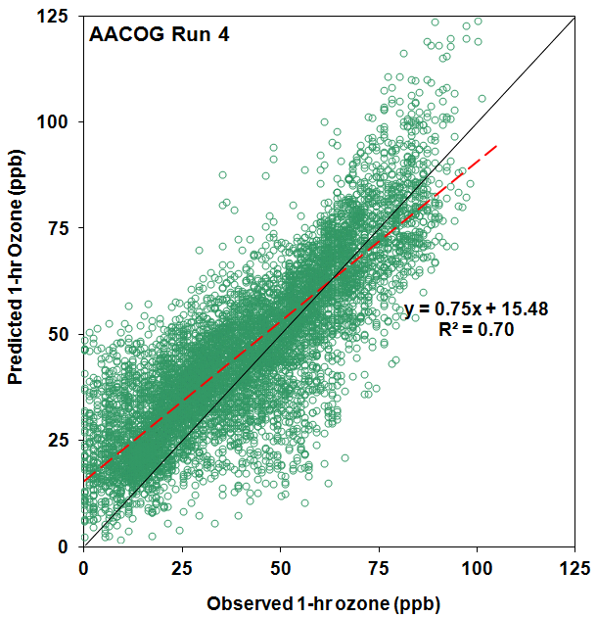
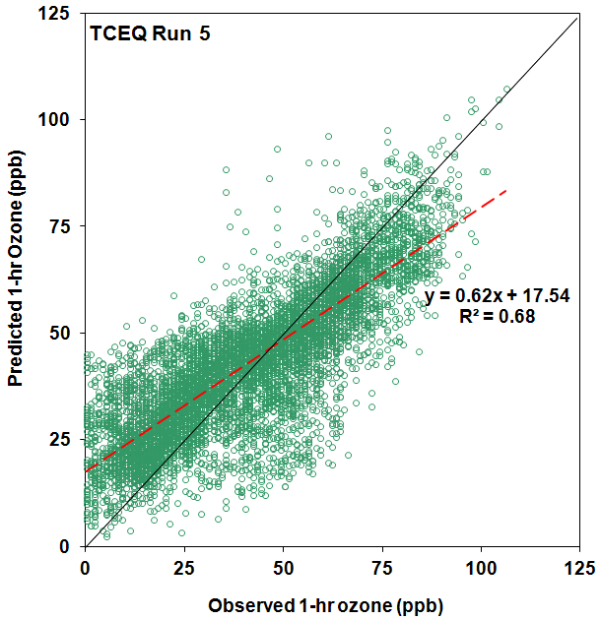
Figure 3-24: Hourly Ozone Scatter Plots in San Antonio for Base Case AACOG Run 4, and Base Case TCEQ Run 5

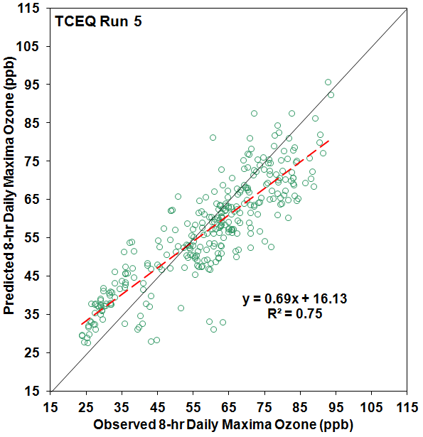
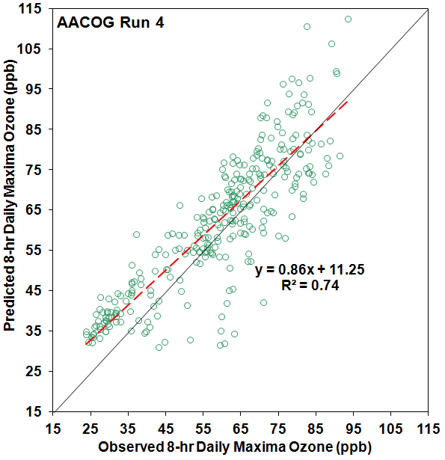
Figure 3-25: 8-Hour Daily Maximum Ozone Scatter Plots for Base Case AACOG Run 4 and TCEQ Run 5

Table 3-4: R² Values for Ozone Scatter Plots by Selected Monitors, Base Case AACOG Run 4 and Base Case TCEQ Run 5
Run | Hourly Ozone R² |  |  |  |  |  | 8-Hour Daily Ozone R²
 | All Hourly Ozone Values |  |  | Hourly Ozone >60 ppb |  |  | All 8-Hour Ozone Values |  |  | 8-Hour Ozone Values >60 ppb
 | All CAMS | C23 | C58 | All CAMS | C23 | C58 | All CAMS | C23 | C58 | All CAMS | C23 | C58
AACOG Run 4 | 0.705 | 0.711 | 0.686 | 0.255 | 0.394 | 0.300 | 0.738 | 0.753 | 0.727 | 0.270 | 0.395 | 0.311
TCEQ Run 5 | 0.678 | 0.678 | 0.678 | 0.202 | 0.327 | 0.299 | 0.716 | 0.717 | 0.730 | 0.192 | 0.276 | 0.320

NO_{X} Scatter Plots
Scatter plots of hourly predicted and observed NO_{X} concentrations at CAMS stations were generated to determine how well the base case runs represented observed NO_{X} values ( Figure 3-26). The NO_{X} data have been collected at C58, C59, C622, and C678 NO_{X} monitors for June 1 – June 30, 2006. These dates do not include the ramp up days from May 24th to May 31st and the ramp down days on July 1st and 2nd.

Model performance was lower for the C58 NO_{X} monitor in northwest San Antonio with an R² value between 0.116 and 0.131 (Table 3-5). The model significantly overpredicted NO_{X} at C58 during most days of the modeling episode. Model performance was slightly improved at C59 and C622 with good performance at C678. TCEQ Run 5 had a better performance at C58, but degraded performance at the other monitors.

Table 3-5: R² Values for NO_{X}, June 2006, Base Case AACOG Run 4 and TCEQ Run 5
Run | All | C58 | C59 | C622 | C678
AACOG Run 4 | 0.296 | 0.116 | 0.304 | 0.275 | 0.556
TCEQ Run 5 | 0.298 | 0.131 | 0.261 | 0.266 | 0.534

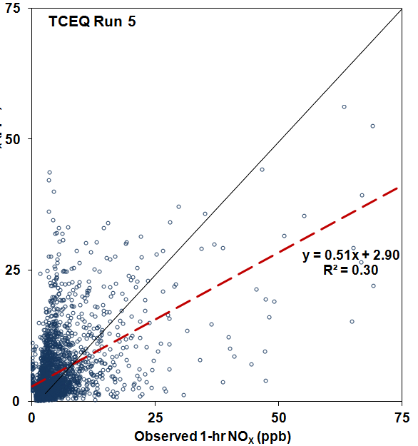
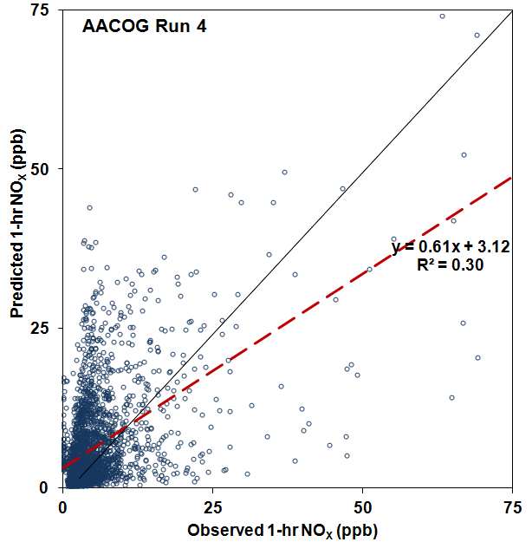
Figure 3-26: Hourly NO_{X} Scatter Plots for Base Case AACOG Run 4 and Base Case TCEQ Run 5

Daily Maximum 8-Hour Ozone Fields
Another means of analyzing model performance recommended by the EPA is use of tile plot graphics. Figure 3-27 shows tile plots of predicted maximum ozone across the modeling domain for TCEQ Run 5 for each day that observed data exceeded the air quality standard. These plots display the geographic distribution of the model’s prediction for maximum ozone levels for each grid in the modeling domain. Observed ozone values for each monitor are presented as an overlay using the same color scale for comparison..

The daily tile plots for June 7, June 8, June 9, and June 14 indicate good correlation between predicted and observed peak ozone (Figure 3-27 for maximum 8-hour ozone and Figure 3-28 for maximum 1-hour ozone). The model accurately predicted the locations of high-ozone located at C58 and low ozone at C23 and the monitors southeast of San Antonio on June 7. There was a slight overprediction of ozone in the San Antonio region on June 13 at C502 and C503 in northwest Bexar County. There was an underprediction at C678, C622, and C59 in southwestern Bexar County on June 28. Ozone was overpredicted at the monitors in northwest San Antonio, C23, C58, C502, and C504, on June 29.

Overall, the tile plots indicated that there were no unusual predicted patterns of ozone formation—ozone plumes were produced in the urban core areas of San Antonio and Austin and along the I-35 corridor. The plots were also animated to examine the timing and location of ozone formation. The animation of the tile plots indicated that there was adequate model performance on all days.

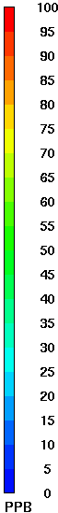
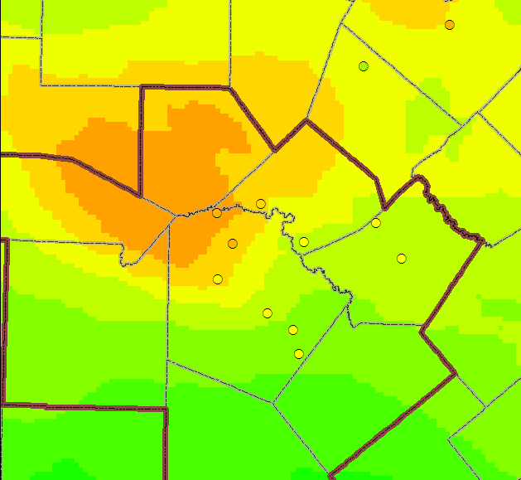
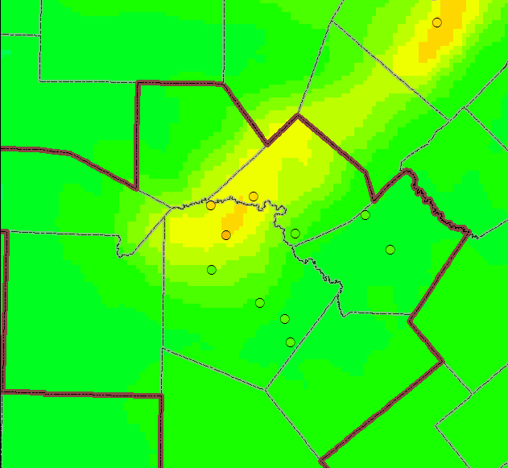
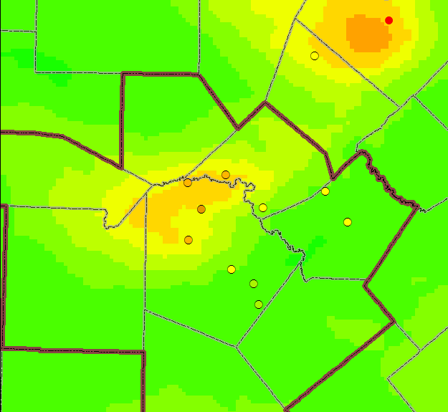
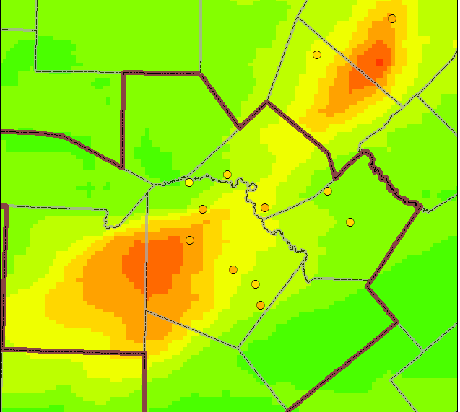
Figure 3-27: Tile Plots of Modeled Maximum 8-Hour Ozone, Base Case TCEQ Run 5 on Exceedance Days
June 3, 2006 June 8, 2006

June 7, 2006 June 9th, 2006
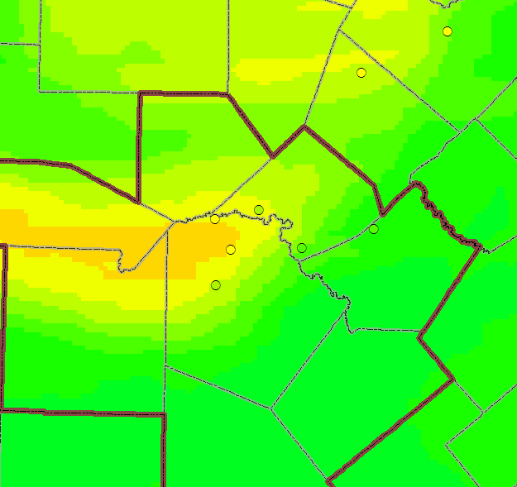
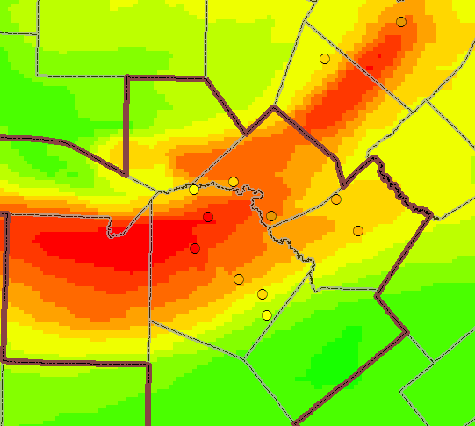
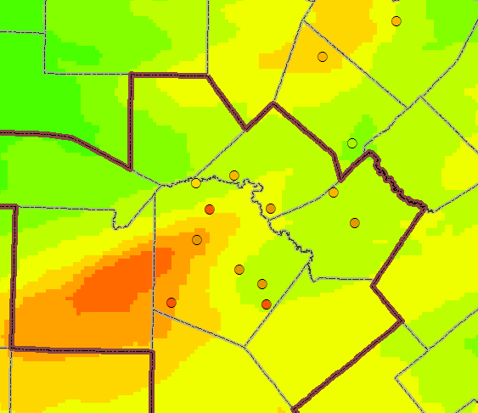
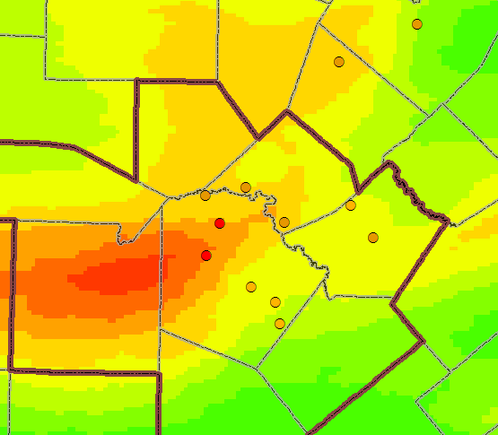
June 12, 2006 June 14, 2006

June 13, 2006 June 28, 2006
June 8th, 2006
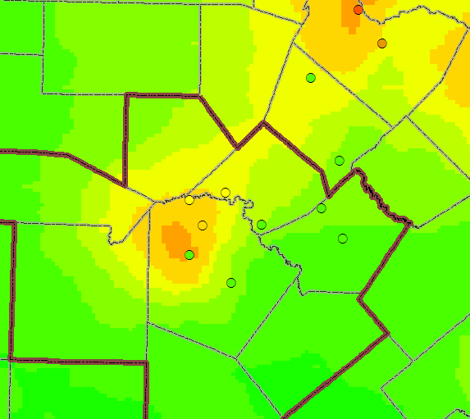
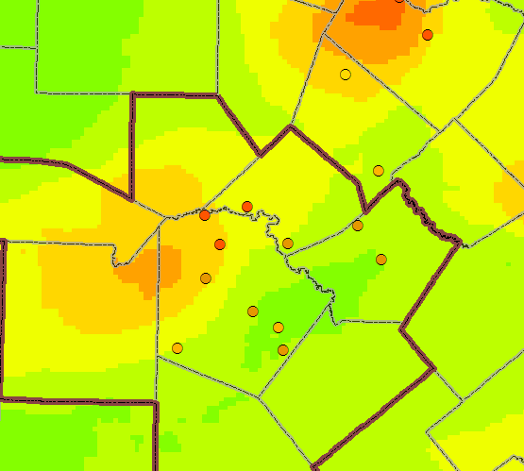
June 29, 2006 June 30, 2006

June 29th, 2006
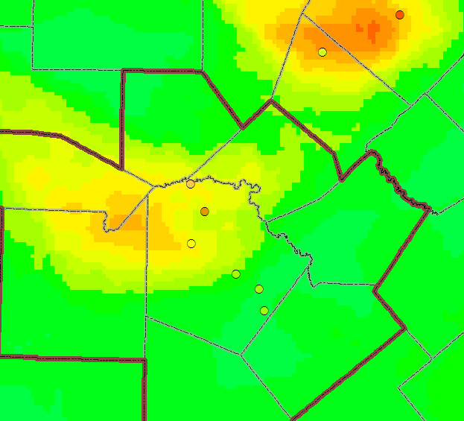
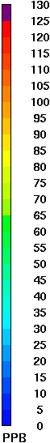
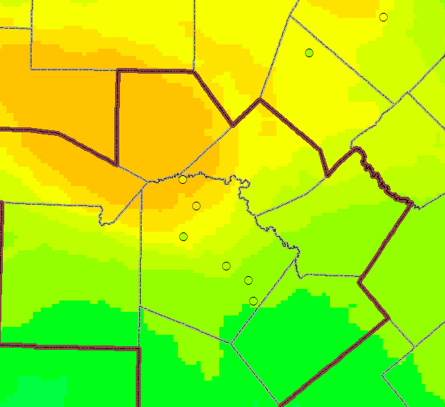
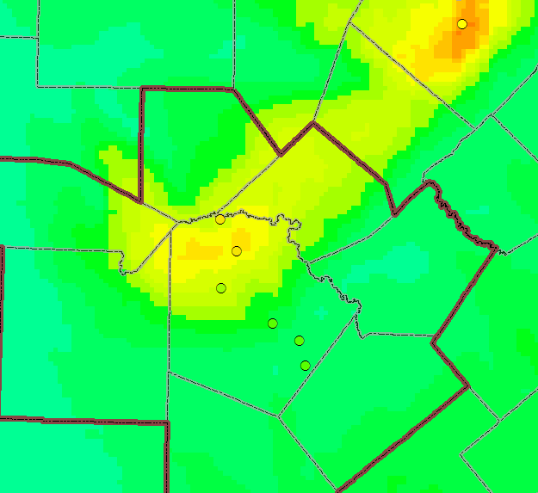
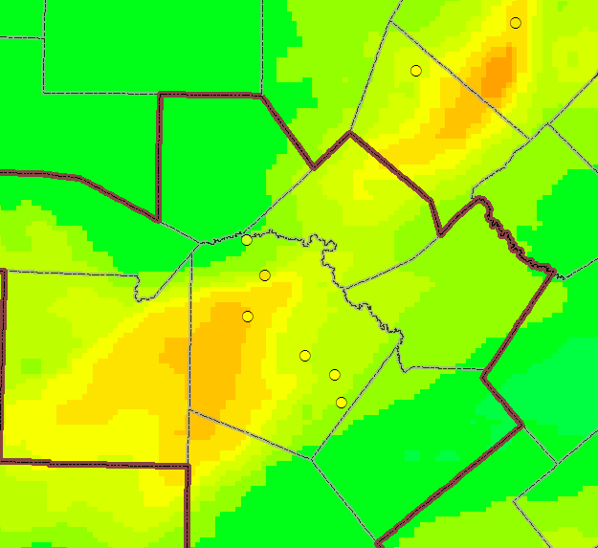
Figure 3-28: Tile Plots of Modeled Peak 1-Hour Ozone, Base Case TCEQ Run 5 on Exceedance Days
June 3, 2006 June 8, 2006

June 7, 2006 June 9, 2006
June 3rd, 2006
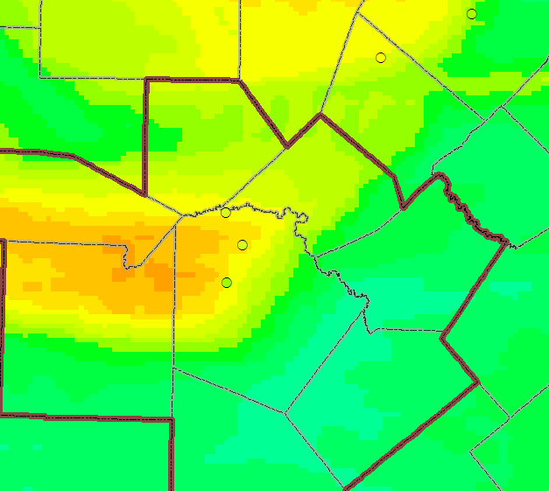
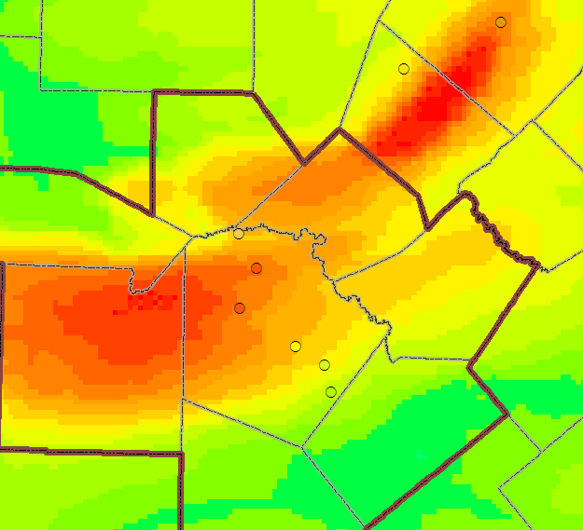
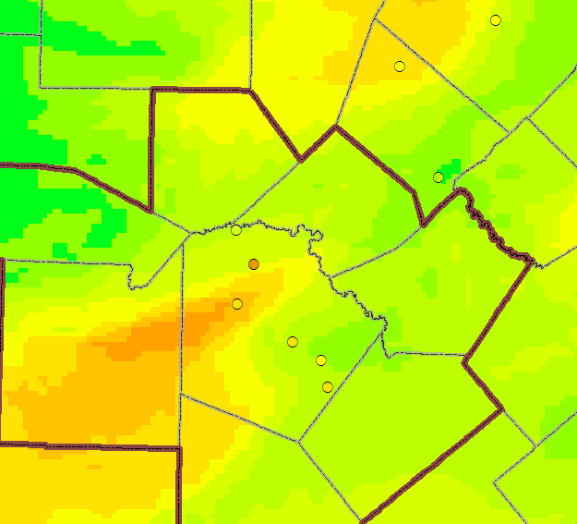
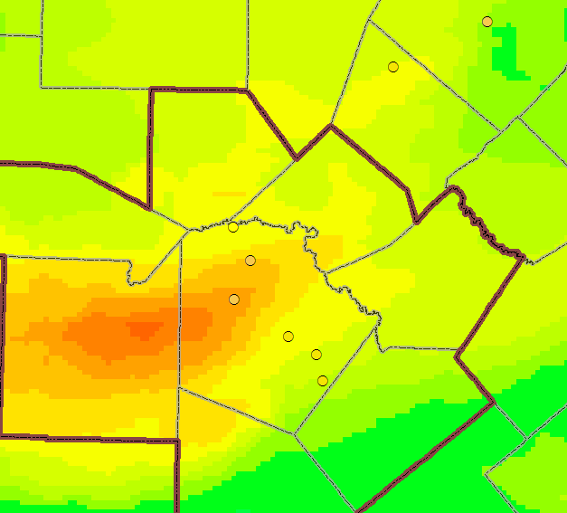
June 12, 2006 June 14, 2006

June 13, 2006 June 28, 2006
June 8th, 2006
June 12th, 2006
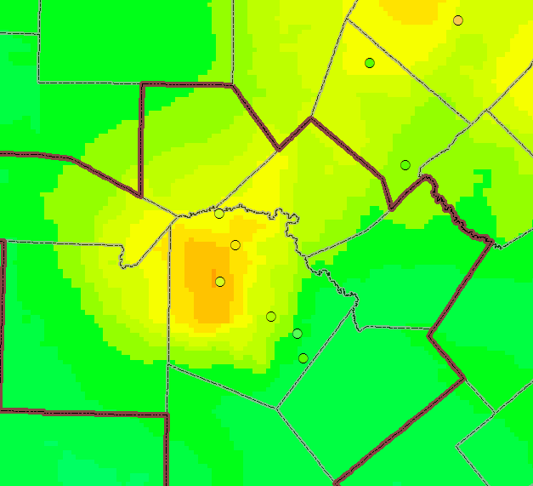
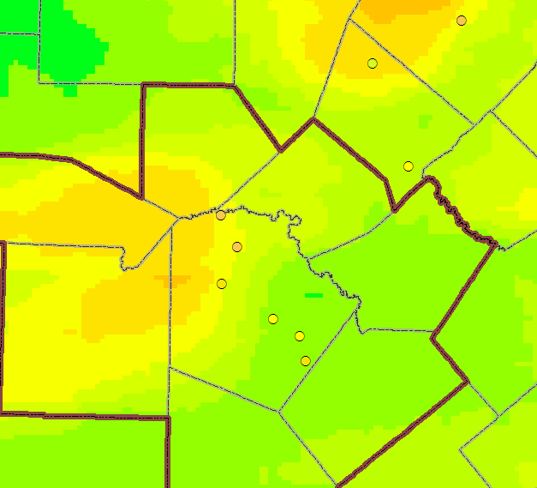
June 29, 2006 June 30, 2006

June 14th, 2006
June 29th, 2006

Table 3-6: Comparison of Observed and Modeled Daily Peak 1-hour Ozone Level within the San Antonio MSA for Base Case AACOG Run 4 and TCEQ Run 5
Modeling Day | Peak 1-hr Observed Ozone (ppb) | AACOG Run 4 |  | TCEQ Run 5
 |  | Modeled Ozone (ppb) | Diff. with Observed Value | Modeled Ozone (ppb) | Diff. with Observed Value
1-Jun-06 | 62 | 67 | 5 | 61 | -1
2-Jun-06 | 78 | 89 | 11 | 74 | -4
3-Jun-06 | 86 | 95 | 9 | 93 | 7
4-Jun-06 | 81 | 97 | 16 | 87 | 6
5-Jun-06 | 70 | 85 | 15 | 75 | 5
6-Jun-06 | 82 | 90 | 8 | 78 | -4
7-Jun-06 | 89 | 99 | 10 | 87 | -2
8-Jun-06 | 96 | 101 | 5 | 91 | -5
9-Jun-06 | 87 | 106 | 19 | 93 | 6
10-Jun-06 | 76 | 99 | 23 | 80 | 4
11-Jun-06 | 68 | 79 | 11 | 74 | 6
12-Jun-06 | 78 | 97 | 19 | 92 | 14
13-Jun-06 | 106 | 135 | 29 | 111 | 5
14-Jun-06 | 94 | 122 | 28 | 98 | 4
15-Jun-06 | 74 | 80 | 6 | 73 | -1
16-Jun-06 | 45 | 52 | 7 | 52 | 7
17-Jun-06 | 53 | 51 | -2 | 48 | -6
18-Jun-06 | 79 | 54 | -25 | 65 | -14
19-Jun-06 | 85 | 81 | -4 | 74 | -11
20-Jun-06 | 35 | 45 | 10 | 48 | 13
21-Jun-06 | 37 | 55 | 18 | 49 | 12
22-Jun-06 | 41 | 56 | 15 | 54 | 13
23-Jun-06 | 60 | 61 | 1 | 79 | 19
24-Jun-06 | 49 | 63 | 14 | 72 | 23
25-Jun-06 | 70 | 78 | 8 | 69 | -1
26-Jun-06 | 86 | 81 | -5 | 74 | -12
27-Jun-06 | 98 | 95 | -3 | 79 | -19
28-Jun-06 | 101 | 113 | 12 | 95 | -6
29-Jun-06 | 94 | 93 | -1 | 88 | -6
30-Jun-06 | 87 | 93 | 6 | 96 | 9
Avg. All Days |  |  | 8.85 |  | 2.06
Avg. on Days > 70 ppb |  |  | 8.62 |  | -1.50
Avg. on Days > 84 ppb |  |  | 8.78 |  | -2.45

Table 3-7: Comparison of Observed and Modeled Daily Maximum 8-Hour Ozone Level within the San Antonio MSA for Base Case AACOG Run 4 and TCEQ Run 5
Modeling Day | Peak 8-hr Observed Ozone (ppb) | AACOG Run 4 |  | TCEQ Run 5
 |  | Ozone (ppb) | Diff. with Observed Value | Ozone (ppb) | Diff. with Observed Value
1-Jun-06 | 56 | 62 | 6 | 55 | -1
2-Jun-06 | 66 | 72 | 6 | 62 | -4
3-Jun-06 | 80 | 84 | 4 | 86 | 6
4-Jun-06 | 73 | 79 | 6 | 75 | 2
5-Jun-06 | 63 | 70 | 7 | 63 | 0
6-Jun-06 | 68 | 79 | 11 | 70 | 2
7-Jun-06 | 76 | 89 | 13 | 76 | 0
8-Jun-06 | 84 | 84 | 0 | 78 | -6
9-Jun-06 | 77 | 95 | 18 | 83 | 6
10-Jun-06 | 71 | 89 | 18 | 73 | 2
11-Jun-06 | 64 | 71 | 7 | 66 | 2
12-Jun-06 | 70 | 84 | 14 | 78 | 8
13-Jun-06 | 93 | 119 | 26 | 97 | 4
14-Jun-06 | 90 | 107 | 17 | 88 | -2
15-Jun-06 | 69 | 75 | 6 | 69 | 0
16-Jun-06 | 35 | 48 | 13 | 47 | 12
17-Jun-06 | 44 | 43 | -1 | 40 | -4
18-Jun-06 | 71 | 47 | -24 | 54 | -17
19-Jun-06 | 65 | 69 | 4 | 62 | -3
20-Jun-06 | 29 | 38 | 9 | 38 | 9
21-Jun-06 | 32 | 46 | 14 | 42 | 10
22-Jun-06 | 36 | 48 | 12 | 47 | 11
23-Jun-06 | 50 | 48 | -2 | 66 | 16
24-Jun-06 | 45 | 53 | 8 | 56 | 11
25-Jun-06 | 65 | 68 | 3 | 66 | 1
26-Jun-06 | 78 | 68 | -10 | 65 | -13
27-Jun-06 | 88 | 86 | -2 | 71 | -17
28-Jun-06 | 90 | 103 | 13 | 84 | -6
29-Jun-06 | 91 | 80 | -11 | 79 | -12
30-Jun-06 | 71 | 77 | 6 | 81 | 10
Avg. All Days |  |  | 7.20 |  | -1.17
Avg. on Days > 60 ppb |  |  | 5.94 |  | -1.75
Avg. on Ozone Exceedance Days |  |  | 5.25 |  | -3.12

In Table 3-6 and Table 3-7, the predicted daily peak 1-hour and 8-hour ozone concentrations within the San Antonio MSA are listed for each run. There was good correlation between observed and predicted ozone on the June 3, 8, 9, 13, and 14 exceedance days. For those days, the difference between observed and predicted values for 8-hour ozone ranged between -6 ppb and 6 ppb. The model overpredicted ozone on June 28 and underpredicted ozone on June 29th for AACOG Run 4.

Model performance was improved using the latest TCEQ emission inventory with MOVES2014 in TCEQ Run 5, especially on the exceedance days of June 9, 13, 14, and 28. The 8-hour ozone on June 9 was overpredicted by 8 ppb for TCEQ Run 5. Also, there was an underprediction of ozone on June 29. Overall modeling performance was excellent for the first half of the episode and good for the second half of the episode.

Summary of CAMx Base Case Runs

R² values in AACOG Run 4 for average 8-hour ozone for all values ranged from 0.727 to 0.753, indicating a strong correlation between predicted and observed ozone data. This correlation diminishes for TCEQ Run 5 with R² values ranging between 0.716 and 0.730, which are still considered to be strongly correlated. Overall, AACOG Run 4 demonstrated the best correlation for both 1-hour and 8-hour ozone concentrations. For hourly ozone prediction, performance was slightly inferior for TCEQ Run 5. The performance for hourly ozone values for all monitors, C23 and C58 was poorer for 1-hour values and on days > 60 ppb. These results indicate infrequent high-ozone values days in the San Antonio area, highlighting the episodic nature of high-ozone days in this region.

Model performance was poor for the C58 NO_{X} monitor in northwest San Antonio with an R² value between 0.116 and 0.131. The model significantly overpredicted NO_{X} at C58 during most days of the modeling episode. Model performance was slightly improved at C59 and C622 with good performance at C678. TCEQ Run 5 had a better performance at C58, but degraded performance at the other monitors.

The only exceedance day on which AACOG Run 4 noticeably failed to meet the EPA recommended value for mean normalized bias was on June 12. Every exceedance day exhibited normalized error within EPA recommended levels. Both base case modeling runs exhibited similar performance for peak error and normalized error and significantly different results for Unpaired Peak Prediction Accuracy during exceedance days. Normalized error on exceedance days was well below EPA’s recommendation of 35 percent. TCEQ Run 5 showed improved results as compared to the AACOG Run 4 for the first half of the month. When statistical analysis was performed on data for individual monitors, model performance showed the results for unpaired peak accuracy were very good for C23, C678, C505, and C503 and the remaining monitors also met EPA recommended guidelines. Normalized error values for all days and on exceedance days were well below EPA’s recommendation of 35 percent. The results of AACOG Run 4 and TCEQ Run 5 demonstrated a good modeling performance overall, with the best performance for normalized error at every monitor.

The tile plots indicated that there were no unusual patterns of ozone formation. As seen on the plots for ozone exceedance days, ozone plumes were produced in the urban core areas of San Antonio and Austin and mainly along the I-35 corridor. These urban plumes were predicted for each urban core and downwind areas of the cities. The daily tile plots for all days indicate good correlation between predicted and observed ozone values, for the exception of June 9 and June 12 when the predicted ozone levels for C23 are overestimated and the ozone plumes are located outside of the urban core. Also, for the June 29 the predicted ozone levels are on the lower ranges of observed values. Ozone was underpredicted at all monitors in San Antonio on June 29. In addition on June 30, the model underpredicted the ozone level for C23, but accurately predicted the ozone level on the rest of the monitors.

Future Year Modeling

The photochemical model developed to simulate the June 2006 high-ozone episode was updated with 2012 and 2018 projected anthropogenic emission inventories to estimate predicted future ozone concentrations under the same meteorological conditions as the 2006 base case. The projected emission inventories account for existing local, state, and federal air quality control strategies to determine whether such measures are sufficient to help the region meet the revised NAAQS 8-hour ozone standard. The 2018 projection cases were compared to the 2012 projection cases to determine future ozone design values.

Projections Cases
A total of 6 projection cases were developed from the June 2006 modeling episode. An addition projection case (Projection Case 1: AACOG EI, MOVES2010b) is provided in the results for comparison purposes.

Projection Case 2: 2012 with only TCEQ existing Emission Inventory (TCEQ EI MOVES2014)
- WRF v3.2
- RPO Grid
- CAMx 6.00
- EPS3 version 1
- Local 2012 San Antonio-New Braunfels MSA emission data including construction equipment, landfill equipment, quarry equipment, agricultural tractors, combines, commercial airports, point sources, and heavy duty truck idling
- Updated 2012 CAPCOG and Milam counties emission inventory including construction and mining equipment, industrial equipment, oil and gas equipment, agricultural equipment, commercial fuel consumption, industrial fuel consumption, Austin-Bergstrom International Airport, residential lawn and garden equipment, heavy duty truck idling, EGU, and NEGU
- MOVES2010a HPMS on-road emission inventories for all areas

Projection Case 3: 2012 with TCEQ Emission Inventory (TCEQ and AACOG EI)
- WRF v3.2
- RPO Grid
- CAMx 6.00
- EPS3 revision 2
- TCEQ 2012 Emission Inventory for the 4-km Grid
- Projected 2012 Emission Inventory by AACOG for the 12-km and 36-km grids
- MOVES2014 HPMS on-road emission inventories for the 4-km grid
- MOVES2010a HPMS on-road emission inventories for the 12-km and 36-km grid

Projection Case 4: 2012 with TCEQ Emission Inventory and Local Data (AACOG EI, MOVES2014)
- WRF v3.2
- RPO Grid
- CAMx 6.00
- EPS3 revision 2
- TCEQ 2012 Emission Inventory for all grids
- Local 2012 San Antonio-New Braunfels MSA emission data including construction equipment, landfill equipment, quarry equipment, agricultural tractors, combines, commercial airports, point sources, and heavy duty truck idling
- Updated 2012 CAPCOG and Milam counties emission inventory including construction and mining equipment, industrial equipment, oil and gas equipment, agricultural equipment, commercial fuel consumption, industrial fuel consumption, Austin-Bergstrom International Airport, residential lawn and garden equipment, heavy duty truck idling, EGU, and NEGU
- MOVES2014 HPMS on-road emission inventories for all grids

Projection Case 2: 2018 with only TCEQ existing Emission Inventory (TCEQ EI MOVES2014)
- WRF v3.2
- RPO Grid
- CAMx 6.00
- EPS3 version 1
- MOVES2010a HPMS on-road emission inventories for all areas
- Local 2018 San Antonio-New Braunfels MSA emission data including construction equipment, landfill equipment, quarry equipment, agricultural tractors, combines, commercial airports, point sources, and heavy duty truck idling
- Updated 2018 CAPCOG and Milam counties emission inventory including construction and mining equipment, industrial equipment, oil and gas equipment, agricultural equipment, commercial fuel consumption, industrial fuel consumption, Austin-Bergstrom International Airport, residential lawn and garden equipment, heavy duty truck idling, EGU, and NEGU
- MOVES2010a HPMS on-road emission inventories for all areas

Projection Case 3: 2018 with projected Emission Inventory and Local Data (TCEQ and AACOG EI)
- WRF v3.2
- RPO Grid
- CAMx 6.00
- EPS3 revision 2
- TCEQ 2018 Emission Inventory for the 4-km Grid
- Projected 2018 Emission Inventory by AACOG for the 12-km and 36-km grids
- MOVES2014 HPMS on-road emission inventories for the 4-km grid
- MOVES2010a HPMS on-road emission inventories for the 12-km and 36-km grid

Projection Case 4: 2018 with TCEQ Emission Inventory and Local Data (AACOG EI, MOVES2014)
- WRF v3.2
- RPO Grid
- CAMx 6.00
- EPS3 revision 2
- TCEQ 2018 Emission Inventory for all grids
- Local 2018 San Antonio-New Braunfels MSA emission data including construction equipment, landfill equipment, quarry equipment, agricultural tractors, combines, commercial airports, point sources, and heavy duty truck idling
- Updated 2018 CAPCOG and Milam counties emission inventory including construction and mining equipment, industrial equipment, oil and gas equipment, agricultural equipment, commercial fuel consumption, industrial fuel consumption, Austin-Bergstrom International Airport, residential lawn and garden equipment, heavy duty truck idling, EGU, and NEGU
- MOVES2014 HPMS on-road emission inventories for all grids

Tile Plots – Ozone Concentration: 2012, and 2018
Tile plots can be used as a means of determining if there is a potential spatial error in the input data. The plots are visual representations of the model output, displaying ozone concentrations by hour for the episode day or the maximum ozone by day. The following 4-km grid 8-hour daily maximum ozone tile plots represent comparisons between the model results for 2006 Baseline, 2012 Projection Case 1 and 2018 Projection Case 1 for each day used to calculate the future modeling design value (Figure 4-1).

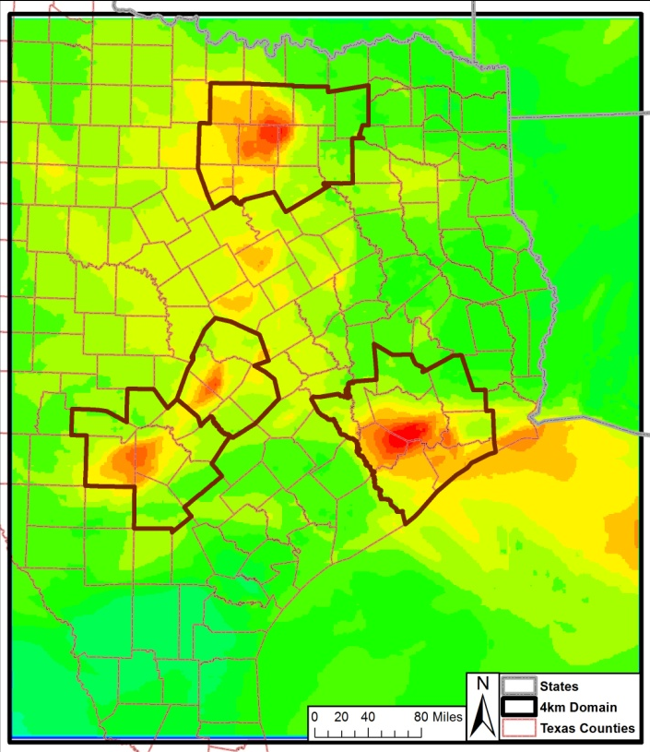
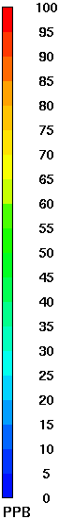
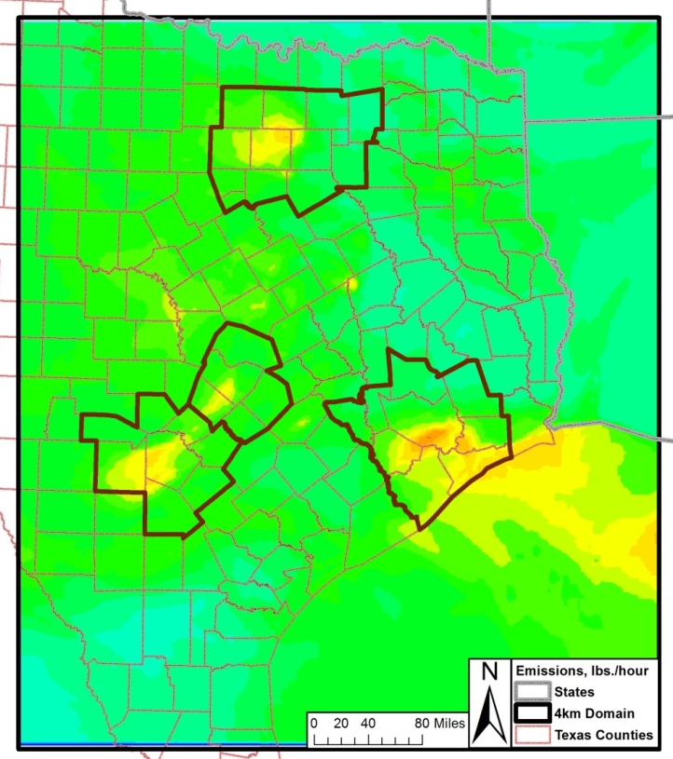
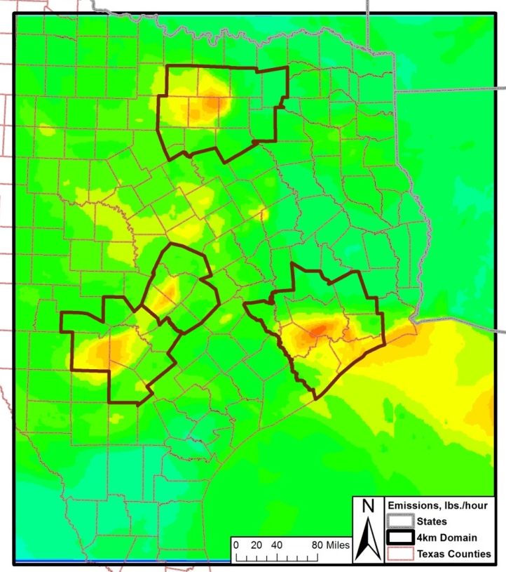
Figure 4-1: Predicted Daily Maximum 8-Hour Ozone Concentrations in the 4-km Subdomain, 2006, 2012 Projection Case 1 and 2018 Projection Case 1
2006, June 3 2012, June 3 2018, June 3

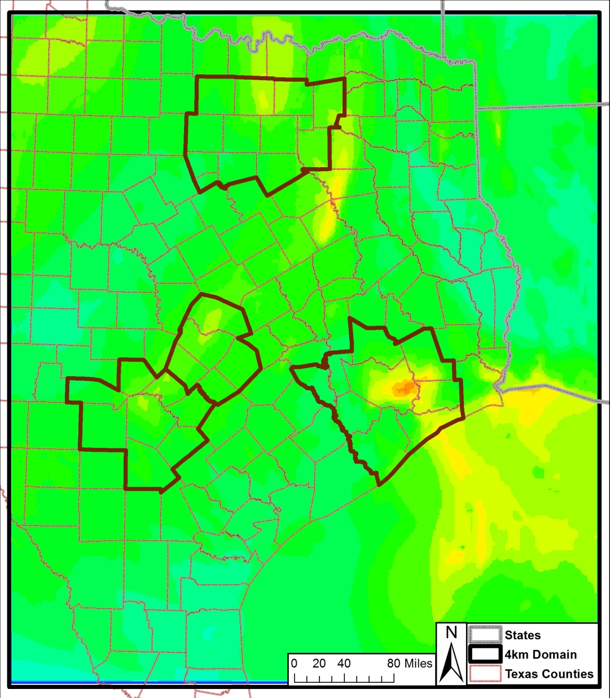
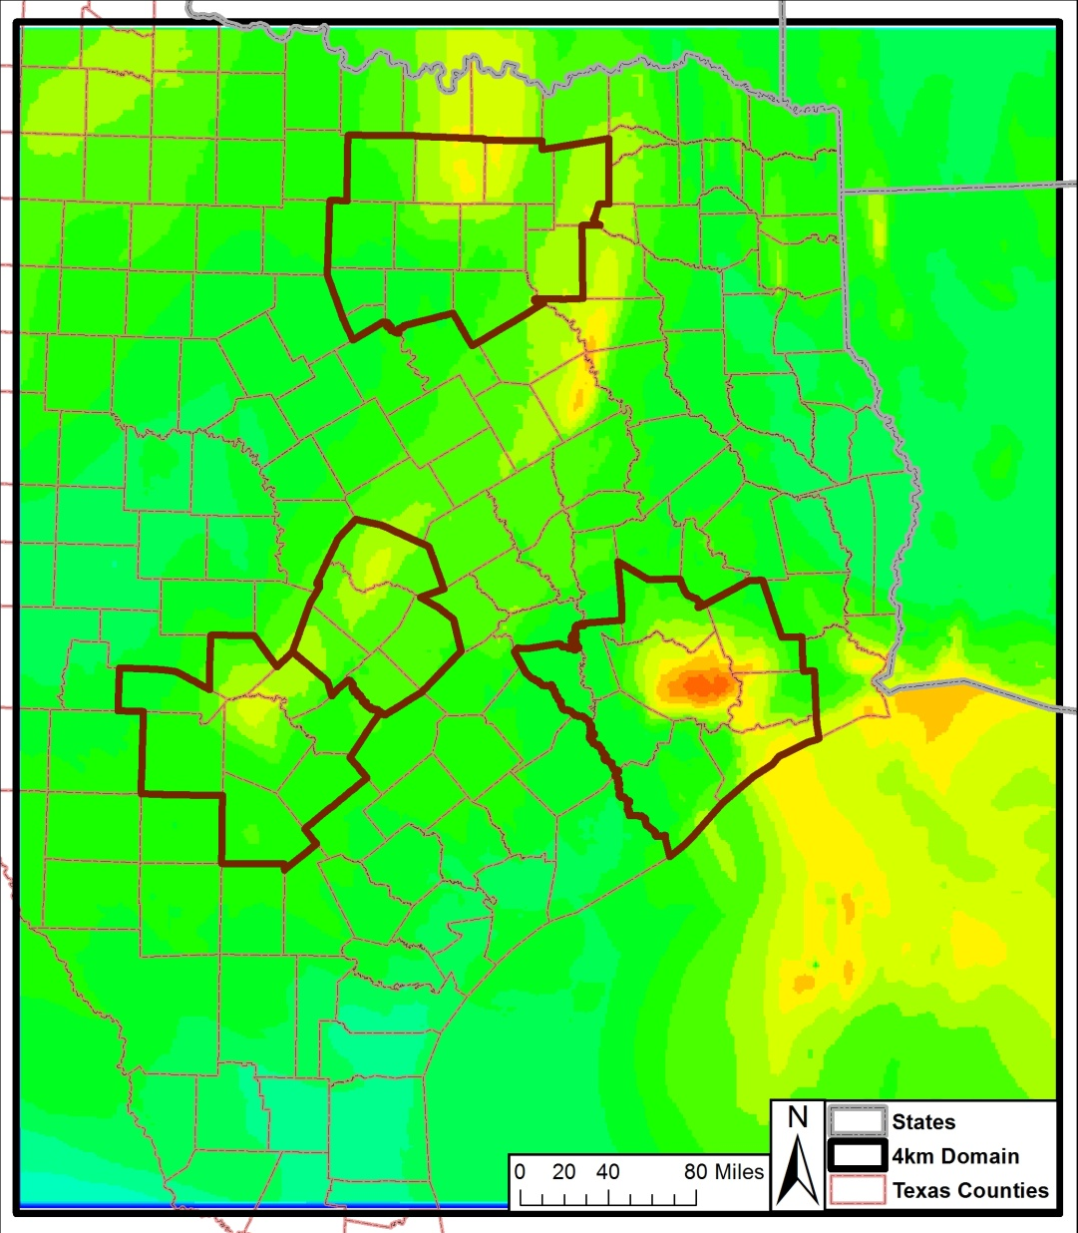
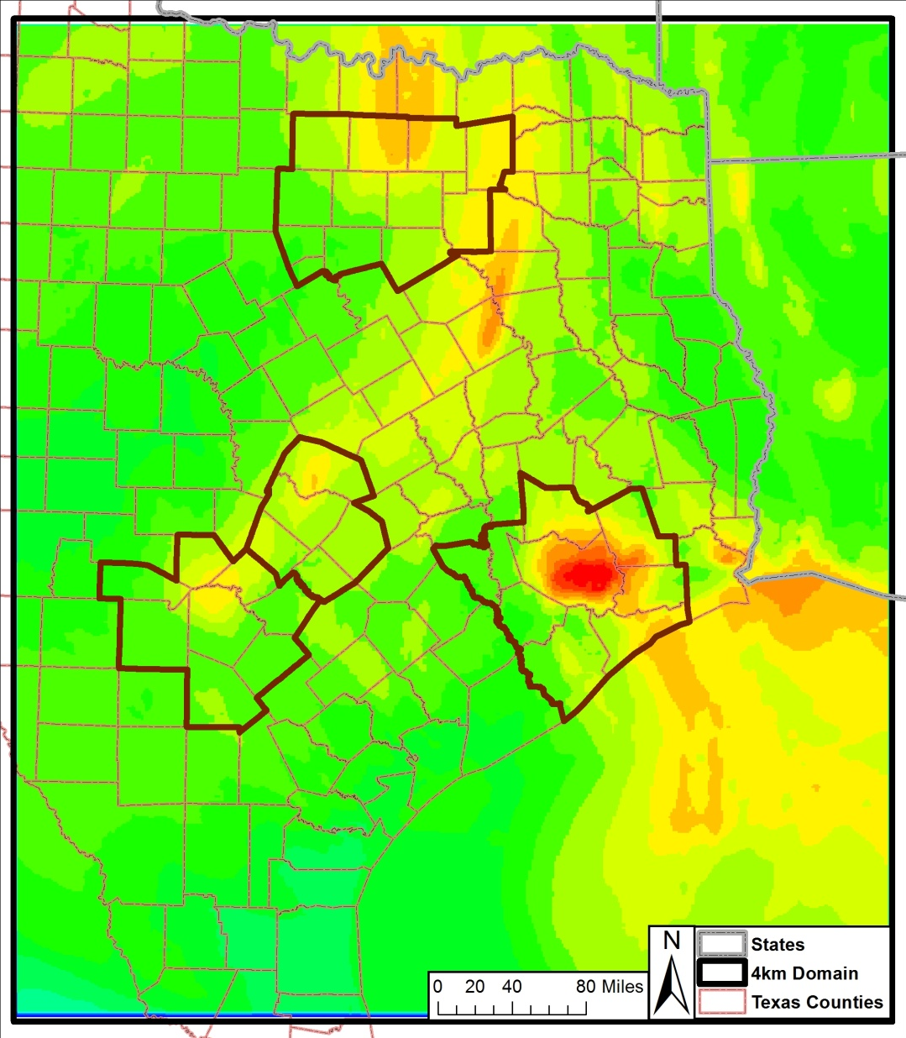
2006, June 4 2012, June 4 2018, June 4

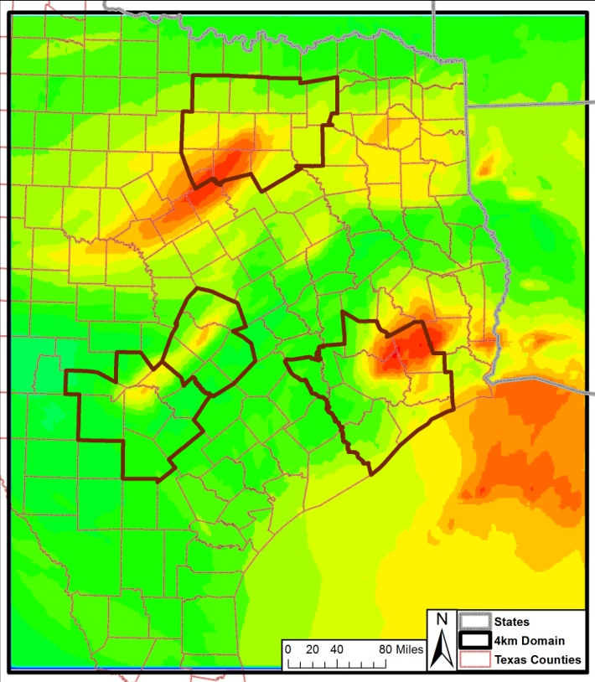
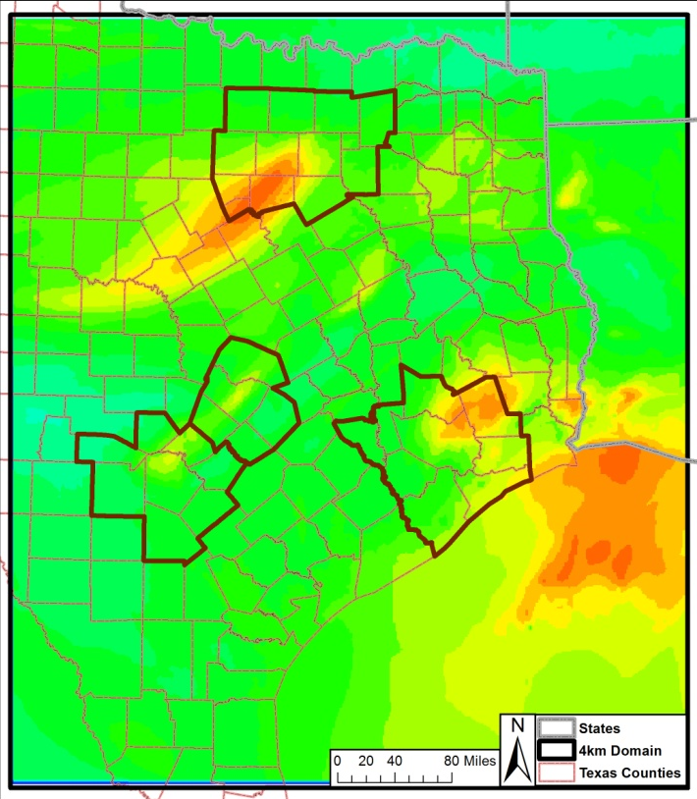
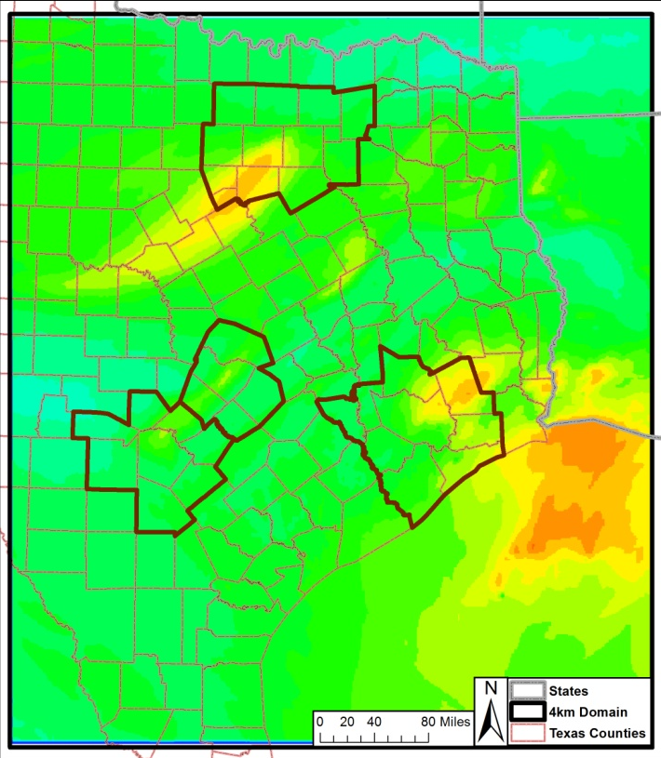
2006, June 7 2012, June 7 2018, June 7

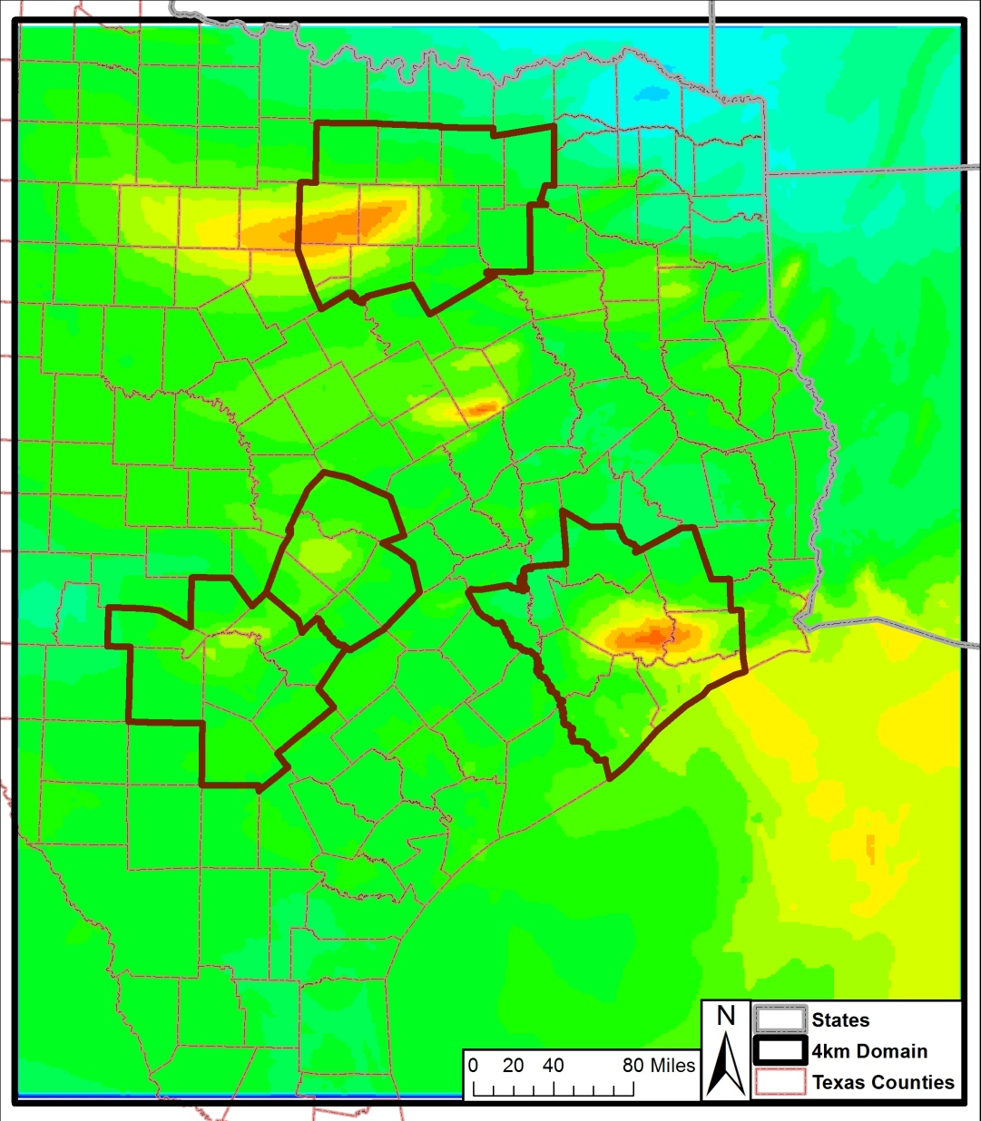
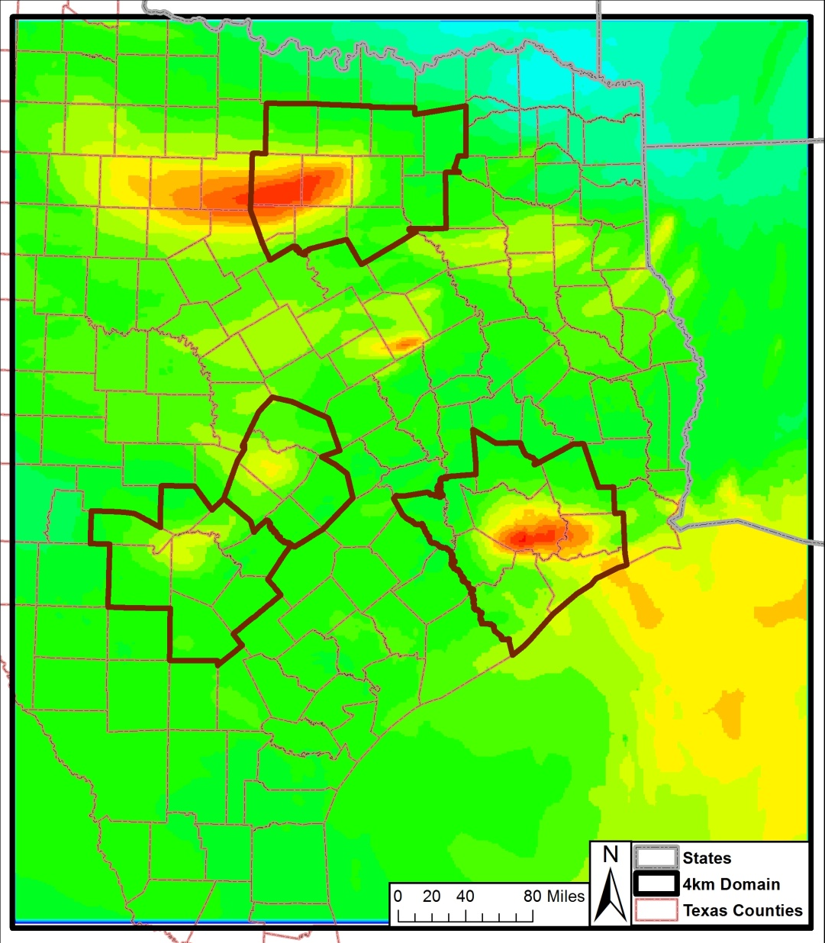
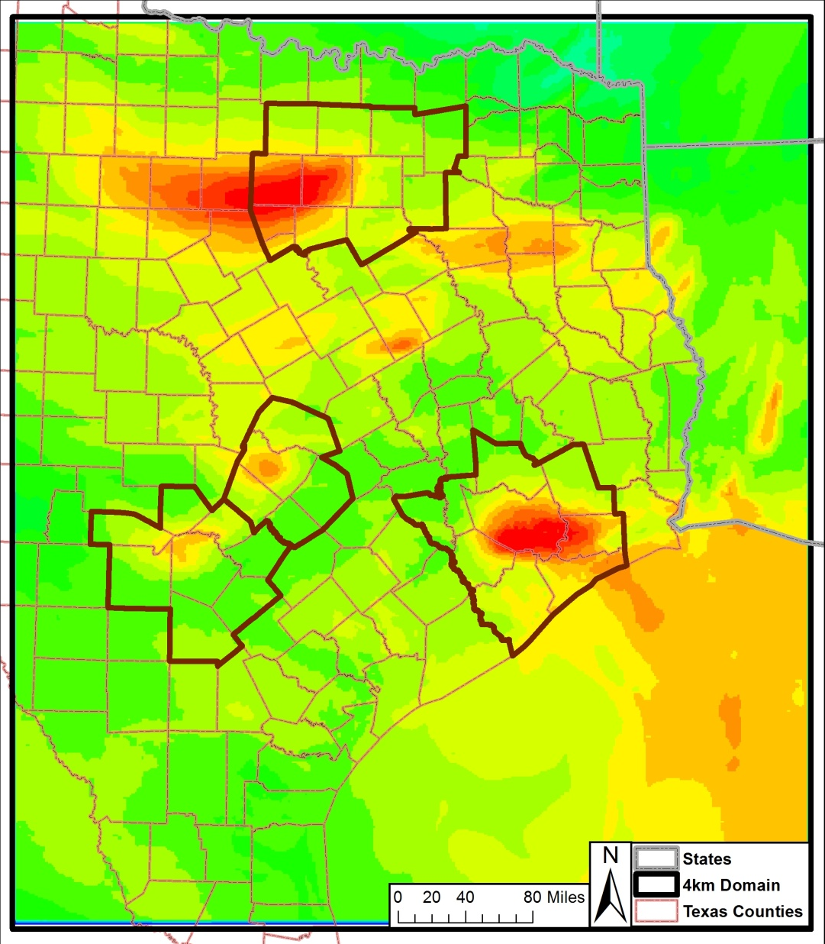
2006, June 8 2012, June 8 2018, June 8

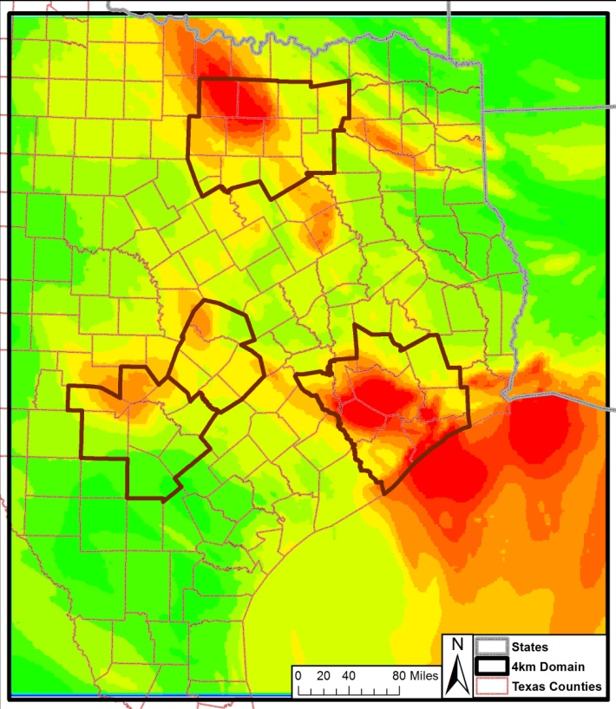
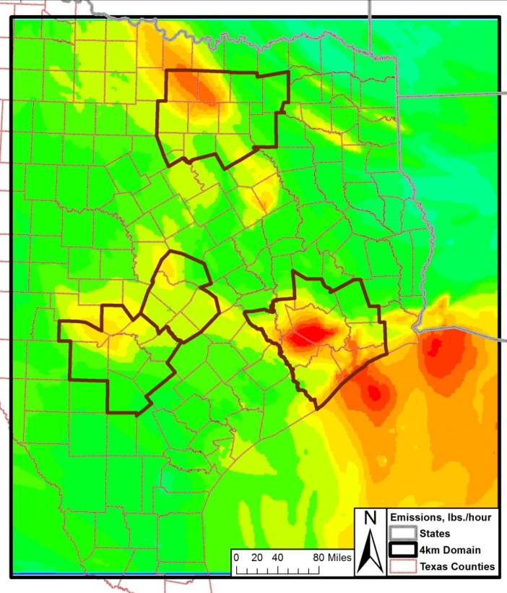
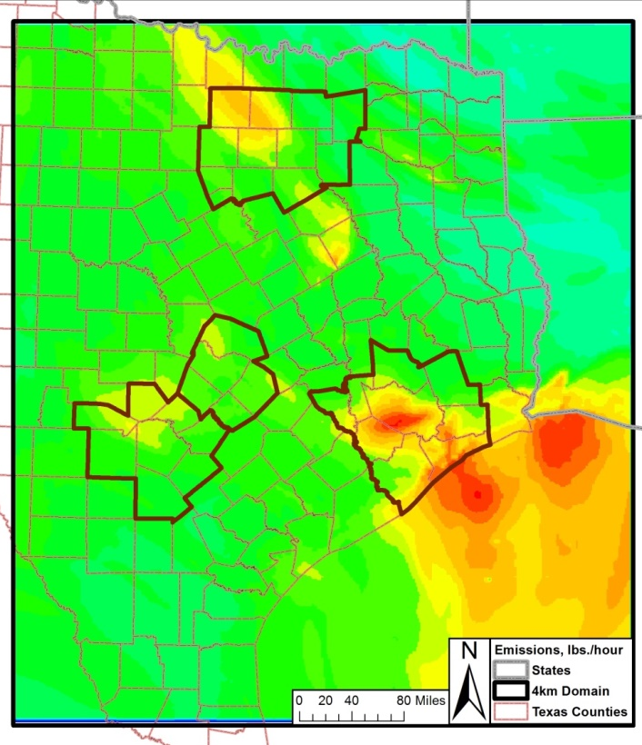
2006, June 9 2012, June 9 2018, June 9

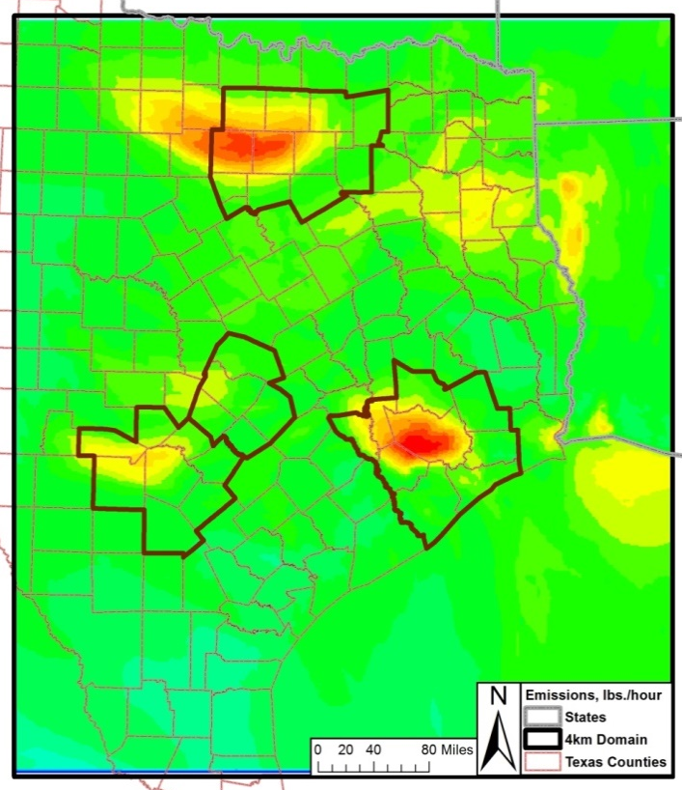
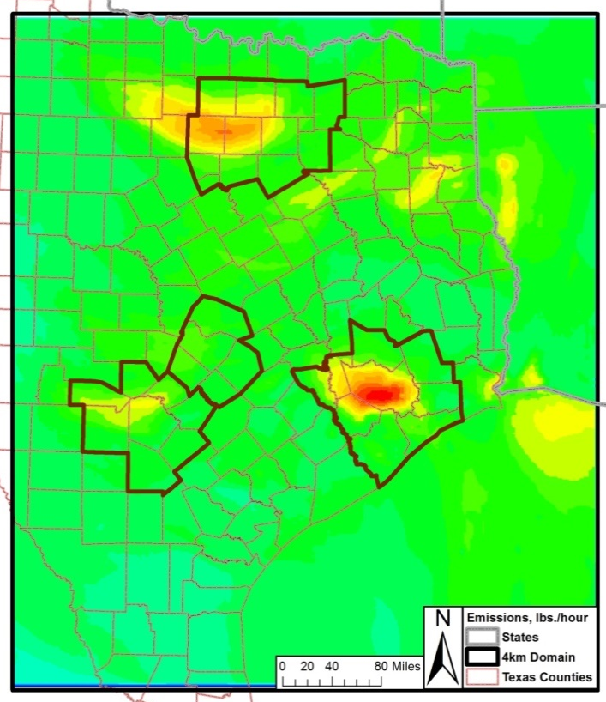
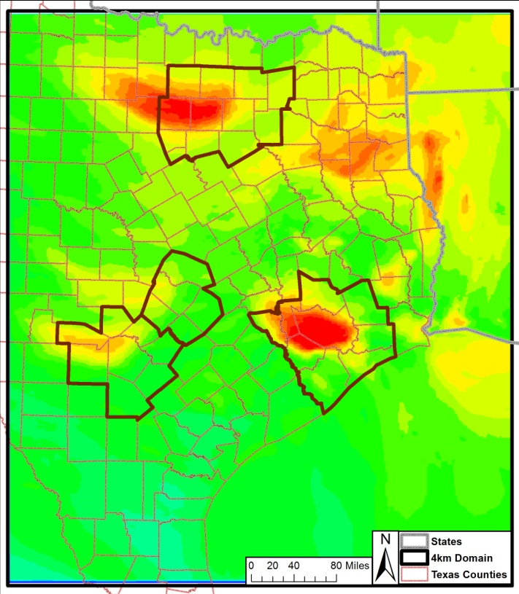
2006, June 12 2012, June 12 2018, June 12

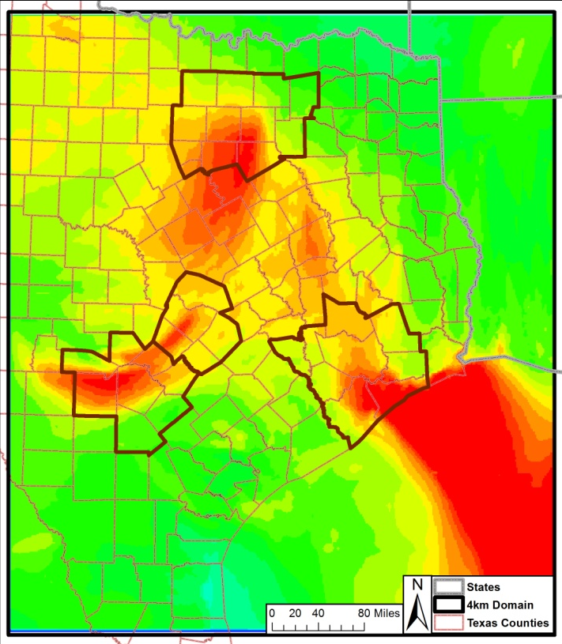
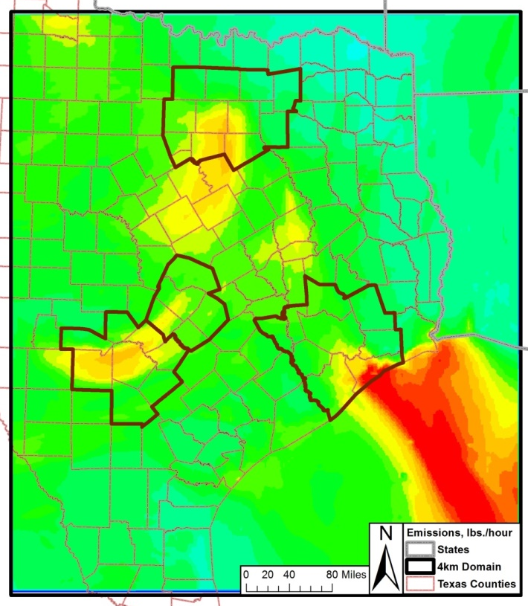
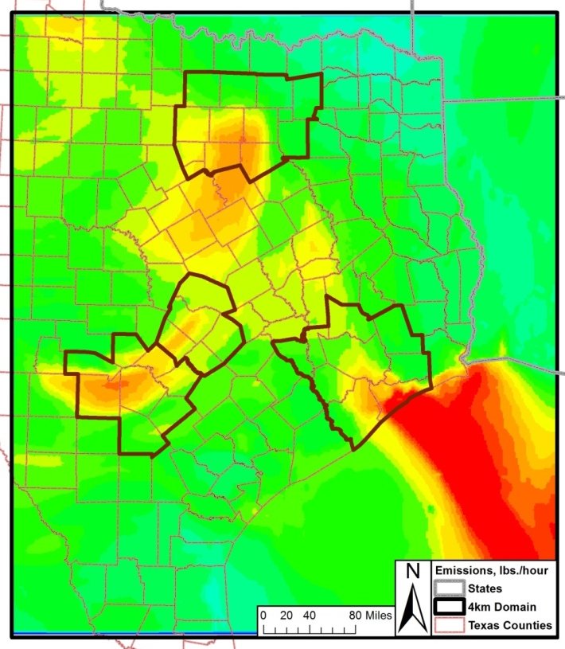
2006, June 13 2012, June 13 2018, June 13

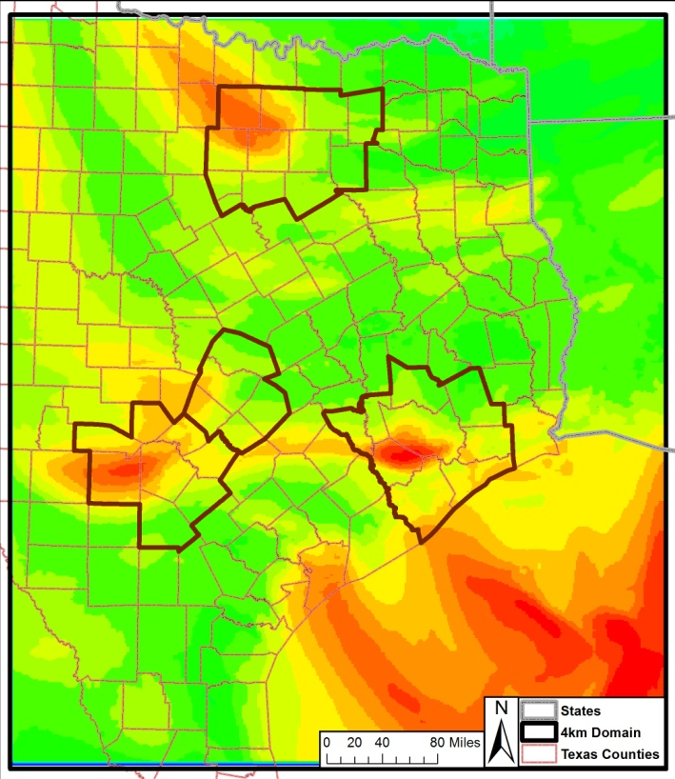
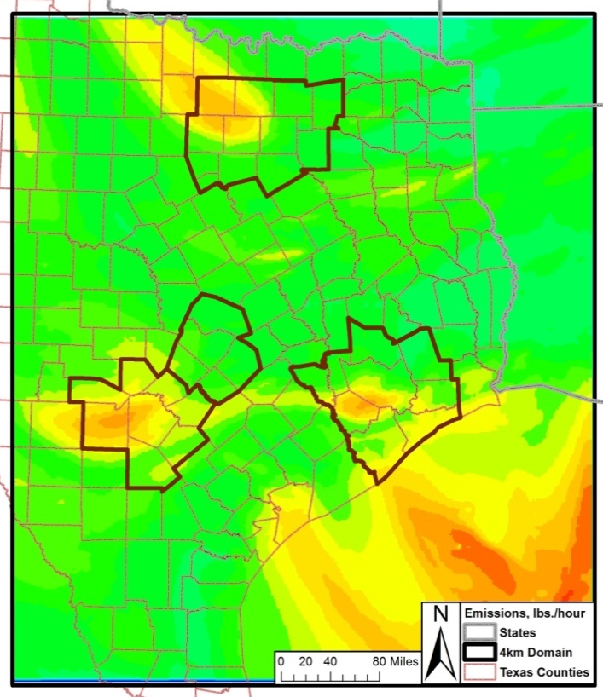
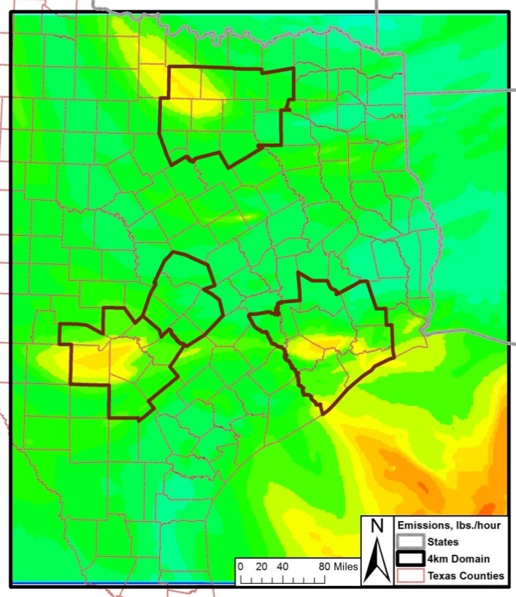
2006, June 14 2012, June 14 2018, June 14

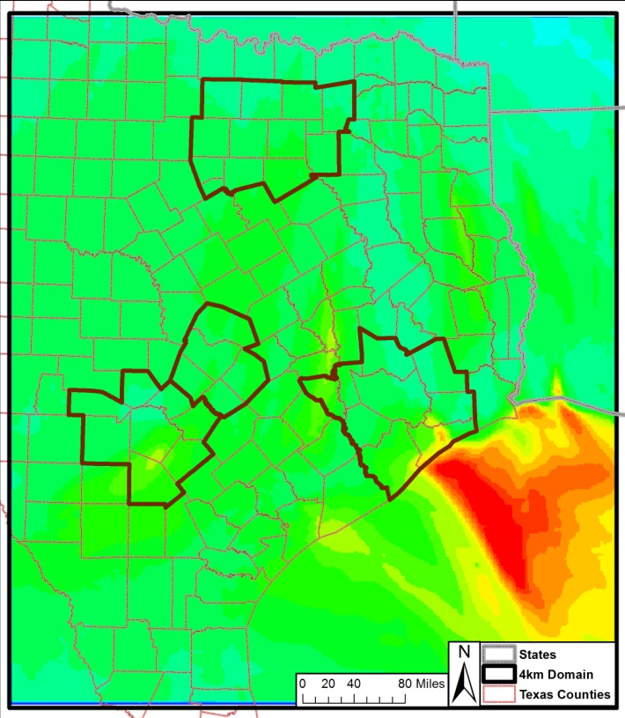
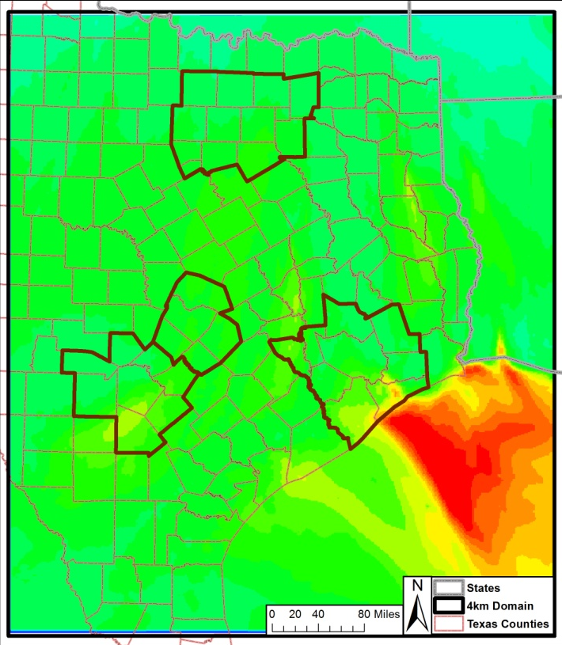
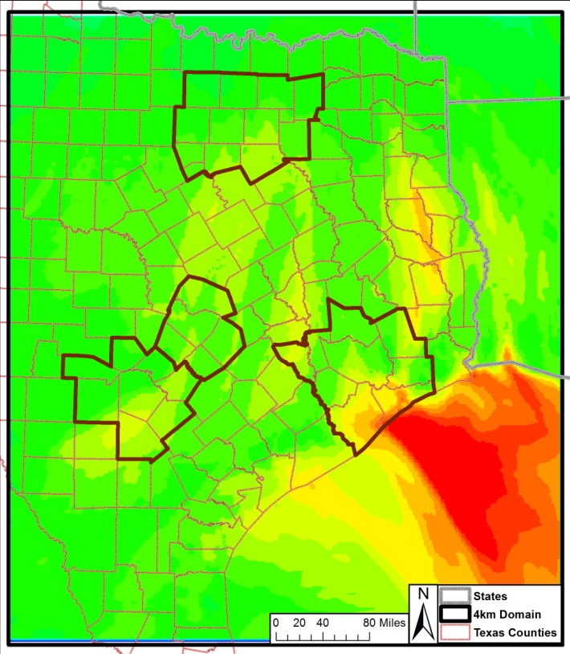
2006, June 25 2012, June 25 2018, June 25
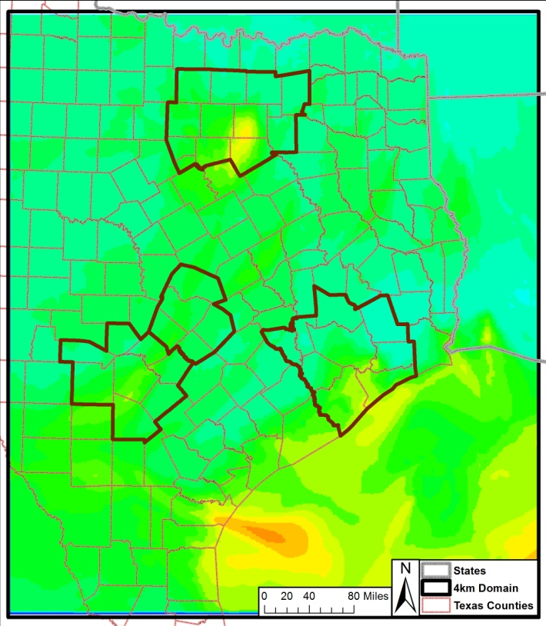
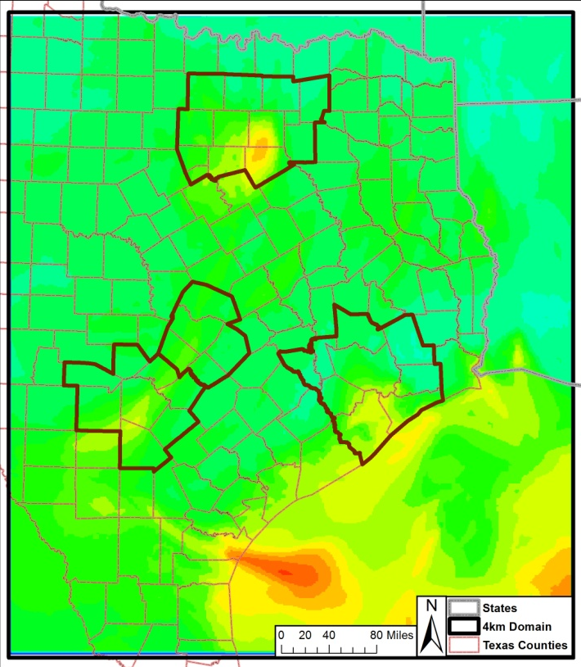
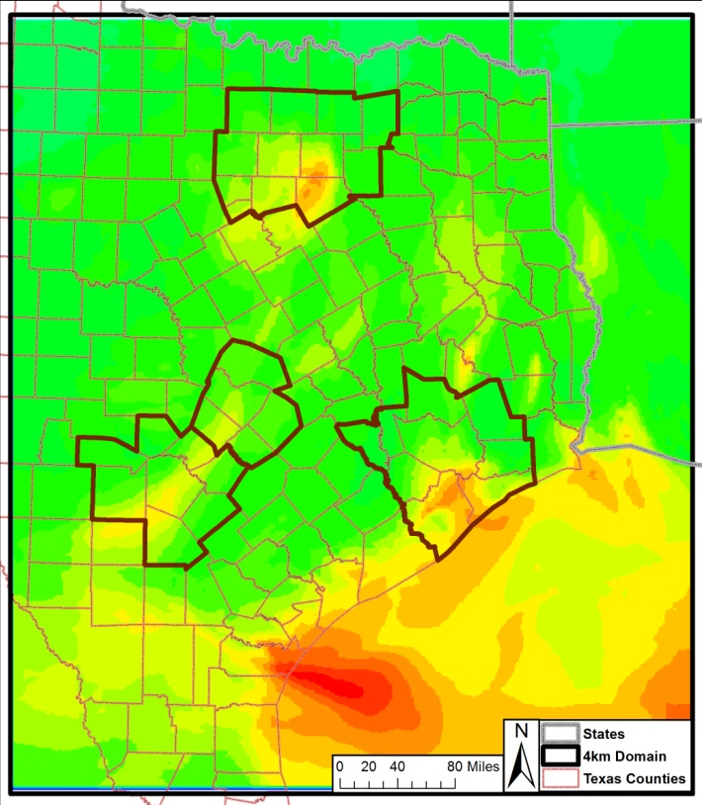
2006, June 27 2012, June 27 2018, June 27
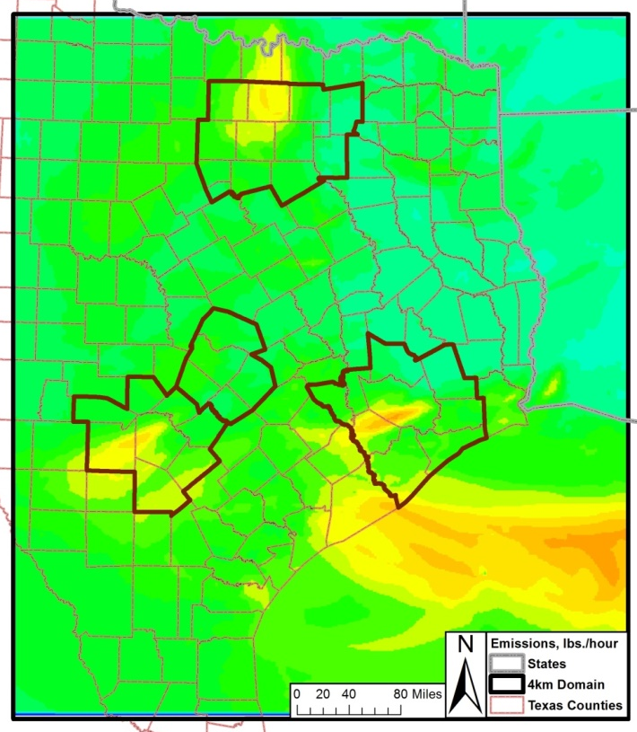
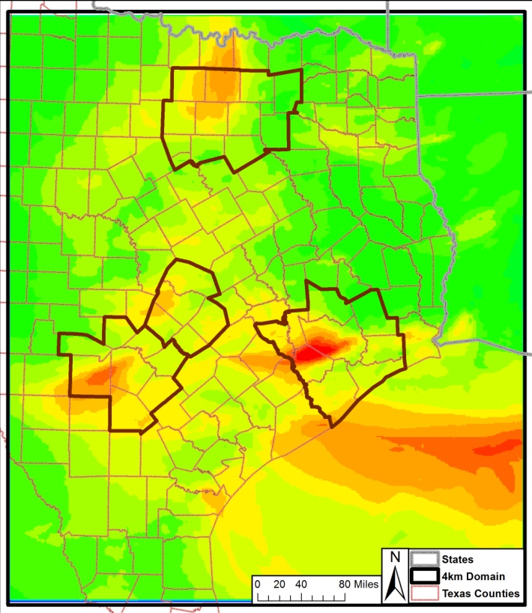
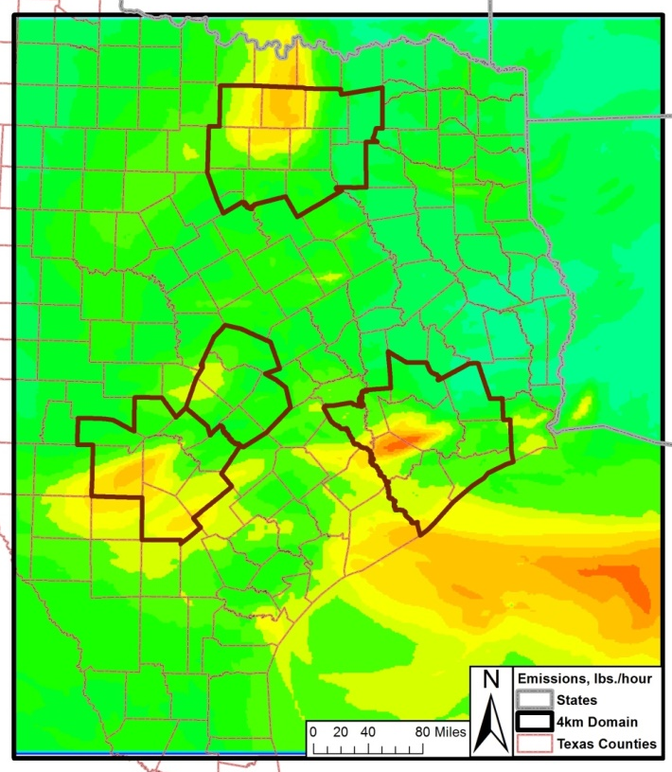
2006, June 28 2012, June 28 2018, June 28

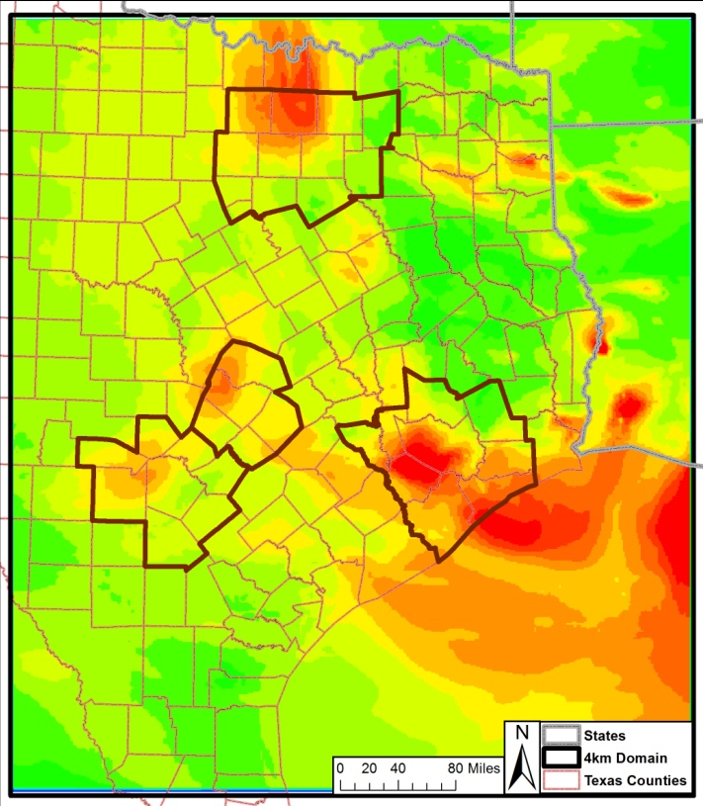
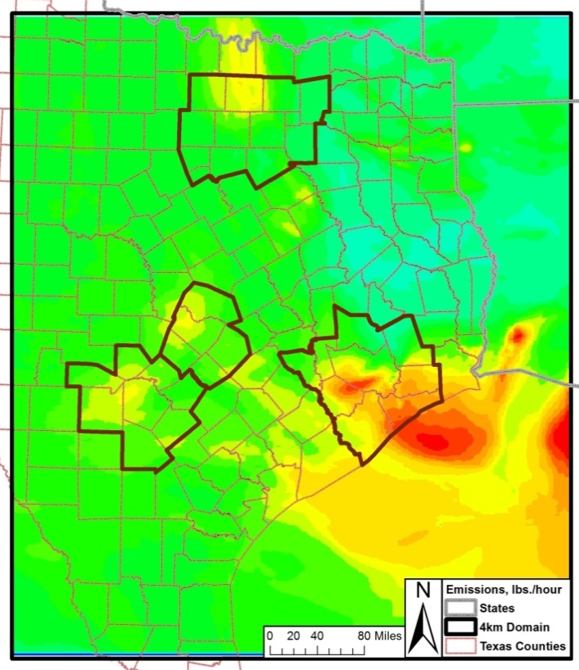
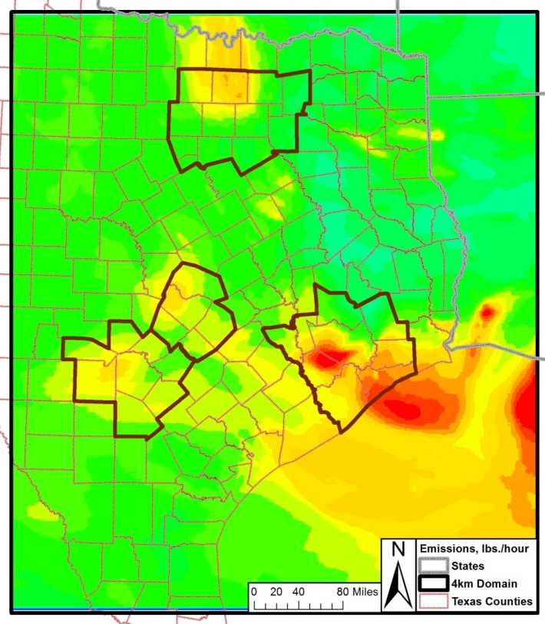
2006, June 29 2012, June 29 2018, June 29

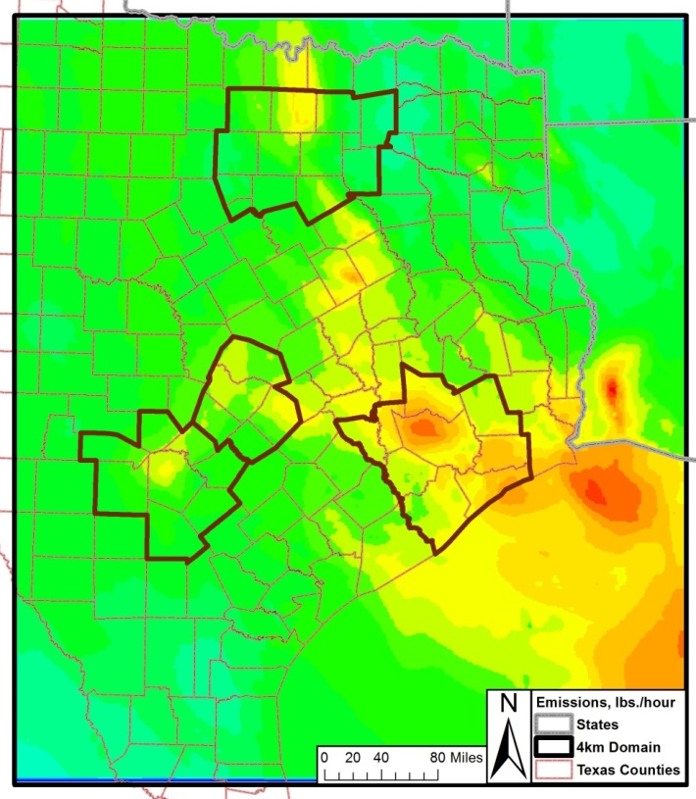
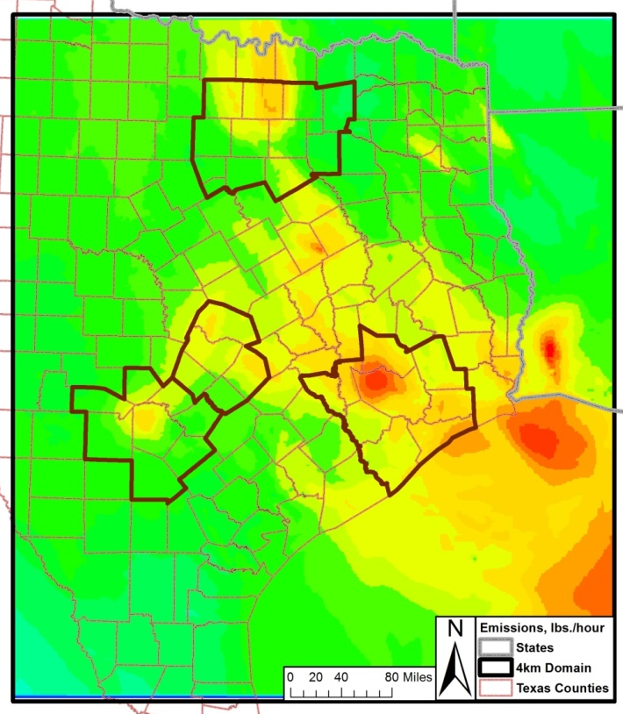
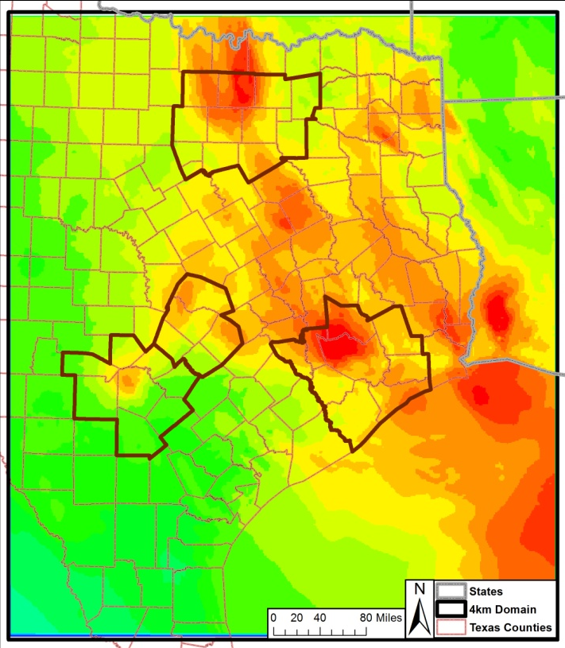
2006, June 30 2012, June 30 2018, June 30

Peak ozone concentrations are predicted downwind of city centers and major point sources in these tile plots. In addition, the overall reduction in total NO_{X} and VOC emissions (local and regional) between 2006 and 2018 diminishes the magnitude of the urban plumes in the 2018 projections.

Although there is an overall reduction of ozone used to predict the future design value in the San Antonio-New Braunfels MSA during 2006 and 2018, significant transport still occurs. On the June 14 tile plots, Houston’s elevated ozone plume can be observed reaching the San Antonio-New Braunfels MSA. Although the concentration of the Houston plume diminishes between the 2006 and 2018 model runs, the tile plots indicate the 8-hour ozone levels in the 2018 scenario remain above 65 ppb. A similar pattern occurs on June 3 and 13 (for 2006, 2012, and 2018) where the Austin plume may have an impact on ozone levels in the San Antonio-New Braunfels MSA. Further analysis of the Austin ozone plume should be conducted through photochemical model Anthropogenic Precursor Culpability Assessment (APCA) run to determine the potential impact..

Modeled Attainment Demonstration
The modeled attainment demonstration at San Antonio-New Braunfels MSA’s regulatory sited monitors was conducted by completing a series of steps that are described in the EPA Guidance on the Use of Models. Two procedures were used to perform the model attainment demonstration: “…a) analyses which estimate whether a set of simulated emissions reductions will result in ambient concentrations that meet the NAAQS and b) an identified set of control measures which will result in the required emissions reductions”.

To determine if a regulatory monitor meets the NAAQS, three calculations were performed:

- Determine the base five-year weighted modeling site-specific design value (DV),
- Calculate the daily relative response factor, and
- Calculation the future site-specific design values.

“The base design value for each monitoring site is the anchor point for estimating future year projected concentration”. Three time periods were used to determine the baseline DVs needed for future year projections. The time periods fell between 2010 and 2014, representing a five-year period based around the 2012 model year. Using Equation 4-1, the average of the 4th highest value (Table 4-1) at each regulatory sited monitor in the San Antonio-New Braunfels MSA was calculated for each of the following periods: 2010-2012, 2011-2013, and 2012-2014. The periods are referred to as 2012, 2013 and 2014 respectively.

Equation 4-1, the Design Value
(DV)_{I} = [(OZONE)_{1.I} + (OZONE)_{2.I} + (OZONE)_{3.I}] / 3

Where,
(DV)_{I} = the baseline ozone modeling DV at site I (ppb)
(OZONE)_{1.I} = the 4th highest ozone for Year 1 at site I (ppb)
(OZONE)_{2.I} = the 4th highest ozone for Year 2 at site I (ppb)
(OZONE)_{3.I} = the 4th highest ozone for Year 3 at site I (ppb)

Sample Equation: the 2012 Design Value for C58
(DV)_{I} = [(78 ppb) + (75 ppb) + (87 ppb)] / 3
= 80 ppb design value at C58

Table 4-1: 4th Highest Ozone Value at Each Regulatory Sited Ozone Monitor in the San Antonio-New Braunfels MSA, 2010-2014
Monitoring Site | 2010 | 2011 | 2012 | 2013 | 2014
CAMS 23 | 72 | 79 | 81 | 76 | 69
CAMS 58 | 78 | 75 | 87 | 83 | 72
CAMS 59 | 67 | 71 | 70 | 69 | 63
CAMS 622 | 69 | 79 | 74 | 73 | 70
CAMS 678 | 64 | 75 | 70 | 76 | 69
Bolded numbers represent values that exceed the 70 ppb standard

The baseline ozone modeling design value was calculated using Equation 4-2. As determined by the EPA, the average DV methodology “has the desired effect of weighting the projected ozone base design values towards the middle year of a five year period”. “The 5-year weighted average value establishes a relatively stable value that is weighted towards the emissions and meteorological modeling year”.

Equation 4-2, the Baseline Design Site-Specific Modeling Design Value
(DVB)_{I} = [(DV 2012)_{I} + (DV 2013)_{I} + (DV 2014)_{I}] / 3

Where,
(DVB)_{I} = the baseline ozone modeling DV at site I (ppb)
(DV 2012)_{I} = the 2010-2012 baseline DV at site I (ppb) from Equation 4-1
(DV 2013)_{I} = the 2011-2013 baseline DV at site I (ppb) from Equation 4-1
(DV 2014)_{I} = the 2012-2014 baseline DV at site I (ppb) from Equation 4-1

Sample Equation: Baseline Design Site-Specific Design Value for C58
(DVB)_{I} = [(80.0 ppb) + (81.7 ppb) + (80.7 ppb)] / 3
= 80.7 ppb baseline design site-specific modeling design value at C58

The baseline modeling DV was calculated for each regulatory monitor that meets EPA’s modeling guideline recommendations (Table 4-2). Although both C622 and C678 are not regulatory ozone monitors, they meet all the site and calibration requirements of the EPA. The 6 non-regulatory sited ozone monitors operated by AACOG were not included in the calculations. As shown, C58 has the highest baseline modeling DV at 80.7 ppb. The baseline modeling DVs at the other regulatory monitors are 77.1 ppb at C23, 73.8 ppb at CAMS 622, 71.6 ppb at C678, and 68.8 ppb at C59.

Table 4-2: Calculated Baseline Modeling Site-Specific Design Value, 2012
Monitoring Site | 2010-2012  DV, ppb | 2011-2013  DV, ppb | 2012-2014  DV, ppb | Baseline DV used in the Modeling Attainment Test, ppb
CAMS 23 | 77.3 | 78.7 | 75.3 | 77.1
CAMS 58 | 80.0 | 81.7 | 80.7 | 80.7
CAMS 59 | 69.3 | 70.0 | 67.3 | 68.8
CAMS 622 | 74.0 | 75.3 | 72.3 | 73.8
CAMS 678 | 69.7 | 73.7 | 71.7 | 71.6
Bolded values on the table are ozone exceedances above 70 ppb standard.

The model attainment test requires the calculation of a daily relative response factor (RRF). Instead of using the absolute photochemical model output, a RRF was calculated using the baseline and future case modeling. The ratio between future and baseline modeling 8-hour ozone predictions near each monitor was multiplied by the monitor-specific modeling DV. The area near a monitor was defined as the 3x3 array of 4-km grid cells surrounding the monitor. The formula used to calculate the Future Design Value is:

Equation 4-3, Future Design Value Calculation
(DVF)_{I} = (RRF)_{I} (DVB)_{I}

Where,
(DVF)_{I} = the estimated future ozone DV for the time attainment is required (ppb)
(RRF)_{I} = the relative response factor, calculated near site I
(DVB)_{I} = the baseline ozone modeling DV at site I (ppb) - from Equation 4-2

Sample Equation: Future Design Value for Base Case 4 at C58
(DVF)_{I} = (0.9472) (80.7 ppb)
= 76.4 ppb Future Design Value for Base Case 4 at C58

The highest predicted 8-hour daily ozone was selected in the 3x3 array for each monitor for both the 2012 and 2018 projection years. The peak ozone grid cell selected in the baseline year is the same cell that is used in the 2018 projection. Once the monitor-specific RRF was calculated for each day, the RRF was averaged for the top 10 highest days with a peak monitor value greater than 60 ppb in the 2012 Projection Case. The future site-specific DV for each monitor is provided in Table 4-3. The gray strike-through numbers are values that fall below the EPA requirement of 60 ppb or were not in the top 10 days.

Table 4-3: Peak 8-Hour Ozone (ppb) Predictions at C23, C58, C59, C622, and C678: 2012 and 2018 Modeled Cases
CAMS | Year | Run Label | Episode days
 |  |  | 1st | 2nd | 3rd | 4th | 5th | 6th | 7th | 8th | 9th | 10th | 11th | 12th | 13th | 14th | 15th
C23 | 2012 | Basecase 1 (AACOG EI, MOVES2010b) | 44.3 | 51.9 | 79.8 | 67.3 | 55.9 | 54.2 | 64.8 | 69.7 | 72.7 | 58.4 | 59.6 | 70.5 | 87.9 | 81.1 | 58.5
 | 2012 | Basecase 2 (TCEQ EI MOVES2014) | 42.7 | 50.8 | 77.4 | 67.4 | 55.8 | 52.8 | 62.9 | 67.8 | 71.6 | 56.4 | 59.0 | 69.6 | 85.1 | 79.6 | 56.7
 | 2012 | Basecase 3 (TCEQ and AACOG EI) | 43.8 | 51.6 | 79.4 | 66.6 | 54.6 | 53.5 | 63.5 | 68.6 | 71.2 | 56.7 | 58.8 | 69.7 | 87.3 | 80.5 | 57.3
 | 2012 | Basecase 4 (AACOG EI, MOVES2014) | 43.0 | 50.8 | 78.4 | 65.8 | 53.8 | 52.9 | 62.8 | 67.4 | 70.3 | 55.6 | 57.8 | 69.3 | 86.8 | 79.8 | 56.3
 | 2018 | Basecase 1 (AACOG EI, MOVES2010b) |  |  | 70.6 | 58.8 |  |  |  | 61.3 | 64.8 |  |  | 63.9 | 77.3 | 73.1
 | 2018 | Basecase 2 (TCEQ EI MOVES2014) |  |  | 70.0 | 58.8 |  |  |  | 59.2 | 63.6 |  |  | 62.7 | 77.5 | 73.5
 | 2018 | Basecase 3 (TCEQ and AACOG EI) |  |  | 75.3 | 58.0 |  |  |  | 60.5 | 64.3 |  |  | 63.3 | 80.7 | 78.5
 | 2018 | Basecase 4 (AACOG EI, MOVES2014) |  |  | 75.3 | 57.7 |  |  |  | 59.5 | 63.4 |  |  | 63.0 | 80.3 | 78.0
C58 | 2012 | Basecase 1 (AACOG EI, MOVES2010b) | 45.3 | 52.3 | 72.6 | 68.4 | 56.7 | 61.1 | 68.6 | 70.8 | 72.6 | 63.0 | 62.0 | 71.5 | 86.2 | 76.6 | 60.6
 | 2012 | Basecase 2 (TCEQ EI MOVES2014) | 44.5 | 51.3 | 70.4 | 68.2 | 56.2 | 60.0 | 66.0 | 68.4 | 70.9 | 61.7 | 61.1 | 70.8 | 83.3 | 75.4 | 59.1
 | 2012 | Basecase 3 (TCEQ and AACOG EI) | 44.9 | 51.9 | 72.1 | 67.7 | 55.5 | 60.0 | 67.4 | 69.7 | 71.2 | 61.6 | 61.5 | 71.2 | 85.7 | 76.1 | 59.4
 | 2012 | Basecase 4 (AACOG EI, MOVES2014) | 44.2 | 51.3 | 71.2 | 67.0 | 54.7 | 59.5 | 66.6 | 68.5 | 70.3 | 60.6 | 60.5 | 70.8 | 85.2 | 75.4 | 58.4
 | 2018 | Basecase 1 (AACOG EI, MOVES2010b) |  |  | 66.1 |  |  |  | 61.2 | 63.1 | 64.6 |  |  | 65.7 | 77.1 | 69.8
 | 2018 | Basecase 2 (TCEQ EI MOVES2014) |  |  | 67.9 | 62.0 |  |  | 59.2 | 61.4 | 62.5 |  |  | 66.1 | 78.3 | 71.8
 | 2018 | Basecase 3 (TCEQ and AACOG EI) |  |  | 73.2 | 61.0 |  |  |  | 64.5 | 64.2 |  |  | 68.9 | 83.0 | 75.6
 | 2018 | Basecase 4 (AACOG EI, MOVES2014) |  |  | 73.2 | 60.7 |  |  | 59.8 | 63.6 | 63.4 |  |  | 68.6 | 82.5 | 75.3
C59 | 2012 | Basecase 1 (AACOG EI, MOVES2010b) | 43.4 | 53.2 | 66.6 | 57.9 | 49.1 | 47.2 | 49.6 | 55.4 | 58.7 | 57.0 | 50.0 | 49.9 | 68.9 | 68.1 | 56.9
 | 2012 | Basecase 2 (TCEQ EI MOVES2014) | 41.8 | 51.4 | 63.8 | 57.5 | 48.9 | 46.8 | 49.3 | 54.9 | 57.9 | 53.5 | 50.2 | 50.8 | 67.8 | 67.5 | 55.2
 | 2012 | Basecase 3 (TCEQ and AACOG EI) | 42.9 | 52.6 | 64.9 | 56.6 | 48.2 | 46.3 | 48.3 | 54.3 | 56.9 | 54.7 | 49.1 | 48.9 | 67.2 | 66.1 | 55.8
 | 2012 | Basecase 4 (AACOG EI, MOVES2014) | 41.9 | 51.4 | 64.0 | 55.8 | 47.3 | 45.8 | 47.3 | 52.9 | 55.6 | 53.3 | 48.3 | 48.5 | 66.6 | 65.3 | 54.7
 | 2018 | Basecase 1 (AACOG EI, MOVES2010b) |  |  | 60.9 |  |  |  |  |  |  |  |  |  | 63.7 | 63.1
 | 2018 | Basecase 2 (TCEQ EI MOVES2014) |  |  | 58.6 |  |  |  |  |  |  |  |  |  | 62.9 | 61.8
 | 2018 | Basecase 3 (TCEQ and AACOG EI) |  |  | 61.8 |  |  |  |  |  |  |  |  |  | 62.7 | 63.4
 | 2018 | Basecase 4 (AACOG EI, MOVES2014) |  |  | 61.8 |  |  |  |  |  |  |  |  |  | 62.1 | 62.9
C622 | 2012 | Basecase 1 (AACOG EI, MOVES2010b) | 43.4 | 52.5 | 66.6 | 61.2 | 49.5 | 47.6 | 54.2 | 57.5 | 61.6 | 58.0 | 51.0 | 51.7 | 73.9 | 66.7 | 56.7
 | 2012 | Basecase 2 (TCEQ EI MOVES2014) | 41.8 | 51.2 | 63.8 | 60.5 | 49.6 | 47.6 | 53.1 | 56.5 | 60.6 | 55.3 | 51.2 | 52.4 | 71.9 | 65.9 | 55.2
 | 2012 | Basecase 3 (TCEQ and AACOG EI) | 42.9 | 51.9 | 64.9 | 59.8 | 48.5 | 46.5 | 52.7 | 56.4 | 59.6 | 55.7 | 50.0 | 50.8 | 72.8 | 65.6 | 55.6
 | 2012 | Basecase 4 (AACOG EI, MOVES2014) | 41.9 | 51.2 | 64.0 | 59.1 | 47.7 | 46.0 | 51.7 | 55.1 | 58.4 | 54.4 | 49.1 | 50.5 | 72.3 | 64.8 | 54.5
 | 2018 | Basecase 1 (AACOG EI, MOVES2010b) |  |  | 60.9 | 57.1 |  |  |  |  | 57.4 |  |  |  | 67.4 | 60.5
 | 2018 | Basecase 2 (TCEQ EI MOVES2014) |  |  | 58.6 | 57.1 |  |  |  |  | 55.9 |  |  |  | 67.7 | 60.1
 | 2018 | Basecase 3 (TCEQ and AACOG EI) |  |  | 61.8 |  |  |  |  |  |  |  |  |  | 67.0 | 61.8
 | 2018 | Basecase 4 (AACOG EI, MOVES2014) |  |  | 61.8 |  |  |  |  |  |  |  |  |  | 66.5 | 61.2

CAMS | Year | Run Label | Episode days
 |  |  | 1st | 2nd | 3rd | 4th | 5th | 6th | 7th | 8th | 9th | 10th | 11th | 12th | 13th | 14th | 15th
C678 | 2012 | Basecase 1 (AACOG EI, MOVES2010b) | 44.0 | 51.8 | 68.2 | 63.8 | 51.6 | 50.4 | 58.0 | 61.2 | 65.2 | 60.3 | 55.5 | 58.8 | 80.1 | 69.3 | 56.9
 | 2012 | Basecase 2 (TCEQ EI MOVES2014) | 42.2 | 50.9 | 66.6 | 62.9 | 51.2 | 50.6 | 56.0 | 59.4 | 64.1 | 57.8 | 55.0 | 58.6 | 77.6 | 69.1 | 55.5
 | 2012 | Basecase 3 (TCEQ and AACOG EI) | 43.4 | 51.5 | 67.5 | 62.4 | 50.3 | 49.5 | 56.5 | 60.2 | 63.3 | 58.1 | 54.3 | 57.9 | 78.9 | 68.5 | 55.8
 | 2012 | Basecase 4 (AACOG EI, MOVES2014) | 42.5 | 50.9 | 66.6 | 61.6 | 49.5 | 49.0 | 55.6 | 58.9 | 62.2 | 56.9 | 53.3 | 57.6 | 78.4 | 67.8 | 54.7
 | 2018 | Basecase 1 (AACOG EI, MOVES2010b) |  |  | 61.1 | 59.1 |  |  |  | 55.8 | 60.7 |  |  |  | 71.6 | 62.8
 | 2018 | Basecase 2 (TCEQ EI MOVES2014) |  |  | 61.5 | 59.1 |  |  |  |  | 59.5 |  |  |  | 71.0 | 62.5
 | 2018 | Basecase 3 (TCEQ and AACOG EI) |  |  | 63.9 | 58.1 |  |  |  | - | 60.0 |  |  |  | 71.6 | 65.0
 | 2018 | Basecase 4 (AACOG EI, MOVES2014) |  |  | 64.0 | 57.8 |  |  |  |  | 59.1 |  |  |  | 71.1 | 64.4

CAMS | Year | Run Label | Episode days |  |  |  |  |  |  |  |  |  |  |  |  |  |  | Design Value
 |  |  | 16th | 17th | 18th | 19th | 20th | 21st | 22nd | 23rd | 24th | 25th | 26th | 27th | 28th | 29th | 30th
C23 | 2012 | Basecase 1 (AACOG EI, MOVES2010b) | 41.5 | 34.3 | 45.2 | 52.4 | 34.8 | 36.1 | 41.6 | 54.6 | 41.6 | 47.2 | 49.4 | 56.8 | 79.6 | 75.4 | 76.1 | 77.1
 | 2012 | Basecase 2 (TCEQ EI MOVES2014) | 41.0 | 34.4 | 46.3 | 52.6 | 35.1 | 36.1 | 41.7 | 53.8 | 40.5 | 46.2 | 44.3 | 52.8 | 74.8 | 71.9 | 73.6 | 77.1
 | 2012 | Basecase 3 (TCEQ and AACOG EI) | 41.0 | 34.0 | 45.7 | 52.5 | 34.0 | 35.7 | 41.1 | 54.3 | 41.0 | 46.7 | 48.6 | 55.7 | 78.5 | 74.5 | 75.4 | 77.1
 | 2012 | Basecase 4 (AACOG EI, MOVES2014) | 40.7 | 33.9 | 45.3 | 52.3 | 33.9 | 35.5 | 41.1 | 53.8 | 40.2 | 46.1 | 44.3 | 52.8 | 76.4 | 72.3 | 73.9 | 77.1
 | 2018 | Basecase 1 (AACOG EI, MOVES2010b) |  |  |  |  |  |  |  |  |  |  |  |  | 68.5 | 67.8 | 68.1 | 68.4
 | 2018 | Basecase 2 (TCEQ EI MOVES2014) |  |  |  |  |  |  |  |  |  |  |  |  | 69.1 | 65.5 | 66.2 | 69.5
 | 2018 | Basecase 3 (TCEQ and AACOG EI) |  |  |  |  |  |  |  |  |  |  |  |  | 74.6 | 67.8 | 67.4 | 70.8
 | 2018 | Basecase 4 (AACOG EI, MOVES2014) |  |  |  |  |  |  |  |  |  |  |  |  | 74.2 | 66.6 | 66.6 | 71.3
C58 | 2012 | Basecase 1 (AACOG EI, MOVES2010b) | 43.4 | 37.5 | 47.1 | 46.9 | 37.0 | 38.2 | 42.6 | 59.5 | 38.5 | 46.3 | 46.2 | 51.3 | 69.2 | 74.3 | 75.0 | 80.7
 | 2012 | Basecase 2 (TCEQ EI MOVES2014) | 43.2 | 37.5 | 48.1 | 47.0 | 37.3 | 38.1 | 42.7 | 58.6 | 37.5 | 43.5 | 41.1 | 47.4 | 64.5 | 70.9 | 72.0 | 80.7
 | 2012 | Basecase 3 (TCEQ and AACOG EI) | 42.8 | 36.5 | 47.5 | 47.1 | 36.1 | 37.5 | 42.1 | 59.1 | 38.0 | 44.1 | 45.4 | 50.3 | 68.0 | 73.6 | 74.2 | 80.7
 | 2012 | Basecase 4 (AACOG EI, MOVES2014) | 42.6 | 36.5 | 47.2 | 46.9 | 36.0 | 37.3 | 42.1 | 58.7 | 37.1 | 43.5 | 41.0 | 47.4 | 65.7 | 71.4 | 72.6 | 80.7
 | 2018 | Basecase 1 (AACOG EI, MOVES2010b) |  |  |  |  |  |  |  |  |  |  |  |  | 62.3 | 67.7 | 67.3 | 72.8
 | 2018 | Basecase 2 (TCEQ EI MOVES2014) |  |  |  |  |  |  |  |  |  |  |  |  |  | 66.1 | 65.1 | 74.4
 | 2018 | Basecase 3 (TCEQ and AACOG EI) |  |  |  |  |  |  |  |  |  |  |  |  | 66.9 | 69.1 | 66.7 | 76.6
 | 2018 | Basecase 4 (AACOG EI, MOVES2014) |  |  |  |  |  |  |  |  |  |  |  |  |  | 68.0 | 65.8 | 76.4
C59 | 2012 | Basecase 1 (AACOG EI, MOVES2010b) | 37.1 | 32.0 | 38.0 | 52.1 | 29.6 | 33.2 | 36.7 | 40.5 | 50.7 | 62.7 | 54.9 | 59.9 | 64.9 | 64.1 | 58.5 | 68.8
 | 2012 | Basecase 2 (TCEQ EI MOVES2014) | 37.2 | 32.2 | 39.3 | 52.5 | 30.8 | 33.0 | 37.2 | 41.2 | 49.1 | 62.1 | 50.6 | 55.9 | 61.9 | 61.9 | 57.5 | 68.8
 | 2012 | Basecase 3 (TCEQ and AACOG EI) | 36.7 | 31.5 | 37.3 | 52.4 | 29.2 | 32.5 | 36.3 | 39.8 | 50.5 | 62.6 | 54.4 | 58.9 | 63.3 | 62.1 | 57.4 | 68.8
 | 2012 | Basecase 4 (AACOG EI, MOVES2014) | 36.6 | 31.4 | 37.2 | 52.0 | 29.1 | 32.3 | 36.2 | 39.2 | 49.6 | 62.1 | 50.8 | 55.9 | 61.2 | 59.4 | 55.6 | 68.8
 | 2018 | Basecase 1 (AACOG EI, MOVES2010b) |  |  |  |  |  |  |  |  |  | 57.4 |  |  | 58.6 | 59.9 |  | 63.3
 | 2018 | Basecase 2 (TCEQ EI MOVES2014) |  |  |  |  |  |  |  |  |  | 57.4 |  |  | 57.1 | 56.9 |  | 63.4
 | 2018 | Basecase 3 (TCEQ and AACOG EI) |  |  |  |  |  |  |  |  |  | 60.1 |  |  | 57.6 | 58.8 |  | 64.9
 | 2018 | Basecase 4 (AACOG EI, MOVES2014) |  |  |  |  |  |  |  |  |  | 60.1 |  |  | 57.1 | 57.2 |  | 65.6
C622 | 2012 | Basecase 1 (AACOG EI, MOVES2010b) | 37.1 | 32.0 | 41.3 | 54.1 | 29.1 | 32.9 | 36.6 | 44.8 | 49.3 | 57.5 | 55.8 | 61.3 | 63.1 | 62.9 | 60.0 | 73.8
 | 2012 | Basecase 2 (TCEQ EI MOVES2014) | 37.2 | 32.2 | 42.5 | 54.2 | 30.8 | 33.0 | 37.2 | 44.6 | 47.8 | 57.9 | 51.6 | 57.9 | 59.7 | 60.8 | 58.7 | 73.8
 | 2012 | Basecase 3 (TCEQ and AACOG EI) | 36.7 | 31.5 | 40.9 | 54.4 | 28.7 | 32.3 | 36.3 | 43.9 | 48.9 | 57.8 | 55.7 | 60.9 | 61.4 | 60.9 | 59.0 | 73.8
 | 2012 | Basecase 4 (AACOG EI, MOVES2014) | 36.6 | 31.4 | 40.7 | 54.1 | 28.7 | 32.0 | 36.2 | 43.3 | 48.0 | 57.3 | 52.0 | 57.9 | 59.2 | 58.0 | 57.3 | 73.8
 | 2018 | Basecase 1 (AACOG EI, MOVES2010b) |  |  |  |  |  |  |  |  |  |  |  | 53.6 | 57.1 | 58.6 | 56.7 | 67.7
 | 2018 | Basecase 2 (TCEQ EI MOVES2014) |  |  |  |  |  |  |  |  |  |  |  |  |  | 56.0 |  | 68.4
 | 2018 | Basecase 3 (TCEQ and AACOG EI) |  |  |  |  |  |  |  |  |  |  |  | 55.3 | 55.5 | 57.4 |  | 68.5
 | 2018 | Basecase 4 (AACOG EI, MOVES2014) |  |  |  |  |  |  |  |  |  |  |  |  |  |  |  | 69.5

CAMS | Year | Run Label | Episode days |  |  |  |  |  |  |  |  |  |  |  |  |  |  | Design Value
 |  |  | 16th | 17th | 18th | 19th | 20th | 21st | 22nd | 23rd | 24th | 25th | 26th | 27th | 28th | 29th | 30th
C678 | 2012 | Basecase 1 (AACOG EI, MOVES2010b) | 38.3 | 33.2 | 45.1 | 57.8 | 31.5 | 33.9 | 38.4 | 49.5 | 48.1 | 55.3 | 58.2 | 66.1 | 65.7 | 66.3 | 64.5 | 71.6
 | 2012 | Basecase 2 (TCEQ EI MOVES2014) | 38.2 | 33.7 | 46.0 | 57.4 | 32.6 | 34.2 | 38.6 | 48.8 | 46.5 | 55.0 | 53.9 | 62.2 | 62.0 | 63.3 | 62.6 | 71.6
 | 2012 | Basecase 3 (TCEQ and AACOG EI) | 37.9 | 32.6 | 45.3 | 57.9 | 30.6 | 33.2 | 37.7 | 48.5 | 47.7 | 55.6 | 57.8 | 65.4 | 64.6 | 64.6 | 63.8 | 71.6
 | 2012 | Basecase 4 (AACOG EI, MOVES2014) | 37.7 | 32.5 | 44.9 | 57.6 | 30.5 | 33.0 | 37.7 | 48.0 | 46.8 | 55.1 | 54.2 | 62.2 | 62.3 | 61.9 | 62.2 | 71.6
 | 2018 | Basecase 1 (AACOG EI, MOVES2010b) |  |  |  |  |  |  |  |  |  |  |  | 57.7 | 58.6 | 61.2 | 60.0 | 65.0
 | 2018 | Basecase 2 (TCEQ EI MOVES2014) |  |  |  |  |  |  |  |  |  |  |  | 57.6 | 56.3 | 58.4 | 58.7 | 66.0
 | 2018 | Basecase 3 (TCEQ and AACOG EI) |  |  |  |  |  |  |  |  |  |  |  | 59.4 | 57.7 | 59.9 | 59.2 | 66.3
 | 2018 | Basecase 4 (AACOG EI, MOVES2014) |  |  |  |  |  |  |  |  |  |  |  | 58.9 | 57.1 | 58.4 | 58.4 | 67.2

For Projection Case 1 with AACOG’s local emission inventory with MOVES2010a, the 2018 8-hour ozone design value was 68.4 ppb at C23, 72.8 ppb at C58, and 63.3 ppb at C59. Under the Projection Case 2 with TCEQ emission inventory with MOVES2014, the design values was 69.5 ppb at C23, 74.4 ppb at C58, and 63.3 ppb at C59 (Figure 4-2). When Projection Case 4 was run with both TCEQ updated 2012 and 2018 emissions inventories, and AACOG’s local emission inventory, the predicted design values were 71.3 ppb at C23, 76.4 ppb at C58, and 65.6 ppb at C59.

The design value in 2018 increased between Projection Case 1 to Projection Case 4 by 2.9 ppb at C23, 3.8 ppb at C58, and 1.3 ppb at C59. Both C58 and C23 do not meet the 70 ppb 8-hour ozone standard. As indicated by the modeling results, it will be difficult for the San Antonio-New Braunfels MSA to attain the new standard by 2018.

Figure 4-2: Change in San Antonio-New Braunfels MSA 8-Hour Design Values, 2018
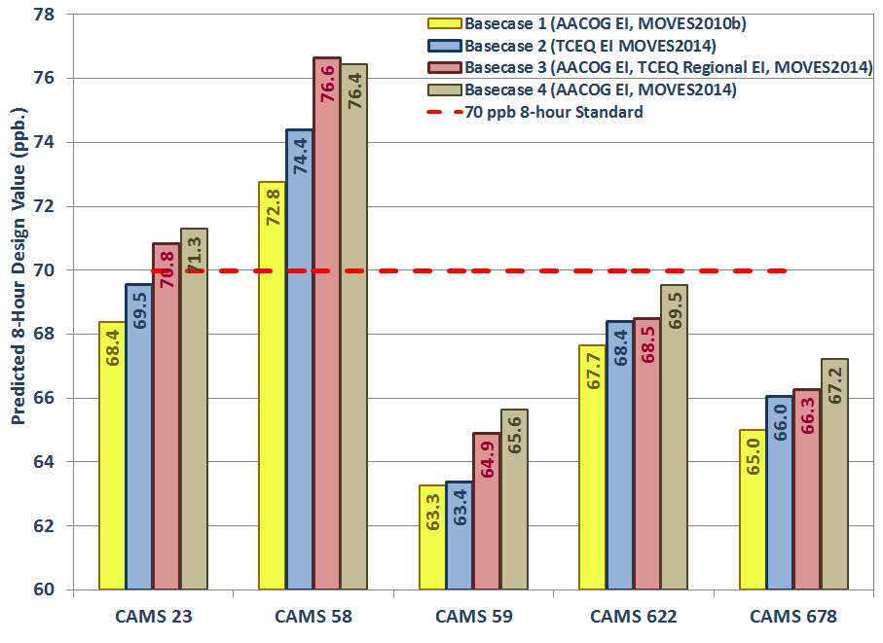

Minimum Threshold Analysis
The methodology used above follows the EPA’s guidance on calculating future design values. However, other methodologies may be used to calculate future design values, so that model sensitivity can be tested. The minimum threshold used in the design value calculation was based on EPA’s recommended lowest threshold of 60 ppb. By increasing the minimum threshold to 65, 70, and 75 ppb, the future predicted design value increased at C23 and C58 (Figure 4-3). The change in 2018 RRFs, the future design values, and the number of days that meet each criterion are provided in Table 4-4.

By raising the minimum threshold to 70 ppb, used in the above attainment demonstration, the applicable days drop below EPA’s guidance that suggests at least 10 days be included in the analysis. At 75 ppb, the number of days falls below 5 for every monitor. While the calculation then uses days that modeled higher baseline ozone concentrations, the calculation becomes less statistically robust.

The design value increased at both C58 and C23 when the minimum threshold was increased. When the minimum threshold was raised to 70 ppb, the maximum design value increased 1.2 ppb at C58 and 1.0 ppb at C23. Under the minimum threshold of 75 ppb, the maximum design value was increased to 79.3 ppb at C58 which is significantly higher than the 70 ppb ozone standard. However, there were only 2 days included in the calculation.

Figure 4-3: Minimum Threshold Analysis 8-Hour Design Values, 2018
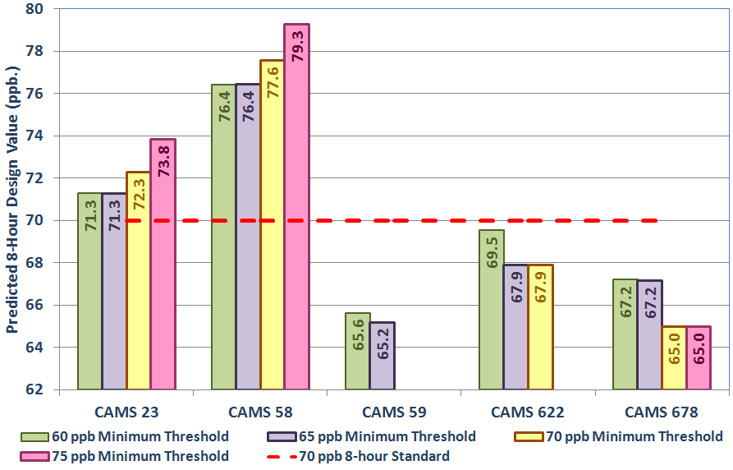

Table 4-4: Minimum Threshold Analysis for base Case 2 (TCEQ), 2018.
Site | 2014 Modeling DV | 60 ppb |  |  | 65 ppb |  |  | 70 ppb |  |  | 75 ppb
 |  | RRF | DVF | # Days | RRF | DVF | # Days | RRF | DVF | # Days | RRF | DVF | # Days
C23 | 77.1 | 0.9247 | 71.3 | 10 | 0.9247 | 71.3 | 10 | 0.9377 | 72.3 | 7 | 0.9575 | 73.8 | 4
C58 | 80.7 | 0.9472 | 76.4 | 10 | 0.9472 | 76.4 | 10 | 0.9613 | 77.6 | 7 | 0.9825 | 79.3 | 2
C59 | 68.8 | 0.9541 | 65.6 | 3 | 0.9477 | 65.2 | 2
C622 | 73.8 | 0.9422 | 69.5 | 6 | 0.9199 | 67.9 | 1 | 0.9199 | 67.9 | 1
C678 | 71.6 | 0.9387 | 67.2 | 9 | 0.9379 | 67.2 | 3 | 0.9075 | 65.0 | 1 | 0.9075 | 65.0 | 1

Grid Cell Array Size Analysis
In the recent Dec. 2014 modeling guidance, EPA recommends “that the RRF be based on a 3x3 array of cells centered on the location of the grid cell containing the monitor.” The 2014 modeling guidance is an updated of the 2007 EPA modeling guidance where a 7x7 grid array is recommended instead. EPA also “recommends that the grid cell with the highest base year ozone value in the 3x3 array be used for both the base and future components of the RRF calculation”. The photochemical model was tested using different grid cell arrays to determine the model responses.

Figure 4-4: Grid Cell Array Size around Regulatory Sited San Antonio-New Braunfels Ozone Monitors
Plot Date: June 14, 2013
Map Compilation: June 14, 2013
Source: Monitor Locations based on TCEQ data.

The size of the grid cell array around each monitor can impact the future predicted design value. By testing the change in the grid cell array, the accuracy of the model prediction can be tested. The 3x3, 5x5, and 7x7 grid cell arrays used in the alternative DV calculations for the regulatory sited monitors in the San Antonio-New Braunfels MSA are shown in Figure 4-4. A 5x5 or 7x7 grid cell array shows overlap among several of San Antonio monitors.

The maximum DV at C58 decrease from 76.4 ppb to 76.2 ppb when a 7x7 grid cell array is used instead of a 3x3 grid cell array (Figure 4-5). For the other four monitors, the design value changed between -0.2 ppb to 0.9 ppb when using the 7x7 grid cell array (Table 4-5). The photochemical model overall was not sensitivity to changes in the design value when different grid cell arrays are used. Since the future year 2018 grid cell has to be in the same cell with the highest value in the 2012 baseline, the model may not been as sensitive to changes in the grid cell array.

Figure 4-5: Grid Cell Array 8-Hour Design Values, 2018
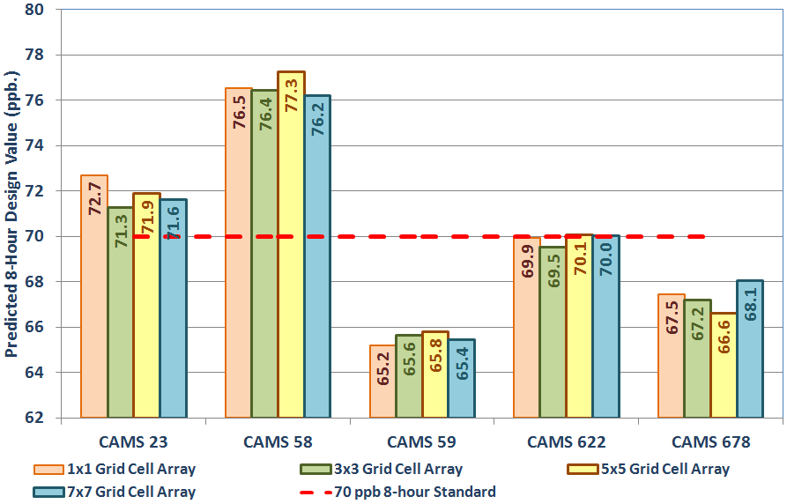

Table 4-5: RRFs and DVFs using 1x1, 3x3, 5x5, and 7x7 Grid Cell Arrays, 2018
Site | 2012 DV | 1x1 Grid Cell Array |  |  | 3x3 Grid Cell Array |  |  | 5x5 Grid Cell Array |  |  | 7x7 Grid Cell Array
 |  | RRF | DV | # Days | RRF | DV | # Days | RRF | DV | # Days | RRF | DV | # Days
C23 | 77.1 | 0.9429 | 72.7 | 10 | 0.9247 | 71.3 | 10 | 0.9326 | 71.9 | 10 | 0.9289 | 71.6 | 10
C58 | 80.7 | 0.9482 | 76.5 | 10 | 0.9472 | 76.4 | 10 | 0.9573 | 77.3 | 10 | 0.9441 | 76.2 | 10
C59 | 68.8 | 0.9478 | 65.2 | 3 | 0.9541 | 65.6 | 3 | 0.9562 | 65.8 | 7 | 0.9511 | 65.4 | 10
C622 | 73.8 | 0.9477 | 69.9 | 3 | 0.9422 | 69.5 | 6 | 0.9495 | 70.1 | 10 | 0.9489 | 70.0 | 10
C678 | 71.6 | 0.9423 | 67.5 | 8 | 0.9387 | 67.2 | 9 | 0.9306 | 66.6 | 10 | 0.9506 | 68.1 | 10

San Antonio-New Braunfels MSA Counties APCA Run

APCA Run Setup
“ENVIRON developed an ozone source attribution approach that has become known as the “Ozone Source Apportionment Technology”, or OSAT. OSAT provides a method for estimating the contributions of multiple source areas, categories, and pollutant types to ozone formation in a single model run.” “OSAT uses multiple tracer species to track the fate of ozone precursor emissions (VOC and NO_{X}) and the ozone formation caused by these emissions within a simulation. The tracers operate as spectators to the normal CAMx calculations so that the underlying CAMx predicted relationships between emission groups (sources) and ozone concentrations at specific locations (receptors) are not perturbed.”

“The ozone reaction tracers allow ozone formation from multiple “source groupings” to be tracked simultaneously within a single simulation. A source grouping can be defined in terms of geographical area and/or emission category.” “So that all sources of ozone precursors are accounted, the CAMx boundary conditions and initial conditions are always tracked as separate source groupings. The methodology is designed so that all ozone and precursor concentrations are attributed among the selected source groupings at all times. Thus, for all receptor locations and times, the ozone (or ozone precursor concentrations) predicted by CAMx is attributed among the source groupings selected for OSAT. The methodology also estimates the fractions of ozone arriving at the receptor that were formed en route under VOC- or NO_{X}-limited conditions. This information indicates how ozone concentrations at the receptor will respond to reductions in VOC and NO_{X} precursor emissions”.

“Anthropogenic Precursor Culpability Assessment (APCA). APCA differs from OSAT in recognizing that certain emission groups are not controllable (e.g., biogenic emissions) and that apportioning ozone production to these groups does not provide information that is relevant to control strategies. To address this, in situations where OSAT would attribute ozone production to non-controllable (i.e., biogenic) emissions, APCA re-allocates that ozone production to the controllable portion of precursors that participated in ozone formation with the non-controllable precursor. In the case where biogenic emissions are the uncontrollable source category, APCA would only attribute ozone production to biogenic emissions when ozone formation is due to the interaction of biogenic VOC with biogenic NO_{X}.”
The June episode was run at the 4-km, 12-km, and 36-km grid sizes using APCA. For the APCA run, the receptors defined in the run are the 3 regulatory monitors in the San Antonio-New Braunfels MSA: C23, C58, and C59. The APCA run was also divided into 9 geographical areas, initial conditions, and boundary conditions. Figure 5-1 shows the geographical regions at the 4-km grid level. The geographic source apportionment areas are:
- Atascosa County | - Bandera County
- Bexar County | - Comal County
- Guadalupe County | - Kendall County
- Medina County | - Wilson County
- Initial Conditions | - Boundary conditions

The design value days used in the analysis are (same days used in calculating the RRF):
- CAMS 23: June 3, 4, 8, 9, 12, 13, 14, 28, 29, and 30
- CAMS 58: June 3, 4, 7, 8, 9, 12, 13, 14, 29, and 30
- CAMS 59: June 3, 13, 14, 25, 28, and 29
Data for May 24th to May 30th was not included in the analysis because these days were only run at the 36-km grid level.

Figure 5-1: APCA Regions for San Antonio-New Braunfels MSA Counties at the 4-Km grid Level, 2018
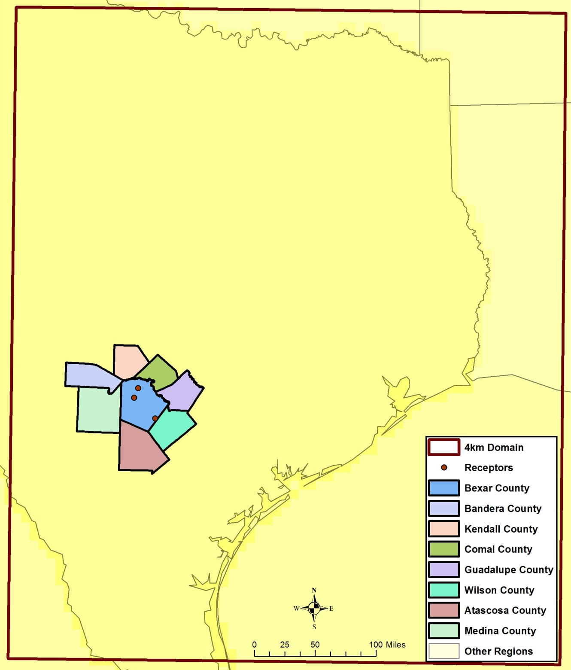
Plot Date: Sept. 10, 2015
Map Compilation: Sept. 10, 2015
Source: APCA run Setup for counties

Contribution by Source Region
As expected, Bexar County emissions were the largest contribution of peak hourly ozone on design value days at C58 (27.8 percent in Table 5-1). Surprisingly, the second largest contribution came from Guadalupe County, 6.9 percent. Other contributions were Comal County at 0.9 percent, Atascosa County, at 0.7 percent, and Wilson County at 0.3 percent. Emissions from outside the 8 county San Antonio-New Braunfels MSA was 63.3 percent. These emissions are beyond local control and contribute significantly to local ozone.

The results for C23 are very similar to C58 except there was an even higher contribution from Bexar County (32.1 percent). At C59, both Bexar County, 9.8 percent, and Guadalupe County, 8.3 percent, had a significant impact on peak 1-hour ozone on Design Value days. Since the C59 monitor is located in southwest Bexar County, most of the counties’ emissions are usually downwind from the monitoring site.

Interquartile range (ICQ) plots in Figure 5-2 show Bexar County’s contribution on design value days has a wide range of values at C58. “The interquartile range of an observation variable is the difference of its upper and lower quartiles. It is a measure of how far apart the middle portion of data spreads in value.” The ICQ plots also include the maximum and minimum values. The maximum impact of Bexar County is 37.8 ppb at C58 monitor and 39.0 ppb at C23 monitor on Design Value days. Guadalupe County’s maximum contribution was 26.2 ppb at C58 and 21.6 ppb at C23. Comal County had a maximum contribution of 2.7 ppb, Atascosa county had a maximum contribution of 2.3 ppb, and Wilson County had a maximum contribution of 1.2 ppb. These results shows local emission sources can have a significant impact on ozone recorded at local regulatory monitors.

Table 5-1: APCA results for C58, C23, C59 by San Antonio-New Braunfels MSA County, 2018
Monitor | Region | All Days |  | Days > 65 ppb |  | Design Value Days (Average) |  | Design Value Days (Peak 1-hour)
 |  | ppb | % | ppb | % | ppb | % | ppb | %
C58 | Initial Conditions | 0.96 | 2.6% | 0.82 | 2.0% | 0.87 | 2.0% | 0.74 | 1.0%
 | Boundary | 15.68 | 41.8% | 16.05 | 38.1% | 12.56 | 29.5% | 19.14 | 26.6%
 | Other Regions | 15.88 | 42.3% | 18.70 | 44.4% | 20.13 | 47.3% | 25.69 | 35.7%
 | Atascosa | 0.18 | 0.5% | 0.22 | 0.5% | 0.20 | 0.5% | 0.51 | 0.7%
 | Bandera | 0.00 | 0.0% | 0.00 | 0.0% | 0.00 | 0.0% | 0.00 | 0.0%
 | Bexar | 3.71 | 9.9% | 4.70 | 11.2% | 6.37 | 15.0% | 19.98 | 27.8%
 | Comal | 0.13 | 0.4% | 0.18 | 0.4% | 0.20 | 0.5% | 0.67 | 0.9%
 | Guadalupe | 0.88 | 2.3% | 1.35 | 3.2% | 2.06 | 4.8% | 4.95 | 6.9%
 | Kendall | 0.03 | 0.1% | 0.02 | 0.0% | 0.01 | 0.0% | 0.02 | 0.0%
 | Medina | 0.01 | 0.0% | 0.01 | 0.0% | 0.01 | 0.0% | 0.01 | 0.0%
 | Wilson | 0.06 | 0.2% | 0.07 | 0.2% | 0.10 | 0.2% | 0.23 | 0.3%
 | Total | 37.53 | 100.0% | 42.13 | 100.0% | 42.51 | 100.0% | 71.96 | 100.0%
C23 | Initial Conditions | 0.94 | 2.6% | 0.83 | 2.0% | 0.82 | 1.8% | 0.72 | 0.9%
 | Boundary | 15.40 | 42.1% | 15.76 | 38.0% | 15.75 | 34.3% | 20.74 | 27.0%
 | Other Regions | 15.03 | 41.1% | 17.79 | 42.9% | 19.52 | 42.5% | 25.38 | 33.0%
 | Atascosa | 0.25 | 0.7% | 0.29 | 0.7% | 0.20 | 0.4% | 0.54 | 0.7%
 | Bandera | 0.00 | 0.0% | 0.00 | 0.0% | 0.00 | 0.0% | 0.00 | 0.0%
 | Bexar | 3.98 | 10.9% | 5.38 | 13.0% | 7.42 | 16.1% | 24.67 | 32.1%
 | Comal | 0.09 | 0.2% | 0.11 | 0.3% | 0.13 | 0.3% | 0.29 | 0.4%
 | Guadalupe | 0.79 | 2.2% | 1.19 | 2.9% | 1.98 | 4.3% | 4.19 | 5.5%
 | Kendall | 0.02 | 0.1% | 0.02 | 0.0% | 0.01 | 0.0% | 0.01 | 0.0%
 | Medina | 0.02 | 0.0% | 0.01 | 0.0% | 0.01 | 0.0% | 0.01 | 0.0%
 | Wilson | 0.06 | 0.2% | 0.07 | 0.2% | 0.11 | 0.2% | 0.28 | 0.4%
 | Total | 36.58 | 100.0% | 41.45 | 100.0% | 45.95 | 100.0% | 76.83 | 100.0%

Monitor | Region | All Days |  | Days > 65 ppb |  | Design Value Days (Average) |  | Design Value Days (Peak 1-hour)
 |  | ppb | % | ppb | % | ppb | % | ppb | %
C59 | Initial Conditions | 1.13 | 3.1% | 1.01 | 2.5% | 0.79 | 1.8% | 0.51 | 0.9%
 | Boundary | 16.22 | 44.1% | 16.35 | 40.6% | 16.19 | 36.9% | 16.89 | 28.7%
 | Other Regions | 17.23 | 46.8% | 20.47 | 50.8% | 22.04 | 50.2% | 29.47 | 50.1%
 | Atascosa | 0.18 | 0.5% | 0.23 | 0.6% | 0.11 | 0.3% | 0.24 | 0.4%
 | Bandera | 0.00 | 0.0% | 0.00 | 0.0% | 0.00 | 0.0% | 0.00 | 0.0%
 | Bexar | 1.27 | 3.5% | 1.31 | 3.3% | 3.19 | 7.3% | 5.76 | 9.8%
 | Comal | 0.03 | 0.1% | 0.02 | 0.1% | 0.03 | 0.1% | 0.15 | 0.3%
 | Guadalupe | 0.54 | 1.5% | 0.61 | 1.5% | 1.23 | 2.8% | 4.85 | 8.2%
 | Kendall | 0.00 | 0.0% | 0.00 | 0.0% | 0.00 | 0.0% | 0.00 | 0.0%
 | Medina | 0.00 | 0.0% | 0.00 | 0.0% | 0.01 | 0.0% | 0.00 | 0.0%
 | Wilson | 0.19 | 0.5% | 0.26 | 0.7% | 0.30 | 0.7% | 0.94 | 1.6%
 | Total | 36.79 | 100.0% | 40.28 | 100.0% | 43.88 | 100.0% | 58.82 | 100.0%

Figure 5-2: ICQ plots for C58, C23, and C59 for Hourly Ozone on Design Value Days, 2018
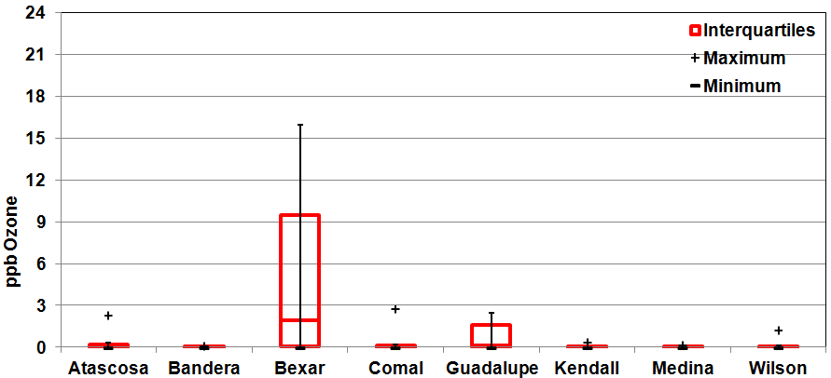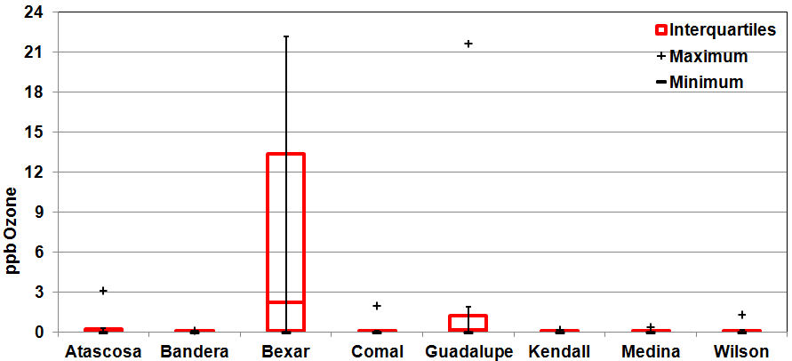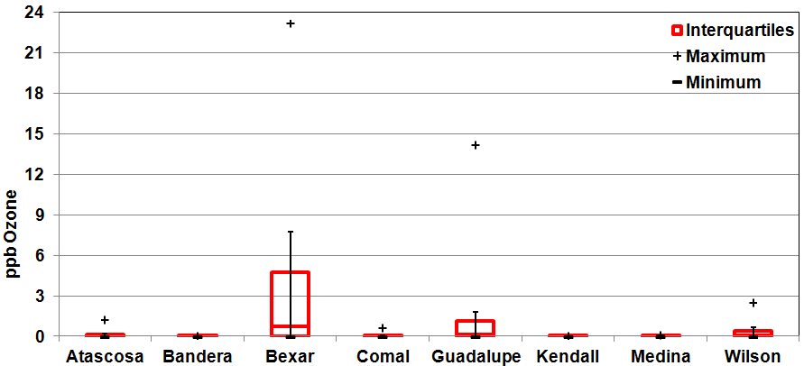
C58

C23

C59
Figure 5-3: Pie Chart for C58 for Average Peak 1-Hour Ozone on Design Value Days, 2018
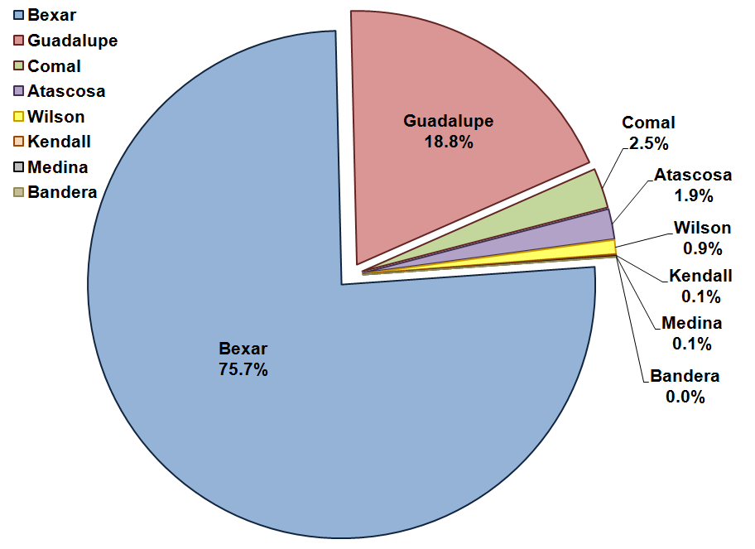
Figure 5-4: Pie Chart for C23 for Average Peak 1-Hour Ozone on Design Value Days, 2018
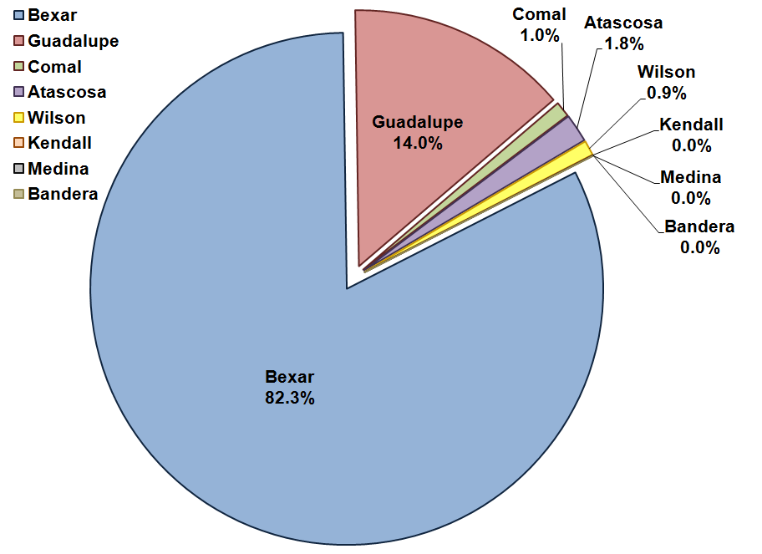
Figure 5-5: Pie Chart for C59 for Average Peak 1-Hour Ozone on Design Value Days, 2018
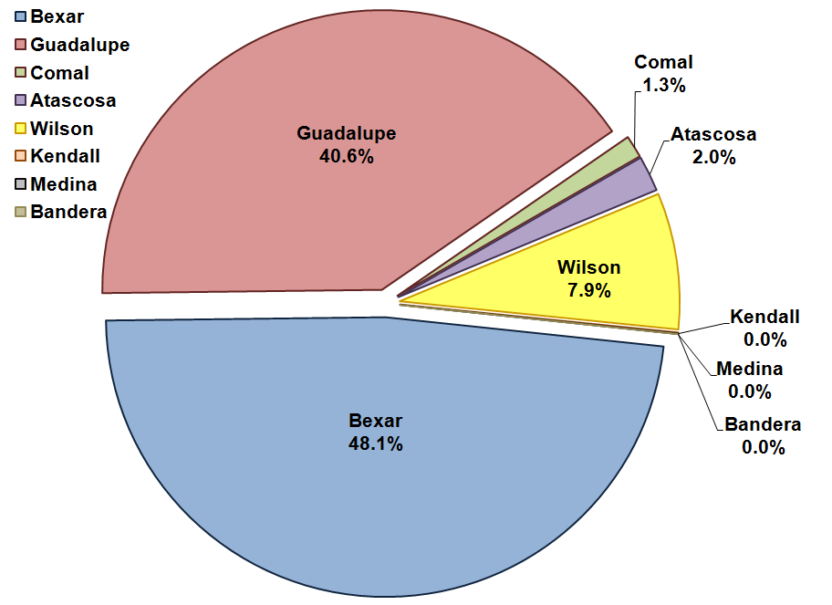

Other States APCA Run

APCA Run Setup
An APCA was also run at the 4-km, 12-km, and 36-km grid sizes to analysis the impact of other states on ozone recorded at regulatory monitors in the San Antonio-New Braunfels MSA. For the APCA run, the receptors defined in the run are the 3 regulatory monitors in the San Antonio-New Braunfels MSA: C23, C58, and C59. The APCA run was divided into 26 geographical areas, initial conditions, and boundary conditions (Figure 6-1). The geographic source apportionment areas are:
- Alabama | - Arkansas | - Colorado
- Florida | - Georgia | - Kentucky
- Kansas | - Illinois | - Indiana
- Louisiana | - Ohio | - Oklahoma
- Mississippi | - Missouri | - New Mexico
- North Carolina | - South Carolina | - Tennessee
- Texas | - Virginia | - West Virginia
- North Central US | - North Eastern US | - Western US
- Gulf of Mexico, Atlantic Ozone and Pacific Ocean | - International (Canada, Mexico, and Caribbean) | - Boundary conditions
- Initial Conditions

Figure 6-1: APCA Other States/Regions at the 36-Km Grid Level, 2018
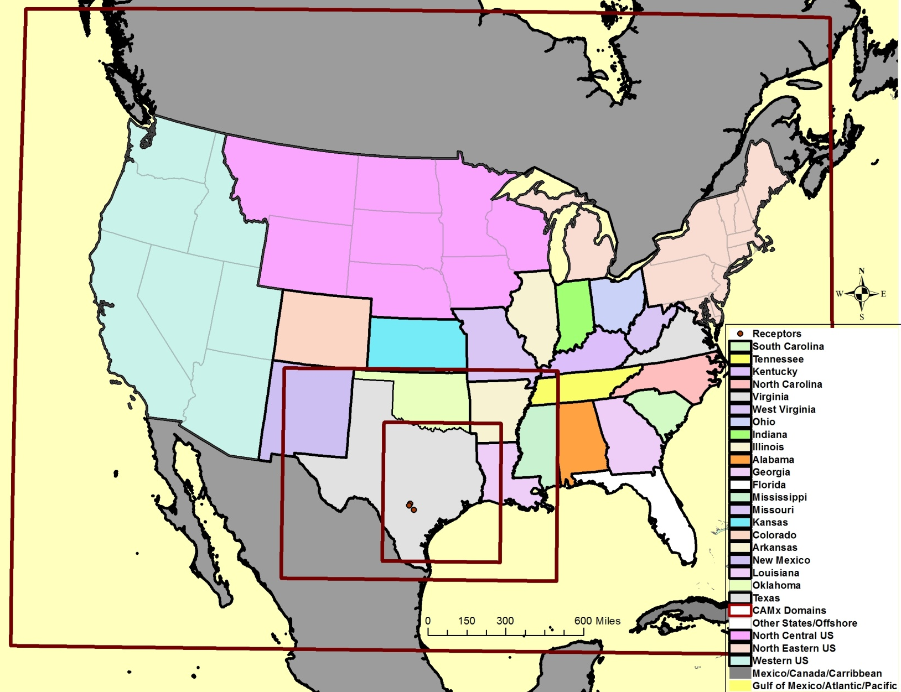
Plot Date: July 30, 2015
Map Compilation: Oct 16, 2015
Source: APCA run Setup

Contribution by Source Region
In the APCA run, Texas emission sources were the largest contribution of peak hourly ozone on design value days at C58 (60.0 percent in Table 6-1). Emission reduction controls in Texas can be effective in reducing ozone levels at the regulatory monitors in San Antonio-New Braunfels MSA. There was also a significant contribution from the Gulf of Mexico, Atlantic, and Pacific ocean regions (4.3 percent) in 2018. From other states, Louisiana at 3.4 percent had the highest contribution to peak 1-hour ozone followed by Oklahoma at 1.3 percent. Surprisingly, both Western U.S. (1.3 percent) and North Central U.S. (1.0 percent) had larger contribution to ozone in San Antonio-New Braunfels MSA than expected. These regions were not spilt into separate states because the expected contribution was predicted to be smaller than the results indicate. Other states that had a significant contribution to peak 1-hour ozone were Kansas (0.7 percent), Arkansas (0.6 percent), and Colorado (0.5 percent).

The results for C23 are very similar to C58 except there was a slightly less contribution from Texas (58.1 percent) and from the Gulf of Mexico, Atlantic, and Pacific oceans (3.6 percent). The results are similar because the emission sources are generated at a large state levels and travel significant distances before arriving in at local ozone monitors. At C59, Texas contribution on peak 1-hour ozone (52.1 percent) was even less then at the other two monitors because this monitor is often upwind of the San Antonio urban core and other large local emission sources on high-ozone days. North Central U.S. (1.6 percent), Kansas (1.0 percent), Florida (0.6 percent) have a greater impact on local ozone at this monitor.

Table 6-1: APCA results for C58, C23, and C59 by Source Region for Other States/Regions, 2018
Monitor | Region | All Days |  | Days > 65 ppb |  | Design Value Days (Average) |  | Design Value Days (Peak 1-hour)
 |  | ppb | % | ppb | % | ppb | % | ppb | %
C58 | Initial Conditions | 0.84 | 2.4% | 0.83 | 2.1% | 0.87 | 2.0% | 0.74 | 1.1%
 | Boundary | 15.85 | 45.0% | 16.00 | 40.9% | 15.90 | 37.0% | 19.05 | 27.8%
 | Gulf of Mexico/Atlantic/Pacific | 2.70 | 7.7% | 2.39 | 6.1% | 3.27 | 7.6% | 2.92 | 4.3%
 | Texas | 12.84 | 36.4% | 15.85 | 40.5% | 19.16 | 44.6% | 41.15 | 60.0%
 | Louisiana | 1.32 | 3.7% | 1.85 | 4.7% | 2.06 | 4.8% | 2.33 | 3.4%
 | Arkansas | 0.23 | 0.6% | 0.31 | 0.8% | 0.32 | 0.7% | 0.40 | 0.6%
 | Oklahoma | 0.65 | 1.8% | 0.85 | 2.2% | 0.55 | 1.3% | 0.87 | 1.3%
 | Mexico/Canada/Caribbean | 0.31 | 0.9% | 0.38 | 1.0% | 0.34 | 0.8% | 0.42 | 0.6%
 | Kansas | 0.31 | 0.9% | 0.46 | 1.2% | 0.31 | 0.7% | 0.46 | 0.7%
 | Missouri | 0.13 | 0.4% | 0.17 | 0.4% | 0.18 | 0.4% | 0.21 | 0.3%
 | Kentucky | 0.04 | 0.1% | 0.05 | 0.1% | 0.06 | 0.1% | 0.06 | 0.1%
 | Tennessee | 0.04 | 0.1% | 0.05 | 0.1% | 0.05 | 0.1% | 0.05 | 0.1%
 | Mississippi | 0.31 | 0.9% | 0.39 | 1.0% | 0.33 | 0.8% | 0.29 | 0.4%
 | New Mexico | 0.11 | 0.3% | 0.14 | 0.4% | 0.18 | 0.4% | 0.25 | 0.4%
 | Colorado | 0.17 | 0.5% | 0.22 | 0.6% | 0.25 | 0.6% | 0.35 | 0.5%
 | Alabama | 0.20 | 0.6% | 0.22 | 0.6% | 0.24 | 0.5% | 0.20 | 0.3%
 | Georgia | 0.10 | 0.3% | 0.08 | 0.2% | 0.09 | 0.2% | 0.07 | 0.1%
 | Florida | 0.38 | 1.1% | 0.17 | 0.4% | 0.21 | 0.5% | 0.15 | 0.2%
 | S. Carolina | 0.03 | 0.1% | 0.03 | 0.1% | 0.02 | 0.1% | 0.02 | 0.0%
 | N. Carolina | 0.03 | 0.1% | 0.03 | 0.1% | 0.02 | 0.1% | 0.02 | 0.0%
 | Virginia | 0.02 | 0.0% | 0.01 | 0.0% | 0.01 | 0.0% | 0.01 | 0.0%
 | W. Virginia | 0.01 | 0.0% | 0.01 | 0.0% | 0.01 | 0.0% | 0.01 | 0.0%
 | Ohio | 0.02 | 0.1% | 0.02 | 0.1% | 0.03 | 0.1% | 0.03 | 0.0%
 | Indiana | 0.04 | 0.1% | 0.06 | 0.1% | 0.07 | 0.2% | 0.08 | 0.1%
 | Illinois | 0.11 | 0.3% | 0.14 | 0.4% | 0.17 | 0.4% | 0.19 | 0.3%
 | North East US | 0.06 | 0.2% | 0.05 | 0.1% | 0.04 | 0.1% | 0.04 | 0.1%
 | North Central US | 0.53 | 1.5% | 0.80 | 2.0% | 0.56 | 1.3% | 0.69 | 1.0%
 | Western US | 0.46 | 1.3% | 0.59 | 1.5% | 0.62 | 1.5% | 0.89 | 1.3%
 | Total | 35.23 | 100.0% | 39.12 | 100.0% | 43.01 | 100.0% | 68.61 | 100.0%

Monitor | Region | All Days |  | Days > 65 ppb |  | Design Value Days (Average) |  | Design Value Days (Peak 1-hour)
 |  | ppb | % | ppb | % | ppb | % | ppb | %
C23 | Initial Conditions | 0.83 | 2.3% | 0.83 | 2.0% | 0.82 | 1.8% | 0.72 | 0.9%
 | Boundary | 15.59 | 42.2% | 15.71 | 37.9% | 15.69 | 34.2% | 20.66 | 26.9%
 | Gulf of Mexico/Atlantic/Pacific | 2.74 | 7.4% | 2.43 | 5.9% | 3.10 | 6.8% | 2.73 | 3.6%
 | Texas | 12.30 | 33.3% | 15.55 | 37.5% | 19.86 | 43.2% | 44.65 | 58.1%
 | Louisiana | 1.28 | 3.5% | 1.82 | 4.4% | 1.86 | 4.1% | 2.14 | 2.8%
 | Arkansas | 0.22 | 0.6% | 0.30 | 0.7% | 0.32 | 0.7% | 0.38 | 0.5%
 | Oklahoma | 0.61 | 1.7% | 0.81 | 1.9% | 0.59 | 1.3% | 1.00 | 1.3%
 | Mexico/Canada/Caribbean | 0.31 | 0.8% | 0.37 | 0.9% | 0.32 | 0.7% | 0.40 | 0.5%
 | Kansas | 0.30 | 0.8% | 0.44 | 1.1% | 0.37 | 0.8% | 0.61 | 0.8%
 | Missouri | 0.13 | 0.3% | 0.17 | 0.4% | 0.17 | 0.4% | 0.21 | 0.3%
 | Kentucky | 0.04 | 0.1% | 0.04 | 0.1% | 0.05 | 0.1% | 0.05 | 0.1%
 | Tennessee | 0.04 | 0.1% | 0.05 | 0.1% | 0.05 | 0.1% | 0.04 | 0.1%
 | Mississippi | 0.31 | 0.8% | 0.40 | 1.0% | 0.31 | 0.7% | 0.28 | 0.4%
 | New Mexico | 0.11 | 0.3% | 0.14 | 0.3% | 0.14 | 0.3% | 0.20 | 0.3%
 | Colorado | 0.17 | 0.5% | 0.22 | 0.5% | 0.21 | 0.5% | 0.32 | 0.4%
 | Alabama | 0.20 | 0.5% | 0.22 | 0.5% | 0.22 | 0.5% | 0.20 | 0.3%
 | Georgia | 0.10 | 0.3% | 0.09 | 0.2% | 0.09 | 0.2% | 0.07 | 0.1%
 | Florida | 0.38 | 1.0% | 0.18 | 0.4% | 0.21 | 0.5% | 0.15 | 0.2%
 | S. Carolina | 0.03 | 0.1% | 0.03 | 0.1% | 0.02 | 0.0% | 0.02 | 0.0%
 | N. Carolina | 0.03 | 0.1% | 0.03 | 0.1% | 0.02 | 0.0% | 0.02 | 0.0%
 | Virginia | 0.02 | 0.0% | 0.01 | 0.0% | 0.01 | 0.0% | 0.01 | 0.0%
 | W. Virginia | 0.01 | 0.0% | 0.01 | 0.0% | 0.01 | 0.0% | 0.01 | 0.0%
 | Ohio | 0.02 | 0.1% | 0.02 | 0.1% | 0.03 | 0.1% | 0.03 | 0.0%
 | Indiana | 0.04 | 0.1% | 0.06 | 0.1% | 0.06 | 0.1% | 0.07 | 0.1%
 | Illinois | 0.10 | 0.3% | 0.14 | 0.3% | 0.15 | 0.3% | 0.17 | 0.2%
 | North East US | 0.05 | 0.1% | 0.05 | 0.1% | 0.04 | 0.1% | 0.04 | 0.0%
 | North Central US | 0.51 | 1.4% | 0.77 | 1.8% | 0.69 | 1.5% | 0.90 | 1.2%
 | Western US | 0.45 | 1.2% | 0.58 | 1.4% | 0.52 | 1.1% | 0.76 | 1.0%
 | Total | 36.93 | 100.0% | 41.45 | 100.0% | 45.95 | 100.0% | 76.83 | 100.0%

Monitor | Region | All Days |  | Days > 65 ppb |  | Design Value Days (Average) |  | Design Value Days (Peak 1-hour)
 |  | ppb | % | ppb | % | ppb | % | ppb | %
C59 | Initial Conditions | 1.00 | 2.7% | 1.01 | 2.5% | 0.79 | 1.8% | 0.51 | 0.9%
 | Boundary | 16.40 | 44.3% | 16.30 | 40.6% | 16.14 | 36.8% | 16.84 | 28.6%
 | Gulf of Mexico/Atlantic/Pacific | 3.61 | 9.7% | 3.26 | 8.1% | 3.20 | 7.3% | 3.18 | 5.4%
 | Texas | 10.00 | 27.0% | 11.92 | 29.7% | 17.28 | 39.4% | 30.65 | 52.1%
 | Louisiana | 1.54 | 4.1% | 2.22 | 5.5% | 1.56 | 3.5% | 1.83 | 3.1%
 | Arkansas | 0.25 | 0.7% | 0.35 | 0.9% | 0.29 | 0.7% | 0.39 | 0.7%
 | Oklahoma | 0.55 | 1.5% | 0.77 | 1.9% | 0.73 | 1.7% | 1.02 | 1.7%
 | Mexico/Canada/Caribbean | 0.30 | 0.8% | 0.36 | 0.9% | 0.29 | 0.7% | 0.35 | 0.6%
 | Kansas | 0.30 | 0.8% | 0.45 | 1.1% | 0.45 | 1.0% | 0.62 | 1.0%
 | Missouri | 0.14 | 0.4% | 0.19 | 0.5% | 0.14 | 0.3% | 0.17 | 0.3%
 | Kentucky | 0.04 | 0.1% | 0.06 | 0.1% | 0.03 | 0.1% | 0.02 | 0.0%
 | Tennessee | 0.05 | 0.1% | 0.06 | 0.1% | 0.03 | 0.1% | 0.02 | 0.0%
 | Mississippi | 0.39 | 1.1% | 0.53 | 1.3% | 0.31 | 0.7% | 0.31 | 0.5%
 | New Mexico | 0.10 | 0.3% | 0.14 | 0.3% | 0.13 | 0.3% | 0.15 | 0.3%
 | Colorado | 0.17 | 0.5% | 0.22 | 0.6% | 0.24 | 0.6% | 0.31 | 0.5%
 | Alabama | 0.25 | 0.7% | 0.28 | 0.7% | 0.19 | 0.4% | 0.17 | 0.3%
 | Georgia | 0.12 | 0.3% | 0.10 | 0.3% | 0.12 | 0.3% | 0.09 | 0.2%
 | Florida | 0.51 | 1.4% | 0.25 | 0.6% | 0.46 | 1.1% | 0.36 | 0.6%
 | S. Carolina | 0.04 | 0.1% | 0.03 | 0.1% | 0.03 | 0.1% | 0.02 | 0.0%
 | N. Carolina | 0.03 | 0.1% | 0.03 | 0.1% | 0.03 | 0.1% | 0.02 | 0.0%
 | Virginia | 0.02 | 0.0% | 0.02 | 0.0% | 0.01 | 0.0% | 0.01 | 0.0%
 | W. Virginia | 0.01 | 0.0% | 0.01 | 0.0% | 0.01 | 0.0% | 0.01 | 0.0%
 | Ohio | 0.02 | 0.1% | 0.02 | 0.1% | 0.02 | 0.0% | 0.02 | 0.0%
 | Indiana | 0.05 | 0.1% | 0.06 | 0.1% | 0.03 | 0.1% | 0.04 | 0.1%
 | Illinois | 0.12 | 0.3% | 0.14 | 0.3% | 0.10 | 0.2% | 0.11 | 0.2%
 | North East US | 0.06 | 0.2% | 0.05 | 0.1% | 0.03 | 0.1% | 0.03 | 0.0%
 | North Central US | 0.54 | 1.4% | 0.77 | 1.9% | 0.77 | 1.7% | 0.96 | 1.6%
 | Western US | 0.46 | 1.2% | 0.58 | 1.5% | 0.47 | 1.1% | 0.62 | 1.1%
 | Total | 37.06 | 100.0% | 40.19 | 100.0% | 43.88 | 100.0% | 58.82 | 100.0%

Figure 6-2: Pie Chart for C58 by States/Other Regions besides Texas for Average Peak 1-Hour on High-Ozone Days, 2018
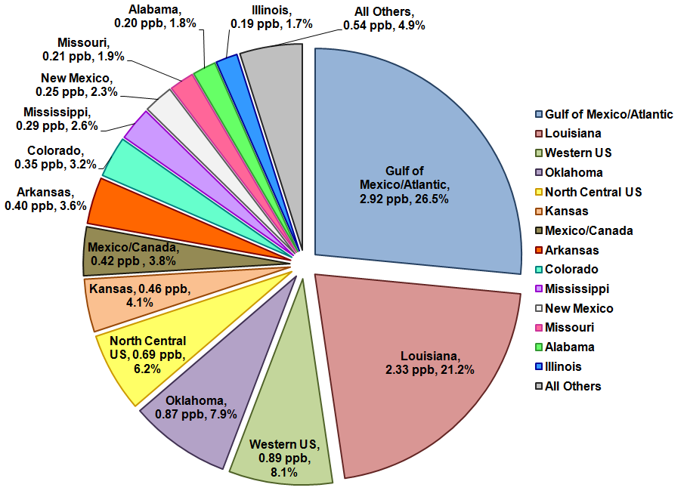
Figure 6-3: Pie Chart for C23 by States/Other Regions besides Texas for Average Peak 1-Hour on High-Ozone Days, 2018
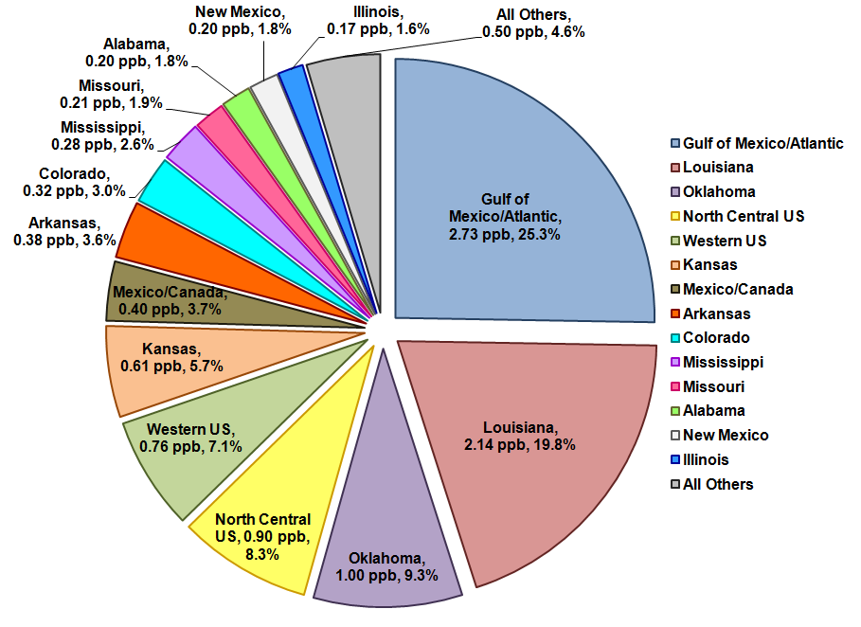
Figure 6-4: Pie Chart for C59 by States/Other Regions besides Texas for Average Peak 1-Hour on High-Ozone Days, 2018
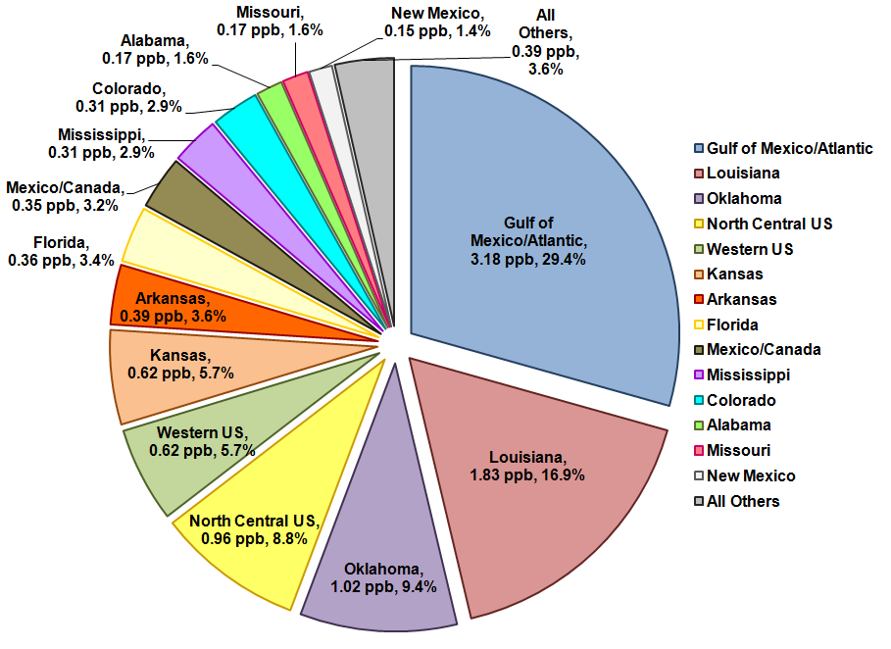

Interquartile range (ICQ) plots in Figure 6-5 shows some states can contribute a wide range of values at C58. Texas can contribute up to 60.6 ppb of hourly ozone at the C58 monitor. Both of the Gulf of Mexico, Atlantic, and Pacific ocean regions can contribute up to 13.6 ppb and Louisiana can contribute up to 7.0 ppb. Oklahoma (2.6 ppb), Western U.S. (2.4 ppb), and North Central U.S. (1.9 ppb) can also have a significant maximum impact on local hourly ozone. Although the average impact from Mississippi was only 0.3 ppb, the maximum impact was as high as 2.6 ppb. Anthropogenic emissions from Mexico and Canada had a small local impact with a maximum impact of only 0.9 ppb on high-ozone days.

Figure 6-5: ICQ plots for C58, C23, and C59 for Hourly Ozone by Other States/Regions besides Texas on Design Value Days, 2018
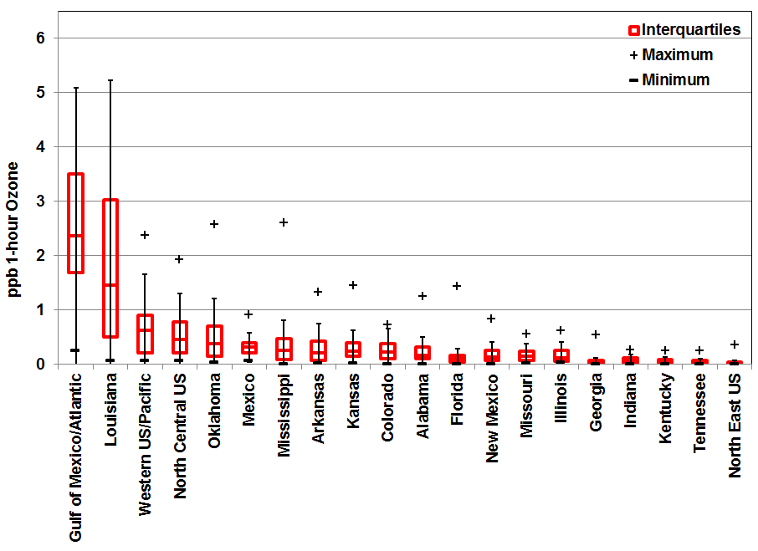
C58

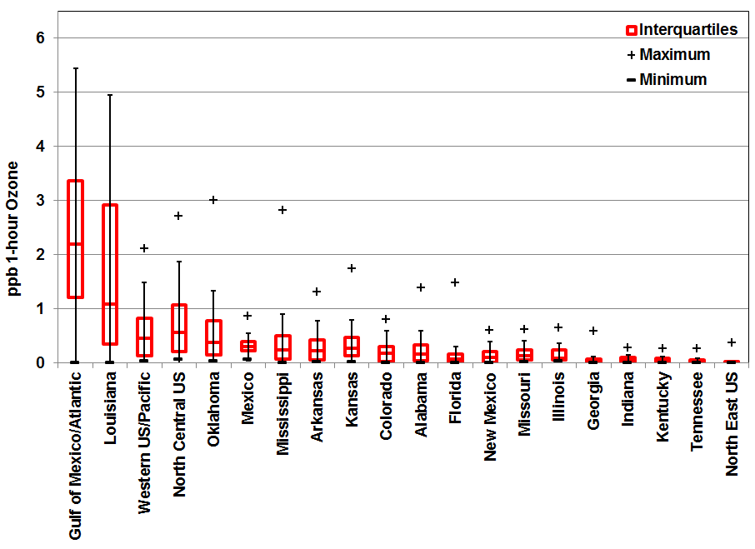
C23

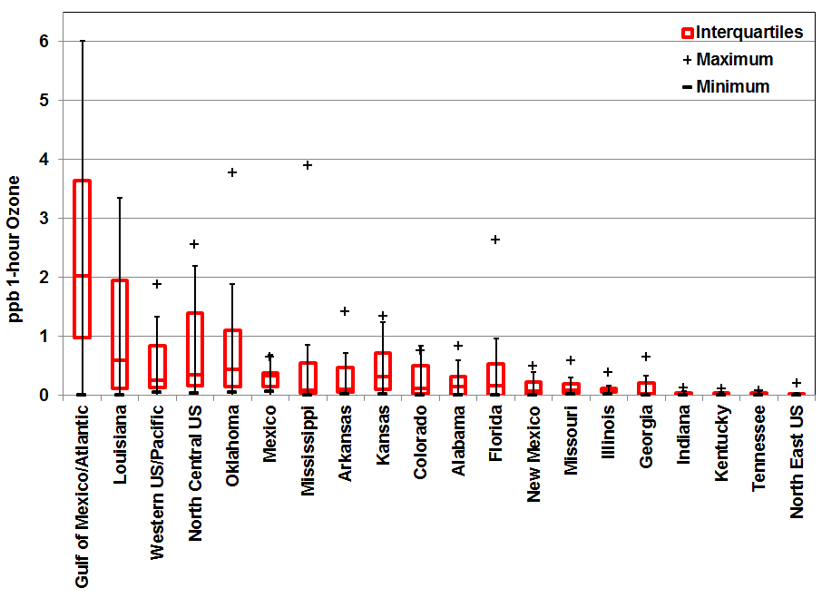
C59

Appendix A: Run Log
Run Number | Run ID | Projection Year | Date | Test | Remarks
1 | Base Case AACOG Run 4 | 2006 | 07/23/2014 | Base Case Modeling with Local Data | RPO 36-km grid system, 12-km grid, and 4-km grid  camx5.40_v2  Advection_Solver = PPM  Chemistry_Solver = EBI  PiG_Submodel = GREASD  Drydep_Model = ZHANG03  Wet_Deposition = true  ACM2_Diffusion = true  TUV_Cloud_Adjust = true  Staggered_Winds = true  Chemistry_Parameters = CAMx5.4.chemparam.7  Photolyis_Rates = camx_cb6_photorate.rpo_36km+tx_12k  m+tx_4km.tceq2zhang26a.2012AUG02.tuv48  Boundary_Conditions = camx_cb05_bc.geoschem.rpo_36km  Albedo_Haze_Ozone = camx_aho.rpo_36km+tx_12km+tx_4km.t  ceq2zhang26a.2012AUG02  Landuse_Grid(1) = camx_landuse.rpo_36km.tceq2zhang26a.lai2006jun  Landuse_Grid(2) = camx_landuse.tx_12km.tceq2zhang26a.lai2006jun  Landuse_Grid(3) = camx_landuse.tx_4km.tceq2zhang26a.lai2006jun  ZP_Grid(1) = camx_zp.rpo_36km.2006ep0ext_5layer_YSU_KF_WSM5.v32  ZP_Grid(2) = camx_zp.tx_12km.2006ep0ext_5layer_YSU_KF_WSM5.v32  ZP_Grid(3) = camx_zp.tx_4km.2006ep0ext_5layer_YSU_WSM6_3dsfc_fddats.v32  Wind_Grid(1) = camx_wind.rpo_36km.2006ep0ext_5layer_YSU_KF_WSM5.v32  Wind_Grid(2) = camx_wind.tx_12km.2006ep0ext_5layer_YSU_KF_WSM5.v32  Wind_Grid(3) = camx_wind.tx_4km.2006ep0ext_5layer_YSU_WSM6_3dsfc_fddats.v32  Temp_Grid(1) = camx_temp.rpo_36km.2006ep0ext_5layer_YSU_KF_WSM5.v32  Temp_Grid(2) = camx_temp.tx_12km.2006ep0ext_5layer_YSU_KF_WSM5.v32  Temp_Grid(3) = camx_temp.tx_4km.2006ep0ext_5layer_YSU_WSM6_3dsfc_fddats.v32',  Vapor_Grid(1) = camx_hum.rpo_36km.2006ep0ext_5layer_YSU_KF_WSM5.v32',  Vapor_Grid(2) = camx_hum.tx_12km.2006ep0ext_5layer_YSU_KF_WSM5.v32',  Vapor_Grid(3) = camx_hum.tx_4km.2006ep0ext_5layer_YSU_WSM6_3dsfc_fddats.v32',  Cloud_Grid(1) = camx_cr.rpo_36km.2006ep0ext_5layer_YSU_KF_WSM5.v32',  Cloud_Grid(2) = camx_cr.tx_12km.2006ep0ext_5layer_YSU_KF_WSM5.v32',  Cloud_Grid(3) = camx_cr.tx_4km.2006ep0ext_5layer_YSU_WSM6_3dsfc_fddats.v32',  Kv_Grid(1) = camx_kv.rpo_36km.2006ep0ext_5layer_YSU_KF_WSM5.YSU.v32.kv100',  Kv_Grid(2) = camx_kv.tx_12km.2006ep0ext_5layer_YSU_KF_WSM5.YSU.v32.kv100',  Kv_Grid(3) = camx_kv.tx_4km.2006ep0ext_5layer_YSU_WSM6_3dsfc_fddats.YSU.v32.kv100',  Emiss_Grid(1) = camx_cb6p_ei_lo.rider8.bl06_06jun.reg2a.rpo_36km',  Emiss_Grid(2) = lo_emiss.bio.tx_12km.cb6.bl.06jun.reg1.tx_12km',  Emiss_Grid(3) = lo_emiss.bio.tx_4km.cb6.AACOG.06jun.reg1.tx_4km',  Local Emission Inventory = Local San Antonio-New Braunfels MSA emission data including construction equipment, landfill equipment, quarry equipment, agricultural tractors, combines, commercial airports, point sources, and heavy duty truck idling
2 | Base Case TCEQ Run 5 | 2006 | 05/28/2015 |  | Same as Run 1 but  Camx6.0  EPS3 version 2 to process the emissions  Chemistry_Parameters = CAMx6.0.chemparam.7'  Photolyis_Rates = camx6_cb6_tuv.20060528.rpo_36km.2013MAY08.tuv48  Boundary_Conditions = camx_cb05_bc.20060528.geoschem.rpo_36km  Ozone_Column = camx6_o3c.20060528.rpo_36km.2013MAY0  Surface_Grid(1) = camx6_landuse.rpo_36km.tceq2zhang26a.lai200606  Met3D_Grid(1) = camx6_met3d.2006_5layer_YSU_KF_WSM5.rpo_36km.v33  Met2D_Grid(1) = camx6_met2d.2006_5layer_YSU_KF_WSM5.rpo_36km.v33  Vdiff_Grid(1) = camx6_kv.2006_5layer_YSU_KF_WSM5.rpo_36km.v33.YSU.kv100  Cloud_Grid(1) = camx6_cr.2006_5layer_YSU_KF_WSM5.rpo_36km.v33  Emiss_Grid(1) = lo_emiss.bio.tx_36km.cb6.bl.06jun.reg1.tx_36km  Surface_Grid(2) = camx6_landuse.tx_12km.tceq2zhang26a.lai200606  Met3D_Grid(2) = camx6_met3d.2006_5layer_YSU_KF_WSM5.tx_12km.v33  Met2D_Grid(2) = camx6_met2d.2006_5layer_YSU_KF_WSM5.tx_12km.v33  Vdiff_Grid(2) = camx6_kv.2006_5layer_YSU_KF_WSM5.tx_12km.v33.YSU.kv100  Cloud_Grid(2) = camx6_cr.2006_5layer_YSU_KF_WSM5.tx_12km.v33  Emiss_Grid(2) = lo_emiss.bio.tx_12km.cb6.bl.06jun.reg1.tx_12km  Surface_Grid(3) = camx6_landuse.tx_4km.tceq2zhang26a.lai200606  Met3D_Grid(3 )= camx6_met3d.2006_5layer_YSU_WSM6_3dsfc1h_fddats_gq_sfc_0.tx_4km.v33  Met2D_Grid(3) = camx6_met2d.2006_5layer_YSU_WSM6_3dsfc1h_fddats_gq_sfc_0.tx_4km.v33  Vdiff_Grid(3) = camx6_kv.2006_5layer_YSU_WSM6_3dsfc1h_fddats_gq_sfc_0.tx_4km.v33.YSU.kv100  Cloud_Grid(3) = camx6_cr.2006_5layer_YSU_WSM6_3dsfc1h_fddats_gq_sfc_0.tx_4km.v33  Emiss_Grid(3) = lo_emiss.bio.tx_4km.cb6.TCEQ.2018.EPS3_v2.reg1.tx_4km  No Local Emission Inventory  MOVES2014 HPMS on-road emission inventories for all areas
3 | 2012 with only TCEQ existing Emission Inventory | 2012 | 04/11/2015 |  | Same as Run 2 but  EPS3 version 1  Local 2012 San Antonio-New Braunfels MSA emission data including construction equipment, landfill equipment, quarry equipment, agricultural tractors, combines, commercial airports, point sources, and heavy duty truck idling  Updated 2012 CAPCOG and Milam counties emission inventory including construction and mining equipment, industrial equipment, oil and gas equipment, agricultural equipment, commercial fuel consumption, industrial fuel consumption, Austin-Bergstrom International Airport, residential lawn and garden equipment, heavy duty truck idling, EGU, and NEGU  MOVES2010a HPMS on-road emission inventories for all areas
4 | 2012 with TCEQ Emission Inventory | 2012 | 09/18/2015 |  | Same as Run 2 but  EPS3 revision 2  TCEQ 2012 Emission Inventory for the 4-km Grid  MOVES2014 HPMS on-road emission inventories for the 4-km grid
5 | 2012 with TCEQ Emission Inventory and Local Data | 2012 | 06/13/2015 |  | Same as Run 2 but  EPS3 revision 2  TCEQ 2012 Emission Inventory for all grids  MOVES2014 HPMS on-road emission inventories for all grids
6 | 2018 with only TCEQ existing Emission Inventory | 2018 | 06/27/2015 |  | Same as Run 3 but  2018 Emission Inventory
7 | 2018 with projected Emission Inventory and Local Data | 2018 | 10/05/2015 |  | Same as Run 4 but  2018 Emission Inventory
8 | 2018 with TCEQ Emission Inventory and Local Data | 2018 | 10/08/2015 |  | Same as Run 5 but  2018 Emission Inventory
9 | Alamo Cement | 2018 | 07/10/2015 | Sensitivity Test on Alamo Cement | Same as run 7 but  Removal of Alamo Cement from the NEGU Point Source File
10 | San Antonio-New Braunfels MSA Counties APCA Run | 2018 | 07/15/15 | Test the impact of each county in the San Antonio New Braunfels MSA | Same as run 8 but  APCA turn on
11 | Other States APCA Run | 2018 | 07/23/15 | Test the Impact of other States on Regions | Same as run 8 but  APCA turn on

Environmental Protection Agency (EPA), “The Plain English Guide to the Clean Air Act.” Available online: http://www.epa.gov/air/caa/peg/. Accessed 07/30/15.
EPA, October 2015. “EPA Strengthens the Air Quality Standards for Ground-Level Ozone”. Available online: http://www3.epa.gov/airquality/ozonepollution/actions.html#current. Accessed 10/19/15.
EPA, Nov. 25, 2014. “National Ambient Air Quality Standards for Ozone”. EPA-HQ-OAR-2008-0699; FRL-9918-43-OAR. Available online: http://www.epa.gov/airquality/ozonepollution/pdfs/20141125proposal.pdf. Accessed 08/27/15.
Environmental Protection Agency (EPA), “The Plain English Guide to the Clean Air Act.” Available online: http://www.epa.gov/air/caa/peg/. Accessed 07/30/15.
Source: EPA, Dec. 2014. “Proposed Revisions to National Ambient Air Quality Standards for Ozone”. Available online: http://www.epa.gov/groundlevelozone/actions.html. Accessed 07/30/15.
EPA, July 21, 2015. “Process of Reviewing the National Ambient Air Quality Standards”. Available online: http://www.epa.gov/ttn/naaqs/review.html. Accessed 07/30/15.
EPA, April 19, 2013. “Factors EPA Will Consider as the Basis for Nonattainment Area Boundaries”. Available online: http://www.epa.gov/pmdesignations/2006standards/documents/9factors2008.htm. Accessed 07/30/15.
EPA, March 2008. “Fact Sheet: Final Revisions to the National Ambient Air Quality Standards For Ozone”. Available online: http://www.epa.gov/groundlevelozone/pdfs/2008_03_factsheet.pdf. Accessed 07/30/15.
Texas Commission on Environmental Quality (TCEQ). “Four Highest Eight-Hour Ozone Concentrations.“ Austin, Texas. Available online: http://www.tceq.state.tx.us/cgi-bin/compliance/monops/8hr_4highest.pl. Accessed 07/30/15.
TCEQ, “Air and Water Monitoring”. Austin, Texas. Available online: http://www.tceq.state.tx.us/assets/public/compliance/monops/graphics/clickable/region13.gif. Accessed 07/26/15.
ENVIRON International Corporation, April 2014. “User’s Guide COMPREHENSIVE AIR QUALITY MODEL WITH EXTENSIONS Version 6.1”. Novato, California. Available online: http://www.camx.com/files/camxusersguide_v6-10.pdf. Accessed 08/10/15. p. 144.
TCEQ, May 2013. “Select a Monitoring Site in the San Antonio Region”. Available online: http://www.tceq.state.tx.us/cgi-bin/compliance/monops/select_summary.pl?region13.gif. Accessed: 08/28/15
EPA, Dec. 2014. “Modeling Guidance for Demonstrating Attainment of Air Quality Goals for Ozone, PM_{2.5}, and Regional Haze 2014 Draft”. Available online: http://www.epa.gov/scram001/guidance/guide/Draft_O3-PM-RH_Modeling_Guidance-2014.pdf. Accessed 07/31/15.
National Center for Atmospheric Research. “WRF Model Version 3.2“ Available online: http://www.wrf-model.org/index.php. Accessed 07/21/15.
ENVIRON International Corporation, April 2014. “User’s Guide COMPREHENSIVE AIR QUALITY MODEL WITH EXTENSIONS Version 6.1”. Novato, California. Available online: http://www.camx.com/files/camxusersguide_v6-10.pdf. Accessed 08/10/15. p. 144.
Colella, P. and P.R. Woodward, 1984. “The Piecewise Parabolic Method (PPM) for Gas-Dynamical Simulations.” Journal of Computation Physics. Volume 54, pp. 174-201. Available online: http://seesar.lbl.gov/anag/publications/colella/A_1_4_1984.pdf. Accessed: 07/24/15.
Yarwood. G, Whitten G. Z., Gookyoung, H, Mellberg, J. and Estes, M. 2010. “Updates to the Carbon Bond Mechanism for Version 6 (CB6)”. Presented at the 9th Annual CMAS Conference, Chapel Hill, NC, October 11-13, 2010. Available online: http://www.cmascenter.org/conference/2010/abstracts/emery_updates_carbon_2010.pdf. Accessed 07/10/15.
Zhang, L., S. Gong, J. Padro and L. Barrie, 2001: “A sizesegregated particle dry deposition scheme for an atmospheric aerosol module”. Atmospheric Environment. 35 3, 549–560. Available online: http://citeseerx.ist.psu.edu/viewdoc/download;jsessionid=8159D0EBE784EBC207E3237CD6F60BBA?doi=10.1.1.467.1727&rep=rep1&type=pdf. Accessed 07/31/15.
AACOG, April 2009. “Conceptual Model - Ozone Analysis of the San Antonio Region: Updates through Year 2008”. San Antonio, Texas. Available online: https://www.aacog.com/index.aspx?NID=98. Accessed 08/17/15.
TCEQ. “Rider 8 State and Local Air Quality Planning Program - Modeling Domains”. Austin, Texas. Available online: http://www.tceq.texas.gov/airquality/airmod/rider8/modeling/domain. Accessed 07/10/15.
Susan Kemball-Cook, Yiqin Jia, Ed Tai, and Greg Yarwood August 31, 2007. “Performance Evaluation of an MM5 Simulation of May 29-July 3, 2006.” Prepared for Texas Commission on Environmental Quality. ENVIRON International Corporation, Novato, CA. p. 2-1. Available online: http://www.tceq.state.tx.us/assets/public/implementation/air/am/contracts/reports/mm/2006_MM5_Modeling_Final_Report-20070830.pdf. Accessed 06/24/13.
ENVIRON International Corporation, August 2009. “User’s Guide Emissions Processor Version 3”. Novato, CA. Available online: ftp://amdaftp.tceq.texas.gov/pub/HGB8H2/ei/EPS3_manual/EPS3UG_UserGuide_200908.pdf. Accessed 06/27/13.
Greg Yarwood, Jaegun Jung, Gary Z. Whitten, Gookyoung Heo, Jocelyn Mellberg, and Mark Estes, Oct. 2010. “Updates to the Carbon Bond Mechanism for Version 6 (CB6)”. Presented at the 9th Annual CMAS Conference, Chapel Hill, NC, October 11-13, 2010. p. 2. Available online: http://www.cmascenter.org/conference/2010/abstracts/emery_updates_carbon_2010.pdf. Accessed 06/27/13.
Eastern Research Group, Inc, Jan. 1997. “Introduction: The Value of QA/QC’. Quality Assurance Committee Emission Inventory Improvement Program, U.S. Environmental Protection Agency. p. 1.2-1. Available online: http://www.epa.gov/ttn/chief/eiip/techreport/volume06/vi01.pdf. Accessed 06/04/2012.
Ibid., p. 1.2-2.
The University of North Carolina at Chapel Hill, UNC Institute for the Environment. “PAVE User's Guide - Version 2.3”. Available online http://www.ie.unc.edu/cempd/EDSS/pave_doc/index.shtml#TOC. Accessed 08/07/13.
L. Zhang, J. R. Brook, and R. Vet, 2003. “A revised parameterization for Gaseous Dry Deposition in Air-Quality Models”. Atmos. Chem. Phys., 3, 2067–2082. Available online: http://www.atmos-chem-phys.net/3/2067/2003/acp-3-2067-2003.pdf. Accessed 06/24/13.
Jonathan Pleim. “A New Combined Local and Non-Local Pbl Model for Meteorology and Air Quality Modeling”. U.S. Environmental Protection Agency, Research Triangle Park, NC. Available online: http://www.cmascenter.org/conference/2006/abstracts/pleim_session1.pdf. Accessed 06/24/13
ENVIRON International Corporation, May 2008. “User’s Guide: Comprehensive Air Quality Modeling with Extensions, Version 5.40”. Novato, CA. p. 4-1.
Harvard University and Dalhousie University, April 12, 2013. “GEOS–Chem Model”. Available online: http://geos-chem.org/. Accessed 06/24/13.
Shunlin Liang, Zhiqiang Xiao, 2012. “Global Land Surface Products: Leaf Area Index Product Data Collection (1985-2010)”. Beijing Normal University. Available online: http://glcf.umd.edu/data/lai/index.shtml. Accessed 06/24/13.
AACOG, October 2013. “Development of the Extended June 2006 Photochemical Modeling Episode”. San Antonio, Texas. Available online: http://www.aacog.com/DocumentCenter/View/19262. Accessed 10/26/2015.
EPA, Dec. 3, 2014. “Modeling Guidance for Demonstrating Attainment of Air Quality Goals for Ozone, PM_{2.5}, and Regional Haze”. Research Triangle Park, North Carolina. p. 39. Available online: http://www.epa.gov/scram001/guidance/guide/Draft_O3-PM-RH_Modeling_Guidance-2014.pdf. Accessed 08/04/15. p. 64.
Ibid., p. 68.
EPA, Dec. 3, 2014. “Modeling Guidance for Demonstrating Attainment of Air Quality Goals for Ozone, PM_{2.5}, and Regional Haze”. Research Triangle Park, North Carolina. p. 39. Available online: http://www.epa.gov/scram001/guidance/guide/Draft_O3-PM-RH_Modeling_Guidance-2014.pdf. Accessed 08/04/15. p. 65.
EPA, Dec. 3, 2014. “Modeling Guidance for Demonstrating Attainment of Air Quality Goals for Ozone, PM_{2.5}, and Regional Haze”. Research Triangle Park, North Carolina. p. 39. Available online: http://www.epa.gov/scram001/guidance/guide/Draft_O3-PM-RH_Modeling_Guidance-2014.pdf. Accessed 08/04/15.
Ibid., p. 95.
Ibid., p. 97.
Ibid., p. 98.
Ibid., p. 99.
Ibid., p. 102.
TCEQ. “Appendix C: Photochemical Modeling for the DFW Attainment Demonstration SIP Revision for the 1997 Eight-Hour Ozone Standard”. Austin, Texas. p. c-127. Available online: http://www.tceq.texas.gov/assets/public/implementation/air/sip/dfw/ad_2011/AppC_CAMx_ado.pdf. Accessed 06/20/13.
EPA, Dec. 3, 2014. “Modeling Guidance for Demonstrating Attainment of Air Quality Goals for Ozone, PM_{2.5}, and Regional Haze”. Research Triangle Park, North Carolina. p. 39. Available online: http://www.epa.gov/scram001/guidance/guide/Draft_O3-PM-RH_Modeling_Guidance-2014.pdf. Accessed 08/04/15. p. 102.
Ibid., p. 103.
ENVIRON International Corporation, April 2014. “User’s Guide COMPREHENSIVE AIR QUALITY MODEL WITH EXTENSIONS Version 6.1”. Novato, California. Available online: http://www.camx.com/files/camxusersguide_v6-10.pdf. Accessed 08/10/15. p. 144.
Ibid.
Ibid.
Ibid.
Ibid. p. 160-161.
Dr. Chi Yau, 2015. “Interquartile Range”. Available online: http://www.r-tutor.com/elementary-statistics/numerical-measures/interquartile-range. Accessed: 08/12/15.

