FY 2014 - FY 2015

MPO
ALAMO AREA METROPOLITAN PLANNING ORGANIZATION

Ozone Analysis
June 2006 Photochemical Modeling Episode

Technical Report

October 2015

Prepared by the Alamo Area Council of Governments

Title: Ozone Analysis  June 2006 Photochemical Modeling Episode |  | Report Date: October 2015
Authors: AACOG Natural Resources Department |  | Type of Report: Technical Analysis
Performing Organization Name & Address:  Alamo Area Council of Governments  8700 Tesoro Drive Suite 700  San Antonio, Texas 78217 |  | Period Covered: 2012 and 2018
Sponsoring Agency Name:
Alamo Area Metropolitan Planning Organization
Supplementary Notes: N/A |  | Date of Approval: |  | Reference No.:
Abstract: Using photochemical modeling, AACOG predicted ambient ozone concentrations in the San Antonio-New Braunfels MSA for the year 2018 in order to forecast the region’s ability to meet federal ozone standards and to identify factors that will enhance control strategy selection. The results of the 2018 projection runs indicate that all local regulatory monitors will meet the ozone standard established in 2008 (75 ppb), but not a more stringent standard of 65 -70 ppb, as proposed by the EPA. Specifically, the model’s 2018 projection forecasts that ozone concentrations at the Camp Bullis monitor (C58) will fail to meet either a 65 ppb or 70 ppb threshold and ozone concentrations at the Marshall High School monitor (C23) will fail to meet a 65 ppb threshold in 2018. Model sensitivity runs predicted that 8-hour average ozone concentrations decreased by 17.7 ppb at C58 and 17.8 ppb at C23 when all local anthropogenic precursor emissions were removed from the 2018 projection. The model was significantly more sensitive to changes in NO_{X} than VOC emissions, which indicates that NO_{X} controls may be more effective in reducing ozone locally. The removal of non-road/off-road/oil and gas equipment NO_{X} emissions from the model resulted in the greatest reductions in local ambient ozone, followed by point source, mobile source, and area source NO_{X} emissions. Model runs in which on-road emissions were reduced by one ton for each hourly time segment during the day predicted that the greatest reductions in ozone would occur between 9 am and 11 am. Therefore, strategies that target a reduction in early lunch hour trips may be more effective at controlling ozone pollution than those that reduce emissions during the morning rush hour. In terms of the influence of NOx and VOC emissions by region, the model determined that San Antonio-New Braunfels emissions were responsible for the largest contribution to peak hourly ozone values at C58 on design value days. These results indicate that local controls can be effective in reducing ozone concentrations. Biogenic emissions did not have a significant impact on local ozone formation.

Related Reports:  FY 2012 - FY 2013, UPWP 3.3, Development of the Extended June 2006 Photochemical Modeling Episode | Distribution Statement:  Alamo Area Council of  Governments, Natural Resources Department |  | Permanent File:  Alamo Area Council of  Governments, Natural Resources Department
No. of Pages: 90
This study was funded by
the U.S. Department of Transportation,
the Texas Department of Transportation, and
the Alamo Area Metropolitan Planning Organization.

The contents of this report reflect the views of the authors who are responsible for the opinions, findings and conclusions presented herein. The contents do not necessarily reflect the views or policies of the Federal Highway Administration, the Federal Transit Administration, the Texas Commission on Environmental Quality, or the Texas Department of Transportation.

Executive Summary
The U.S. Environmental Protection Agency (EPA) is charged by the United States Congress with the maintenance of regional air quality across the United States through a series of standards, the National Ambient Air Quality Standards (NAAQS). When regions fail to comply with these standards, the Clean Air Act requires that the state, in consultation with local governments, revise the state implementation plan (SIP) to address the violation. Ground-level ozone is one of the most common air pollutants in the country as well as one of the six “criteria” pollutants for which the EPA established standards. Under the current ozone standard, a region is in violation of the Clean Air Act if the annual fourth highest 8-hour average ozone concentration, averaged over three consecutive years, exceeds 75 parts per billion (ppb). Applying this formula to the most recent and complete 3-year data set, 2012 – 2014, the result for the Camp Bullis monitor (C58) in north central San Antonio is 80 ppb, well above the 75 ppb standard established in 2008, .

In November 2014, the EPA announced its intent to modify the ozone standard within a range of 65 to 70 ppb. That new standard should be announced by October 1, 2015. The likely timeline for the designation and implementation process for the new standard is provided below. This timeline does not include potential delays in implementation due to possible litigation over the new proposed standard.
- November 25, 2014 | EPA released a proposal to update the NAAQS for Ground-Level Ozone and set the standards within a range of 65 to 70 ppb.
- December 17, 2014 | Proposed rule is published in the Federal Register
- October 1, 2015 | Court-ordered deadline for EPA to issue the final ozone standard
- October 1, 2017 | EPA determination of attainment or non-attainment for affected areas (EPA anticipates it to be based on the 2014 - 2016 3-year average in the San Antonio-New Braunfels MSA)
- October 1, 2020 | SIP elements for non-attainment areas are due
- December 31, 2020 | Attainment deadline for “Marginal” areas
- December 31, 2023 | Attainment deadline for “Moderate” areas
The Alamo Area Council of Governments conducted ozone analyses using a photochemical modeling episode provided by the Texas Commission on Environmental Quality that simulates an actual high ozone episode which prevailed in the eastern half of the State over the course of several weeks. The photochemical modeling episode is based on the time period between May 24, 2006 and July 2, 2006, and was made available to AACOG and other nonattainment and near-nonattainment areas for regional-level analyses. The June 2006 model was projected to 2012 and 2018 using forecasted changes in anthropogenic emissions. The results of the 2018 projection indicate that all regulatory-sited monitors in the San Antonio area would meet the 75 ppb 8-hour ozone standard established in 2008. However, the 2008 standard is likely to be replaced with a revised ozone standard within a range of 65 ppb to 70 ppb by October 1, 2015. The 2018 model projection indicates that ozone concentrations at the Camp Bullis monitor (C58) will not meet a 70 ppb standard, and neither C58 nor the Marshall High School monitor (C23) will meet a 65 ppb standard. Therefore, if the EPA lowers the 8-hour ozone standard, it will be difficult for the San Antonio-New Braunfels MSA to comply.

Thirty one runs were conducted using the 2018 projection to assess how sensitive the model is to changes in the emission inventory inputs and the impact of control strategy scenarios. Ozone decreased 17.7 ppb at C58 and 17.8 ppb at C23 when all San Antonio-New Braunfels MSA anthropogenic emissions were removed from the 2018 projection. Local regulatory ozone monitors were much less sensitive to changes in VOC emissions than NO_{X}, indicating local ozone concentrations are influenced by NO_{x} to a much greater extent than VOCs. With a 75% reduction in NO_{X,} the model predicted the 8-hour average ozone modeling design value (DV) would decrease by13.2 ppb at C588. . A sensitivity test conducted by removing emissions on the basis of source, indicated that reductions of non-road/off-road/oil and gas equipment NO_{X} emissions resulted in the greatest reductions in local ambient ozone, followed by point source, mobile source, and area source NO_{X} emissions. Model runs in which on-road emissions were reduced by one ton for each hourly time segment during the day predicted that the greatest reductions in ozone would occur between 9 am and 11 am. The results indicate that control strategies that target early lunch hour trips may be more effective at controlling local ozone pollution than reducing emissions during the morning rush hour.

An additional analysis was conducted using the model’s Anthropogenic Precursor Culpability Assessment (APCA) tool. APCA “provides a method for estimating the contributions of multiple source areas, categories, and pollutant types to ozone formation in a single model run.” For this run, San Antonio-New Braunfels MSA emissions were found to provide the largest contribution to peak hourly ozone on design value days at C58. This result indicates that local controls can be effective in reducing ozone at the monitors. Another regional category, which was made up of Texas counties that are mostly rural areas and small cities, made a surprisingly high contribution to peak one-hour ozone at C58. Consequently, control measures introduced state-wide may help reduce ozone at local monitors. Emissions from Austin and Houston areas also had a significant contribution to local ozone, while the Dallas and Waco/Temple areas were less influential than expected. This is probably due to the wind directions at 100 meter elevation that were primarily from the southeast during the episode on high ozone days greater than 60 ppb. Lastly, Northern Mexico and Canada only had a small contribution to local hourly peak ozone concentrations on design value days.

In addition to regional evaluations, the APCA run was used to determine contributions to local ozone concentrations by emission source groupings in the modeling domain. The largest emission source contributing to ozone readings at C58 on days > 70 ppb was point sources. The second largest source was boundary conditions followed by on-road emissions and non-road/off-road equipment. Biogenic emissions did not have a significant impact on local ozone formation. By including both source regions and emission sources in the APCA run, the contribution of San Antonio-New Braunfels emission sources could also be analyzed. Point sources and on-road sources had the largest contribution to ozone at C58 on days > 70 ppb. Local non-road and off-road emissions and area sources also had significant contribution at C58. Control measures that target these sources could reduce ozone levels at the regulatory monitors.

Table of Contents

Executive Summary iv
List of Figures viii
List of Tables x
List of Equations xi
1 Background 1-1
1.1 Ozone Standard 1-1
1.2 Design Value at Ozone Monitors in San Antonio 1-3
1.3 Ozone Analysis 1-4
2 Meteorological and Photochemical Modeling Development 2-1
2.1 EPA Modeling Guidance 2-1
2.2 Model Selection 2-1
2.3 Modeling Domain 2-2
2.4 Base Case Emissions Inventory 2-4
2.5 Emission Inventory Parameters 2-4
2.6 Quality Assurance (QA) 2-5
2.7 Emission Inventory Projections, 2012 and 2018 2-6
2.8 Eagle Ford Emissions 2-9
2.9 Summary of the 2012 and 2018 Projection Year Emission Inventory Development 2-14
2.10 Emission Inventory Tile Plots 2-17
3 Future Year Modeling 3-1
3.1 Projections Cases 3-1
3.2 Tile Plots – Ozone Concentration: 2012, and 2018 3-2
3.3 Modeled Attainment Demonstration 3-11
3.4 Minimum Threshold Analysis 3-16
3.5 Grid Cell Array Size Analysis 3-19
4 Sensitivity Runs 4-1
4.1 Zero San Antonio-New Braunfels MSA Emissions 4-1
4.2 Incremental Removal of VOC and NOx Precursor Emissions 4-2
4.3 Removal of Ten Tons of VOC and NO_{X} Precursor Emissions by Source Category 4-4
4.4 Hourly On-Road Runs 4-6
5 Anthropogenic Precursor Culpability Assessment (APCA) Run 5-1
5.1 APCA Run Setup 5-1
5.2 Contribution by Source Region 5-2
5.3 Contribution by All Emission Sources 5-8
5.4 Contribution by San Antonio-New Braunfels MSA Emission Sources 5-12
5.5 Contribution by San Antonio-New Braunfels MSA NO_{X} and VOC Emission 5-18

List of Figures

Figure 1-1: Air Quality Monitoring Sites in the San Antonio-New Braunfels MSA 1-5
Figure 2-1: Nested Photochemical Modeling Grids for June 2006 Episode 2-3
Figure 2-2: TxDOT Traffic Count Locations in the Eagle Ford Region 2-11
Figure 2-3: Distribution of Heavy Duty Trucks by Time of Day in the Eagle Ford, 2012 2-13
Figure 2-4: Distribution of Light Duty Trucks by Time of Day in the Eagle Ford, 2012 2-14
Figure 2-5: NO_{X} Emissions (tons/day) for the San Antonio-New Braunfels MSA, 2012 and 2018 2-15
Figure 2-6: VOC Emissions (tons/day) for the San Antonio-New Braunfels MSA, 2012 and 2018 2-15
Figure 2-7: Texas Area Emissions 4-km Grid Tile Plots, 2012 and 2018 Weekday, 12:00–13:00 2-18
Figure 2-8: United States On-Road Emissions 4-km grid Tile Plots, 2012 and 2018 Weekday, 12:00 – 13:00 2-19
Figure 2-9: Texas Non-Road Emissions 4-km grid Tile Plots, 2012 and 2018 Weekday, 12:00 – 13:00 2-20
Figure 2-10: United States Oil and Gas Emissions 4-km grid Tile Plots, 2012 and 2018 Weekday, 12:00 – 13:00 2-21
Figure 2-11: United States Off-Road Emissions 4-km grid Tile Plots, 2012 and 2018 Weekday, 12:00 – 13:00 2-22
Figure 2-12: Texas Low Points Emissions 4-km grid Tile Plots, 2012 and 2018 Weekday, 12:00 – 13:00 2-23
Figure 3-1: Predicted Daily Maximum 8-hour Ozone Concentrations in the 4-km Subdomain, 2012 Projection Case 1 and 2018 Projection case 1 3-3
Figure 3-2: Change in San Antonio-New Braunfels MSA Eight-Hour Design Values, 2018 3-16
Figure 3-3: Minimum Threshold Analysis Eight-Hour Design Values, 2018 3-17
Figure 3-4: Grid Cell Array Size around Regulatory Sited San Antonio-New Braunfels Ozone Monitors 3-19
Figure 3-5: Grid Cell Array Eight-Hour Design Values, 2018 3-20
Figure 4-1: Predicted Ozone Design Value after Removing all Local Anthropogenic NO_{X} and VOC emissions from the San Antonio-New Braunfels MSA, 2018 4-2
Figure 4-2: Predicted Ozone Design Value at C58 after Removing Local NO_{X} and VOC Emissions, 2018 4-3
Figure 4-3: Predicted Ozone Design Value at C23 after Removing Local NO_{X} and VOC Emissions, 2018 4-4
Figure 4-4: Predicted Ozone Design Value after Removing 10 tons from Local NO_{X} and VOC Emissions by Source Category, 2018 4-6
Figure 4-5: Predicted Ozone Design Value after Removing 1 tons from Local On-Road NO_{X} Emissions by Hour, 2018 4-8
Figure 5-1: APCA Regions at the 36 km Grid Level, 2018 5-1
Figure 5-2: APCA Regions at the 4 km Grid Level, 2018 5-1
Figure 5-3: C58 Hourly ACPA Results by Source Region, 2018 5-3
Figure 5-4: ICQ Plots for C58, C23, and C59 by Source Region on Days > 70 ppb, 2018 5-7
Figure 5-5: Pie Chart for C58 by All Emission Sources for Average Peak 1-Hour Ozone on Days > 70 ppb, 2018 5-9
Figure 5-6: Pie Chart for C23 by All Emission Sources for Average Peak 1-Hour Ozone on Days > 70 ppb, 2018 5-9
Figure 5-7: Pie Chart for C59 by All Emission Sources for Average Peak 1-hour Ozone on Days > 70 ppb, 2018 5-10
Figure 5-8: Pie Chart for C58 by Local Emission Sources for Average Peak 1-hour Ozone on Days > 70 ppb, 2018 5-13
Figure 5-9: Pie Chart for C23 by Local Emission Sources for Average Peak 1-hour Ozone on Days > 70 ppb, 2018 5-13
Figure 5-10: Pie Chart for C59 by Local Emission Sources for Average Peak 1-hour Ozone on Days > 70 ppb, 2018 5-14
Figure 5-11: ICQ plots for C58, C23, C59 by Local Emission Source on Days > 70 ppb, 2018 5-17
Figure 5-12: Average Hourly Contribution from Local NO_{X} and VOC Emissions Sources on Days > 70 ppb, C58, 2018 5-18

List of Tables

Table 1-1: 4th Highest Ozone Values and Design Values at San Antonio Regional Monitors, 2012-2014 1-3
Table 2-1: Emission Inventory Sources by Type for 2012 and 2018 2-7
Table 2-2 TxDOT Traffic Count Data and MOVES Source Type, 2012 2-12
Table 2-3 MOVES2014 Ozone Season Day Emission Factors for On-Road Vehicles in Eagle Ford Counties, 2012 2-13
Table 2-4: NO_{X} Emissions (tons/day) for the San Antonio-New Braunfels MSA, 2012 and 2018 Eagle Ford Moderate Scenario 2-16
Table 2-5: VOC Emissions (tons/day) for the San Antonio-New Braunfels MSA, 2012 and 2018 Eagle Ford Moderate Scenario 2-16
Table 3-1: Fourth Highest Ozone Value at Each Regulatory Sited Ozone Monitor in the San Antonio-New Braunfels MSA, 2010-2014 3-12
Table 3-2: Calculated Baseline Modeling Site-Specific Design Value, 2012 3-13
Table 3-3: Peak 8-hour Ozone (ppb) Predictions at C23, C58, C59, C622, and C678: 2012 and 2018 Modeled Cases 3-14
Table 3-4: Minimum Threshold Analysis for base Case 2 (TCEQ), 2018. 3-18
Table 3-5: RRFs and DVFs using 1x1, 3x3, 5x5, and 7x7 Grid Cell Arrays, 2018 3-21
Table 4-1: Predicted Ozone Design Value at C23, C58, C59, C622, and C622 after Removing All Local NO_{X} and VOC Emissions, 2018 4-1
Table 4-2: Predicted Ozone Design Value at C23, C58, C59, C622, and C622 after Removing Local NO_{X} and VOC Emissions, 2018 4-4
Table 4-3: Photochemical Model Inputs for Each Ten Ton Run, 2018 4-5
Table 4-4: Predicted Ozone Design Value at C23, C58, C59, C622, and C622 after Removing 10 tons of VOC or NO_{X} by source category, 2018 4-6
Table 4-5: Photochemical Model Inputs for Each Hourly 1 Ton Run, 2018 4-7
Table 4-6: Predicted Ozone Design Value at C23, C58, C59, C622, and C622 after Removing One Ton from Local On-Road NOx Emissions by Hour, 2018 4-8
Table 5-1: APCA Results for C58, C23, C59 by Source Region, 2018 5-5
Table 5-2: APCA results for C58, C23, C59 by All Emission Source, 2018 5-11
Table 5-3: APCA results for C58, C23, C59 by Local Emission Source, 2018 5-15
Table 5-4: Average Hourly Contribution from Local NO_{X} and VOC Emissions Sources on Days > 70 ppb, C58, 2018 5-19

List of Equations

Equation 3-1, The Design Value 3-11
Equation 3-2, The Baseline Design Site-Specific Modeling Design Value 3-12
Equation 3-3, Future Design Value Calculation 3-13

Background

The U.S. Environmental Protection Agency (EPA) is charged by the United States Congress with the maintenance of regional air quality across the United States through a series of standards, the National Ambient Air Quality Standards (NAAQS). When regions fail to comply with these standards, the Clean Air Act (CAA) requires that the state, in consultation with local governments, revise the state implementation plan (SIP) to address the violation. The SIP is a blueprint for the methodology that the region and state will follow to attain and maintain the federal air quality standards.

Ozone Standard
Ground-level ozone is one of the most common air pollutants in the country as well as one of the six “criteria” pollutants for which the EPA established standards. The Clean Air Act (CAA) requires the Environmental Protection Agency (EPA) to set National Ambient Air Quality Standards (NAAQS) for pollutants considered harmful to public health and the environment. EPA has set NAAQS for six principal pollutants, which are called "criteria" pollutants. The CAA requires primary standards to be “requisite to protect public health with an adequate margin of safety,” including the health of groups of people considered more at risk. The Clean Air Act bars EPA from considering cost in setting the NAAQS.

“Sections 108 and 109 of the CAA govern the establishment, review, and revision, as appropriate, of the National Ambient Air Quality Standards (NAAQS) to provide protection for the nation’s public health and the environment. The CAA requires periodic review of the science upon which the standards are based and the standards themselves.” The timeline provided highlights historical or future dates related to revising the NAAQS. The timeline does not include potential delays in implementation due to possible ligation for the most recently proposed standard.
Date | Action
March 27, 2008 | EPA revised primary and secondary ozone standards from 84 ppb to 75 ppb (8-hour average). In 2013, the D.C. Circuit remanded the secondary standard to the Agency for reconsideration because the Agency did not determine what level of protection was requisite to protect the public welfare.
January 19, 2010 | EPA proposed to reconsider the 2008 ozone standard.  - Change primary standard to within range of 60 to 70 ppb.
September 2, 2011 | January 2010 proposal was withdrawn and EPA focused on the upcoming 5 year review.
June 19, 2013 | Coalition of public health and environmental groups, including Sierra Club and American Lung Association (ALA), file lawsuits in federal court asking the court to set a deadline for action on overdue ozone standard reviews.
April 29, 2014 | U.S. District Court in San Francisco ordered EPA to complete the review of the ozone standards (proposal by Dec.1, 2014, final by Oct.1, 2015).
November 25, 2014 | EPA released a proposal to update the NAAQS for ground-level ozone  - EPA proposed the 8-hour standards to be set within a range of 65 to 70 parts per billion (ppb).  - EPA sought comment on the lower proposed standard and a 60 ppb standard
December 17, 2014 | Rule is published in the Federal Register
January - February 2015 | Three public hearings were held on the Proposed Ozone Standard
March 17, 2015 | Comments were due to the EPA on the Proposed Rule
October 1, 2015 | Court-ordered deadline for EPA to issue the final ozone standard
October 1, 2017 | EPA determination of attainment or non-attainment for affected areas (may be based on 2014, 2015, and 2016 3-year average in the San Antonio-New Braunfels MSA)
October 1, 2020 | SIP elements for non-attainment areas are due
December 31, 2020 | Attainment deadline for “Marginal” areas
December 31, 2023 | Attainment deadline for “Moderate” areas

EPA has a list of factors they believe are appropriate to consider when determining nonattainment boundaries. In addition to the following nine factors, the EPA also considers any other relevant information provided by states or tribes:

- Emission data
- Air quality data
- Population density and degree of urbanization (including commercial development)
- Traffic and commuting patterns
- Growth rates and patterns
- Meteorology (weather/transport patterns)
- Geography/topography (mountain ranges or other air basin boundaries)
- Jurisdictional boundaries (e.g., counties, air districts, Reservations, metropolitan planning organizations (MPOs))
- Level of control of emission sources

“In general, a State’s demonstration supporting the boundary recommendation for an area should show that: 1) violations are not occurring in the excluded portions of the recommended area, and 2) the excluded portions do not contain emission sources that contribute to the observed violations. A State submittal that only addresses whether monitored violations are occurring in an area will not suffice as the sole justification for designating the boundaries of a nonattainment area.”

Design Value at Ozone Monitors in San Antonio
A region is in violation of the Clean Air Act if the annual fourth highest 8-hour average ozone concentration, averaged over three consecutive years, exceeds 75 parts per billion (ppb). This average is referred to as the design value. The fourth highest 8-hour averages and design values for the three most recent complete years of data, 2012-2014, from the three regulatory continuous ambient monitoring stations (CAMS) in the San Antonio region are listed in Table 1-1.

Table 1-1: 4th Highest Ozone Values and Design Values at San Antonio Regional Monitors, 2012-2014
CAMS | 2012 (ppb) | 2013 (ppb) | 2014 (ppb) | 2012-2014  Design Value
C23 | 87 | 83 | 72 | 75
C58 | 81 | 76 | 69 | 80
C59 | 70 | 69 | 63 | 67
Bolded values on the table are above the 75 ppb standard

Under the 2008 revision of the ozone standard, a region is in violation of the ozone NAAQS when the design value exceeds 75 ppb. As shown in Table 1-1, the 2012 - 2014 design value (truncated average) is 80 ppb at C58, 75 ppb at C23, and 67 ppb at C59, indicating that the San Antonio region has a monitor measuring concentrations in violation of the 75 ppb eight hour ozone NAAQS.

There are 21 regulatory and non-regulatory air quality monitors in the San Antonio region that record meteorological data and air pollutant concentrations, including ozone levels. The data collected at these sites is processed for quality assurance by the Texas Commission on Environmental Quality (TCEQ) and is accessible via the Internet. Figure 1-1 displays the location of the CAMS within the San Antonio region. Meteorological data measured at these sites includes temperature, wind speed, wind direction, precipitation, solar radiation, and relative humidity. Most stations measure one or more air pollutants including ozone (O₃), carbon monoxide (CO), nitrogen oxides (NO, NO₂), particulate matter equal to or less than 2.5 micrometers in diameter (PM2.5), particulate matter greater than 2.5 but less than 10 micrometers in diameter (PM10), and volatile organic compounds (VOCs). Ozone is monitored at C23, C58, C59, C501, C502, C503, C504, C505, C506, C622, and C678.

Ozone Analysis

The Alamo Area Council of Governments conducts ozone analysis using photochemical models that simulate actual high ozone episodes which prevailed in the region over the course of several days. The modeling episode currently being refined and used for the San Antonio, regions is based on the May 24th to July 2nd, 2006 time period. Both Austin and Dallas are also using the same episode to conduct photochemical modeling analysis in their regions. This episode included several periods of high ozone across Texas.

Once completed, the May 24th to July 2nd, 2006 model was projected to 2012 and 2018 using forecasted changes in anthropogenic emissions. The years 2012 and 2018 were selected because of the availability of several forecasted emissions inventories from previous work completed by TCEQ. Since photochemical models simulate the atmospheric and meteorological conditions that helped produce high ozone values during a particular episode, an important advantage the models provide is the ability to test various scenarios, such as changes in emission rates, under the same set of meteorological conditions that favor high ozone concentrations.

A number of runs were conducted on the 2018 projection to assess how sensitive the model is to changes in the emission inventory and to the impact of control strategy scenarios. Sensitivity runs included zeroing San Antonio-New Braunfels MSA emissions, incremental removal of VOC and NO_{X} precursor emissions, removal of 10 tons of VOC and NO_{X} precursor emissions by source category, and hourly on-road runs. Additional analysis was conducted on using the Anthropogenic Precursor Culpability Assessment (APCA) tool in the photochemical model. APCA “provides a method for estimating the contributions of multiple source areas, categories, and pollutant types to ozone formation in a single model run.”
Figure 1-1: Air Quality Monitoring Sites in the San Antonio-New Braunfels MSA
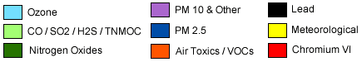
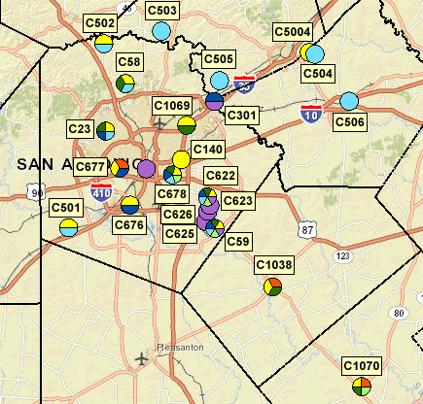

Meteorological and Photochemical Modeling Development

EPA Modeling Guidance

If a region fails to meet the National Ambient Air Quality Standards (NAAQS), EPA can designate the region as a non-attainment area. The state must submit a State Implementation Plan (SIP) revision designed to achieve attainment of the ozone NAAQS for all nonattainment areas. Most ozone SIPs require photochemical modeling be conducted to determine if a region can meet air quality standards. EPA modeling guidance provides a detailed process, from the planning stage through control strategy development and evaluation, for developing and analyzing photochemical modeling episodes.

Model Selection

The Weather Research and Forecasting (WRF) model was selected for the meteorological inputs into the photochemical model. WRF v3.2, released in April 2010, was used to calculate the meteorological inputs for the June 2006 photochemical model. The “WRF Model is a next-generation mesoscale numerical weather prediction system designed to serve both operational forecasting and atmospheric research needs. It features multiple dynamical cores, a 3-dimensional variational (3DVAR) data assimilation system, and a software architecture allowing for computational parallelism and system extensibility. WRF is suitable for a broad spectrum of applications across scales ranging from meters to thousands of kilometers.”

The latest version of Comprehensive Air Quality Model with Extensions (CAMx 6.0) eulerian photochemical dispersion model was used in all the photochemical model runs performed by AACOG. CAMx advanced technical features were used to model the June 2006 episode and are described in the CAMx user guide. The advanced CAMx features include:

- Two-way nested grid structure: for the 36-, 12-, and 4-km grid system
- Plume-in-grid (PiG): to track chemistry and dispersion of large individual point source NO_{X} emission plumes
- Horizontal advection solver: Piecewise Parabolic Method (PPM)
- Gas phase chemistry mechanism: Carbon Bond Version 6 (CB6)
- Multiple gas phase chemical solver: set to Euler-Backward Iterative (EBI) to increase the speed and accuracy of the chemistry solution
- Dry deposition model: set to ZHANG03 – “This parameterization calculates particle dry deposition velocities as a function of particle size and density as well as relevant meteorological variables.”

All the CAMx advanced settings used to simulate the May 24th to July 2nd, June 2006 episode are consistent with settings used to conduct SIP modeling for other areas in Texas. Both the CAMx and WRF models are being used to develop ozone air quality attainment demonstrations for multiple Texas regions including Dallas and Houston. The attainment demonstrations are used to determine if a region meets the ozone NAAQS. Both WRF and CAMx met all EPA recommendations regarding the selection of a model.

Modeling Domain
The modeling domain identifies the geographic boundaries of the study area including the horizontal grid, vertical layers, and initial and boundary conditions. The June 2006 meteorological and photochemical modeling domains include all of the eastern and central U.S. as well as parts of southeastern Canada and northern Mexico. The modeling domains are large enough to capture major sources that would be upwind from San Antonio, as winds tend to arrive from the southeast, east, and northeast on ozone exceedance days.

The photochemical modeling domain covers a much larger geographical area than southern Texas alone to reduce the influence of boundary conditions (Figure 2-1). The grid system used in the model is consistent with EPA’s Regional Planning Organizations (RPO) Lambert Conformal Conic map projection with the following parameters:

• First true latitude (Alpha): 33°N
• Second true latitude (Beta): 45°N
• Central longitude (Gamma): 97°W
• Projection origin: (97°W, 40°N)
• Spheroid: perfect sphere, radius: 6,370 km

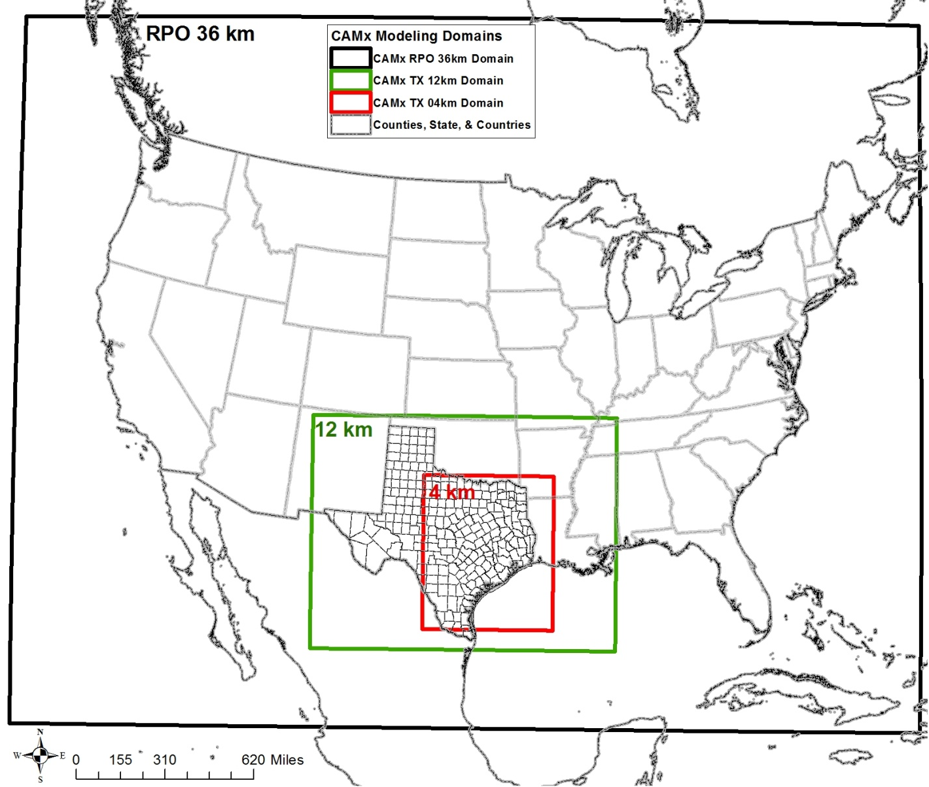
Figure 2-1: Nested Photochemical Modeling Grids for June 2006 Episode
Coordinates from NW to SE corners:
CAMx RPO 36-km = 148 x 112 (-2,736, 1,944) to (2,592, -2,088)
CAMx TX 12-km = 149 x 110 (-984, -312) to (804, -1,632)
CAMx TX 4-km = 191 x 218 (-328, -644) to (436, -1,516)

Plot Date: June 26, 2014
Fuel Type
Green: Biomass
Blue: Natural Gas
Red: Coal
Black: Petcoke
Map Compilation: June 10, 2013
Source: TCEQ.

The meteorological model has 38 vertical layers extending from the surface up to approximately 15 km, while the CAMx model uses 28 vertical layers up to approximately 13.6 km. The surface layer is roughly 34 m thick. The meteorological and photochemical layers are finer at the surface to capture vertical gradients as the mixing height changes during the day and to model pollutant concentrations at the surface.

Base Case Emissions Inventory
Two anthropogenic emission inventories were created for the June 2006 modeling episode: 2012 projection case, and 2018 projection case. The model was run with the projected emission inventories to predict the impact of emissions changes over time–both quantitative and spatial–on ozone formation and dispersion. Model inputs accounted for the chemical and meteorological characteristics associated with the May 24-July 2, 2006 episode. The meteorological inputs, chemistry parameters, and biogenic emissions were identical for every model run.

Before the emission inventories were entered into the photochemical model, the emissions were pre-processed using the Emissions Processing System 3.0 (EPS3) to allocate the data to the proper spatial and temporal resolutions used by the photochemical model. The Emissions Processing System allocates emissions to account for monthly, weekly, and hourly variations in emission rates, assigns emissions to the appropriate grid cells, and disaggregates or speciates chemical compounds for the photochemical model’s chemical mechanism. To accurately predict ozone formation, the photochemical model requires a detailed emission inventory for every grid used in the model.

Emission Inventory Parameters
CO, NO_{X}, and VOC emissions from all anthropogenic and biogenic sources were included in the model for all grid domains. Emissions data was processed through EPS3 for the following source categories:

- Biogenic
- Point
- Area
- Non-road
- Off-road
- Oil and gas (including the Eagle Ford)
- Mobile

The emissions for each of these categories were temporally allocated to the appropriate hours, week days, and seasons based on data obtained from surveys of local sources. In the absence of survey data, EPA defaults or other appropriate surrogates were used. All VOC and NO_{X} emissions were chemically speciated in EPS3 based on the latest version of the carbon bond mechanism design, Carbon Bond 6 (CB6).

Quality Assurance (QA)
“An overall QA program comprises two distinct components. The quality control (QC) is systems of routine technical activities implemented by inventory development personnel to measure and control the quality of the inventory as it is being developed. The QC system is designed to:

- Provide routine and consistent checks and documentation points in the inventory development process to verify data integrity, correctness, and completeness;
- Identify and reduce errors and omissions;
- Maximize consistency within the inventory preparation and documentation process; and
- Facilitate internal and external inventory review processes.

QC activities include technical reviews, accuracy checks, and the use of approved standardized procedures for emission calculations. These activities should be included in inventory development planning, data collection and analysis, emission calculations, and reporting.”

Equations, data sources, and methodologies were checked throughout the processing of each emission source. “Simple QA procedures, such as checking calculations and data input, can and should be implemented early and often in the process. More comprehensive procedures should target:

- Critical points in the process;
- Critical components of the inventory; and
- Areas or activities where problems are anticipated”

Quality assurance (QA) procedures used to check emissions inventory preparation for the photochemical mode included:

- Examination of raw data files for inconsistencies in emissions and/or locations,
- Review of message files from EPS3 scripts for errors and warnings,
- Verification of consistency between input and output data, and
- Creation of output emissions and ozone tile plots for visual review.

Special emphasis was placed on critical components, such as on-road vehicles, Eagle Ford emission sources, and point sources, for quality checks.

All raw data files were checked to ensure emissions were consistent by county and source type. Any inconsistencies were noted, checked, and corrected. When running the EPS3 job scripts, several message files are generated from each script that record data inputs, results, and errors. As part of the QA procedure, modeling staff reviewed all error messages and corrected the input data accordingly.

Errors can occur in EPS3 and go unnoticed by the built-in quality assurance mechanisms; therefore, further QA methods were applied. Input and output emissions by source category were compared. If there were inconsistencies between values, input data was reviewed and any necessary corrections were made. Emission tile plots by source category were also developed and reviewed for inconsistencies in emissions and spatial allocation. When errors and omissions were identified, they were corrected and all documentation was updated with the corrections.

Emission Inventory Projections, 2012 and 2018
The 2012 and 2018 projection inventories were used as inputs in the photochemical model to calculate future ozone concentrations. Table 2-1 shows the data sources for the 2012 and 2018 Emissions Inventory. The 2012 and 2018 modeling emission inventories account for existing and planned emission control strategies, including the Federal Motor Vehicle Control Program (FMVCP), Texas Low Emission Diesel (TxLED) program, Tier 4 emission standards, Mass Emissions Cap and Trade (MECT) program in Houston, Highly Reactive VOC Emission Cap and Trade (HECT) program in the Houston, and phase one of the cross-state air pollution rule (CSAAPR).

Table 2-1: Emission Inventory Sources by Type for 2012 and 2018
Type | Sub Category | Source
Point | Electric Generating Units (EGU) | - Ozone Season Day emissions from TCEQ  - Each modeling day has the same emissions  - Local data for EGUs in the San Antonio-New Braunfels MSA (CPS Energy and San Miguel)  - Local Data from Capital Area Council of Governments (CAPCOG) for all EGUs
 | Non-Electric Generating Units (NEGU) | - Ozone Season Day emissions from TCEQ  - Local data for Cement Kilns in the San Antonio-New Braunfels MSA and Austin–Round Rock–San Marcos MSA (Alamo Cement, Chemical Lime, Capitol Cement, TXI, CEMEX)  - Local data from CAPCOG for al NEGUs  - Offshore platforms monthly emissions from 2011 GWEI.
Area | Area Sources | - Ozone Season Day emissions from TCEQ  - Local data from CAPCOG for commercial fuel consumption and industrial fuel consumption
Mobile | All Categories | - Ozone Season Day emissions from TCEQ using MOVES 2014.  - Within Texas, the vehicle miles traveled (VMT) estimates are based on the Highway Performance Monitoring System (HPMS) for more rural areas.  - Local data for Extended Diesel Truck Idling  - Local data from CAPCOG heavy duty truck idling
Non-Road | All Categories | - Ozone Season Day emissions from TCEQ using TexN 1.61 model  - Local data for construction equipment, quarry equipment, mining equipment, landfill equipment, agricultural tractors, and combines projected to 2012 and 2018 using TexN model  - Local data from CAPCOG for construction and mining equipment, industrial equipment, agricultural equipment, and residential lawn and garden equipment
Off-Road | Locomotives | - Ozone Season Day emissions from TCEQ based on the 2011 NEI for linehaul and switcher locomotives
 | Marine | - Ozone Season Day emissions from TCEQ
 | Aircraft | - Ozone Season Day emissions from TCEQ using Eastern Research Group (ERG) 2011 airport Data  - Local data for San Antonio International Airport (SAIA)  - Local data from CAPCOG for Austin-Bergstrom International Airport (ABIA)

Type | Sub Category | Source
Oil and Gas | Oil and Gas Production | - Oil and gas shale production emission inventory from TCEQ for Barnet, Haynesville, and Permian Basin  - Other oil and gas emissions, including offshore, from TCEQ  - Local Data from CAPCOG for construction and mining equipment, industrial equipment, oil and gas equipment, agricultural equipment, , commercial fuel consumption, industrial fuel consumption, Austin-Bergstrom International Airport, residential lawn and garden equipment, heavy duty truck idling
 | Drill Rig | - Drill rigs emissions from TCEQ
 | Eagle Ford | - Local Eagle Ford Emission Inventory for Exploration, Pad Constriction, Drilling, Hydraulic Fracturing, Completion, Production, Mid-Stream, and On-Road emissions
Biogenic | All Categories | - Same emissions as 2006

Eagle Ford Emissions
“The Eagle Ford Shale is a hydrocarbon producing formation of significant importance due to its capability of producing both gas and more oil than other traditional shale plays. It contains a much higher carbonate shale percentage, upwards to 70% in south Texas, and becomes shallower and the shale content increases as it moves to the northwest. The high percentage of carbonate makes it more brittle and ‘fracable’.” Hydraulic fracturing is a technological advancement which allows producers to recover natural gas and oil resources from these shale formations. Emission processes include exploration and pad construction, drilling, hydraulic fracturing and completion operations, production, and midstream facilities. Emissions sources can include drill rigs, compressors, pumps, heaters, other non-road equipment, process emissions, flares, storage tanks, and fugitive emissions.

Existing oil and gas production inventories in Texas and data from the Railroad Commission of Texas were used to develop an emissions inventory of the Eagle Ford. These studies include: Eastern Research Group’s (ERG) “Characterization of Oil and Gas Production Equipment and Develop a Methodology to Estimate Statewide Emissions”, ERG’s Drilling Rig Emission Inventory for the State of Texas, and ENVIRON’s ”An Emission Inventory for Natural Gas Development in the Haynesville Shale and Evaluation of Ozone Impacts.” TCEQ conducted a mail survey through the Barnett Shale area special inventory phase two study on natural gas fracturing operations west of Dallas. The results from the final Barnett Shale study were also used to calculate production and midstream emissions. TCEQ’s statewide survey on pneumatic devises was also used to calculate emissions. Through this process, local officials worked with oil and gas companies, drilling contractors, engine manufactures, and industry representatives to refine data inputs and the emission inventory.

Heavy duty diesel trucks carry equipment and light duty trucks transport employees and supplies to the well pad. TxDOT collected short term traffic count data during May 2012 in districts that are being impacted by oil, gas, and wind energy expansion activities. Traffic count data was collected in the Eagle Ford from the TxDOT districts of Corpus, Laredo, Pharr, San Antonio, and Yoakum. Most of the 15 minute traffic counts were collected over one or two days. The data collected included data hourly counts by vehicle classification for each traffic lane at the 16 sites used in this study (Figure 2-2). Traffic count data on additional 10 sites in these TxDOT traffic districts was collected, but the data at these sites was not used in this study because the sites were not located in the Eagle Ford or on major highways. The traffic count data was collected by TxDOT using Federal Highway Administration (FHWA) 13-bin vehicle classification system. The FHWA bin classification was converted to MOVES2014 Source Type ID in Table 2-2 to calculate on-road emission factors. All vehicles used are passenger truck or short-haul trucks because the truck operating in the Eagle Ford only travels short distances and passenger cars do not have the capability to drive on well pad sites.

EPA’s MOVES2014 model was used to estimate emissions from vehicles while idling or transporting employees, equipment, and materials to the oil fields for 2012 and 2018. Since the contiguous Eagle Ford counties experience similar meteorological conditions, MOVES2014 was run only for Webb County and the results were applied to the rest of the counties. For climate and transportation inputs, all MOVES’s default data was used with the exception of the vehicle speed table which had been modified for an average speed of 35 miles per an hour. Similar to the Pinedale Anticline Project in Wyoming, an average speed of 35 miles per hour was used for both vehicle types because the 25 miles per hour used in other studies are too slow for rural areas typical of the Eagle Ford (Table 2-3).

NO_{X} emission reductions from the use of TxLED in affected counties were included in the calculations of on-road emissions. According to TCEQ, “TxLED requirements are intended to result in reductions in NO_{X} emissions from diesel engines. Currently, reduction factors of 5.7% (0.057) for on-road use and 7.0% (0.07) for non-road use have been accepted as a NO_{X} reduction estimate resulting from use of TxLED fuel. However, this reduction estimate is subject to change, based on the standards accepted by the EPA for use in the Texas State Implementation Plan (SIP).” Figure 2-3 shows the hourly distribution for heavy duty trucks, while Figure 2-4 shows the hourly distribution for light duty trucks used to adjust hourly on-road emissions. The same hourly breakdown for light duty and heavy duty vehicles were used for each Eagle Ford on-road emission inventory category.

Figure 2-2: TxDOT Traffic Count Locations in the Eagle Ford Region
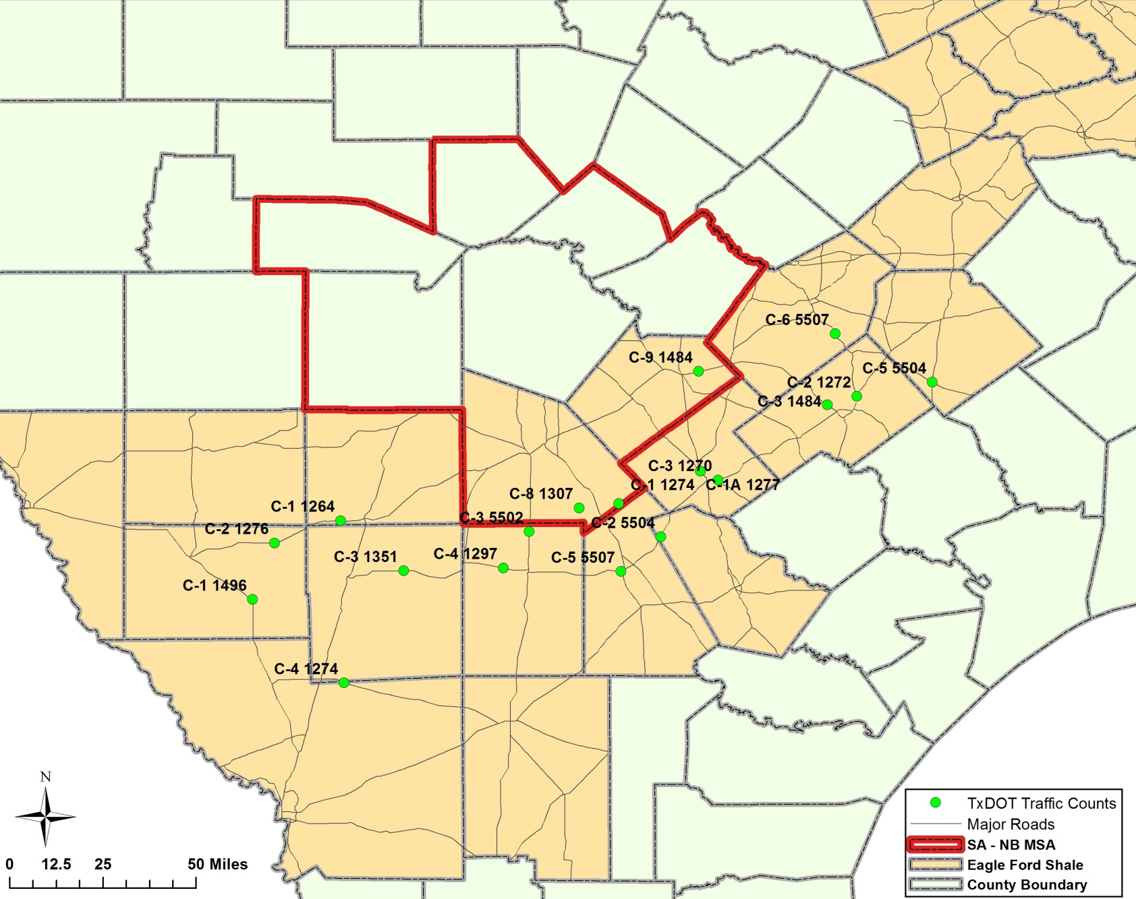

Table 2-2 TxDOT Traffic Count Data and MOVES Source Type, 2012
Description | FHWA Vehicle Class | Traffic Counts | MOVES Source Type ID | Fuel Type | Percentage | Eagle Ford EI Vehicle Classification
Motorcycles | 1 | 738 | Not Used
Passenger cars | 2 | 23,880
Other 2-axle, 4-tire single-unit vehicles | 3 | 52,200 | 31 (Passenger Truck) | Gasoline and Diesel | 100.0% | Employees and Supplies
Buses | 4 | 179 | Not Used
2-axle, 6-tire single-unit trucks | 5 | 3,377 | 52 (Single Unit Short-haul Truck) | Diesel | 19.5% | Equipment
3-axle single-unit trucks | 6 | 2,410
4- or more axle single-unit trucks | 7 | 505
4- or less axle single-trailer trucks | 8 | 2,641 | 61 (Combination Short-haul Truck) | Diesel | 80.5%
5-axle single-trailer trucks | 9 | 17,979
6- or more axle single-trailer trucks | 10 | 1,951
5- or less axle multi-trailer trucks | 11 | 1,222
6-axle multi-trailer trucks | 12 | 191
7- or more axle multi-trailer trucks | 13 | 1,995

Table 2-3 MOVES2014 Ozone Season Day Emission Factors for On-Road Vehicles in Eagle Ford Counties, 2012
Vehicle Type | Fuel Type | Location | Speed | VOC EF | NO_{X} EF | CO EF
Light Duty Trucks | Diesel and Gasoline | On-Road | 35 mph | 1.012 g/mile | 1.432 g/mile | 11.090 g/mile
 |  | Idling | - | 8.866 g/hr | 8.155 g/hr | 84.594 g/hr
Heavy Duty Trucks | Diesel | On-Road | 35 mph | 0.775 g/mile | 8.866 g/mile | 2.892 g/mile
 |  | Idling | - | 20.338 g/hr | 120.392 g/hr | 72.269 g/hr

Figure 2-3: Distribution of Heavy Duty Trucks by Time of Day in the Eagle Ford, 2012
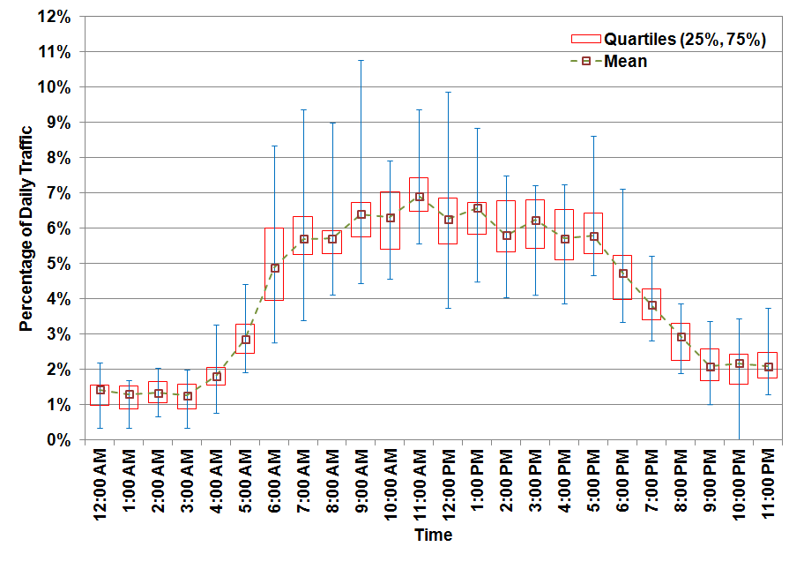

Figure 2-4: Distribution of Light Duty Trucks by Time of Day in the Eagle Ford, 2012
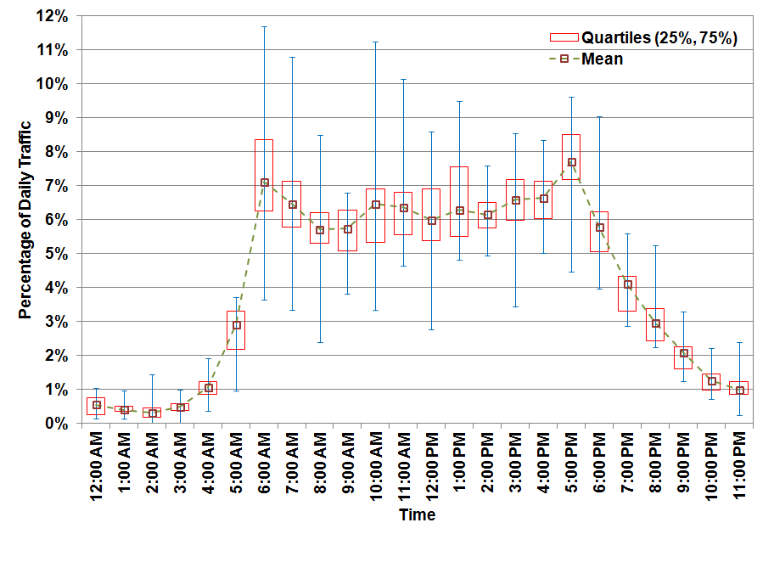

Summary of the 2012 and 2018 Projection Year Emission Inventory Development
Projected NO_{X} and VOC emissions (tons/day) for the San Antonio-New Braunfels MSA region are provided in Figure 2-5 and Figure 2-6. Emissions are lower on Saturday and Sunday compared to weekdays. Estimated NO_{X} emissions are significantly lower in 2018: emissions decreased from 172 tons per weekday in 2012 to 134.0 tons per weekday in 2018. VOC emissions increased from 239 tons per weekday in 2012 to 249 tons per weekday in 2018.

The largest source of NO_{X} emissions in 2012 are on-road vehicles, 76 tons per weekday, followed by point, 58 tons per weekday, and oil and gas production, 13 tons per weekday (Table 2-4). By 2018, the largest sources of NO_{X} emissions are point, 70 tons per weekday, followed by on-road, 37 tons per weekday, and non-road, 12 tons per weekday. As expected, the largest contributors of VOC emissions are oil and gas production at 101 tons per weekday and area sources at 100 tons per weekday in 2018 (Table 2-5). Other significant sources of VOC emissions in the San Antonio-New Braunfels MSA are on-road, 23 tons per weekday in 2018, and non-road, 14 tons per weekday in 2018.

Figure 2-5: NO_{X} Emissions (tons/day) for the San Antonio-New Braunfels MSA, 2012 and 2018
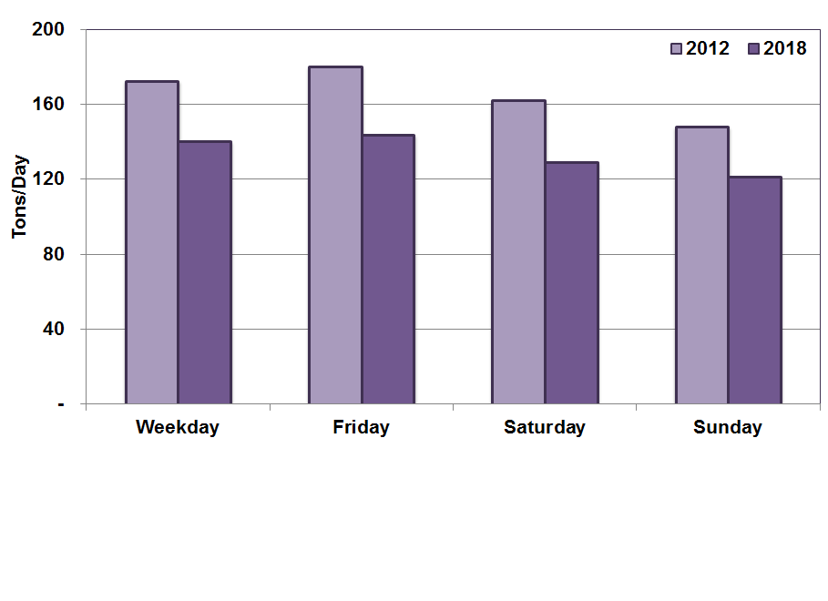

Figure 2-6: VOC Emissions (tons/day) for the San Antonio-New Braunfels MSA, 2012 and 2018
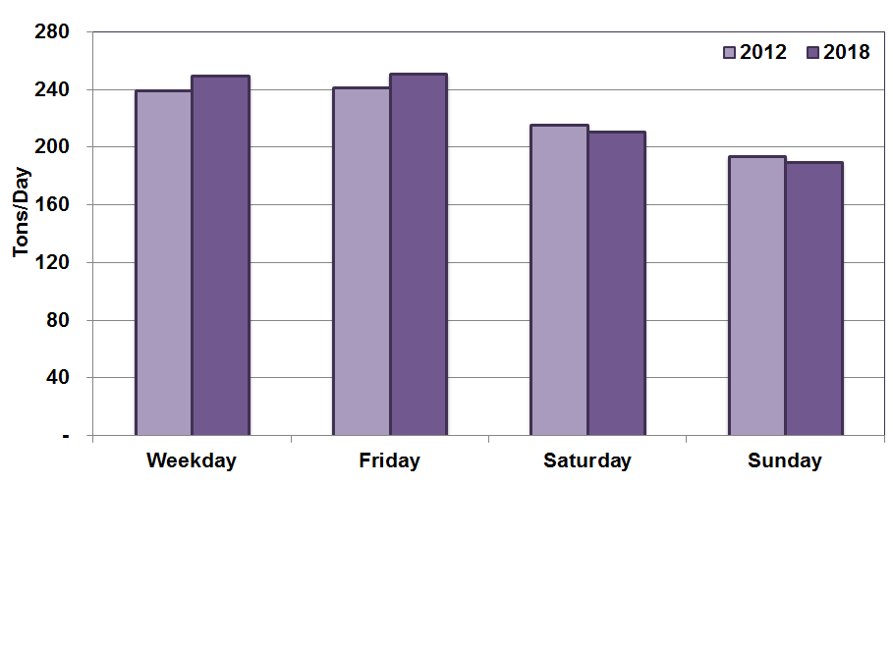

Table 2-4: NO_{X} Emissions (tons/day) for the San Antonio-New Braunfels MSA, 2012 and 2018 Eagle Ford Moderate Scenario
Year | Day of Week | On-Road | Point | Area | Non-Road | Off-Road | Oil and Gas | Total NO_{X}
2012 | Weekday | 76.0 | 57.5 | 7.8 | 10.7 | 7.2 | 12.9 | 172.1
 | Friday | 83.8 | 57.5 | 7.8 | 10.7 | 7.2 | 12.9 | 179.9
 | Saturday | 62.2 | 57.5 | 6.1 | 15.8 | 7.2 | 12.9 | 161.6
 | Sunday | 52.3 | 57.5 | 4.4 | 13.4 | 7.2 | 12.9 | 147.6
2018 | Weekday | 37.4 | 69.8 | 8.1 | 12.4 | 6.5 | 5.6 | 139.9
 | Friday | 41.0 | 69.8 | 8.1 | 12.4 | 6.5 | 5.6 | 143.4
 | Saturday | 30.5 | 69.8 | 6.3 | 10.2 | 6.5 | 5.6 | 128.9
 | Sunday | 26.0 | 69.8 | 4.5 | 8.6 | 6.5 | 5.6 | 120.9

Table 2-5: VOC Emissions (tons/day) for the San Antonio-New Braunfels MSA, 2012 and 2018 Eagle Ford Moderate Scenario
Year | Day of Week | On-Road | Point | Area | Non-Road | Off-Road | Oil and Gas | Total VOC
2012 | Weekday | 35.3 | 9.7 | 96.3 | 9.8 | 1.1 | 86.7 | 238.9
 | Friday | 36.9 | 9.7 | 96.3 | 9.8 | 1.1 | 86.7 | 240.6
 | Saturday | 31.4 | 9.7 | 50.2 | 36.0 | 1.1 | 86.7 | 215.1
 | Sunday | 29.7 | 9.7 | 32.4 | 33.7 | 1.1 | 86.7 | 193.4
2018 | Weekday | 23.2 | 10.0 | 99.9 | 14.2 | 1.1 | 101.0 | 249.3
 | Friday | 24.0 | 10.0 | 99.9 | 14.2 | 1.1 | 101.0 | 250.1
 | Saturday | 20.9 | 10.0 | 51.9 | 24.9 | 1.1 | 101.0 | 209.9
 | Sunday | 20.1 | 10.0 | 33.6 | 23.3 | 1.1 | 101.0 | 189.1

Emission Inventory Tile Plots

The graphic software, Package for Analysis and Visualization of Environmental data (PAVE), was used to display EPS3 formatted 4-km fine grid emissions by source type. Tile plots are used to visually verify the distribution of emissions in the photochemical model compared to actual locations. Also, hourly tile plots were checked to make sure there were no unusual patterns of emissions. Through the use of emission tile plots, the photochemical modeling emission inputs were evaluated spatially for accuracy using EPA modeling guidance.

Emission plots of TCEQ emission files in PAVE were used to check the emission inventory inputs. Texas Area Source NO_{X} and VOC emissions tile plots are provided in Figure 2-7 for 2012, and 2018. As expected, these plots show concentrations of high NO_{X} and VOC emissions in the population centers Texas. The highest emissions are in Houston, Dallas, San Antonio, and Austin, while the less populated counties tend to have the lowest emissions. When comparing projection years, area source emissions are similar for 2012, and 2018. There is a significant decrease in total on-road NO_{X} and VOC emissions from 2012 to 2018 (Figure 2-8). Reasons for these decreases can be attributed to more stringent emissions standards for gasoline and diesel engines, and attrition of older, higher polluting vehicles. The largest concentrations of on-road emissions are in Dallas, Houston, Austin, and San Antonio. On-road emissions are also concentrated in other urban areas and along major highways including I-10, I-35, and I-37.

Similar to on-road emissions, there is a significant decrease in non-road emissions from 2012 to 2018 (Figure 2-9). Like area sources, non-road emissions were concentrated in large urban areas in Texas. Oil and gas emissions are concentrated in oil and gas fields across Texas and Louisiana (Figure 2-10). NO_{X} emissions across all the fields decreased in 2018 as emission controls are placed on compressors and cleaner Tier 4 generators replace older equipment. Overall there is a decrease in oil and gas VOC emissions, but emissions from some fields increase depending on projected growth in production.

Off-road emissions on land are concentrated along railway lines with some emissions near large lakes in Texas (Figure 2-11). Offshore emissions are also concentrated along main shipping channels with major destinations to Corpus Christi, Galveston, Houston, Beaumont, and Lake Charles. These cities have major port facilities for transporting raw materials and finished products. Low level point source emissions below 34 meters are concentrated in Dallas, Houston, and San Antonio (Figure 2-12). These urban areas have the highest concentrations of large industrial point sources. There are also numerous low level off-shore point sources in the 4km grid. The off shore point sources are usually oil and gas production facilities.

Figure 2-7: Texas Area Emissions 4-km Grid Tile Plots, 2012 and 2018 Weekday, 12:00–13:00
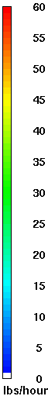
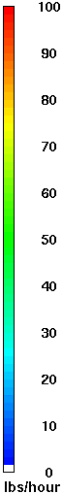
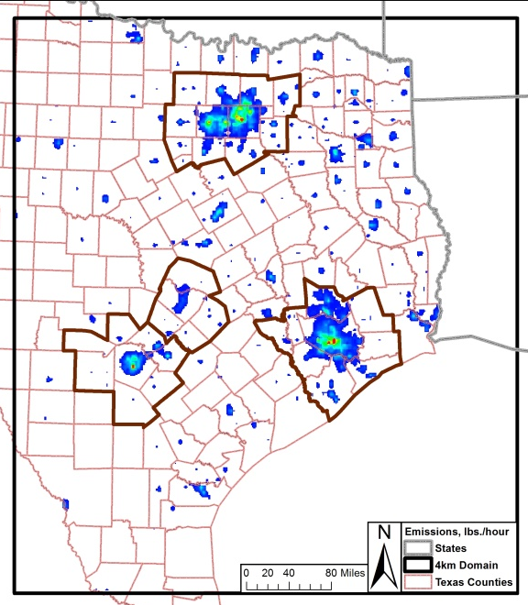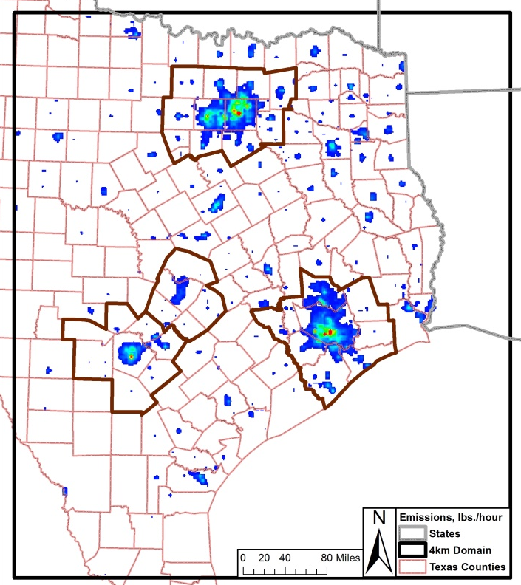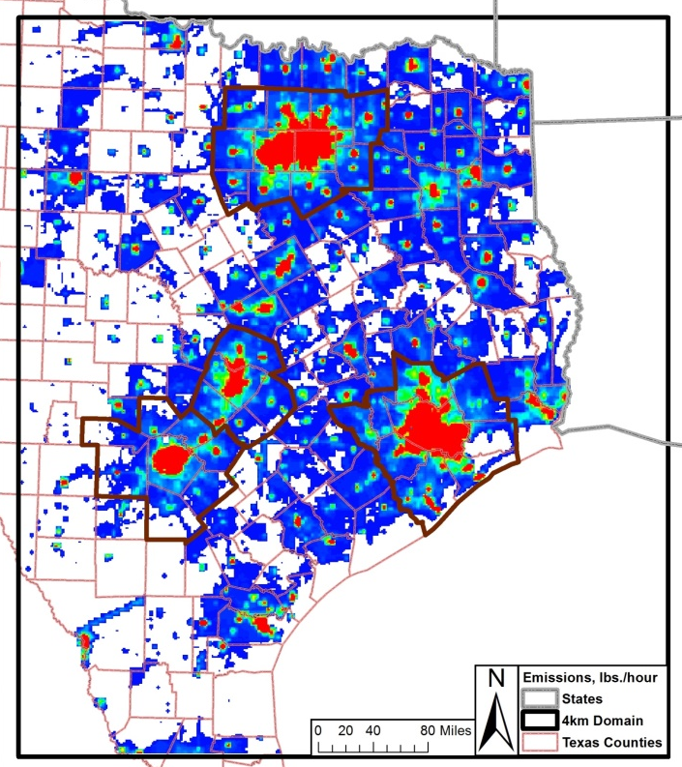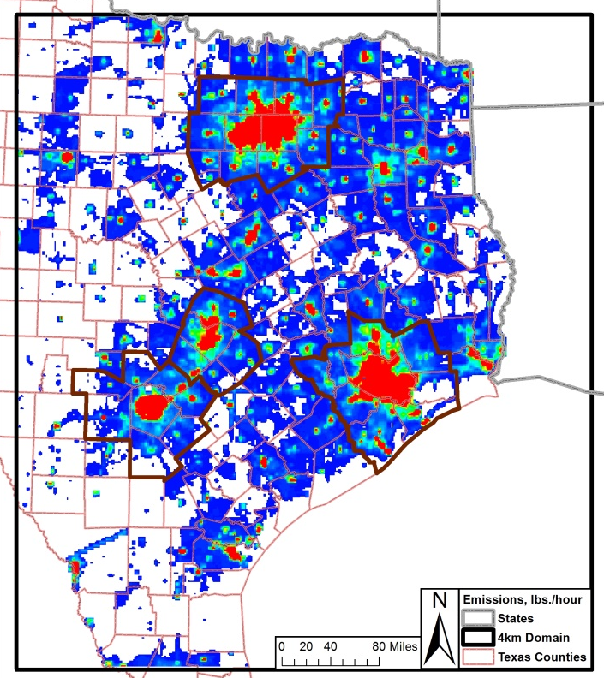
2012 NO_{X} 2018 NO_{X}

2012 VOC 2018 VOC

Figure 2-8: United States On-Road Emissions 4-km grid Tile Plots, 2012 and 2018 Weekday, 12:00 – 13:00
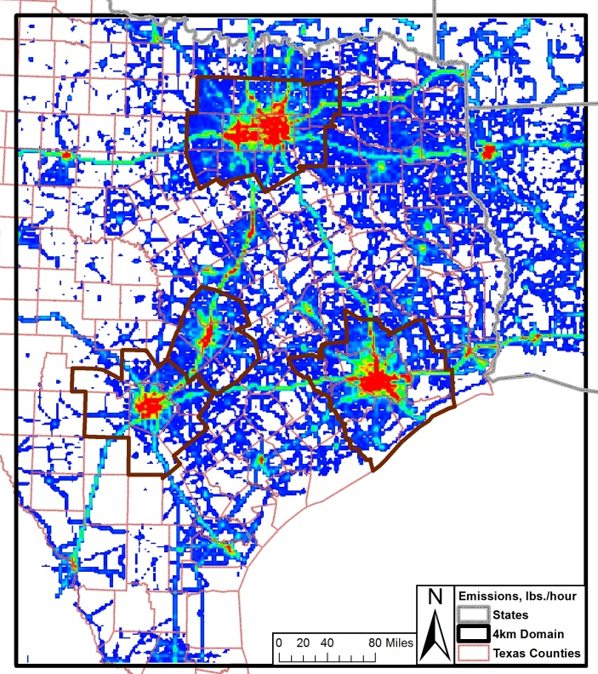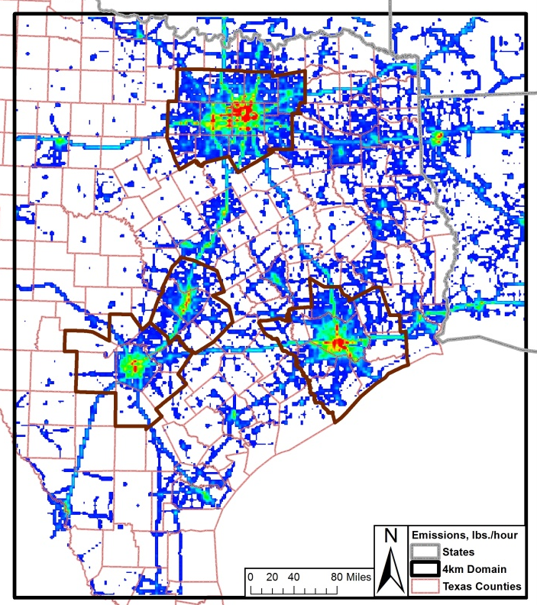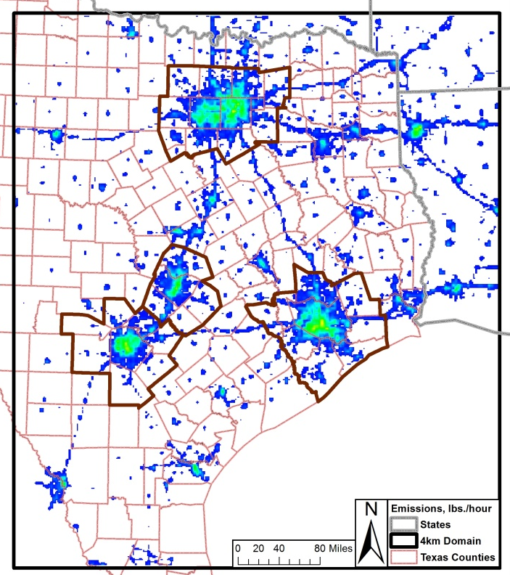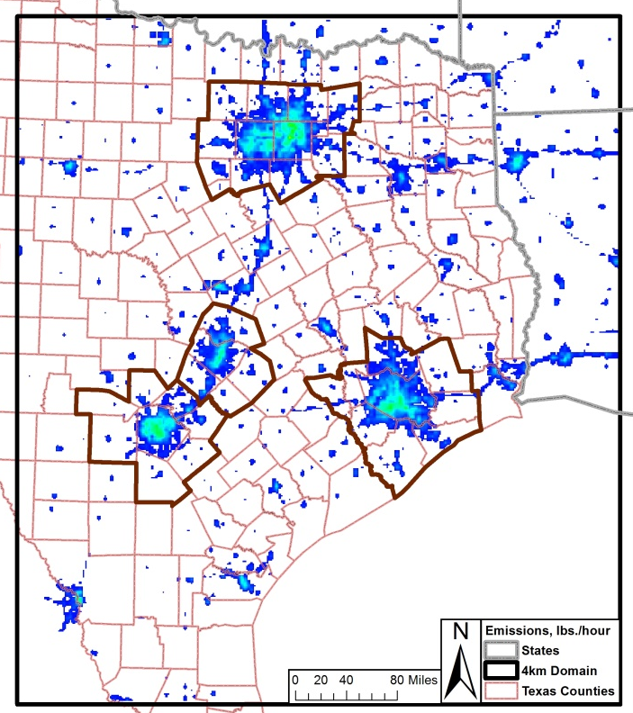
2012 NO_{X} 2018 NO_{X}

2012 VOC 2018 VOC

Figure 2-9: Texas Non-Road Emissions 4-km grid Tile Plots, 2012 and 2018 Weekday, 12:00 – 13:00
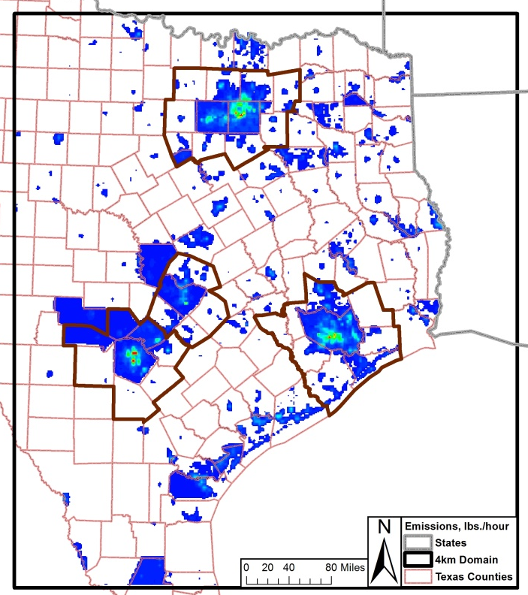
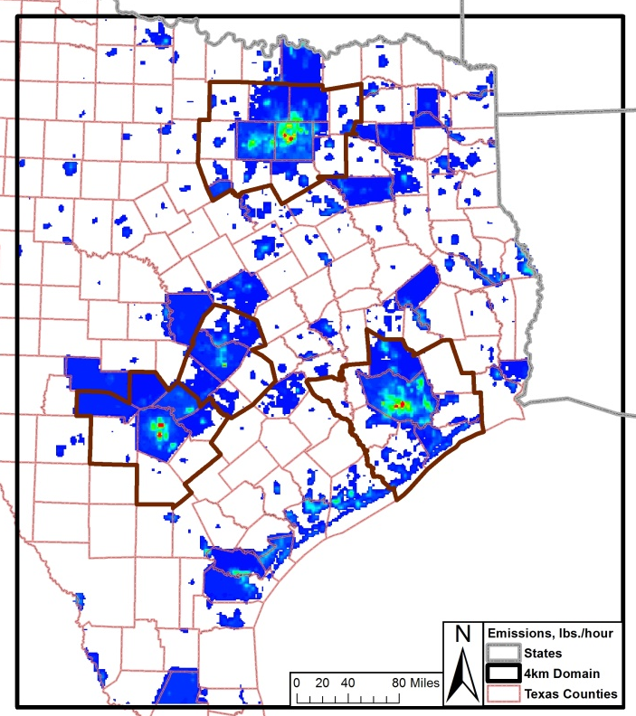
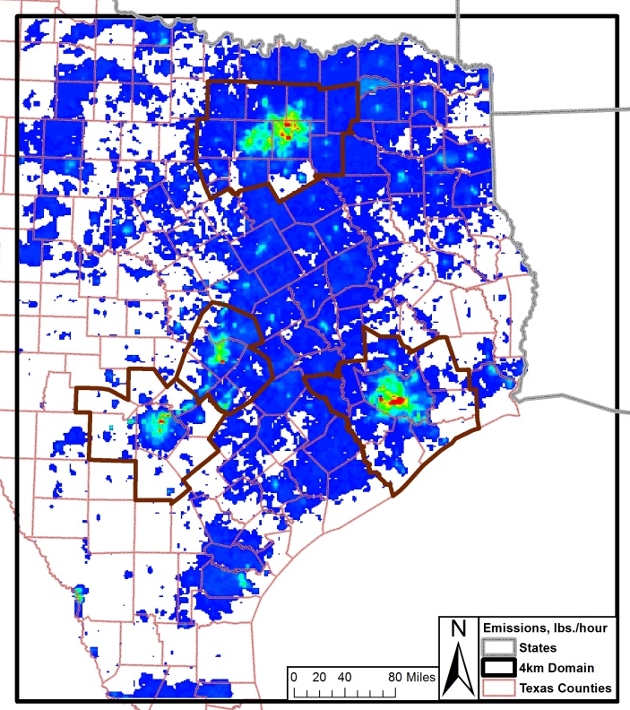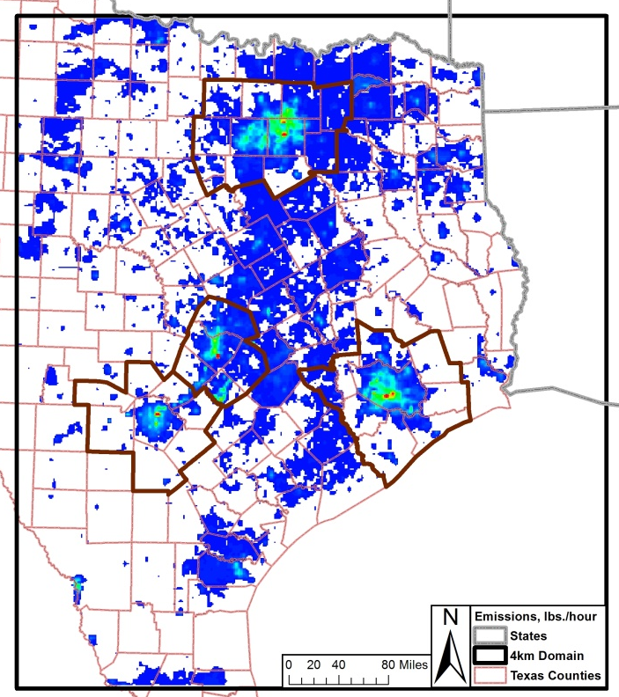
2012 NO_{X} 2018 NO_{X}

2012 VOC 2018 VOC

Figure 2-10: United States Oil and Gas Emissions 4-km grid Tile Plots, 2012 and 2018 Weekday, 12:00 – 13:00
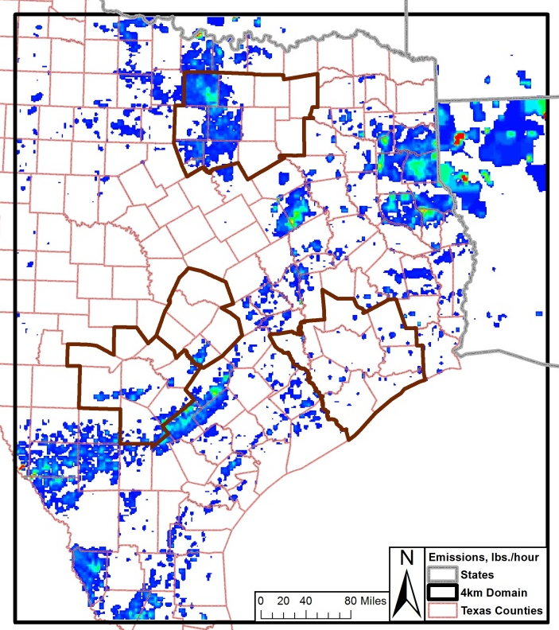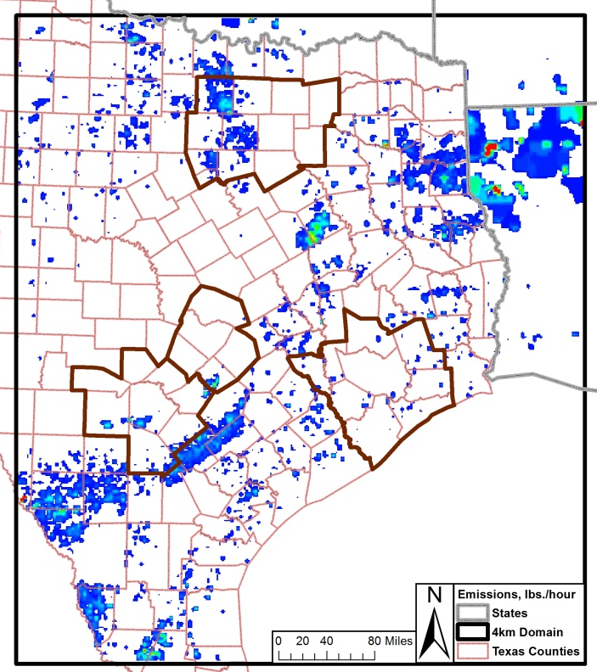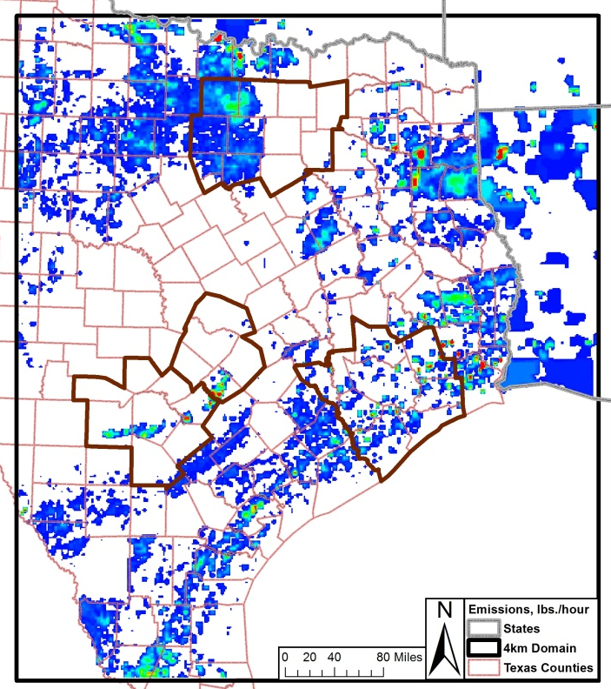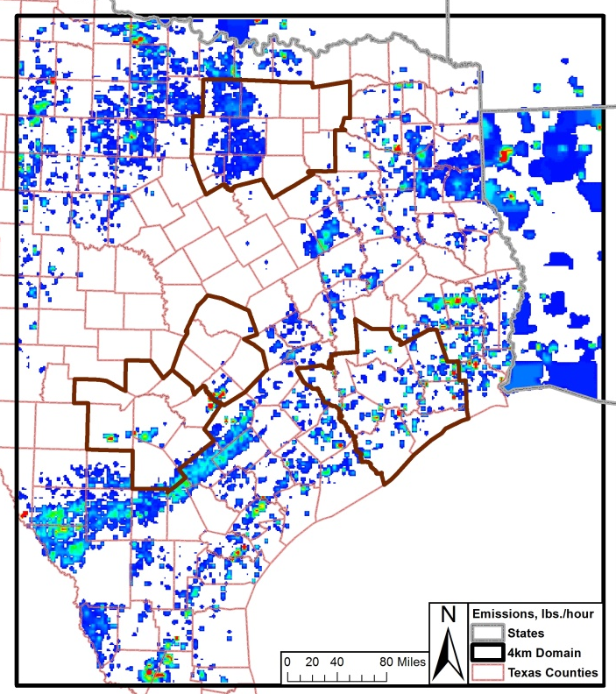
2012 NO_{X} 2018 NO_{X}

2012 VOC 2018 VOC

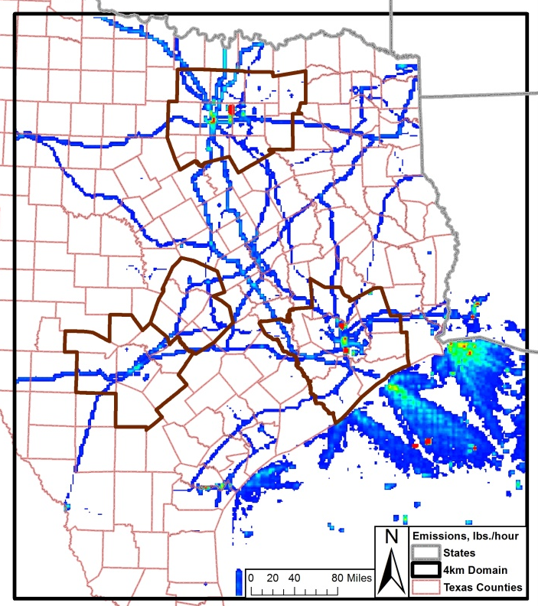
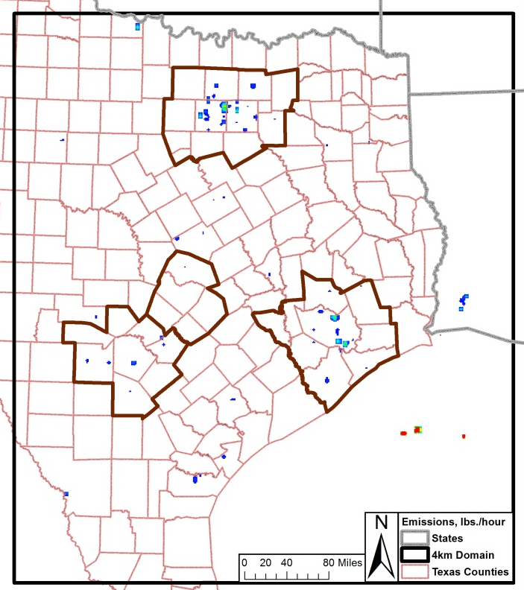
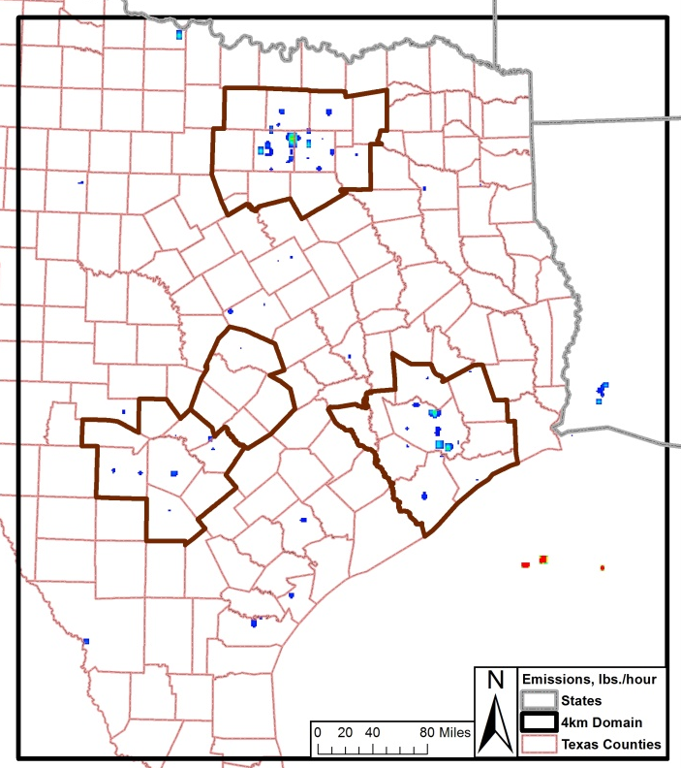
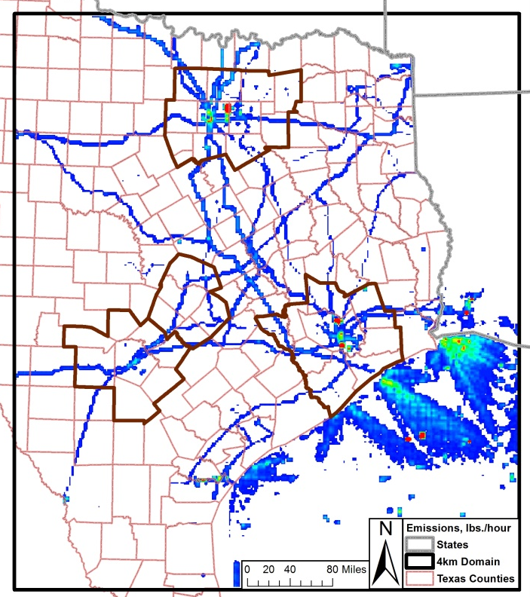
Figure 2-11: United States Off-Road Emissions 4-km grid Tile Plots, 2012 and 2018 Weekday, 12:00 – 13:00
2012 NO_{X} 2018 NO_{X}

2012 VOC 2018 VOC

Figure 2-12: Texas Low Points Emissions 4-km grid Tile Plots, 2012 and 2018 Weekday, 12:00 – 13:00
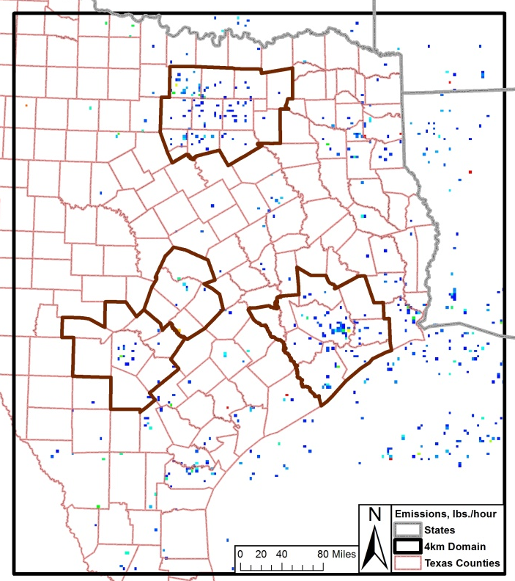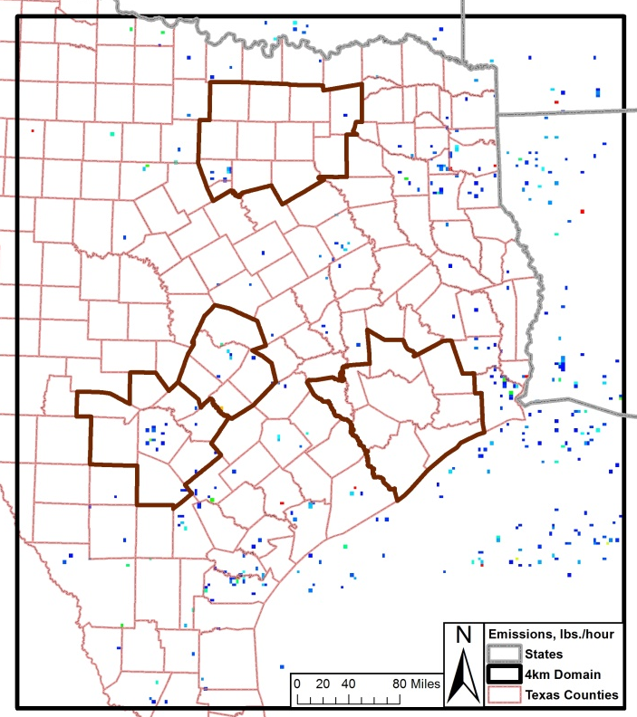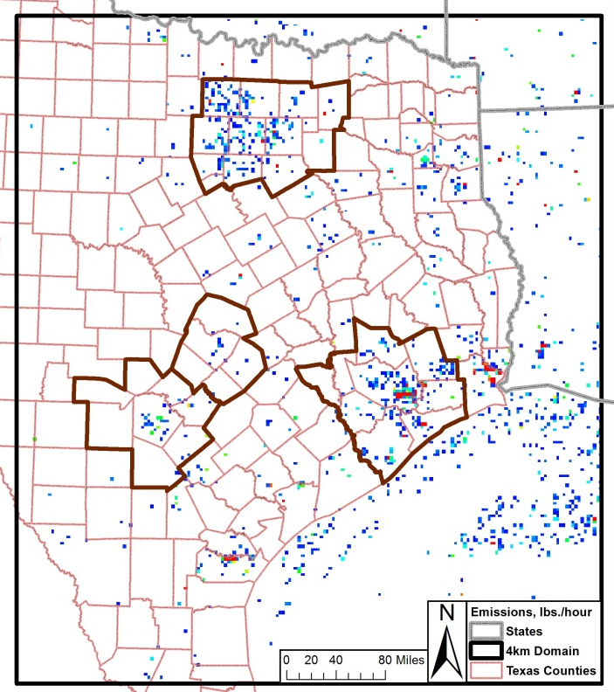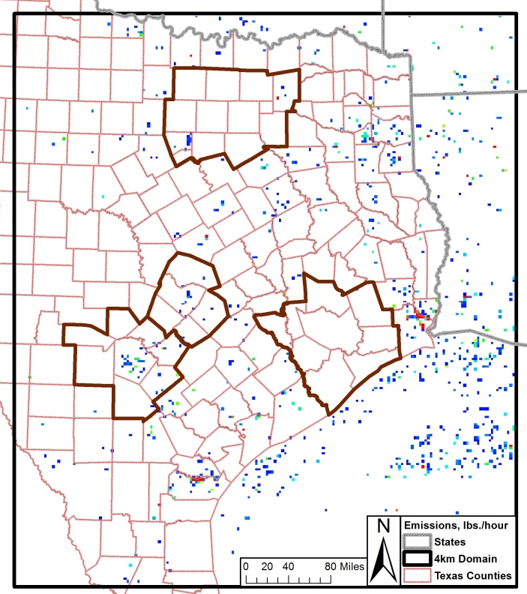
2012 NO_{X} 2018 NO_{X}

2012 VOC 2018 VOC

Future Year Modeling

The photochemical model developed to simulate the May 24th – July 2nd, June 2006 high-ozone episode was updated with 2012 and 2018 projected anthropogenic emission inventories to estimate predicted future ozone concentrations under the same meteorological conditions as the 2006 base case. The projected emission inventories account for existing local, state, and federal air quality control strategies to determine whether such measures are sufficient to help the region meet a revision to the NAAQS 8-hour ozone standard. The 2018 projection cases were compared to the 2012 projection cases to determine future ozone design values.

Projections Cases
A total of 4 projection cases were developed from the June 2006 modeling episode.

Projection Case 1: 2012 with projected Emission Inventory

- WRF v3.2
- RPO Grid
- CAMx 6.00
- EPS3
- Projected 2012 Emission Inventory by AACOG
- Local 2012 San Antonio-New Braunfels MSA emission data including construction equipment, landfill equipment, quarry equipment, agricultural tractors, combines, commercial airports, point sources, and heavy duty truck idling
- Eagle Ford 2012 emission inventory
- Updated 2012 CAPCOG and Milam counties emission inventory including construction and mining equipment, industrial equipment, oil and gas equipment, agricultural equipment, commercial fuel consumption, industrial fuel consumption, Austin-Bergstrom International Airport, residential lawn and garden equipment, heavy duty truck idling, EGU, and NEGU
- 2012 Austin-Round Rock MSA on-road link base MOVES 2010b emission inventory
- Eagle Ford Moderate Scenario
- MOVES2010a HPMS on-road emission inventories for all other counties

Projection Case 2: 2012 with only TCEQ existing Emission Inventory
- WRF v3.2
- RPO Grid
- CAMx 6.00
- EPS3 version 2
- TCEQ 2012 Emission Inventory
- Eagle Ford Low Scenario
- MOVES2014 HPMS on-road emission inventories for all areas

Projection Case 1: 2018 with projected Emission Inventory
- WRF v3.2
- RPO Grid
- CAMx 6.00
- EPS3
- Projected 2018 Emission Inventory by AACOG
- Local 2018 San Antonio-New Braunfels MSA emission data including construction equipment, landfill equipment, quarry equipment, agricultural tractors, combines, commercial airports, point sources, and heavy duty truck idling
- Eagle Ford 2018 moderate scenario emission inventory
- Updated 2018 CAPCOG and Milam counties emission inventory including construction and mining equipment, industrial equipment, oil and gas equipment, agricultural equipment, , commercial fuel consumption, industrial fuel consumption, Austin-Bergstrom International Airport, residential lawn and garden equipment, heavy duty truck idling, EGU, and NEGU
- 2018 Austin-Round Rock MSA on-road link base MOVES 2010b emission inventory
- Eagle Ford Moderate Scenario
- MOVES2010a HPMS on-road emission inventories for all other counties

Projection Case 2: 2018 with only TCEQ existing Emission Inventory
- WRF v3.2
- RPO Grid
- CAMx 6.00
- EPS3 version 2
- TCEQ 2018 Emission Inventory
- Eagle Ford Low Scenario
- MOVES2014 HPMS on-road emission inventories for all areas

Tile Plots – Ozone Concentration: 2012, and 2018
Tile plots can be used as a means of determining if there is an error in the input data. The plots are visual representations of the model output, displaying ozone concentrations by hour for the episode day or the maximum ozone by day. The following 4-km grid 8-hour daily maximum ozone tile plots represent comparisons between the model results for 2012 projection case 1 and 2018 projection case 1 for each day > 70 ppb in 2012 (Figure 3-1).

Figure 3-1: Predicted Daily Maximum 8-hour Ozone Concentrations in the 4-km Subdomain, 2012 Projection Case 1 and 2018 Projection case 1
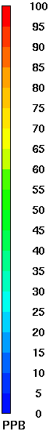
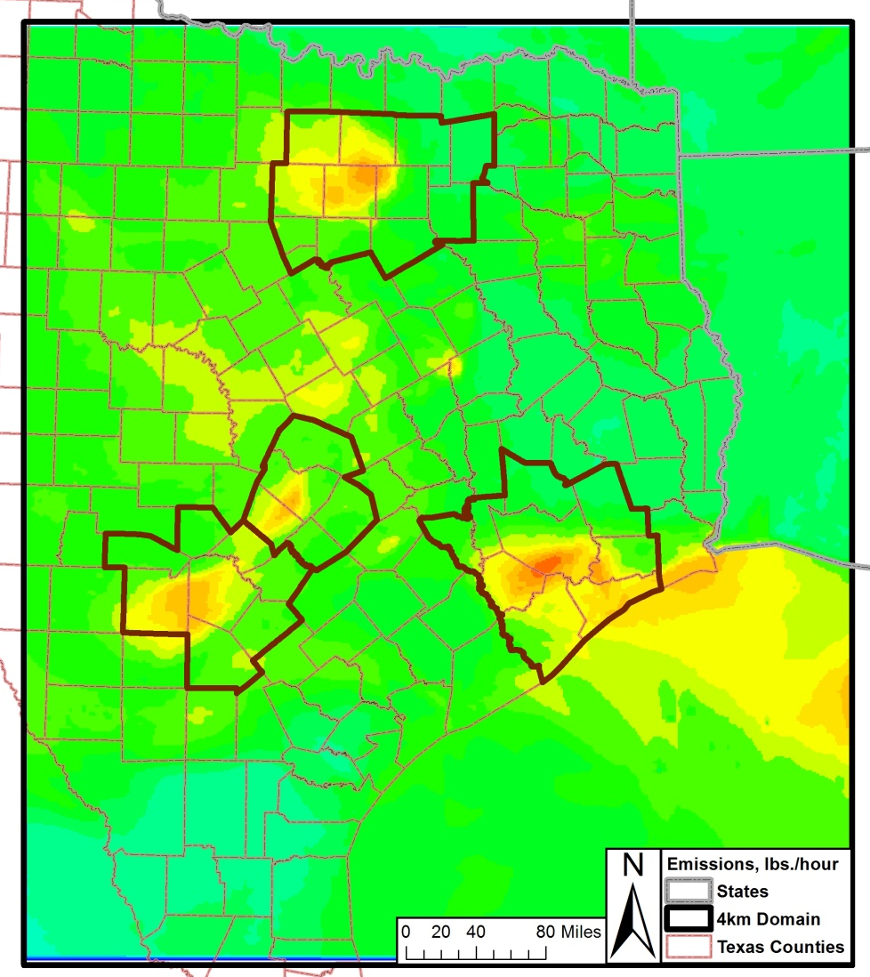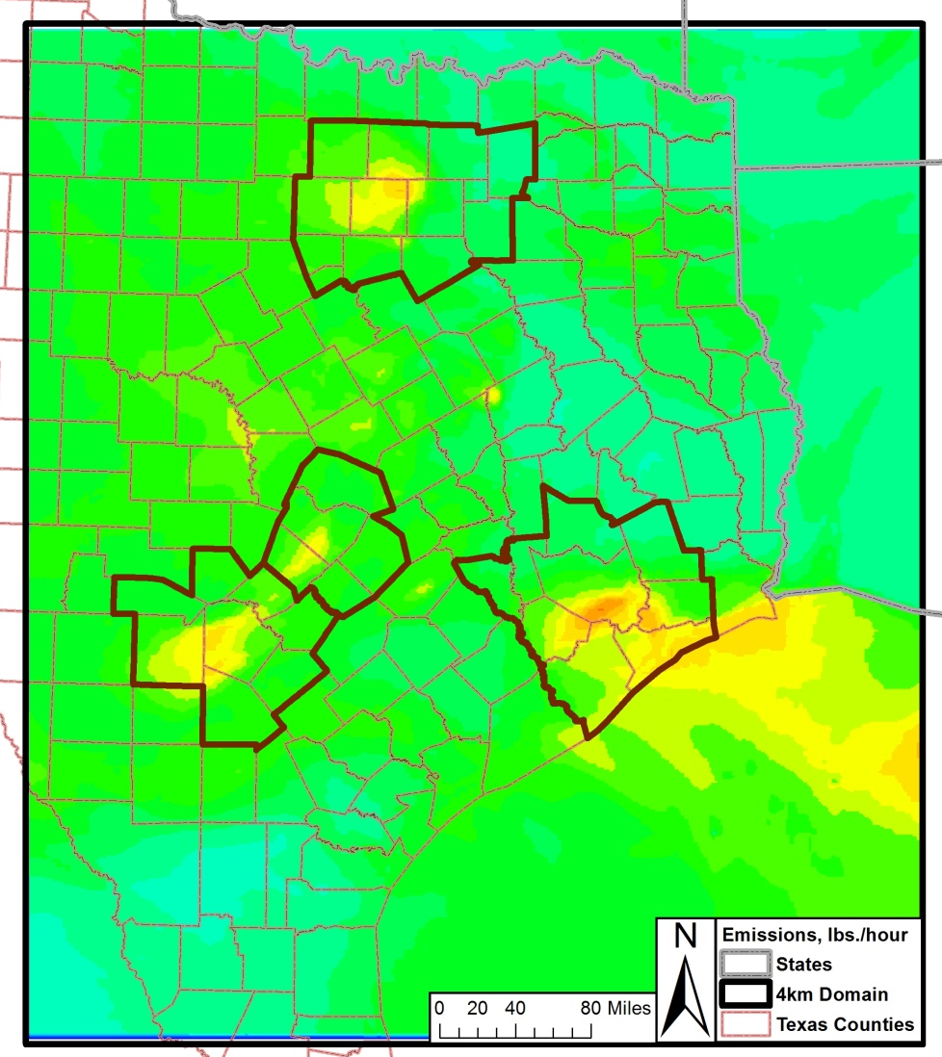
2012, June 3 2018, June 3

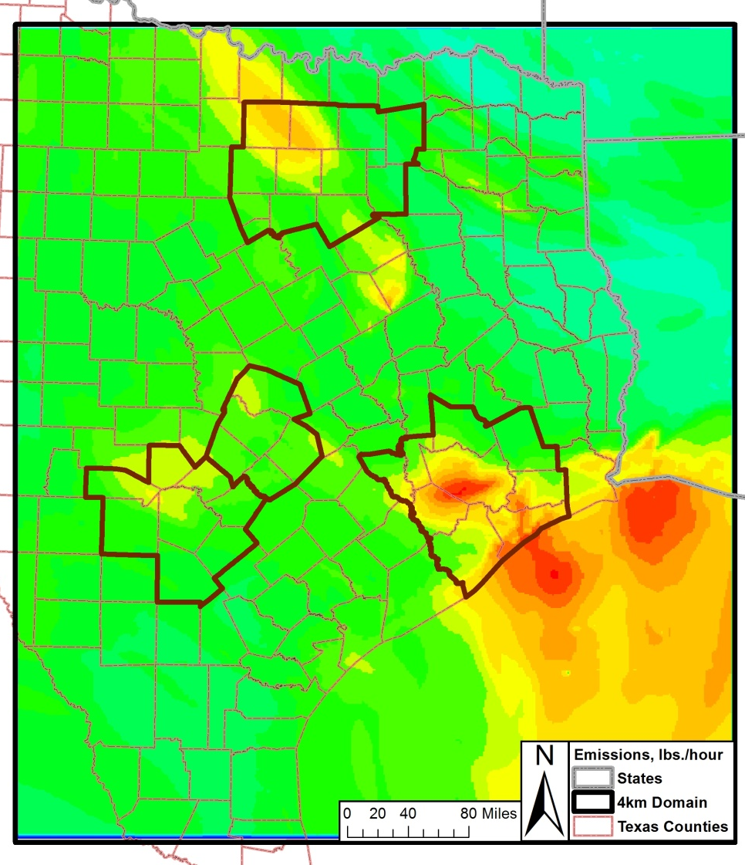
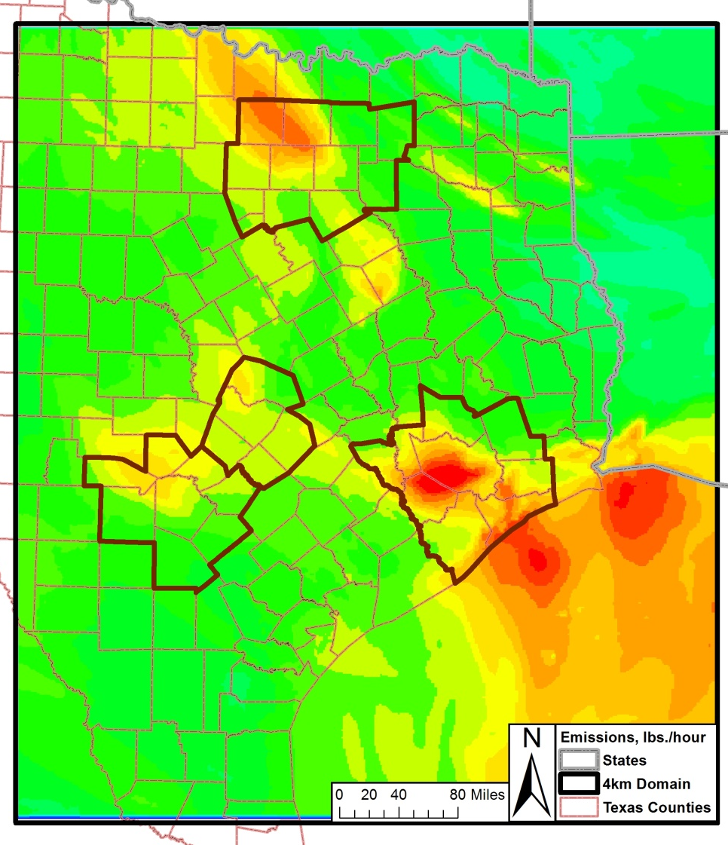
2012, June 9 2018, June 9

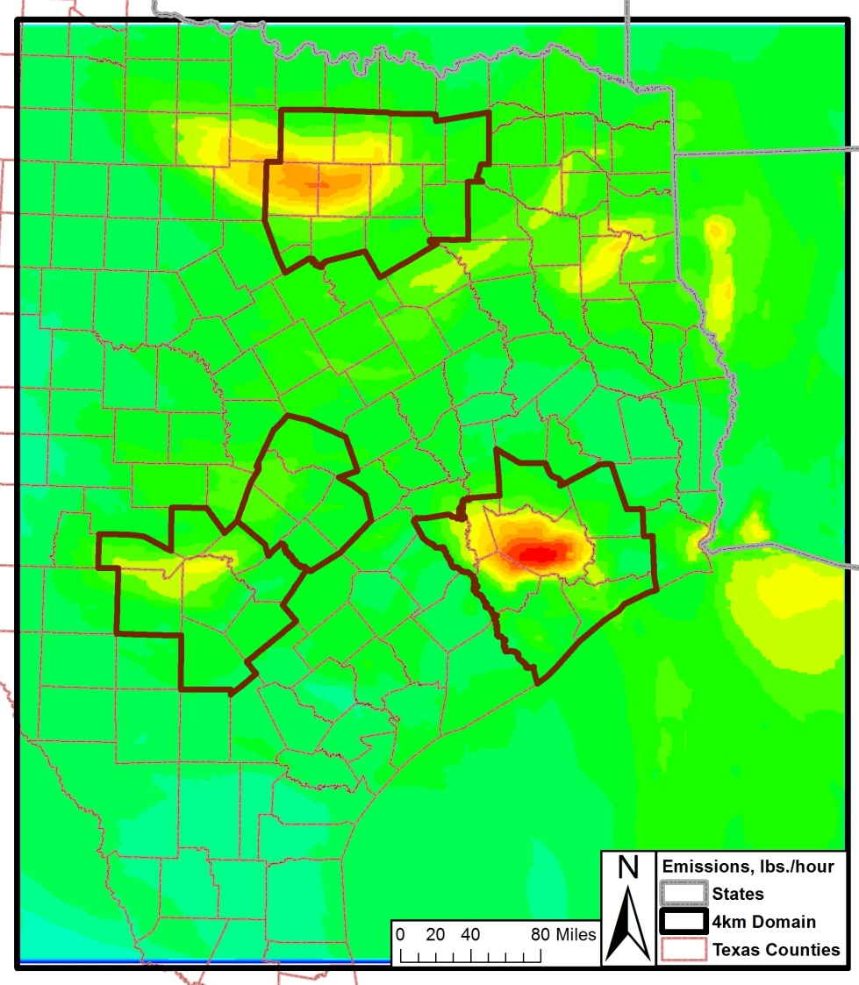
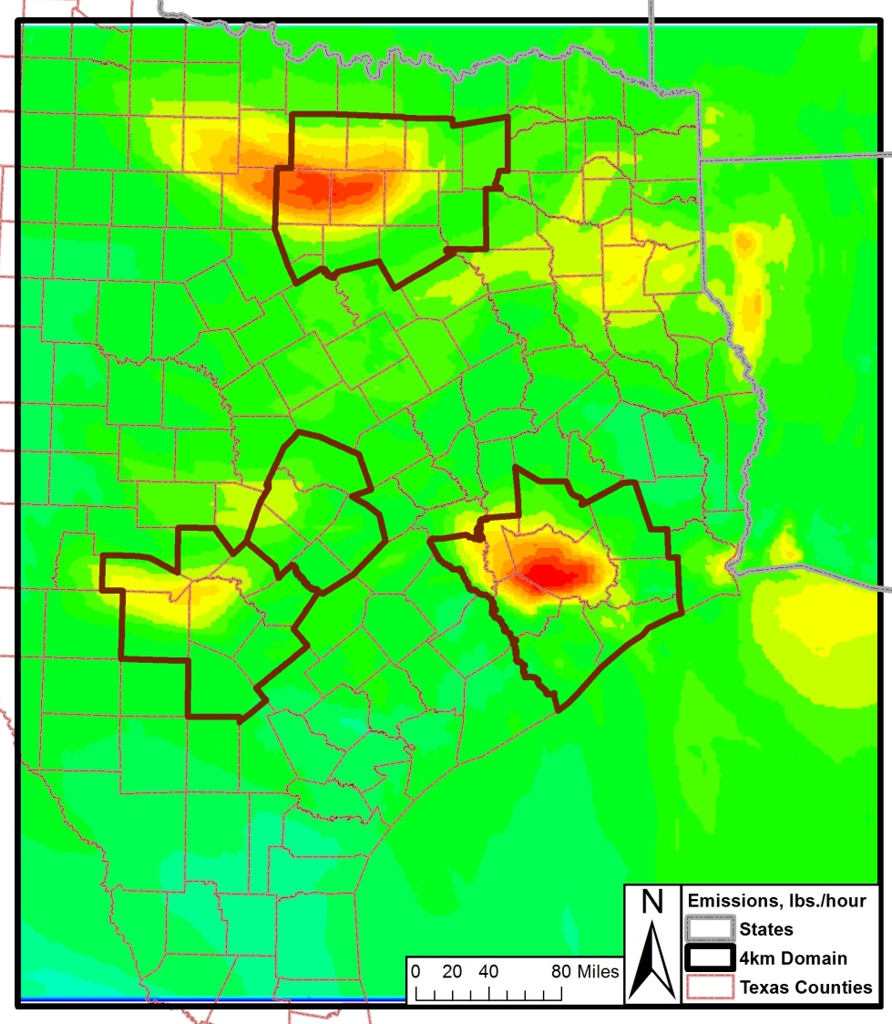
2012, June 12 2018, June 12

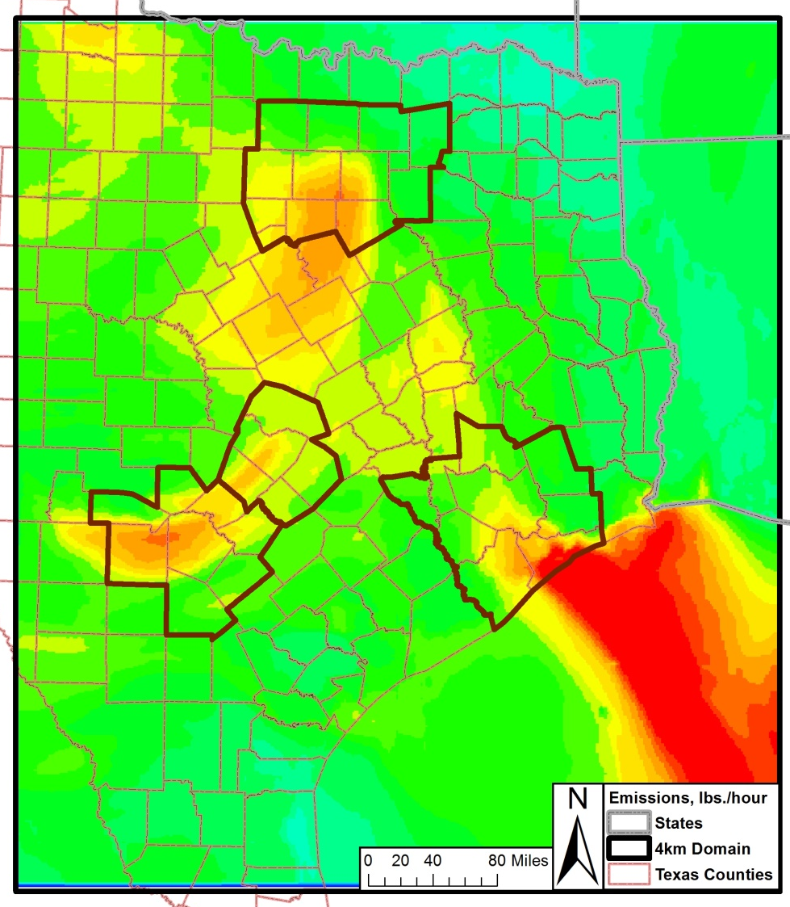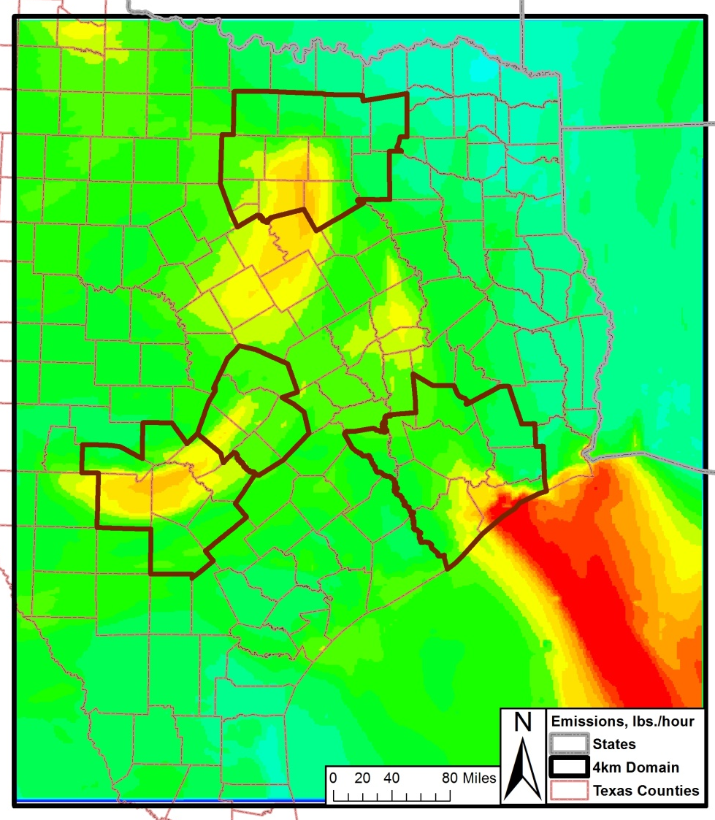
2012, June 13 2018, June 13

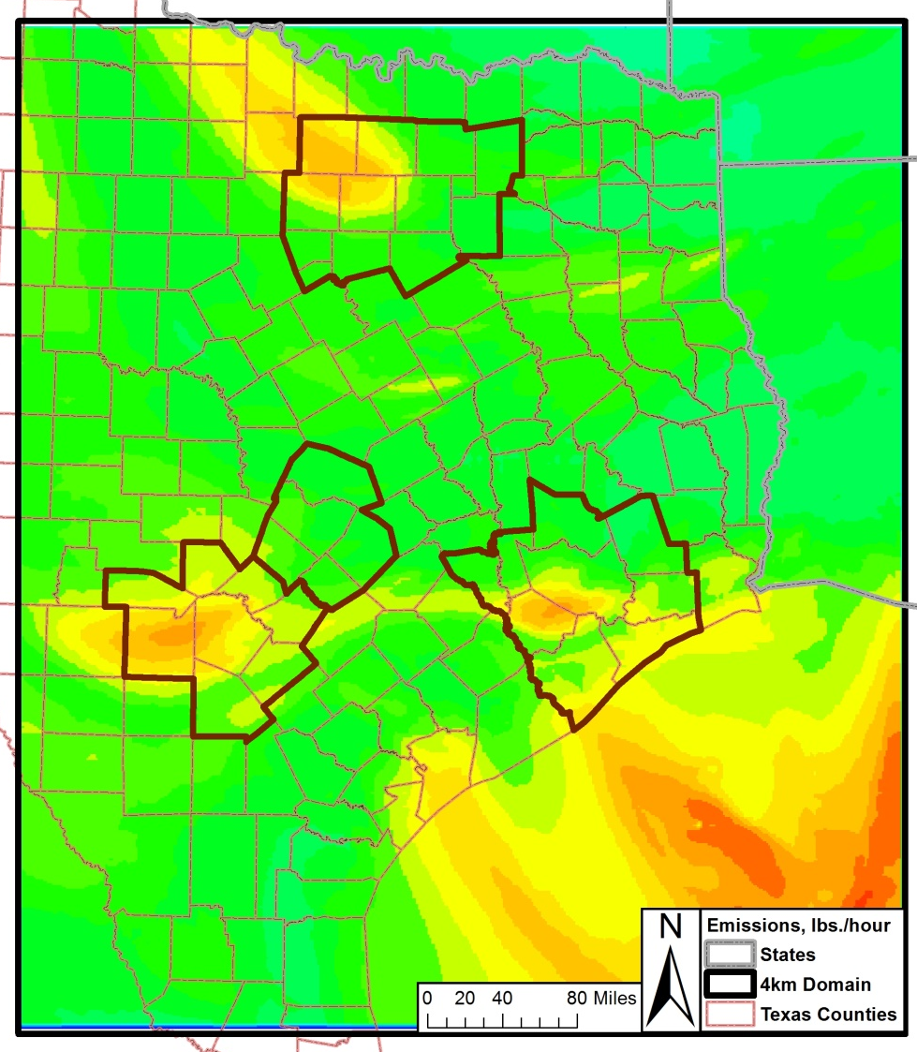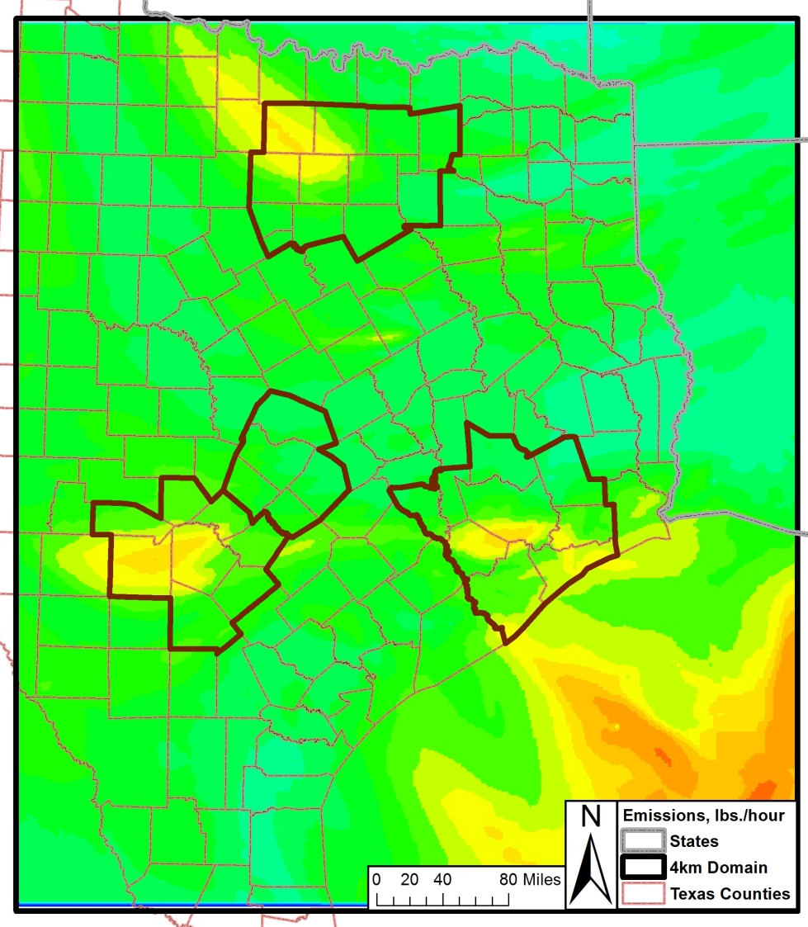
2012, June 14 2018, June 14

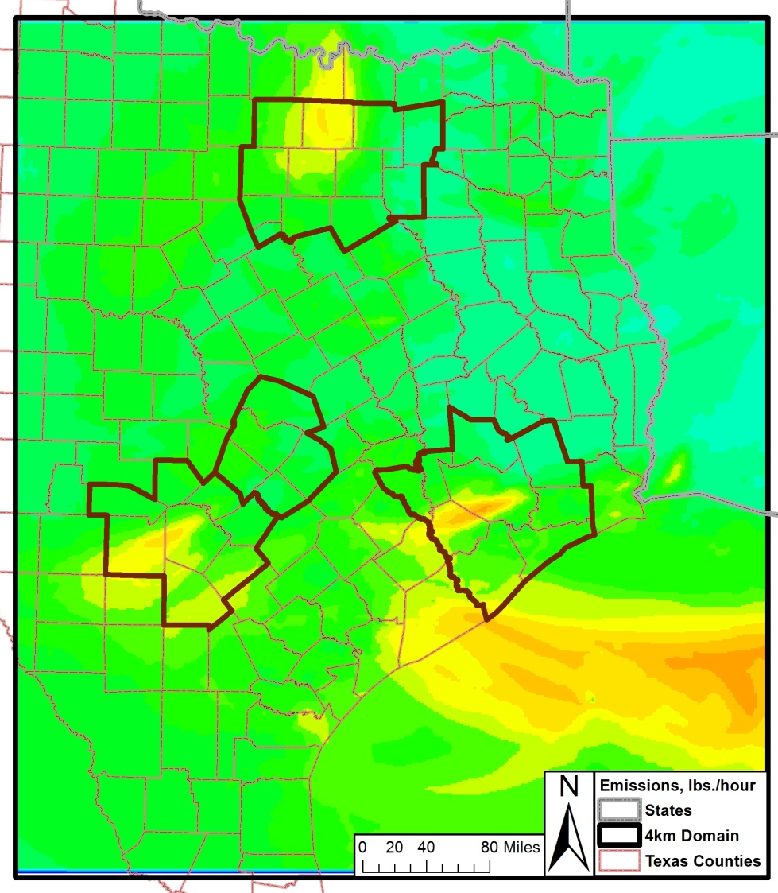
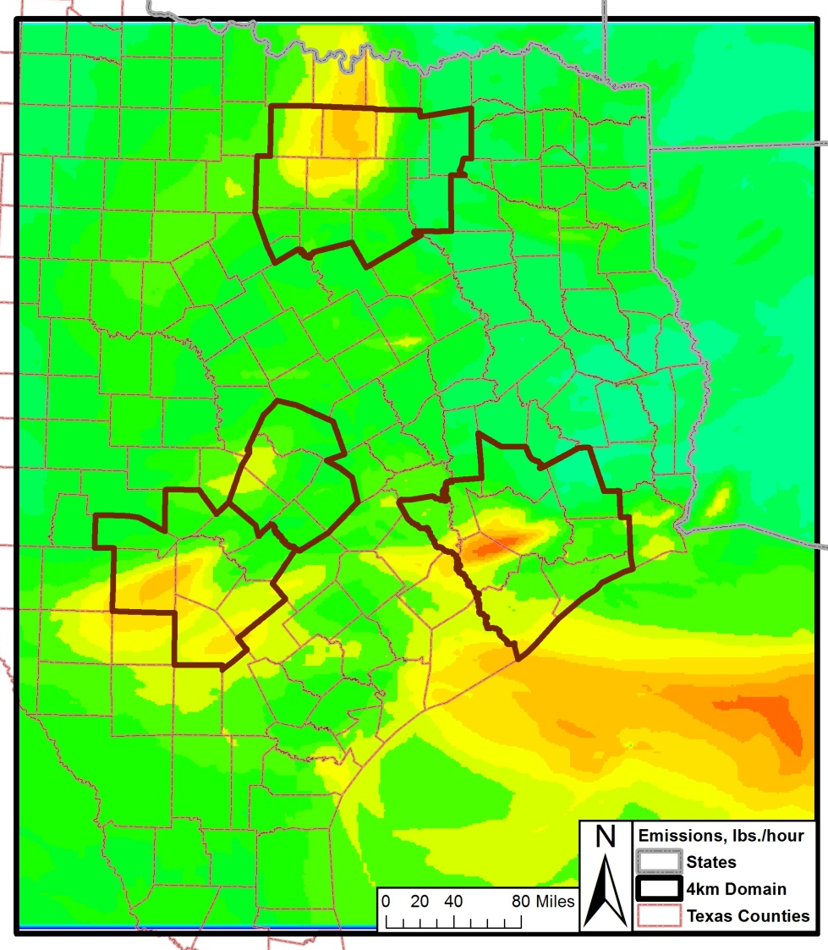
2012, June 28 2018, June 28

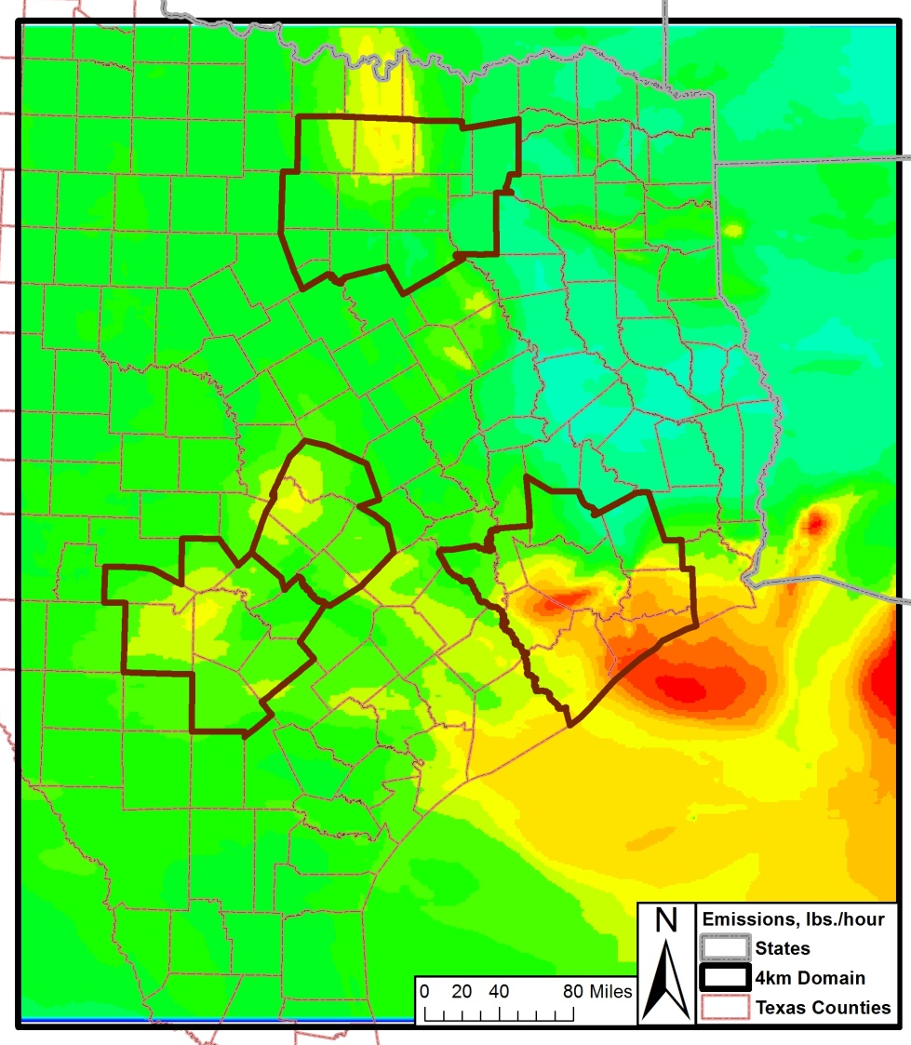
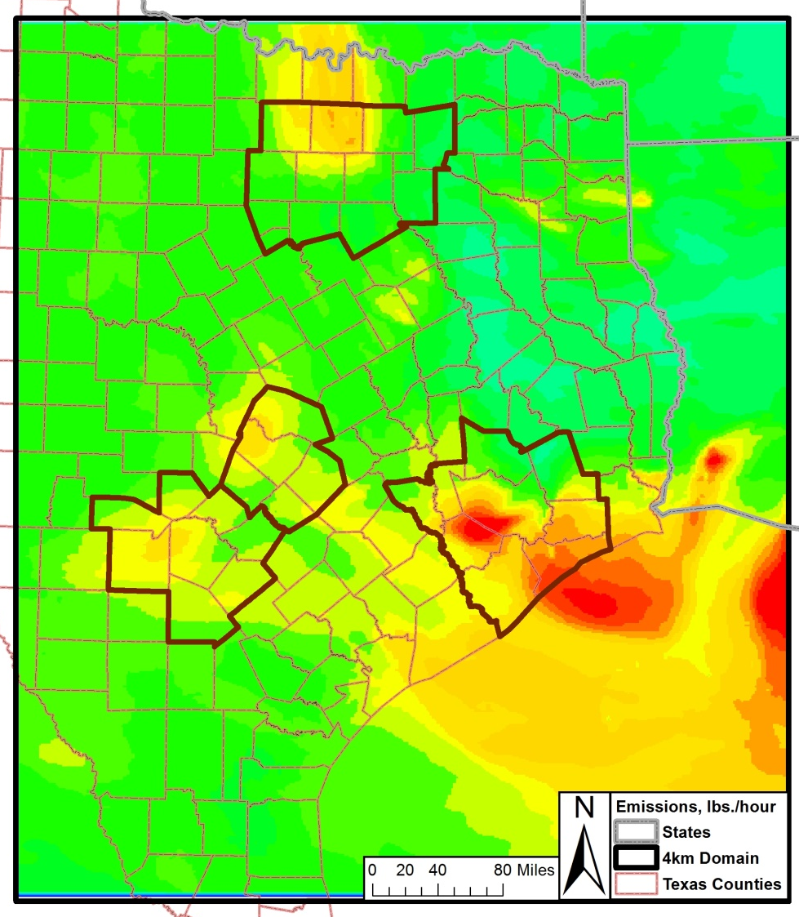
2012, June 29 2018, June 29

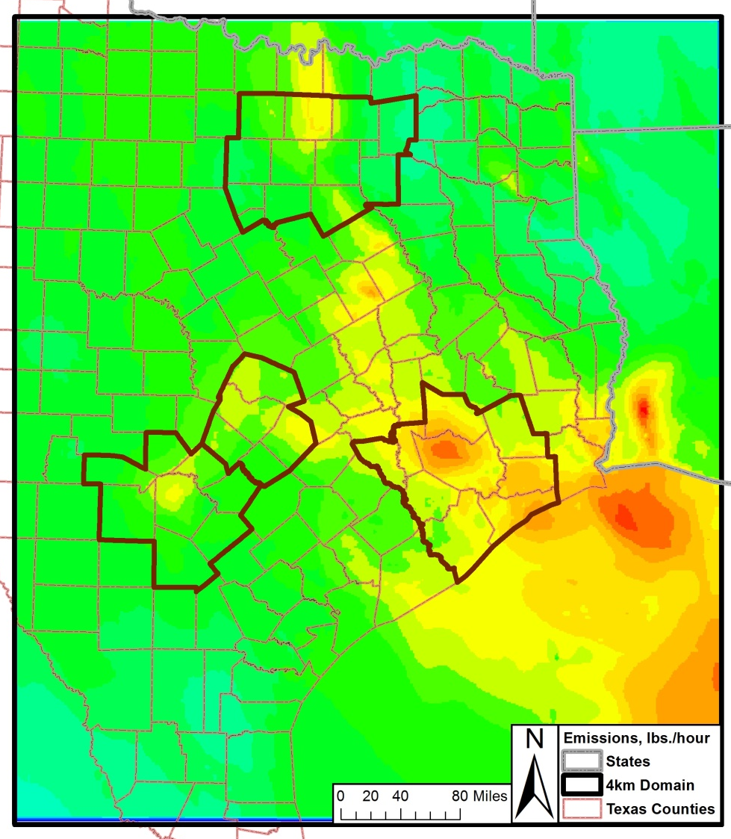
2012, June 30 2018, June 30
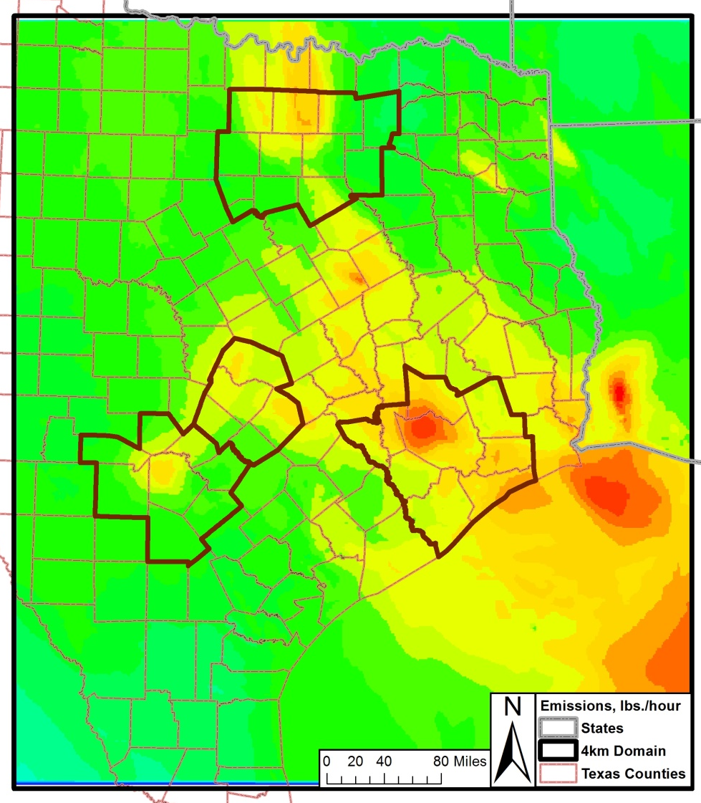

Peak ozone concentrations are predicted downwind of city centers and major point sources in these tile plots. In addition, the overall reduction in total NO_{X}, VOC, and CO emissions (local and regional) between 2012 and 2018 diminishes the magnitude of the urban plumes in the 2018 projections.

Although there is an overall reduction of ozone on every day > 70 ppb in the San Antonio-New Braunfels MSA between 2012 and 2018, significant transport still occurs. On the June 14 plots, Houston’s elevated ozone plume can be observed reaching the San Antonio-New Braunfels MSA. Although the concentration of the Houston plume diminishes between the 2012 and 2018 model runs, the tile plots indicate the 8-hour ozone levels in the 2018 scenario remain above 65 ppb. A similar pattern occurs on June 3 and 13 where the Austin plume has a significant impact on ozone levels in the San Antonio-New Braunfels MSA in both 2012 and 2018.

Modeled Attainment Demonstration
The modeled attainment demonstration at San Antonio-New Braunfels MSA’s regulatory sited monitors was conducted by completing a series of steps that are described in the EPA Guidance on the Use of Models. Two procedures were used to perform the model attainment demonstration: “…a) analyses which estimate whether a set of simulated emissions reductions will result in ambient concentrations that meet the NAAQS and b) an identified set of control measures which will result in the required emissions reductions”.

To determine if a regulatory monitor meets the NAAQS, three calculations were performed:

- determine the base five year weighted modeling site-specific design value (DV),
- calculate the daily relative response factor, and
- calculate of the future site-specific design values.

“The base design value for each monitoring site is the anchor point for estimating future year projected concentration”. Three time periods were used to determine the baseline DVs needed for future year projections. The time periods fell between 2010 and 2014, representing a five-year period based around the 2012 model year.Using Equation 3-1, the average of the 4th highest value (Table 3-1) at each regulatory sited monitor in the San Antonio-New Braunfels MSA was calculated for each of the 3-year period: 2010-2012, 2011-2013, and 2012-2014. The periods are referred to as 2012, 2013 and 2014 respectively.

Equation 3-1, The Design Value
(DV)_{I} = [(OZONE)_{1.I} + (OZONE)_{2.I} + (OZONE)_{3.I}] / 3

Where,
(DV)_{I} = the baseline ozone modeling DV at site I (ppb)
(OZONE)_{1.I} = the 4th highest ozone for Year 1 at site I (ppb)
(OZONE)_{2.I} = the 4th highest ozone for Year 2 at site I (ppb)
(OZONE)_{3.I} = the 4th highest ozone for Year 3 at site I (ppb)

Sample Equation: The 2012 Design Value for C58
(DV)_{I} = [(78 ppb) + (75 ppb) + (87 ppb)] / 3
= 80.0 ppb design value at C58

Table 3-1: Fourth Highest Ozone Value at Each Regulatory Sited Ozone Monitor in the San Antonio-New Braunfels MSA, 2010-2014
Monitoring Site | 2010 | 2011 | 2012 | 2013 | 2014
CAMS 23 | 72 | 79 | 81 | 76 | 69
CAMS 58 | 78 | 75 | 87 | 83 | 72
CAMS 59 | 67 | 71 | 70 | 69 | 63
CAMS 622 | 69 | 79 | 74 | 73 | 70
CAMS 678 | 64 | 75 | 70 | 76 | 69

The baseline ozone modeling design value was calculated using Equation 3-2. As determined by the EPA, the average DV methodology “has the desire effect of weighting the projected ozone base design values towards the middle year of a five year period”. “The 5-year weighted average value establishes a relatively stable value that is weighted towards the emissions and meteorological modeling year”.

Equation 3-2, The Baseline Design Site-Specific Modeling Design Value
(DVB)_{I} = [(DV 2012)_{I} + (DV 2013)_{I} + (DV 2014)_{I}] / 3

Where,
(DVB)_{I} = the baseline ozone modeling DV at site I (ppb)
(DV 2012)_{I} = the 2010-2012 baseline DV at site I (ppb) from Equation 3-1
(DV 2013)_{I} = the 2011-2013 baseline DV at site I (ppb) from Equation 3-1
(DV 2014)_{I} = the 2012-2014 baseline DV at site I (ppb) from Equation 3-1

Sample Equation: Baseline Design Site-Specific Design Value for C58
(DVB)_{I} = [(80.0 ppb) + (81.7 ppb) + (80.7 ppb)] / 3
= 80.7 ppb baseline design site-specific modeling design value at C58

The baseline modeling DV was calculated for each regulatory monitor that meets EPA’s modeling guideline recommendations (Table 3-2). Although both C622 and C678 are not regulatory ozone monitors, they meet all the site and calibration requirements of the EPA. The 6 non-regulatory sited ozone monitors operated by AACOG were not included in the calculations. As shown, C58 has the highest baseline modeling DV at 80.7 ppb. The baseline modeling DVs at the other regulatory monitors are 77.1 ppb at C23, 73.8 ppb at CAMS 622, 71.6 ppb at C678, and 68.8 ppb at C59.

Table 3-2: Calculated Baseline Modeling Site-Specific Design Value, 2012
Monitoring Site | 2010-2012  DV, ppb | 2011-2013  DV, ppb | 2012-2014  DV, ppb | Baseline DV used in the Modeling Attainment Test, ppb
CAMS 23 | 77.3 | 78.7 | 75.3 | 77.1
CAMS 58 | 80.0 | 81.7 | 80.7 | 80.7
CAMS 59 | 69.3 | 70.0 | 67.3 | 68.8
CAMS 622 | 74.0 | 75.3 | 72.3 | 73.8
CAMS 678 | 69.7 | 73.7 | 71.7 | 71.6
Bolded values on the table are ozone exceedances above 75 ppb standard.

The model attainment test requires the calculation of a daily relative response factor (RRF). Instead of using the absolute photochemical model output, a RRF was calculated using the baseline and future case modeling. The ratio between future and baseline modeling 8-hour ozone predictions near each monitor was multiplied by the monitor-specific modeling DV. The area near a monitor was defined as the 3x3 array of grid cells surrounding the monitor. The formula used to calculate the Future Design Value is:

Equation 3-3, Future Design Value Calculation
(DVF)_{I} = (RRF)_{I} (DVB)_{I}

Where,
(DVF)_{I} = the estimated future ozone DV for the time attainment is required (ppb)
(RRF)_{I} = the relative response factor, calculated near site I
(DVB)_{I} = the baseline ozone modeling DV at site I (ppb) - from Equation 3-2

Sample Equation: Future Design Value for Base Case 2 at C58
(DVF)_{I} = (0.9090) (80.7 ppb)
= 73.4 ppb Future Design Value for Base Case 2 at C58

The highest predicted 8-hour daily ozone was selected in the 3x3 array for each monitor for both the 2012 and 2018 projection years. The peak ozone grid cell selected in the baseline year is the same cell that is used in the 2018 projection. Once the monitor-specific RRF was calculated for each day, the RRF was averaged for the top 10 highest days with a peak monitor value greater than 60 ppb in the 2012 base case. The future site-specific DV for each monitor is provided in Table 3-3. The gray strike-through numbers are values that fall below the EPA requirement of 60 ppb.

Table 3-3: Peak 8-hour Ozone (ppb) Predictions at C23, C58, C59, C622, and C678: 2012 and 2018 Modeled Cases
CAMS | Year | Run Label | Episode days
 |  |  | 1st | 2nd | 3rd | 4th | 5th | 6th | 7th | 8th | 9th | 10th | 11th | 12th | 13th | 14th | 15th
C23 | 2012 | Base Case 1 (AACOG) | 44.3 | 51.9 | 79.8 | 67.3 | 55.9 | 54.2 | 64.8 | 69.7 | 72.7 | 58.4 | 59.6 | 70.5 | 87.9 | 81.1 | 58.5
 | 2012 | Base Case 2 (TCEQ) | 42.7 | 50.8 | 77.4 | 67.4 | 55.8 | 52.8 | 62.9 | 67.8 | 71.6 | 56.4 | 59.0 | 69.6 | 85.1 | 79.6 | 56.7
 | 2018 | Base Case 1 (AACOG) |  |  | 70.6 | 58.8 |  |  |  | 61.3 | 64.8 |  |  | 63.9 | 77.3 | 73.1
 | 2018 | Base Case 2 (TCEQ) |  |  | 70.0 | 58.8 |  |  |  | 59.2 | 63.6 |  |  | 62.7 | 77.5 | 73.5
C58 | 2012 | Base Case 1 (AACOG) | 45.3 | 52.3 | 72.6 | 68.4 | 56.7 | 61.1 | 68.6 | 70.8 | 72.6 | 63.0 | 62.0 | 71.5 | 86.2 | 76.6 | 60.6
 | 2012 | Base Case 2 (TCEQ) | 44.5 | 51.3 | 70.4 | 68.2 | 56.2 | 60.0 | 66.0 | 68.4 | 70.9 | 61.7 | 61.1 | 70.8 | 83.3 | 75.4 | 59.1
 | 2018 | Base Case 1 (AACOG) |  |  | 66.1 |  |  |  | 61.2 | 63.1 | 64.6 |  |  | 65.7 | 77.1 | 69.8
 | 2018 | Base Case 2 (TCEQ) |  |  | 67.9 | 62.0 |  |  | 59.2 | 61.4 | 62.5 |  |  | 66.1 | 78.3 | 71.8
C59 | 2012 | Base Case 1 (AACOG) | 43.4 | 53.2 | 66.6 | 57.9 | 49.1 | 47.2 | 49.6 | 55.4 | 58.7 | 57.0 | 50.0 | 49.9 | 68.9 | 68.1 | 56.9
 | 2012 | Base Case 2 (TCEQ) | 41.8 | 51.4 | 63.8 | 57.5 | 48.9 | 46.8 | 49.3 | 54.9 | 57.9 | 53.5 | 50.2 | 50.8 | 67.8 | 67.5 | 55.2
 | 2018 | Base Case 1 (AACOG) |  |  | 60.9 |  |  |  |  |  |  |  |  |  | 63.7 | 63.1
 | 2018 | Base Case 2 (TCEQ) |  |  | 58.6 |  |  |  |  |  |  |  |  |  | 62.9 | 61.8
C622 | 2012 | Base Case 1 (AACOG) | 43.4 | 52.5 | 66.6 | 61.2 | 49.5 | 47.6 | 54.2 | 57.5 | 61.6 | 58.0 | 51.0 | 51.7 | 73.9 | 66.7 | 56.7
 | 2012 | Base Case 2 (TCEQ) | 41.8 | 51.2 | 63.8 | 60.5 | 49.6 | 47.6 | 53.1 | 56.5 | 60.6 | 55.3 | 51.2 | 52.4 | 71.9 | 65.9 | 55.2
 | 2018 | Base Case 1 (AACOG) |  |  | 60.9 | 57.1 |  |  |  |  | 57.4 |  |  |  | 67.4 | 60.5
 | 2018 | Base Case 2 (TCEQ) |  |  | 58.6 | 57.1 |  |  |  |  | 55.9 |  |  |  | 67.7 | 60.1
C678 | 2012 | Base Case 1 (AACOG) | 44.0 | 51.8 | 68.2 | 63.8 | 51.6 | 50.4 | 58.0 | 61.2 | 65.2 | 60.3 | 55.5 | 58.8 | 80.1 | 69.3 | 56.9
 | 2012 | Base Case 2 (TCEQ) | 42.2 | 50.9 | 66.6 | 62.9 | 51.2 | 50.6 | 56.0 | 59.4 | 64.1 | 57.8 | 55.0 | 58.6 | 77.6 | 69.1 | 55.5
 | 2018 | Base Case 1 (AACOG) |  |  | 61.1 | 59.1 |  |  |  | 55.8 | 60.7 |  |  |  | 71.6 | 62.8
 | 2018 | Base Case 2 (TCEQ) |  |  | 61.5 | 59.1 |  |  |  |  | 59.5 |  |  |  | 71.0 | 62.5

CAMS | Year | Run Label | Episode days |  |  |  |  |  |  |  |  |  |  |  |  |  |  | Design Value
 |  |  | 16th | 17th | 18th | 19th | 20th | 21st | 22nd | 23rd | 24th | 25th | 26th | 27th | 28th | 29th | 30th
C23 | 2012 | Base Case 1 (AACOG) | 41.5 | 34.3 | 45.2 | 52.4 | 34.8 | 36.1 | 41.6 | 54.6 | 41.6 | 47.2 | 49.4 | 56.8 | 79.6 | 75.4 | 76.1 | 77.1
 | 2012 | Base Case 2 (TCEQ) | 41.0 | 34.4 | 46.3 | 52.6 | 35.1 | 36.1 | 41.7 | 53.8 | 40.5 | 46.2 | 44.3 | 52.8 | 74.8 | 71.9 | 73.6 | 77.1
 | 2018 | Base Case 1 (AACOG) |  |  |  |  |  |  |  |  |  |  |  |  | 68.5 | 67.8 | 68.1 | 68.4
 | 2018 | Base Case 2 (TCEQ) |  |  |  |  |  |  |  |  |  |  |  |  | 69.1 | 65.5 | 66.2 | 69.5
C58 | 2012 | Base Case 1 (AACOG) | 43.4 | 37.5 | 47.1 | 46.9 | 37.0 | 38.2 | 42.6 | 59.5 | 38.5 | 46.3 | 46.2 | 51.3 | 69.2 | 74.3 | 75.0 | 80.7
 | 2012 | Base Case 2 (TCEQ) | 43.2 | 37.5 | 48.1 | 47.0 | 37.3 | 38.1 | 42.7 | 58.6 | 37.5 | 43.5 | 41.1 | 47.4 | 64.5 | 70.9 | 72.7 | 80.7
 | 2018 | Base Case 1 (AACOG) |  |  |  |  |  |  |  |  |  |  |  |  | 62.3 | 67.7 | 67.3 | 72.8
 | 2018 | Base Case 2 (TCEQ) |  |  |  |  |  |  |  |  |  |  |  |  |  | 66.1 | 65.3 | 74.3
C59 | 2012 | Base Case 1 (AACOG) | 37.1 | 32.0 | 38.0 | 52.1 | 29.6 | 33.2 | 36.7 | 40.5 | 50.7 | 62.7 | 54.9 | 59.9 | 64.9 | 64.1 | 58.5 | 68.8
 | 2012 | Base Case 2 (TCEQ) | 37.2 | 32.2 | 39.3 | 52.5 | 30.8 | 33.0 | 37.2 | 41.2 | 49.1 | 62.1 | 50.6 | 55.9 | 61.9 | 61.9 | 57.1 | 68.8
 | 2018 | Base Case 1 (AACOG) |  |  |  |  |  |  |  |  |  |  |  |  | 58.6 | 59.9 |  | 63.3
 | 2018 | Base Case 2 (TCEQ) |  |  |  |  |  |  |  |  |  |  |  |  | 57.1 | 56.9 |  | 63.4
C622 | 2012 | Base Case 1 (AACOG) | 37.1 | 32.0 | 41.3 | 54.1 | 29.1 | 32.9 | 36.6 | 44.8 | 49.3 | 57.5 | 55.8 | 61.3 | 63.1 | 62.9 | 60.0 | 73.8
 | 2012 | Base Case 2 (TCEQ) | 37.2 | 32.2 | 42.5 | 54.2 | 30.8 | 33.0 | 37.2 | 44.6 | 47.8 | 57.9 | 51.6 | 57.9 | 59.7 | 60.8 | 58.7 | 73.8
 | 2018 | Base Case 1 (AACOG) |  |  |  |  |  |  |  |  |  |  |  | 53.6 | 57.1 | 58.6 | 56.7 | 67.7
 | 2018 | Base Case 2 (TCEQ) |  |  |  |  |  |  |  |  |  |  |  |  |  | 56.0 |  | 68.4
C678 | 2012 | Base Case 1 (AACOG) | 38.3 | 33.2 | 45.1 | 57.8 | 31.5 | 33.9 | 38.4 | 49.5 | 48.1 | 55.3 | 58.2 | 66.1 | 65.7 | 66.3 | 64.5 | 71.6
 | 2012 | Base Case 2 (TCEQ) | 38.2 | 33.7 | 46.0 | 57.4 | 32.6 | 34.2 | 38.6 | 48.8 | 46.5 | 55.0 | 53.9 | 62.2 | 62.0 | 63.3 | 62.0 | 71.6
 | 2018 | Base Case 1 (AACOG) |  |  |  |  |  |  |  |  |  |  |  | 57.7 | 58.6 | 61.2 | 60.0 | 65.0
 | 2018 | Base Case 2 (TCEQ) |  |  |  |  |  |  |  |  |  |  |  | 57.6 | 56.3 | 58.4 | 58.7 | 66.1

For base case 1 with AACOG’s local emission inventory with MOVES2010a, the 2018 8-hour ozone design value was 68.4 ppb at C23, 72.8 ppb at C58, and 63.3 ppb at C59. Under the base case 2 with TCEQ emission inventory with MOVES2014, the design values was 69.5 ppb at C23, 74.3 ppb at C58, and 63.4 ppb at C59 (Figure 3-2). The design value increased 1.1 ppb at C23, 1.5 ppb at C58, and 0.1 ppb at C59 using TCEQ emission inventory projections. All regulatory-sited monitors meet the 75 ppb 8-hour ozone standard for both 2018 projection cases. However, C58 does not meet the proposed 70 ppb standard and both C58 and C23 do not meet the proposed 65 ppb standard. If the EPA lowers the 8-hour ozone standard, it would be difficult for the San Antonio-New Braunfels MSA to attain the new standard.

Figure 3-2: Change in San Antonio-New Braunfels MSA Eight-Hour Design Values, 2018
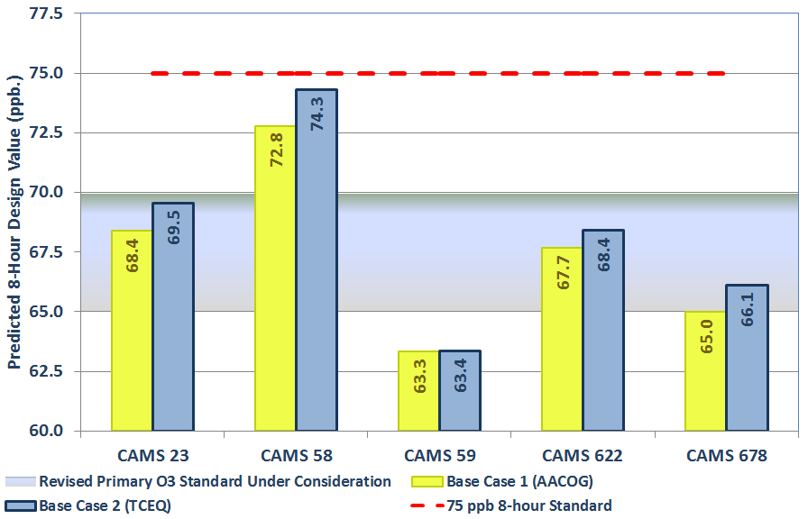

Minimum Threshold Analysis
The methodology used above follows the EPA’s guidance on calculating future design values. However, other methodologies may be used to calculate future design values, so that model sensitivity can be tested. The minimum threshold used in the design value calculation was based on EPA’s recommended lowest threshold of 60 ppb. By increasing the minimum threshold to 65, 70, and 75 ppb, the future predicted design value increased at C23 and C58 (Figure 3-3). The change in 2018 RRFs, the future design values, and the number of days that meet each criterion are provided in Table 3-4.

By raising the minimum threshold to 70 ppb, used in the above attainment demonstration, the applicable days drop below EPA’s guidance that suggests at least 10 days be included in the analysis. At 75 ppb, the number of days falls below 5 for every monitor. While the calculation then uses days that modeled higher baseline ozone concentrations, the calculation becomes less statistically robust.

The design value increased at both C58 and C23 when the minimum threshold was increased. When the minimum threshold was raised to 70 ppb, the maximum design value at C58 and C23 increased 0.6 ppb. Under the minimum threshold of 75 ppb, the maximum design value was increased to 76.3 ppb at C58 which was above the current 75 ppb 8-hour ozone standard. However, there was only 2 days included in the calculation.

Figure 3-3: Minimum Threshold Analysis Eight-Hour Design Values, 2018
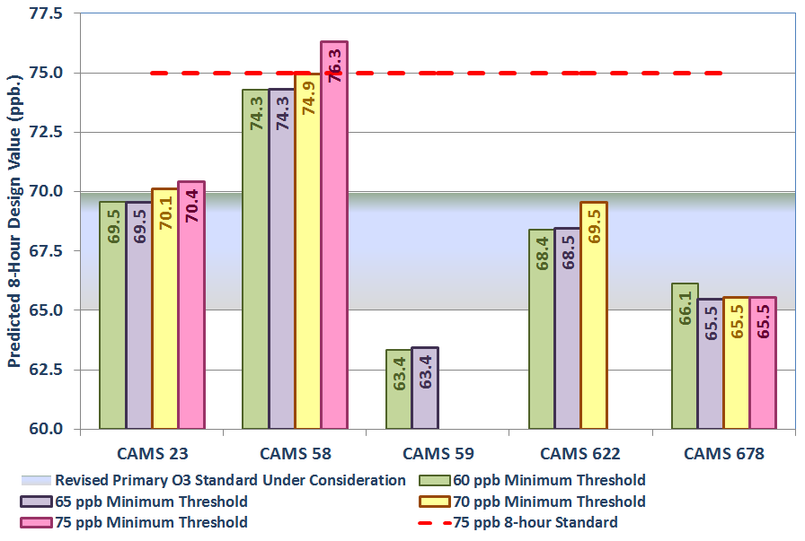

Table 3-4: Minimum Threshold Analysis for base Case 2 (TCEQ), 2018.
Site | 2014 Modeling DV | 60 ppb |  |  | 65 ppb |  |  | 70 ppb |  |  | 75 ppb
 |  | RRF | DVF | # Days | RRF | DVF | # Days | RRF | DVF | # Days | RRF | DVF | # Days
C23 | 77.1 | 0.9021 | 69.5 | 10 | 0.9021 | 69.5 | 10 | 0.9094 | 70.1 | 7 | 0.9134 | 70.4 | 3
C58 | 80.7 | 0.9207 | 74.3 | 10 | 0.9207 | 74.3 | 10 | 0.9287 | 74.9 | 7 | 0.9457 | 76.3 | 2
C59 | 68.8 | 0.9208 | 63.4 | 5 | 0.9219 | 63.4 | 2
C622 | 73.8 | 0.9268 | 68.4 | 6 | 0.9277 | 68.5 | 2 | 0.9424 | 69.5 | 1
C678 | 71.6 | 0.9234 | 66.1 | 9 | 0.9143 | 65.5 | 3 | 0.9152 | 65.5 | 1 | 0.9152 | 65.5 | 1

Grid Cell Array Size Analysis
In the recent Dec. 2014 modeling guidance, EPA recommends “that the RRF be based on a 3x3 array of cells centered on the location of the grid cell containing the monitor”. The 2014 modeling guidance is an updated of the 2007 EPA modeling guidance where a 7x7 grid array is recommended instead. EPA also “recommends that the grid cell with the highest base year ozone value in the 3x3 array be used for both the base and future components of the RRF calculation”. The photochemical model was tested using different grid cell arrays to determine the model responses.

Figure 3-4: Grid Cell Array Size around Regulatory Sited San Antonio-New Braunfels Ozone Monitors
Plot Date: June 14, 2013
Map Compilation: June 14, 2013
Source: Monitor Locations based on TCEQ data.

The size of the grid cell array around each monitor can impact the future predicted design value. By testing the change in the grid cell array, the accuracy of the model prediction can be tested. The 3x3, 5x5, and 7x7 grid cell arrays used in the alternative DV calculations for the regulatory sited monitors in the San Antonio-New Braunfels MSA are shown in Figure 3-4. A 5x5 or 7x7 grid cell array shows overlap among several of San Antonio monitors.

The maximum DV at C58 decrease from 74.3 ppb to 73.8 ppb when a 7x7 grid cell array is used instead of a 3x3 grid cell array (Figure 3-5). For the other four monitors, the design value increases from 0.2 ppb to 0.8 ppb when using the 7x7 grid cell array (Table 3-5). The photochemical model overall was not very sensitivity to changes in the design value when different grid cell arrays are used. Since the future year 2018 grid cell has to be in the same cell with the highest value in the 2012 baseline, the model may not been as sensitive to changes in the grid cell array.

Figure 3-5: Grid Cell Array Eight-Hour Design Values, 2018
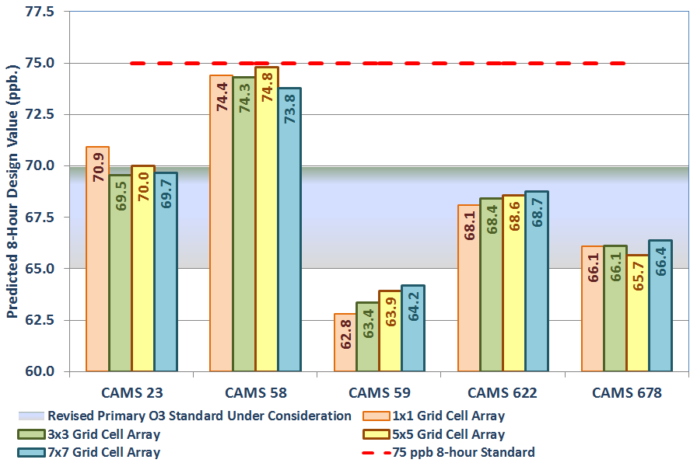

Table 3-5: RRFs and DVFs using 1x1, 3x3, 5x5, and 7x7 Grid Cell Arrays, 2018
Site | 2012 DV | 1x1 Grid Cell Array |  |  | 3x3 Grid Cell Array |  |  | 5x5 Grid Cell Array |  |  | 7x7 Grid Cell Array
 |  | RRF | DV | # Days | RRF | DV | # Days | RRF | DV | # Days | RRF | DV | # Days
C23 | 77.1 | 0.9199 | 70.9 | 10 | 0.9021 | 69.5 | 10 | 0.9080 | 70.0 | 10 | 0.9036 | 69.7 | 10
C58 | 80.7 | 0.9218 | 74.4 | 10 | 0.9207 | 74.3 | 10 | 0.9270 | 74.8 | 10 | 0.9141 | 73.8 | 10
C59 | 68.8 | 0.9129 | 62.8 | 4 | 0.9208 | 63.4 | 5 | 0.9289 | 63.9 | 7 | 0.9329 | 64.2 | 10
C622 | 73.8 | 0.9228 | 68.1 | 3 | 0.9268 | 68.4 | 6 | 0.9289 | 68.6 | 10 | 0.9316 | 68.7 | 10
C678 | 71.6 | 0.9229 | 66.1 | 8 | 0.9234 | 66.1 | 9 | 0.9172 | 65.7 | 10 | 0.9272 | 66.4 | 10

Sensitivity Runs
A number of runs were conducted on the June 2006 episode to assess how sensitive the model is to changes in the emission inventory and to the impact of control strategy scenarios. Control strategy runs included zeroing San Antonio New Braunfels MSA Emissions, incremental removal of VOC and NO_{X} precursor emissions, removal of 10 tons of VOC and NO_{X} precursor emissions by source category, and hourly on-road runs. These runs were conducted to determine emission sources that would be the most effective in reducting ozone readings at local regulatory monitors. The sensitivity runs were conducted using earlier versions of base case run 1 with AACOG’s local emission inventory. The stats are calculated based on a 7x7 grid using EPA’s 2007 modeling guidance.

Zero San Antonio-New Braunfels MSA Emissions
The photochemical model was run with and without local San Antonio-New Braunfels anthropogenic emissions. As provided in Figure 4-1, ozone decreased 17.7 ppb at C58 and 17.8 ppb at C23 when all local anthropogenic emissions were removed. The decrease in the 8-hour ozone was immaterial at C59, C622, and C678: 12.5 ppb, 13.5 ppb, and 14.7 ppb (Table 4-1). These three monitors are located on the southeast side of the city and local emissions have less impact on ozone readings at these monitors. When all local anthropogenic emissions were removed, the predicted 2018 ozone design value at all monitors was well below the current and proposed ozone standards.

Table 4-1: Predicted Ozone Design Value at C23, C58, C59, C622, and C622 after Removing All Local NO_{X} and VOC Emissions, 2018
Scenario | CAMS  23 | CAMS  58 | CAMS  59 | CAMS 622 | CAMS 678
2018 Projection Case | 68.82 | 72.60 | 63.37 | 67.71 | 65.11
Zero San Antonio New Braunfels MSA | 51.05 | 54.88 | 50.89 | 54.22 | 50.45

Figure 4-1: Predicted Ozone Design Value after Removing all Local Anthropogenic NO_{X} and VOC emissions from the San Antonio-New Braunfels MSA, 2018
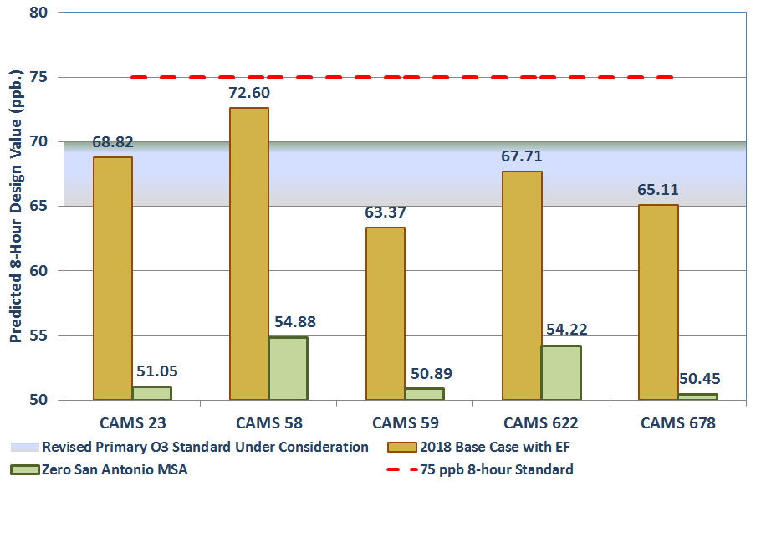

Incremental Removal of VOC and NOx Precursor Emissions
Other runs were conducted by removing 25%, 50%, and 75% anthropogenic emissions from the San Antonio-New Braunfels MSA in the 2018 projection. Figure 4-2 and Figure 4-3 provide the results of NO_{X}, VOC, and NO_{X} + VOC reduction runs for C23 and C58 for the forty-day modeling period. The runs that were performed are:

- 25% reduction in NO_{X} | - 25% reduction in VOC | - 25% reduction in NO_{X} and VOC
- 50% reduction in NO_{X} | - 50% reduction in VOC | - 50% reduction in NO_{X} and VOC
- 75% reduction in NO_{X} | - 75% reduction in VOC | - 75% reduction in NO_{X} and VOC

Figure 4-2: Predicted Ozone Design Value at C58 after Removing Local NO_{X} and VOC Emissions, 2018
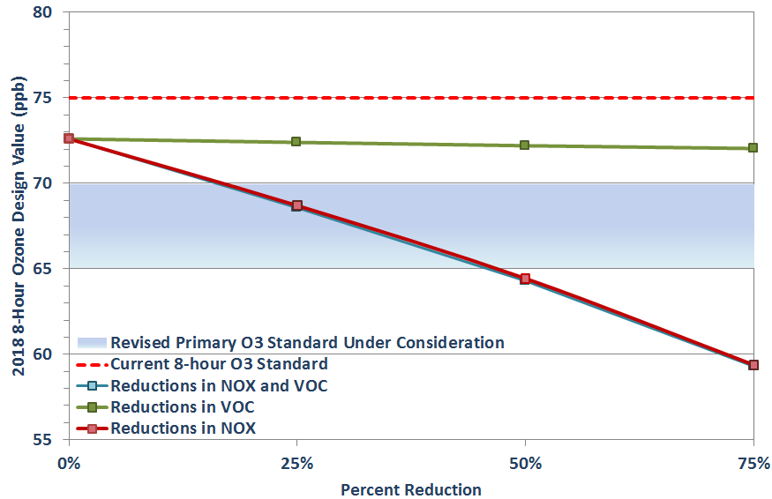

All local regulatory sited ozone monitors were not very sensitive to changes in VOC emissions. When VOC emissions were reduced by 75%, there was only a 0.4 ppb reduction in the 8-hour ozone DV at C23 and a 0.6 ppb reduction in the 8-hour ozone DV at C58 in 2013 (Table 4-2). In light of these results, VOC emission controls may not be the most effective in reducing ozone.

The model was significantly more sensitive to changes in NO_{X} emissions: 12.8 ppb in the 8-hour ozone DV at C23 and 13.2 ppb in the 8-hour ozone DV at C58 in 2013 with a 75% reduction in NO_{X}. These runs indicated that NO_{X} controls with be more effective in reduction the 2018 DV. When both VOC and NO_{X} were reduced by 75%, there was little difference compared to the run where only NO_{X} was reducted. To meet the proposed 70 ppb ozone standard in 2018, local NO_{X} emissions need to be reduced by approximately 25%. To meet the proposed 65 ppb standard, local NO_{X} emissions need to be reduced by approximately 50%.

Figure 4-3: Predicted Ozone Design Value at C23 after Removing Local NO_{X} and VOC Emissions, 2018
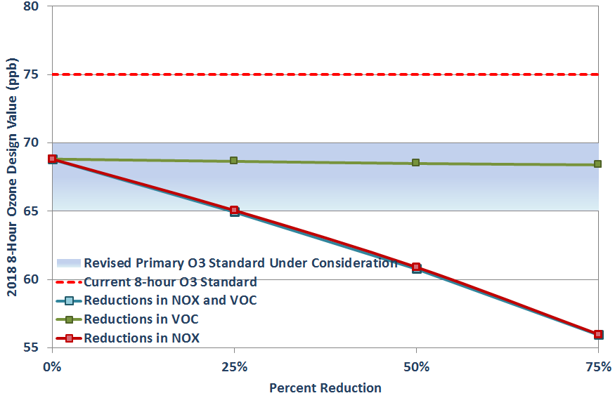

Table 4-2: Predicted Ozone Design Value at C23, C58, C59, C622, and C622 after Removing Local NO_{X} and VOC Emissions, 2018
Scenario | CAMS 23 | CAMS 58 | CAMS 59 | CAMS 622 | CAMS 678
2018 Future Case | 68.82 | 72.60 | 63.37 | 67.71 | 65.11
25 % Reduction in NO_{X} | 65.07 | 68.70 | 60.89 | 64.84 | 62.03
50 % Reduction in NO_{X} | 60.91 | 64.43 | 57.85 | 61.61 | 58.56
75 % Reduction in NO_{X} | 56.00 | 59.38 | 54.47 | 57.64 | 54.33
25 % Reduction in VOC | 68.65 | 72.40 | 63.29 | 67.61 | 64.93
50 % Reduction in VOC | 68.49 | 72.20 | 63.21 | 67.51 | 64.76
75 % Reduction in VOC | 68.39 | 72.04 | 63.24 | 67.55 | 64.57
25% Reduction in NO_{X} and VOC | 64.96 | 68.57 | 60.83 | 64.78 | 61.94
50% Reduction in NO_{X} and VOC | 60.79 | 64.29 | 57.79 | 61.55 | 58.47
75% Reduction in NO_{X} and VOC | 55.96 | 59.30 | 54.46 | 57.63 | 54.30

Removal of Ten Tons of VOC and NO_{X} Precursor Emissions by Source Category
Ten tons of VOC and NO_{X} emissions were removed from area, mobile, and non-road/off-road/oil and gas equipment to determine the impact of reducing different sources from ozone formation. Seven separate photochemical model runs were conducted. A photochemical model run was completed for point sources as well; however, it was only competed with the reduction of ten tons of NO_{X}. This is because there were not more than ten tons of VOC point emissions. The photochemical model adjustment factors for the sensitivity runs are listed in Table 4-3. The runs conducted included:
- 10 tons of VOC removed from Area Sources
- 10 tons of NO_{X} removed from Area Sources
- 10 tons of VOC removed from Mobile Sources
- 10 tons of NO_{X} removed from Mobile Sources
- 10 tons of VOC removed from Non-road, off-road, and oil and gas equipment Sources
- 10 tons of NO_{X} removed from Non-road, off-road, and oil and gas equipment Sources
- 10 tons of NO_{X} removed from Point Sources

Table 4-3: Photochemical Model Inputs for Each Ten Ton Run, 2018
Source Category | Pollutant | Adjustment Factor  (percentage remaining)
Area Sources | VOC | 0.97
 | NO_{X} | 0.21
Mobile | VOC | 0.49
 | NO_{X} | 0.17
Non-Road, Off-Road, and Oil and Gas Equipment | VOC | 0.73
 | NO_{X} | 0.53
Point | NO_{X} | 0.84

Non-road/off-road/oil and gas equipment source NO_{X} emissions had the greatest impact on reducing the 8-hour DV, followed by point source NO_{X} emissions, mobile source NO_{X} emissions and area source NO_{X} emissions. As expected, in Figure 4-4, VOC emission reductions by source category had little impact on the 8-hour DV.

The 2018 DV decreased by -0.93 ppb at C58 when non-road/off-road/oil and gas equipment emissions were reduced by ten tons of NO_{X}. Similarly, the 2018 DV decreased by -0.82 with point source NO_{X} reductions, -0.60 ppb with mobile source NO_{X} reductions, and -0.58 with area source NO_{X} reductions. Table 4-4 shows the forecasted ozone DVs for all monitors after removing ten tons of VOC or NO_{X}.

Figure 4-4: Predicted Ozone Design Value after Removing 10 tons from Local NO_{X} and VOC Emissions by Source Category, 2018
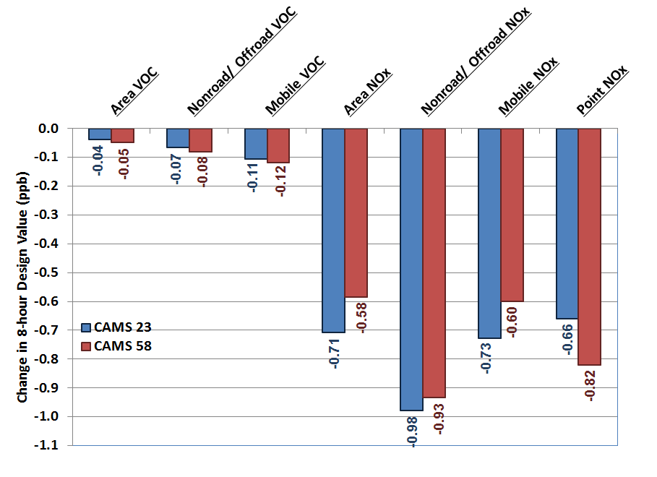

Table 4-4: Predicted Ozone Design Value at C23, C58, C59, C622, and C622 after Removing 10 tons of VOC or NO_{X} by source category, 2018
Scenario | CAMS 23 | CAMS 58 | CAMS 59 | CAMS 622 | CAMS 678
Base Case Run | 68.56 | 72.33 | 62.67 | 67.09 | 64.88
10 ton Reduction in Area Source NO_{X} | 67.85 | 71.75 | 62.55 | 66.81 | 64.44
10 ton Reduction in Area Source VOC | 68.52 | 72.28 | 62.54 | 66.95 | 64.79
10 ton Reduction in Mobile Source NO_{X} | 67.83 | 71.73 | 62.58 | 66.86 | 64.36
10 ton Reduction in Mobile Source VOC | 68.45 | 72.21 | 62.52 | 66.92 | 64.74
10 ton Reduction in Nonroad/Offroad Source NO_{X} | 67.58 | 71.40 | 62.45 | 66.72 | 64.16
10 ton Reduction in Nonroad/Offroad Source VOC | 68.49 | 72.25 | 62.49 | 66.90 | 64.76
10 ton Reduction in Point Source NO_{X} | 67.90 | 71.51 | 61.85 | 66.23 | 64.10

Hourly On-Road Runs
To determine the impact of on-road emissions by hour, photochemical model runs were performed by removing one ton of NO_{X} emissions for every hour between 7:00 a.m. to 1:00 p.m. Table 4-5 shows the NO_{X} adjustment factor for each run by each of the four day types. VOC emissions were not included in the runs because previous runs indicate that VOC emissions do not have a material impact on ozone levels. The runs conducted included:

- 7-8 a.m. run with 1 ton of NO_{X} removed | - 11 a.m. - noon run with 1 ton of NO_{X} removed
- 8-9 a.m. run with 1 ton of NO_{X} removed | - noon - 1 p.m. run with 1 ton of NO_{X} removed
- 9-10 a.m. run with 1 ton of NO_{X} removed | - 1-2 p.m. run with 1 ton of NO_{X} removed
- 10-11 a.m. run with 1 ton of NO_{X} removed

Table 4-5: Photochemical Model Inputs for Each Hourly 1 Ton Run, 2018
Time | NO_{X} Adjustment Factor
 | Weekday | Friday | Saturday | Sunday
7 a.m. – 8 a.m. | 0.535 | 0.545 | 0.185 | 0.000
8 a.m. – 9 a.m. | 0.469 | 0.493 | 0.269 | 0.030
9 a.m. – 10 a.m. | 0.437 | 0.454 | 0.408 | 0.190
10 a.m. – 11 a.m. | 0.485 | 0.500 | 0.477 | 0.335
11a.m. – Noon | 0.525 | 0.550 | 0.556 | 0.450
Noon – 1 p.m. | 0.545 | 0.565 | 0.565 | 0.430
1 p.m. – 2 p.m. | 0.573 | 0.603 | 0.540 | 0.470

The greatest reduction in the ozone DV occurred between 9 a.m. and 11 a.m. (Figure 4-5). Ozone was reduced by 0.63 ppb for the 9 a.m. – 10 a.m. run and 0.64 ppb for the 10 am to 11 am run at C58. Runs for the morning rush hour only showed at reducing 0.15 ppb and the early afternoon trips showed only a 0.16 ppb reduction from 1 p.m. to 2 p.m. As showing in Table 4-6, morning rush hour emissions had less impact on the 2018 DV compared to late morning trips. The results indicate that control strategies that target early lunch hour trips may be more effective at controlling ozone pollution then reducing emissions during the morning and evening rush hours.

Figure 4-5: Predicted Ozone Design Value after Removing 1 tons from Local On-Road NO_{X} Emissions by Hour, 2018
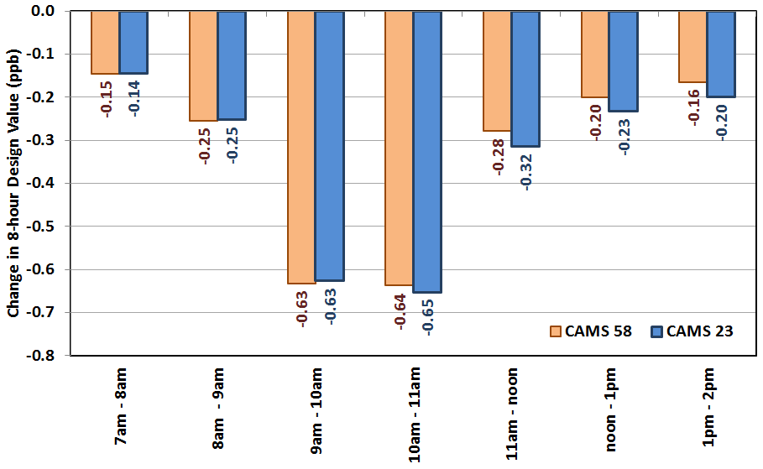

Table 4-6: Predicted Ozone Design Value at C23, C58, C59, C622, and C622 after Removing One Ton from Local On-Road NOx Emissions by Hour, 2018
Scenario | CAMS 23 | CAMS 58 | CAMS 59 | CAMS 622 | CAMS 678
Base Case Run | 68.79 | 72.56 | 62.80 | 67.22 | 65.02
7 a.m. – 8 a.m. | 68.64 | 72.42 | 62.72 | 67.12 | 64.89
8 a.m. – 9 a.m. | 68.54 | 72.31 | 62.73 | 67.13 | 64.83
9 a.m. – 10 a.m. | 68.16 | 71.93 | 62.46 | 66.85 | 64.55
10 a.m. – 11 a.m. | 68.14 | 71.93 | 62.48 | 66.84 | 64.55
11 a.m. – noon | 68.47 | 72.29 | 62.75 | 67.13 | 64.83
noon – 1 p.m. | 68.56 | 72.36 | 62.76 | 67.15 | 64.88
1 p.m. – 2 p.m. | 68.59 | 72.40 | 62.76 | 67.16 | 64.90

Anthropogenic Precursor Culpability Assessment (APCA) Run

APCA Run Setup
“ENVIRON developed an ozone source attribution approach that has become known as the ‘Ozone Source Apportionment Technology,’ or OSAT. OSAT provides a method for estimating the contributions of multiple source areas, categories, and pollutant types to ozone formation in a single model run.” “OSAT uses multiple tracer species to track the fate of ozone precursor emissions (VOC and NO_{X}) and the ozone formation caused by these emissions within a simulation. The tracers operate as spectators to the normal CAMx calculations so that the underlying CAMx predicted relationships between emission groups (sources) and ozone concentrations at specific locations (receptors) are not perturbed.”

“The ozone reaction tracers allow ozone formation from multiple ‘source groupings’ to be tracked simultaneously within a single simulation. A source grouping can be defined in terms of geographical area and/or emission category.” “So that all sources of ozone precursors are accounted, the CAMx boundary conditions and initial conditions are always tracked as separate source groupings. The methodology is designed so that all ozone and precursor concentrations are attributed among the selected source groupings at all times. Thus, for all receptor locations and times, the ozone (or ozone precursor concentrations) predicted by CAMx is attributed among the source groupings selected for OSAT. The methodology also estimates the fractions of ozone arriving at the receptor that were formed en-route under VOC- or NO_{X}-limited conditions. This information indicates how ozone concentrations at the receptor will respond to reductions in VOC and NO_{X} precursor emissions”. Boundary conditions are the conditions beyond the 36 km domain. These emissions represent all NO_{X}, VOC, and Ozone that enter the 36 km modeling domain.

“APCA differs from OSAT in recognizing that certain emission groups are not controllable (e.g., biogenic emissions) and that apportioning ozone production to these groups does not provide information that is relevant to control strategies. To address this, in situations where OSAT would attribute ozone production to non-controllable (i.e., biogenic) emissions, APCA re-allocates that ozone production to the controllable portion of precursors that participated in ozone formation with the non-controllable precursor. In the case where biogenic emissions are the uncontrollable source category, APCA would only attribute ozone production to biogenic emissions when ozone formation is due to the interaction of biogenic VOC with biogenic NO_{X}.”

The June episode was run at the 4 km, 12 km, and 36 km grid sizes using APCA. For the APCA run, the receptors defined in the run were the 3 regulatory monitors in the San Antonio-New Braunfels MSA: C23, C58, and C59. Emission sources were divided into 6 different categories: area, non-road/off-road, on-road, point, oil and gas development, and biogenic.

The APCA run was also divided into 8 geographical areas, initial conditions, and boundary conditions. Figure 5-1 shows the geographical region at the 36 km grid level, while Figure 5-2 shows the geographical regions at the 4 km grid level. The geographic source apportionment areas are:

- Dallas-Fort Worth Nonattainment (NA) Area
- Waco-Temple-IH35 Region
- Austin-Round Rock Metro Stat Area (MSA)
- San Antonio-New Braunfels MSA
- Houston-Galveston-Brazoria NA Area
- Other Texas Counties
- Other US States and Coastal Areas
- International (Canada and Mexico)
- Initial Conditions
- Boundary conditions

The high ozone days used in the analysis are June 3, 8, 9, 12, 13, 14, 28, 29, and 30 and are based on a 7x7 4km grid around each monitoring in accordance with EPA’s 2007 modeling guidance.

Figure 5-1: APCA Regions at the 36 km Grid Level, 2018
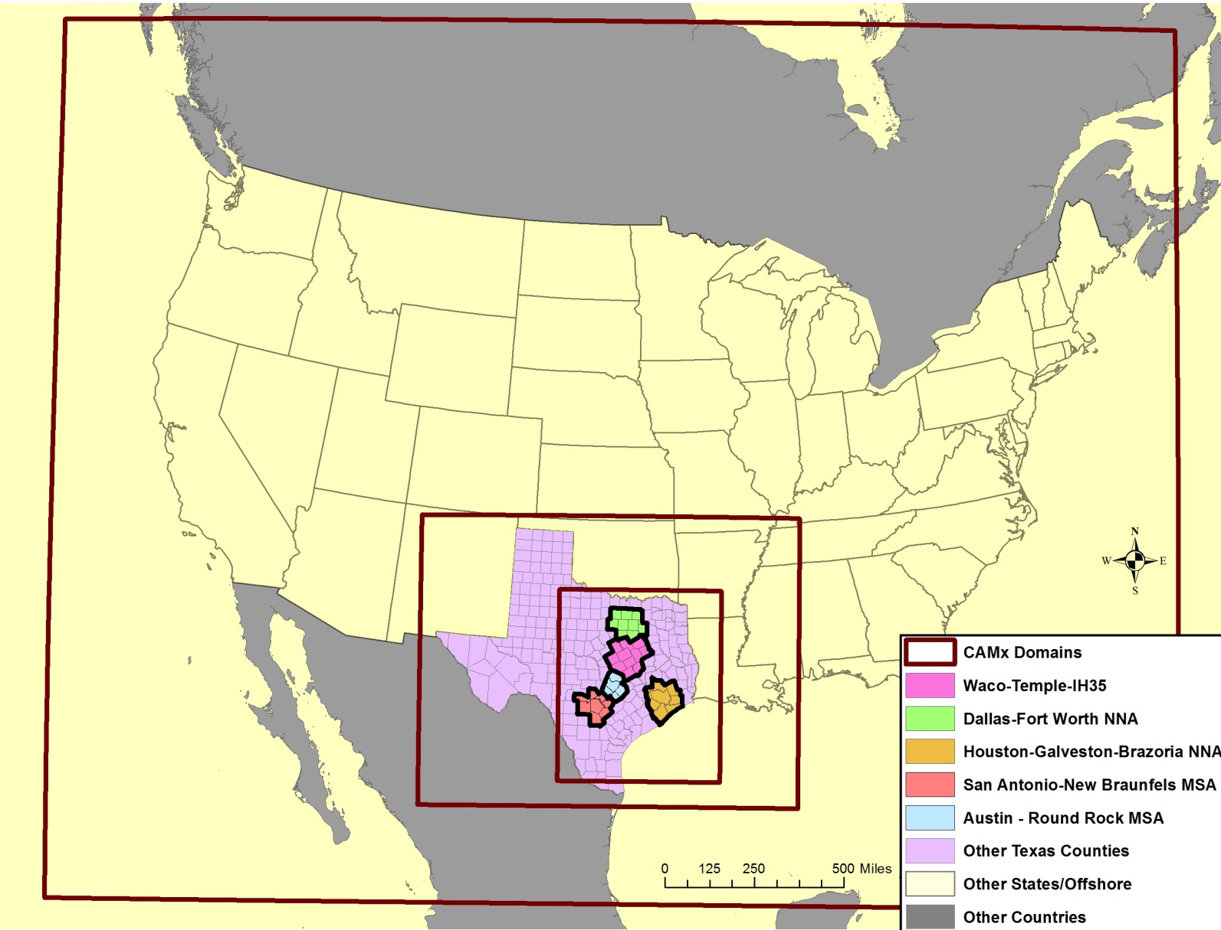
36 km Grid

12 km Grid

4km Grid
Plot Date: April 30, 2015
Map Compilation: July 24, 2015
Source: APCA run Setup

Figure 5-2: APCA Regions at the 4 km Grid Level, 2018
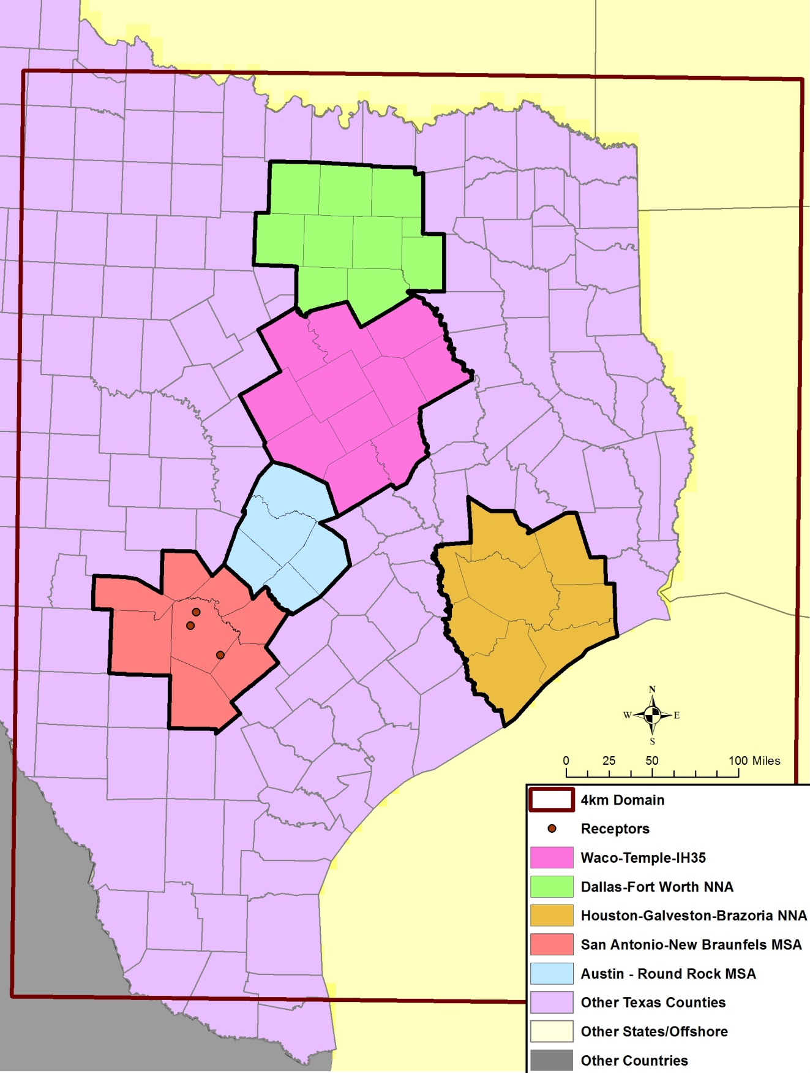
Plot Date: April 30, 2015
Map Compilation: July 24, 2015
Source: APCA run Setup

Contribution by Source Region
Figure 5-3 shows the contribution from each source region for each hour of the modeling episode. As the wind shifts through the modeling episode, the contribution on hourly ozone at C58 from each source region changes. When the winds came from the North and Northeast, there was a larger contribution from Dallas and Austin. When winds came from the east during the modeling episode, the ozone contributions from San Antonio and Houston emissions increased. Data for days between May 24 to May 30 was not included in the analysis because these days were only run at the 36 km grid level. The finer grid levels of 4km and 12km were not available from TCEQ for these modeling days/

Since San Antonio emissions were the largest contribution, 32.3% in Table 5-1, of peak hourly ozone on design value days at C58 local controls can be effective in reduction ozone readings at the monitors. The second largest contribution (29.1%) came from boundary conditions - these conditions are outside of any local or federal controls and any controls in these regions cannot be enforced by EPA because the emissions are from other countries. Other Texas counties that are mostly rural areas and smaller cities contributed a surprising high 9.3% of peak one-hour ozone at C58. Austin, at 6.8%, and Houston, at 4.4%, also had significant contributions to local ozone. Northern Mexico/Canada only had a contribution of 0.6% to local peak hourly ozone on Design Value days. Dallas, at 1.5%, and the Waco/Temple, at 1.5%, had less than expected contributions to peak one-hour ozone. This is probably due to wind directions during the June episode. At 100 meters, back trajectories showed winds primarily coming from the Southeast (38.8%) and the South (22.7%) during the episode on high ozone days greater than 60 ppb. Wind from the Northeast only occurred on 13.7% of the days during the episode.

The results for C23 were very similar to C58, except there was a higher contribution from local sources in the San Antonio-New Braunfels MSA (37.7%). At C59, San Antonio’s emission contribution to peak one-hour ozone (18.9%) was less than at the other two monitors because this monitor is often upwind of the urban core and other large local emission sources on high ozone days. Other Texas counties and Houston have a greater impact on local ozone at this monitor.

Figure 5-3: C58 Hourly ACPA Results by Source Region, 2018
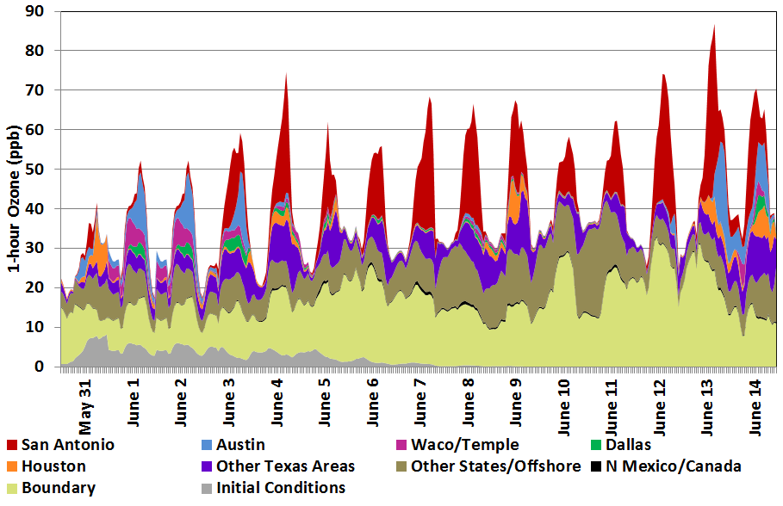

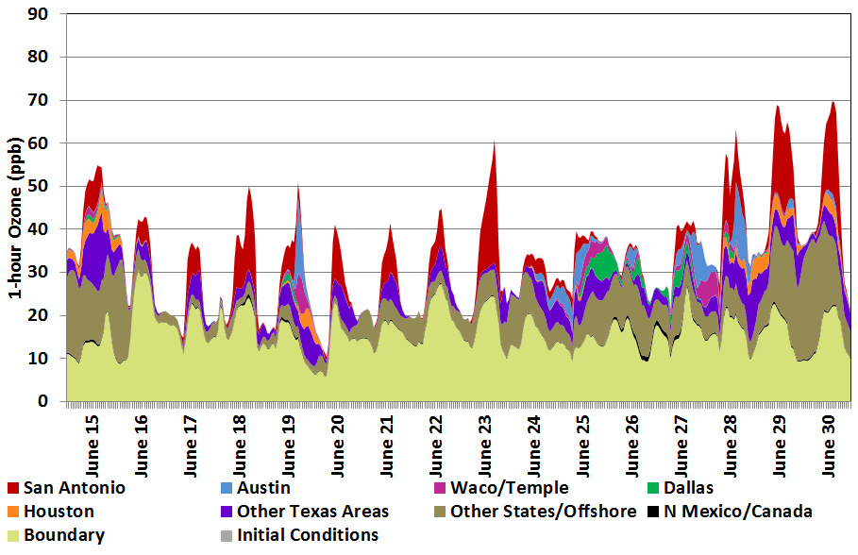
Table 5-1: APCA Results for C58, C23, C59 by Source Region, 2018
Monitor | Region | All Days |  | Days > 65 ppb |  | Days > 70 ppb (Average) |  | Days > 70 ppb  (Peak 1-hour)
 |  | ppb | % | ppb | % | ppb | % | ppb | %
C58 | Initial Conditions | 0.87 | 2.3% | 0.82 | 2.0% | 0.47 | 1.0% | 0.34 | 0.5%
 | Boundary | 15.75 | 42.2% | 16.06 | 38.4% | 16.24 | 35.5% | 19.57 | 28.1%
 | Northern Mexico/Canada | 0.31 | 0.8% | 0.38 | 0.9% | 0.32 | 0.7% | 0.40 | 0.6%
 | Other States/Offshore | 7.88 | 21.1% | 9.09 | 21.8% | 9.70 | 21.2% | 10.44 | 15.0%
 | Other Texas Counties | 4.11 | 11.0% | 4.85 | 11.6% | 5.67 | 12.4% | 6.51 | 9.3%
 | San Antonio | 4.89 | 13.1% | 6.29 | 15.1% | 8.08 | 17.7% | 22.52 | 32.3%
 | Austin | 1.38 | 3.7% | 1.67 | 4.0% | 2.35 | 5.1% | 4.74 | 6.8%
 | Waco/Temple | 0.73 | 2.0% | 0.79 | 1.9% | 0.75 | 1.6% | 1.04 | 1.5%
 | Dallas | 0.50 | 1.3% | 0.63 | 1.5% | 0.50 | 1.1% | 1.04 | 1.5%
 | Houston | 0.91 | 2.4% | 1.19 | 2.8% | 1.69 | 3.7% | 3.05 | 4.4%
 | Total | 37.33 | 100.0% | 41.78 | 100.0% | 45.77 | 100.0% | 69.64 | 100.0%
C23 | Initial Conditions | 0.86 | 2.4% | 0.83 | 2.0% | 0.50 | 1.1% | 0.36 | 0.5%
 | Boundary | 15.41 | 42.4% | 15.70 | 38.3% | 16.07 | 35.1% | 20.50 | 28.5%
 | Northern Mexico/Canada | 0.30 | 0.8% | 0.37 | 0.9% | 0.31 | 0.7% | 0.41 | 0.6%
 | Other States/Offshore | 7.73 | 21.3% | 8.95 | 21.8% | 9.57 | 20.9% | 10.23 | 14.2%
 | Other Texas Counties | 3.98 | 10.9% | 4.74 | 11.6% | 5.47 | 12.0% | 6.31 | 8.8%
 | San Antonio | 5.15 | 14.1% | 6.87 | 16.7% | 9.75 | 21.3% | 27.10 | 37.7%
 | Austin | 0.99 | 2.7% | 1.11 | 2.7% | 1.32 | 2.9% | 2.36 | 3.3%
 | Waco/Temple | 0.62 | 1.7% | 0.67 | 1.6% | 0.62 | 1.4% | 0.97 | 1.3%
 | Dallas | 0.48 | 1.3% | 0.62 | 1.5% | 0.51 | 1.1% | 1.01 | 1.4%
 | Houston | 0.87 | 2.4% | 1.17 | 2.8% | 1.65 | 3.6% | 2.72 | 3.8%
 | Total | 36.39 | 100.0% | 41.03 | 100.0% | 45.77 | 100.0% | 71.95 | 100.0%

Monitor | Region | All Days |  | Days > 65 ppb |  | Days > 70 ppb (Average) |  | Days > 70 ppb  (Peak 1-hour)
 |  | ppb | % | ppb | % | ppb | % | ppb | %
C59 | Initial Conditions | 1.05 | 2.9% | 1.01 | 2.5% | 1.56 | 3.6% | 0.83 | 1.5%
 | Boundary | 16.28 | 44.4% | 16.35 | 40.8% | 17.12 | 39.6% | 16.21 | 29.5%
 | Northern Mexico/Canada | 0.30 | 0.8% | 0.37 | 0.9% | 0.26 | 0.6% | 0.35 | 0.6%
 | Other States/Offshore | 9.23 | 25.2% | 10.68 | 26.6% | 7.43 | 17.2% | 7.28 | 13.3%
 | Other Texas Counties | 4.65 | 12.7% | 5.78 | 14.4% | 7.37 | 17.0% | 11.49 | 20.9%
 | San Antonio | 2.32 | 6.3% | 2.55 | 6.4% | 5.91 | 13.7% | 10.13 | 18.5%
 | Austin | 0.77 | 2.1% | 0.69 | 1.7% | 0.46 | 1.1% | 2.21 | 4.0%
 | Waco/Temple | 0.44 | 1.2% | 0.53 | 1.3% | 0.35 | 0.8% | 1.11 | 2.0%
 | Dallas | 0.38 | 1.1% | 0.56 | 1.4% | 0.68 | 1.6% | 1.67 | 3.0%
 | Houston | 1.22 | 3.3% | 1.56 | 3.9% | 2.10 | 4.9% | 3.60 | 6.6%
 | Total | 36.64 | 100.0% | 40.07 | 100.0% | 43.25 | 100.0% | 54.88 | 100.0%

Figure 5-4: ICQ Plots for C58, C23, and C59 by Source Region on Days > 70 ppb, 2018
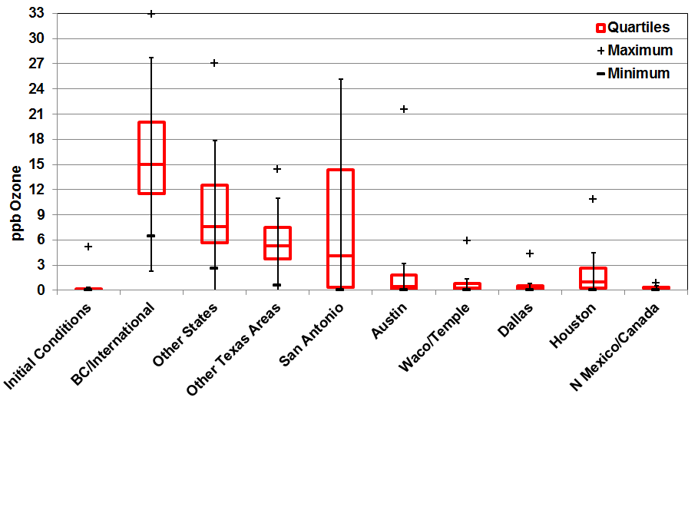
C58

C23

C59
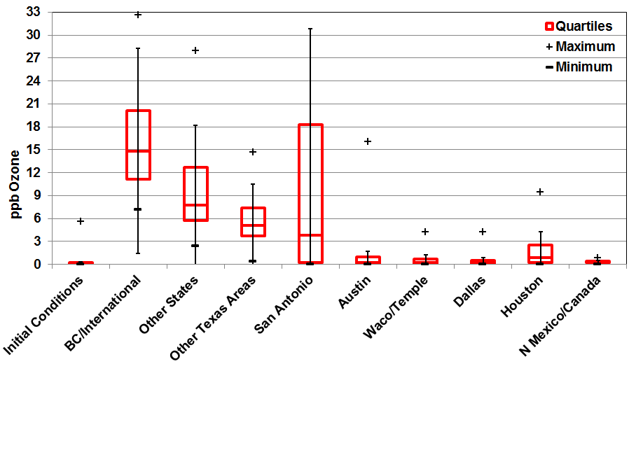
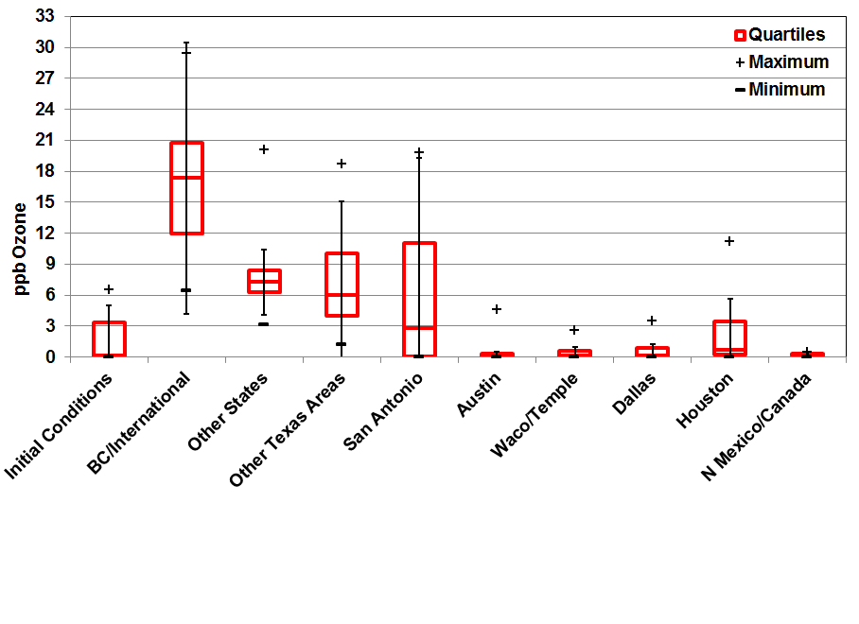
Figure 5-4 includes interquartile range (ICQ) plots that show the distribution of parts per billion of ozone that attribute to the days that are greater than 70 ppb. “The interquartile range of an observation variable is the difference of its upper and lower quartiles. It is a measure of how far apart the middle portion of data spreads in value.” The interquartile range at the San Antonio-New Braunfels MSA indicates that 50% of the middle values in the distribution contribute up to 18 ppb (C23); however, in some cases, the San Antonio-New Braunfels MSA contributes up to 42.4 ppb, as indicated by the maximum value at C23 (not pictured in the graph). Similarly, C58 has a maximum contribution of 40.4 ppb. These results shows local emission sources can have a significant impact on ozone recorded at local regulatory monitors.

In the ICQ plots, Austin’s average contribution to parts per billion of ozone on days > 70 ppb is relatively low; however, with a maximum value of 22 ppb at C58, Austin can have significant impact on one-hour ozone values. Noteworthy is that when winds come from the Northeast, Austin can have a significant increase in recorded ozone at C58. Other Texas Areas (14 ppb) and Houston’s (10 ppb) maximum contributions are also considered to be significant, whereas anthropogenic emissions from Mexico and Canada, whose maximum contribution is0.6 ppb,is not not considered to be significant.

Contribution by All Emission Sources
The APCA run was also split into emission source groupings for all regions in the modeling domain to determine the impact at the regulatory monitors in the San Antonio-New Braunfels MSA. At 32 percent, the largest emission source contributor to ozone readings at C58 on days > 70 ppb was point sources. As Figure 5-5 shows, the second largest source contributor was boundary conditions at 28%, followed by on-road emissions at 17% and non-road/off-road equipment at 12%.

The results were similar for C23 with on-road emissions having a slightly higher contribution at 19% (Figure 5-6). At both C58 and C23 monitors, 7% of the ozone came from area source emissions in the modeling domain. For C59 (Figure 5-7), both on-road and non-road/off-road had a less of an impact at the monitor compared to the other two regulatory monitors. Biogenic emissions, 2-3%, did not have a significant impact on ozone formation in the APCA run at any of the three regulatory monitors (Table 5-2).

Figure 5-5: Pie Chart for C58 by All Emission Sources for Average Peak 1-Hour Ozone on Days > 70 ppb, 2018
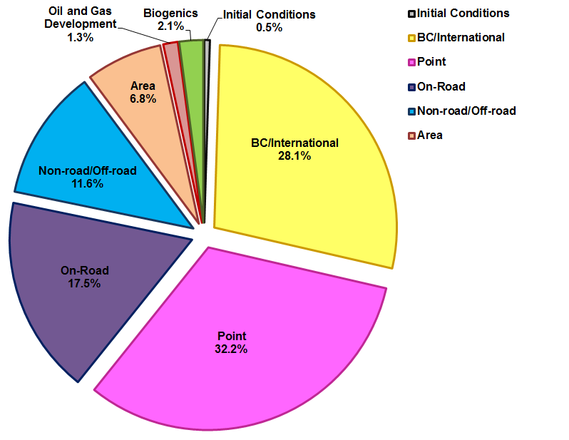
Figure 5-6: Pie Chart for C23 by All Emission Sources for Average Peak 1-Hour Ozone on Days > 70 ppb, 2018
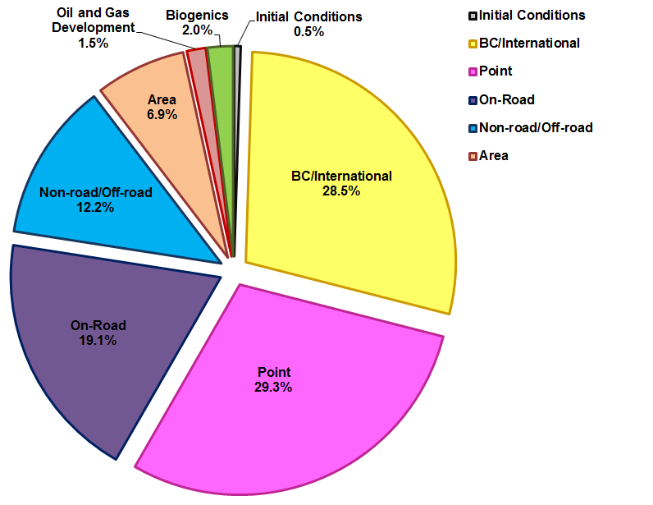
Figure 5-7: Pie Chart for C59 by All Emission Sources for Average Peak 1-hour Ozone on Days > 70 ppb, 2018
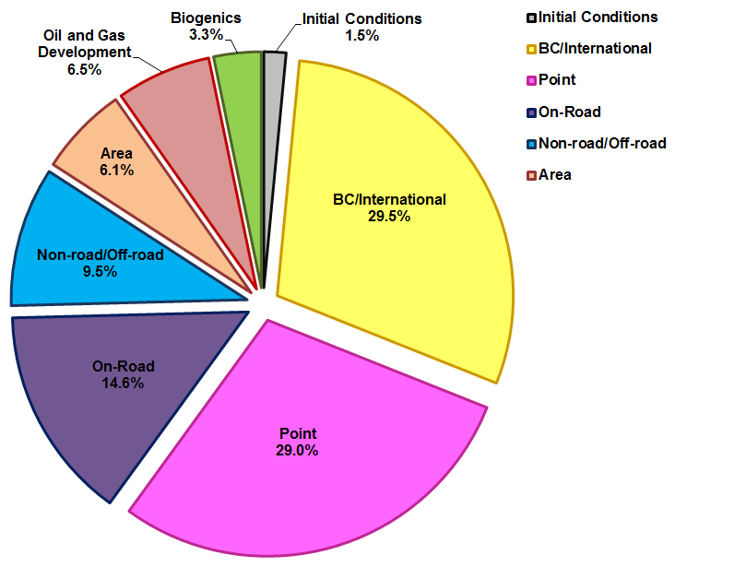

Table 5-2: APCA results for C58, C23, C59 by All Emission Source, 2018
Monitor | Source | All Days |  | Days > 65 ppb |  | Days > 70 ppb (Average) |  | Days > 70 ppb  (Peak 1-hour)
 |  | ppb | % | ppb | % | ppb | % | ppb | %
C58 | Initial Conditions | 0.87 | 2% | 0.82 | 2% | 0.47 | 1% | 0.34 | 0%
 | BC/International | 15.75 | 42% | 16.06 | 38% | 16.24 | 35% | 19.57 | 28%
 | Biogenics | 0.86 | 2% | 1.07 | 3% | 1.10 | 2% | 1.48 | 2%
 | Area | 1.79 | 5% | 2.33 | 6% | 2.57 | 6% | 4.71 | 7%
 | Oil and Gas Development | 0.75 | 2% | 0.84 | 2% | 0.91 | 2% | 0.90 | 1%
 | Non-road/Off-road | 3.32 | 9% | 4.02 | 10% | 5.06 | 11% | 8.07 | 12%
 | On-Road | 5.06 | 14% | 6.22 | 15% | 6.81 | 15% | 12.17 | 17%
 | Point | 8.92 | 24% | 10.42 | 25% | 12.62 | 28% | 22.40 | 32%
 | Total | 37.33 | 100% | 41.78 | 100% | 45.77 | 100% | 69.64 | 100%
C23 | Initial Conditions | 0.86 | 2% | 0.83 | 2% | 0.50 | 1% | 0.36 | 0%
 | BC/International | 15.41 | 42% | 15.70 | 38% | 16.07 | 35% | 20.50 | 28%
 | Biogenics | 0.82 | 2% | 1.02 | 2% | 1.04 | 2% | 1.42 | 2%
 | Area | 1.75 | 5% | 2.32 | 6% | 2.70 | 6% | 5.00 | 7%
 | Oil and Gas Development | 0.80 | 2% | 0.92 | 2% | 1.02 | 2% | 1.05 | 1%
 | Non-road/Off-road | 3.21 | 9% | 3.98 | 10% | 5.23 | 11% | 8.76 | 12%
 | On-Road | 4.95 | 14% | 6.19 | 15% | 7.15 | 16% | 13.77 | 19%
 | Point | 8.59 | 24% | 10.07 | 25% | 12.06 | 26% | 21.11 | 29%
 | Total | 36.39 | 100% | 41.03 | 100% | 45.77 | 100% | 71.95 | 100%
C59 | Initial Conditions | 1.05 | 3% | 1.01 | 3% | 1.56 | 4% | 0.83 | 2%
 | BC/International | 16.28 | 44% | 16.35 | 41% | 17.12 | 40% | 16.21 | 30%
 | Biogenics | 0.83 | 2% | 1.07 | 3% | 1.20 | 3% | 1.78 | 3%
 | Area | 1.32 | 4% | 1.72 | 4% | 2.10 | 5% | 3.36 | 6%
 | Oil and Gas Development | 1.16 | 3% | 1.45 | 4% | 1.69 | 4% | 3.56 | 6%
 | Non-road/Off-road | 3.07 | 8% | 3.68 | 9% | 3.52 | 8% | 5.24 | 10%
 | On-Road | 3.83 | 10% | 4.62 | 12% | 5.31 | 12% | 8.02 | 15%
 | Point | 9.09 | 25% | 10.17 | 25% | 10.76 | 25% | 15.89 | 29%
 | Total | 36.64 | 100% | 40.07 | 100% | 43.25 | 100% | 54.88 | 100%

Contribution by San Antonio-New Braunfels MSA Emission Sources
By including both source regions and emission sources in the APCA run, San Antonio-New Braunfels emission source contributions to local ozone readings can be analyzed. Point sources, 39%, and on-road sources, 30%, had the largest contribution to ozone at C58 on days > 70 ppb (Figure 5-8). Local non-road/off-road emissions at 16% and area sources at 12% also had significant contributions at C58.

Local emission contribution was similar for both C58 and C23 (Figure 5-9). Point source contribution was slightly less (33%) at C23, while on-road (35%) and non-road/off-road (19%) source contributions were a little higher. At C59 in Figure 5-10, almost half of the local contribution came from point source emissions. Local on-road and area source emissions had less of an impact at this monitor. At both C23 and C58, local biogenic emissions contributions to average peak 1-hour ozone was small (less than 1.2%), while local biogenic impact at C59 was 4%. Overall, local emissions sources contributed 21.2 ppb at C58, 25.1 ppb at C23, and 10.8 ppb at C59 to average peak 1-hour ozone on days > 70 ppb (Table 5-3).

The ICQ plots in Figure 5-11, show that there was a wide range in local on-road and point source contribution on days > 70 ppb. Local non-road/off-road and area emission sources had a wide impact on local 1-hour ozone levels. Local point sources had a maximum 1-hour ozone impact of 22.6 ppb on high ozone days, while local on-road sources had a maximum impact of 11.4 ppb at C58. At C23, local point sources had a maximum impact of 20.6 ppb and local on-road sources had a maximum impact of 15.7 ppb in 2018.

Figure 5-8: Pie Chart for C58 by Local Emission Sources for Average Peak 1-hour Ozone on Days > 70 ppb, 2018
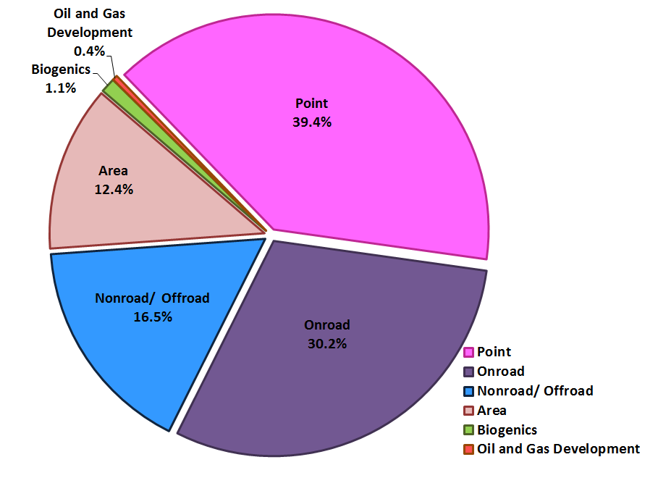
Figure 5-9: Pie Chart for C23 by Local Emission Sources for Average Peak 1-hour Ozone on Days > 70 ppb, 2018
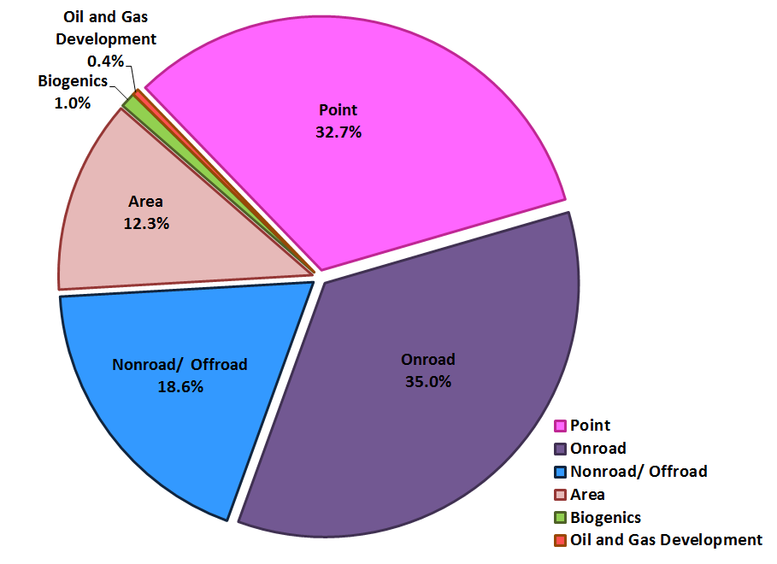
Figure 5-10: Pie Chart for C59 by Local Emission Sources for Average Peak 1-hour Ozone on Days > 70 ppb, 2018
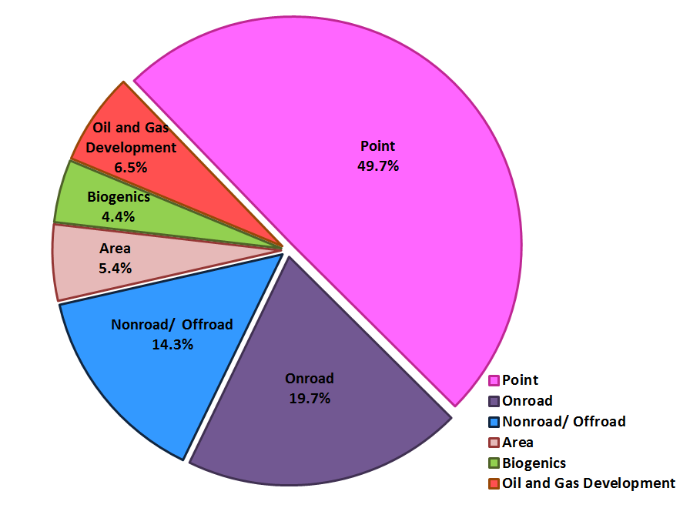

Table 5-3: APCA results for C58, C23, C59 by Local Emission Source, 2018
Monitor | Source | Pollutant | All Days |  | Days > 65 ppb |  | Days > 70 ppb (Average) |  | Days > 70 ppb  (Peak 1-hour)
 |  |  | ppb | % | ppb | % | ppb | % | ppb | %
C58 | Biogenics | NOx | 0.07 | 2% | 0.10 | 2% | 0.11 | 1% | 0.22 | 1%
 |  | VOC | 0.01 | 0% | 0.01 | 0% | 0.01 | 0% | 0.01 | 0%
 | Area | NOx | 0.36 | 8% | 0.53 | 8% | 0.61 | 8% | 1.87 | 9%
 |  | VOC | 0.10 | 2% | 0.14 | 2% | 0.22 | 3% | 0.76 | 4%
 | Oil and Gas Development | NOx | 0.07 | 2% | 0.08 | 1% | 0.05 | 1% | 0.06 | 0%
 |  | VOC | 0.01 | 0% | 0.01 | 0% | 0.01 | 0% | 0.02 | 0%
 | Nonroad/Offroad | NOx | 0.67 | 15% | 0.98 | 16% | 1.20 | 15% | 3.35 | 16%
 |  | VOC | 0.02 | 1% | 0.03 | 1% | 0.04 | 0% | 0.14 | 1%
 | Onroad | NOx | 1.43 | 33% | 2.07 | 33% | 2.35 | 29% | 6.19 | 29%
 |  | VOC | 0.03 | 1% | 0.05 | 1% | 0.07 | 1% | 0.20 | 1%
 | Point | NOx | 1.53 | 35% | 2.28 | 36% | 3.39 | 42% | 8.29 | 39%
 |  | VOC | 0.01 | 0% | 0.02 | 0% | 0.02 | 0% | 0.06 | 0%
 | Total |  | 4.32 | 100% | 6.29 | 100% | 8.08 | 100% | 21.19 | 100%
C23 | Biogenics | NOx | 0.07 | 2% | 0.09 | 1% | 0.11 | 1% | 0.23 | 1%
 |  | VOC | 0.01 | 0% | 0.01 | 0% | 0.01 | 0% | 0.01 | 0%
 | Area | NOx | 0.41 | 9% | 0.65 | 9% | 0.92 | 9% | 2.74 | 11%
 |  | VOC | 0.08 | 2% | 0.12 | 2% | 0.19 | 2% | 0.35 | 1%
 | Oil and Gas Development | NOx | 0.09 | 2% | 0.10 | 1% | 0.07 | 1% | 0.08 | 0%
 |  | VOC | 0.01 | 0% | 0.01 | 0% | 0.01 | 0% | 0.02 | 0%
 | Nonroad/Offroad | NOx | 0.72 | 16% | 1.13 | 16% | 1.67 | 17% | 4.59 | 18%
 |  | VOC | 0.02 | 0% | 0.03 | 0% | 0.03 | 0% | 0.06 | 0%
 | Onroad | NOx | 1.53 | 34% | 2.33 | 34% | 3.12 | 32% | 8.68 | 35%
 |  | VOC | 0.03 | 1% | 0.04 | 1% | 0.06 | 1% | 0.10 | 0%
 | Point | NOx | 1.53 | 34% | 2.35 | 34% | 3.55 | 36% | 8.15 | 33%
 |  | VOC | 0.01 | 0% | 0.01 | 0% | 0.02 | 0% | 0.04 | 0%
 | Total |  | 4.50 | 100% | 6.87 | 100% | 9.75 | 100% | 25.06 | 100%

Monitor | Source | Pollutant | All Days |  | Days > 65 ppb |  | Days > 70 ppb (Average) |  | Days > 70 ppb  (Peak 1-hour)
 |  |  | ppb | % | ppb | % | ppb | % | ppb | %
C59 | Biogenics | NOx | 0.06 | 3% | 0.09 | 3% | 0.16 | 3% | 0.38 | 4%
 |  | VOC | 0.00 | 0% | 0.01 | 0% | 0.01 | 0% | 0.01 | 0%
 | Area | NOx | 0.11 | 5% | 0.13 | 5% | 0.39 | 7% | 0.70 | 6%
 |  | VOC | 0.03 | 1% | 0.03 | 1% | 0.09 | 2% | 0.03 | 0%
 | Oil and Gas Development | NOx | 0.12 | 6% | 0.17 | 6% | 0.08 | 1% | 0.10 | 1%
 |  | VOC | 0.01 | 1% | 0.01 | 1% | 0.01 | 0% | 0.01 | 0%
 | Nonroad/Offroad | NOx | 0.27 | 13% | 0.34 | 13% | 0.73 | 12% | 1.37 | 13%
 |  | VOC | 0.02 | 1% | 0.01 | 1% | 0.04 | 1% | 0.01 | 0%
 | Onroad | NOx | 0.42 | 20% | 0.52 | 20% | 1.22 | 21% | 2.08 | 19%
 |  | VOC | 0.01 | 1% | 0.01 | 0% | 0.03 | 1% | 0.01 | 0%
 | Point | NOx | 1.00 | 49% | 1.24 | 49% | 3.10 | 52% | 6.11 | 56%
 |  | VOC | 0.01 | 0% | 0.01 | 0% | 0.03 | 1% | 0.01 | 0%
 | Total |  | 2.07 | 100% | 2.55 | 100% | 5.91 | 100% | 10.81 | 100%

Figure 5-11: ICQ plots for C58, C23, C59 by Local Emission Source on Days > 70 ppb, 2018
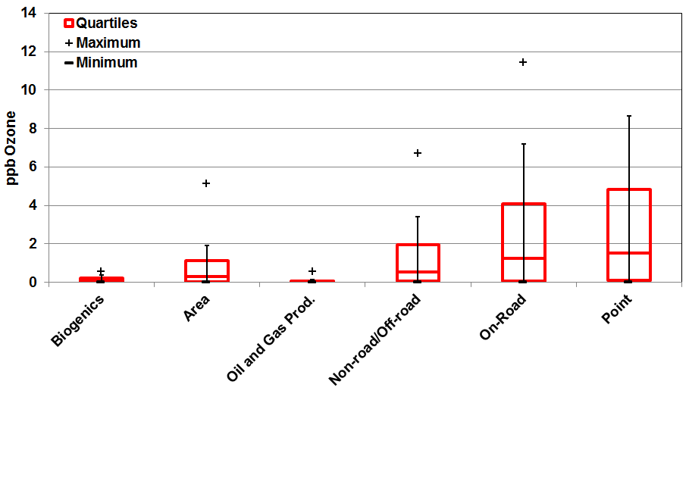
C58

C23

C59
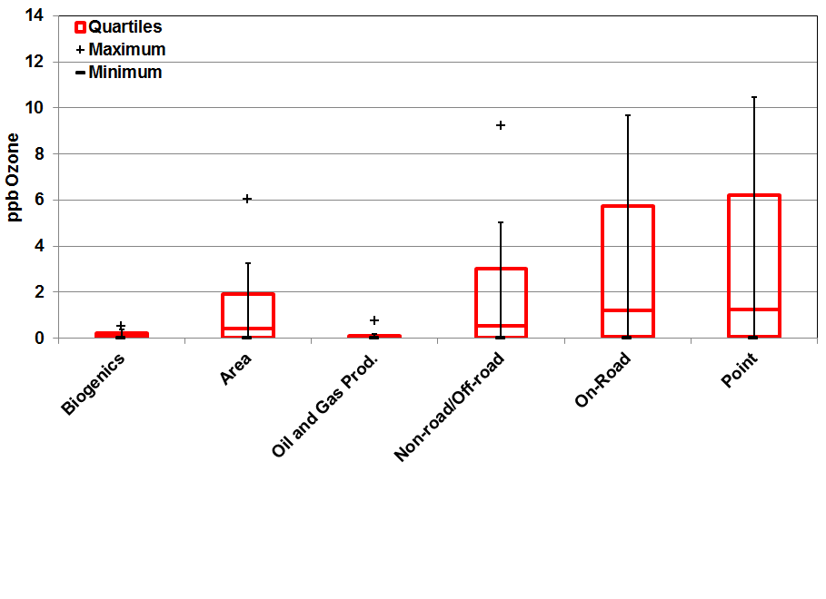
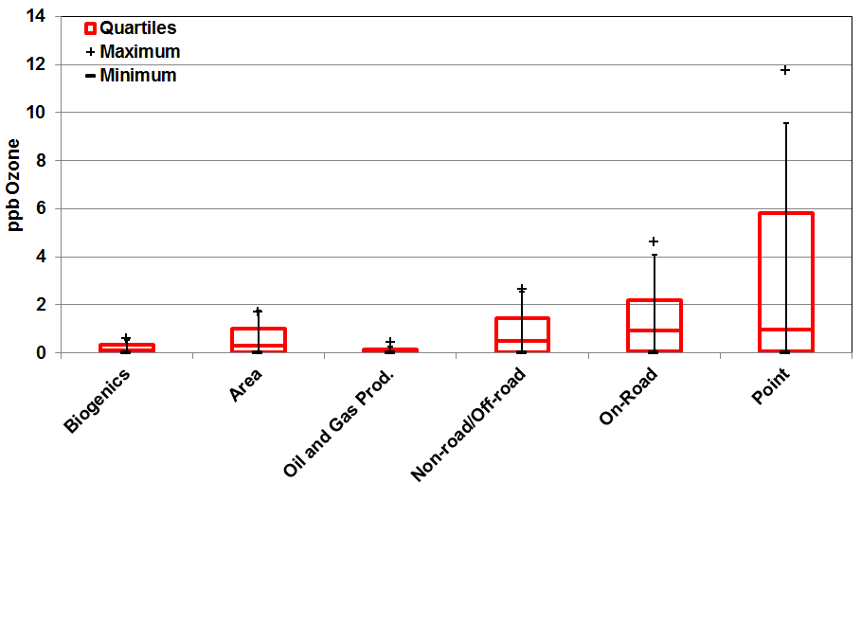

Contribution by San Antonio-New Braunfels MSA NO_{X} and VOC Emission
As part of the APCA runs, local emission sources were also disaggregated into NO_{X} and VOC emission contributions. The hourly contribution from each pollutant type is shown in Figure 5-12. As expected, NO_{X} emissions have a much more significant impact compared to VOC on hourly ozone on days > 70 ppb. NO_{X} contributions to peak local one-hour ozone was 20.8 ppb, while VOC contributions were 1.7 ppb (Table 5-4). Also, the peak VOC contribution occurred earlier in the day at 9 a.m., while peak ozone occurred in the afternoon at 2 p.m. At peak hourly ozone times, local VOC emissions on average only contributed 0.7 ppb to recorded ozone.

The APCA was also run to gain a better understanding of local ozone formation as it related to emission sourcesThe times of maximum 1-hour ozone contribution by emission sources varied. Area source NO_{X} emission peak contribution to hourly ozone was at noon, while on-road and non-road/off-road sources were at 1 p.m. Point sources with a peak impact at 3 p.m. and biogenic sources with a peak impact at 4 p.m. ocurred later in the day.

Figure 5-12: Average Hourly Contribution from Local NO_{X} and VOC Emissions Sources on Days > 70 ppb, C58, 2018
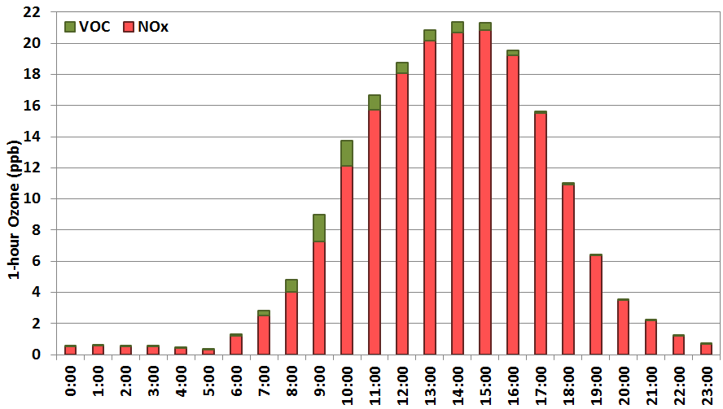

Table 5-4: Average Hourly Contribution from Local NO_{X} and VOC Emissions Sources on Days > 70 ppb, C58, 2018
Hour | NOx |  |  |  |  |  | VOC |  |  |  |  |  | Total
 | Biogenics | Area | Oil and Gas Development | Non-road/  Off-road | Onroad | Point | Biogenics | Area | Oil and Gas Development | Non-road/  Off-road | On-Road | Point | NOx | VOC
0.00 | 0.02 | 0.04 | 0.02 | 0.07 | 0.11 | 0.29 | 0.00 | 0.00 | 0.00 | 0.00 | 0.00 | 0.00 | 0.55 | 0.00
1.00 | 0.02 | 0.04 | 0.03 | 0.07 | 0.12 | 0.29 | 0.00 | 0.00 | 0.00 | 0.00 | 0.00 | 0.00 | 0.56 | 0.00
2.00 | 0.02 | 0.03 | 0.03 | 0.07 | 0.11 | 0.28 | 0.00 | 0.00 | 0.00 | 0.00 | 0.00 | 0.00 | 0.54 | 0.00
3.00 | 0.02 | 0.03 | 0.03 | 0.06 | 0.11 | 0.27 | 0.00 | 0.00 | 0.00 | 0.00 | 0.00 | 0.00 | 0.51 | 0.00
4.00 | 0.01 | 0.03 | 0.02 | 0.05 | 0.09 | 0.24 | 0.00 | 0.00 | 0.00 | 0.00 | 0.00 | 0.00 | 0.43 | 0.00
5.00 | 0.01 | 0.02 | 0.01 | 0.04 | 0.08 | 0.17 | 0.00 | 0.00 | 0.00 | 0.00 | 0.00 | 0.00 | 0.33 | 0.01
6.00 | 0.02 | 0.07 | 0.01 | 0.16 | 0.48 | 0.44 | 0.01 | 0.06 | 0.01 | 0.02 | 0.04 | 0.01 | 1.19 | 0.15
7.00 | 0.05 | 0.15 | 0.02 | 0.33 | 0.99 | 0.97 | 0.02 | 0.15 | 0.01 | 0.03 | 0.07 | 0.02 | 2.51 | 0.30
8.00 | 0.06 | 0.28 | 0.03 | 0.51 | 1.28 | 1.89 | 0.02 | 0.43 | 0.02 | 0.06 | 0.17 | 0.04 | 4.05 | 0.73
9.00 | 0.06 | 0.68 | 0.04 | 1.12 | 2.54 | 2.84 | 0.03 | 1.05 | 0.03 | 0.16 | 0.36 | 0.08 | 7.28 | 1.70
10.00 | 0.11 | 1.29 | 0.06 | 2.04 | 4.53 | 4.13 | 0.02 | 1.00 | 0.03 | 0.17 | 0.31 | 0.08 | 12.15 | 1.62
11.00 | 0.15 | 1.70 | 0.06 | 2.74 | 5.94 | 5.13 | 0.02 | 0.58 | 0.02 | 0.10 | 0.17 | 0.05 | 15.74 | 0.94
12.00 | 0.19 | 1.85 | 0.07 | 3.31 | 6.51 | 6.14 | 0.01 | 0.42 | 0.02 | 0.08 | 0.11 | 0.04 | 18.07 | 0.68
13.00 | 0.22 | 1.80 | 0.08 | 3.57 | 6.58 | 7.89 | 0.01 | 0.44 | 0.02 | 0.08 | 0.11 | 0.04 | 20.15 | 0.71
14.00 | 0.26 | 1.56 | 0.10 | 3.34 | 6.25 | 9.20 | 0.01 | 0.41 | 0.02 | 0.08 | 0.11 | 0.04 | 20.70 | 0.67
15.00 | 0.30 | 1.35 | 0.10 | 3.04 | 5.86 | 10.19 | 0.01 | 0.29 | 0.02 | 0.06 | 0.08 | 0.04 | 20.83 | 0.50
16.00 | 0.31 | 1.17 | 0.08 | 2.67 | 5.07 | 9.94 | 0.01 | 0.16 | 0.02 | 0.04 | 0.05 | 0.03 | 19.24 | 0.30
17.00 | 0.29 | 0.95 | 0.08 | 2.20 | 4.05 | 7.92 | 0.01 | 0.07 | 0.01 | 0.02 | 0.02 | 0.02 | 15.49 | 0.15
18.00 | 0.24 | 0.65 | 0.09 | 1.55 | 2.82 | 5.57 | 0.00 | 0.04 | 0.01 | 0.01 | 0.02 | 0.01 | 10.91 | 0.09
19.00 | 0.15 | 0.38 | 0.08 | 0.86 | 1.46 | 3.44 | 0.00 | 0.03 | 0.00 | 0.01 | 0.01 | 0.01 | 6.38 | 0.07
20.00 | 0.09 | 0.21 | 0.06 | 0.48 | 0.74 | 1.92 | 0.00 | 0.01 | 0.00 | 0.00 | 0.00 | 0.00 | 3.50 | 0.02
21.00 | 0.06 | 0.16 | 0.04 | 0.30 | 0.46 | 1.18 | 0.00 | 0.00 | 0.00 | 0.00 | 0.00 | 0.00 | 2.20 | 0.01
22.00 | 0.04 | 0.08 | 0.03 | 0.14 | 0.23 | 0.70 | 0.00 | 0.00 | 0.00 | 0.00 | 0.00 | 0.00 | 1.22 | 0.01
23.00 | 0.02 | 0.04 | 0.02 | 0.08 | 0.12 | 0.40 | 0.00 | 0.00 | 0.00 | 0.00 | 0.00 | 0.00 | 0.69 | 0.01

Environmental Protection Agency (EPA), “The Plain English Guide to the Clean Air Act.” Available online: http://www.epa.gov/air/caa/peg/. Accessed 07/30/15.
EPA, March 2008. “Fact Sheet: Final Revisions to the National Ambient Air Quality Standards for Ozone”. Available online: http://www.epa.gov/groundlevelozone/pdfs/2008_03_factsheet.pdf. Accessed 07/30/15.
EPA, Nov. 25, 2014. “National Ambient Air Quality Standards for Ozone”. EPA-HQ-OAR-2008-0699; FRL-9918-43-OAR. Available online: http://www.epa.gov/airquality/ozonepollution/pdfs/20141125proposal.pdf. Accessed 08/27/15.
ENVIRON International Corporation, April 2014. “User’s Guide COMPREHENSIVE AIR QUALITY MODEL WITH EXTENSIONS Version 6.1”. Novato, California. Available online: http://www.camx.com/files/camxusersguide_v6-10.pdf. Accessed 08/10/15. p. 144.
Environmental Protection Agency (EPA), “The Plain English Guide to the Clean Air Act.” Available online: http://www.epa.gov/air/caa/peg/. Accessed 07/30/15.
Source: EPA, Dec. 2014. “Proposed Revisions to National Ambient Air Quality Standards for Ozone”. Available online: http://www.epa.gov/groundlevelozone/actions.html. Accessed 07/30/15.
EPA, July 21, 2015. “Process of Reviewing the National Ambient Air Quality Standards”. Available online: http://www.epa.gov/ttn/naaqs/review.html. Accessed 07/30/15.
EPA, April 19, 2013. “Factors EPA Will Consider as the Basis for Nonattainment Area Boundaries”. Available online: http://www.epa.gov/pmdesignations/2006standards/documents/9factors2008.htm. Accessed 07/30/15.
EPA, March 2008. “Fact Sheet: Final Revisions to the National Ambient Air Quality Standards For Ozone”. Available online: http://www.epa.gov/groundlevelozone/pdfs/2008_03_factsheet.pdf. Accessed 07/30/15.
Texas Commission on Environmental Quality (TCEQ). “Four Highest Eight-Hour Ozone Concentrations.“ Austin, Texas. Available online: http://www.tceq.state.tx.us/cgi-bin/compliance/monops/8hr_4highest.pl. Accessed 07/30/15.
TCEQ, “Air and Water Monitoring”. Austin, Texas. Available online: http://www.tceq.state.tx.us/assets/public/compliance/monops/graphics/clickable/region13.gif. Accessed 07/26/15.
ENVIRON International Corporation, April 2014. “User’s Guide COMPREHENSIVE AIR QUALITY MODEL WITH EXTENSIONS Version 6.1”. Novato, California. Available online: http://www.camx.com/files/camxusersguide_v6-10.pdf. Accessed 08/10/15. p. 144.
TCEQ, May 2013. “Select a Monitoring Site in the San Antonio Region”. Available online: http://www.tceq.state.tx.us/cgi-bin/compliance/monops/select_summary.pl?region13.gif. Accessed: 08/28/15
EPA, Dec. 2014. “Modeling Guidance for Demonstrating Attainment of Air Quality Goals for Ozone, PM_{2.5}, and Regional Haze 2014 Draft”. Available online: http://www.epa.gov/scram001/guidance/guide/Draft_O3-PM-RH_Modeling_Guidance-2014.pdf. Accessed 07/31/15.
National Center for Atmospheric Research. “WRF Model Version 3.2“ Available online: http://www.wrf-model.org/index.php. Accessed 07/21/15.
ENVIRON International Corporation, April 2014. “User’s Guide COMPREHENSIVE AIR QUALITY MODEL WITH EXTENSIONS Version 6.1”. Novato, California. Available online: http://www.camx.com/files/camxusersguide_v6-10.pdf. Accessed 08/10/15. p. 144.
Colella, P. and P.R. Woodward, 1984. “The Piecewise Parabolic Method (PPM) for Gas-Dynamical Simulations.” Journal of Computation Physics. Volume 54, pp. 174-201. Available online: http://seesar.lbl.gov/anag/publications/colella/A_1_4_1984.pdf. Accessed: 07/24/15.
Yarwood. G, Whitten G. Z., Gookyoung, H, Mellberg, J. and Estes, M. 2010. “Updates to the Carbon Bond Mechanism for Version 6 (CB6)”. Presented at the 9th Annual CMAS Conference, Chapel Hill, NC, October 11-13, 2010. Available online: http://www.cmascenter.org/conference/2010/abstracts/emery_updates_carbon_2010.pdf. Accessed 07/10/15.
Zhang, L., S. Gong, J. Padro and L. Barrie, 2001: “A sizesegregated particle dry deposition scheme for an atmospheric aerosol module”. Atmospheric Environment. 35 3, 549–560. Available online: http://citeseerx.ist.psu.edu/viewdoc/download;jsessionid=8159D0EBE784EBC207E3237CD6F60BBA?doi=10.1.1.467.1727&rep=rep1&type=pdf. Accessed 07/31/15.
AACOG, April 2009. “Conceptual Model - Ozone Analysis of the San Antonio Region: Updates through Year 2008”. San Antonio, Texas. Available online: https://www.aacog.com/index.aspx?NID=98. Accessed 08/17/15.
TCEQ. “Rider 8 State and Local Air Quality Planning Program - Modeling Domains”. Austin, Texas. Available online: http://www.tceq.texas.gov/airquality/airmod/rider8/modeling/domain. Accessed 07/10/15.
ENVIRON, June 30, 2009. “Application of CAMx for the Austin San Antonio Joint Meteorological Model Refinement Project”. prepared by Chris Emery, Jeremiah Johnson, and Piti Piyachaturawat of ENVIRON International Corporation, Air Sciences Group, Novato, CA, p. 1-2.
Susan Kemball-Cook, Yiqin Jia, Ed Tai, and Greg Yarwood August 31, 2007. “Performance Evaluation of an MM5 Simulation of May 29-July 3, 2006.” Prepared for Texas Commission on Environmental Quality. ENVIRON International Corporation, Novato, CA. p. 2-1. Available online: http://www.tceq.state.tx.us/assets/public/implementation/air/am/contracts/reports/mm/2006_MM5_Modeling_Final_Report-20070830.pdf. Accessed 06/24/13.
ENVIRON International Corporation, August 2009. “User’s Guide Emissions Processor Version 3”. Novato, CA. Available online: ftp://amdaftp.tceq.texas.gov/pub/HGB8H2/ei/EPS3_manual/EPS3UG_UserGuide_200908.pdf. Accessed 06/27/13.
Greg Yarwood, Jaegun Jung, Gary Z. Whitten, Gookyoung Heo, Jocelyn Mellberg, and Mark Estes, Oct. 2010. “Updates to the Carbon Bond Mechanism for Version 6 (CB6)”. Presented at the 9th Annual CMAS Conference, Chapel Hill, NC, October 11-13, 2010. p. 2. Available online: http://www.cmascenter.org/conference/2010/abstracts/emery_updates_carbon_2010.pdf. Accessed 06/27/13.
Eastern Research Group, Inc, Jan. 1997. “Introduction: The Value of QA/QC’. Quality Assurance Committee Emission Inventory Improvement Program, U.S. Environmental Protection Agency. p. 1.2-1. Available online: http://www.epa.gov/ttn/chief/eiip/techreport/volume06/vi01.pdf. Accessed 06/04/2012.
Ibid., p. 1.2-2.
Railroad Commission of Texas, May 22, 2012. “Eagle Ford Information”. Austin, Texas. Available online: http://www.rrc.state.tx.us/eagleford/index.php. Accessed 05/30/2012.
Lorri Pavliska, Texas Department of Transportation, SAT District. San Antonio, Texas.
Federal Highway Administration (FHWA), Nov. 2003. “Introduction to the LTPP Information Management System (IMS)”. FHWA-RD-03-088. Available online: http://www.fhwa.dot.gov/publications/research/infrastructure/pavements/ltpp/reports/03088/12.cfm. Accessed 07/14/14
Office of Transportation and Air Quality, August 2010. “MOVES”. U.S. Environmental Protection Agency, Washington, DC. Available online: http://www.epa.gov/otaq/models/moves/index.htm. Accessed: 04/02/2012.
TCEQ, July 24, 2012. “Texas Emissions Reduction Plan (TERP) Emissions Reduction Incentive Grants Program”. Austin, Texas. Available online: http://www.tceq.texas.gov/assets/public/implementation/air/terp/techsup/2012onvehicle_ts.pdf. Accessed 8/27/13.
The University of North Carolina at Chapel Hill, UNC Institute for the Environment. “PAVE User's Guide - Version 2.3”. Available online http://www.ie.unc.edu/cempd/EDSS/pave_doc/index.shtml#TOC. Accessed 08/07/13.
EPA, Dec. 3, 2014. “Modeling Guidance for Demonstrating Attainment of Air Quality Goals for Ozone, PM_{2.5}, and Regional Haze”. Research Triangle Park, North Carolina. p. 39. Available online: http://www.epa.gov/scram001/guidance/guide/Draft_O3-PM-RH_Modeling_Guidance-2014.pdf. Accessed 08/04/15.
Ibid., p. 95.
Ibid., p. 97.
Ibid., p. 98.
Ibid., p. 99.
Ibid., p. 102.
TCEQ. “Appendix C: Photochemical Modeling for the DFW Attainment Demonstration SIP Revision for the 1997 Eight-Hour Ozone Standard”. Austin, Texas. p. c-127. Available online: http://www.tceq.texas.gov/assets/public/implementation/air/sip/dfw/ad_2011/AppC_CAMx_ado.pdf. Accessed 06/20/13.
EPA, Dec. 3, 2014. “Modeling Guidance for Demonstrating Attainment of Air Quality Goals for Ozone, PM_{2.5}, and Regional Haze”. Research Triangle Park, North Carolina. p. 39. Available online: http://www.epa.gov/scram001/guidance/guide/Draft_O3-PM-RH_Modeling_Guidance-2014.pdf. Accessed 08/04/15. p. 102.
Ibid., p. 103.
EPA, April 2007. “Guidance on the Use of Models and Other Analyses for Demonstrating Attainment of Air Quality Goals for Ozone, PM2.5, and Regional Haze,” EPA -454/B-07-002. Research Triangle Park, North Carolina. p. 2. Available online: http://www.epa.gov/scram001/guidance/guide/final-03-pm-rh-guidance.pdf. Accessed 08/11/15.
ENVIRON International Corporation, April 2014. “User’s Guide COMPREHENSIVE AIR QUALITY MODEL WITH EXTENSIONS Version 6.1”. Novato, California. Available online: http://www.camx.com/files/camxusersguide_v6-10.pdf. Accessed 08/10/15. p. 144.
Ibid.
Ibid.
Ibid.
Ibid. p. 160-161.
EPA, April 2007. “Guidance on the Use of Models and Other Analyses for Demonstrating Attainment of Air Quality Goals for Ozone, PM2.5, and Regional Haze,” EPA -454/B-07-002. Research Triangle Park, North Carolina. p. 2. Available online: http://www.epa.gov/scram001/guidance/guide/final-03-pm-rh-guidance.pdf. Accessed 08/11/15.
Dr. Chi Yau, 2015. “Interquartile Range”. Available online: http://www.r-tutor.com/elementary-statistics/numerical-measures/interquartile-range. Accessed: 08/12/15.

